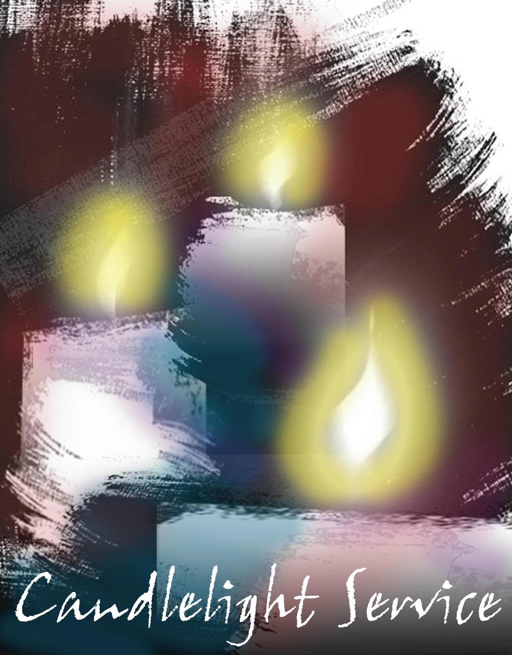

TRINITY LUTHERAN CHURCH

CANDLELIGHT SERVICE

PRELUDE

OPENING HYMN: O COME ALL YE FAITHFUL
1. Oh come, all ye faithful, joyful and triumphant! 2. The highest, most holy, Light of the light eternal,
Oh, come ye, Oh, come ye to Bethlehem! Born of a virgin, a mortal he comes;
Come and behold Him, Son of the Father, Now in flesh appearing!
Born the King of angels: Refrain Refrain

Refrain: O Come Let Us Adore Him, 3. Sing, choirs of angels, sing in exultation,
O Come Let Us Adore Him Sing, all ye citizens of heaven above
O Come Let Us Adore Him Glory to God, in the highest! Refrain
Christ the Lord!

CHRISTMAS GOSPEL: John 1
GREETING
P: The word was made flesh and dwelt among us. C: O come let us adore Him.
P: May the light and peace of Christ be with you all. C: And also with you.

ENTRANCE HYMN: JOY TO THE WORLD
1. Joy to the World, the Lord is come! 2. Joy to the earth! The Savior reigns:
Let earth receive her King; Let men their songs employ,
Let every heart prepare Him room While fields and floods. Rock, hill and plains
And heav’n and nature sing, (2 times) Repeat the sounding joy, Repeat the sounding joy
And Heav’n and nature sing, Repeat, repeat the sounding joy,

3. No more let sin and sorrow grow 4. He rules the world, with truth and grace
Nor thorns infest the ground: And makes the nations prove
He comes to make His blessing flow The glories of His righteousness
Far as the curse is found, And wonders of His love,
Far as the curse is found, And wonders of His love,
Far as, far as the curse is found. And wonders, and wonders of His love.

PRAYER OF THE DAY
Almighty God, you have made yourself known in your Son, Jesus, redeemer of the world. We pray that His birth as a human child will set us free from the old slavery of our sin; through Jesus Christ our Lord, who lives and reigns with you and the Holy Spirit, one God, now and forever, Amen.

FIRST LESSON: Isaiah 9:2-7 The people walking in darkness have seen a great light; on those living in the land of the shadow of death a light has dawned. You have enlarged the nation and increased their joy; they rejoice before you as people rejoice at the harvest, as men rejoice when dividing the plunder. For as in the day of Midian's defeat, you have shattered the yoke that burdens them, the bar across their shoulders, the rod of their oppressor. Every warrior's boot used in battle and every garment rolled in blood will be destined for burning, will be fuel for the fire. For to us a child is born, to us a son is given, and the government will be on his shoulders. And he will be called Wonderful Counselor, Mighty God, Everlasting Father, Prince of Peace. Of the increase of his government and peace there will be no end. He will reign on David's throne and over his kingdom, establishing and upholding it with justice and righteousness from that time on and forever. The zeal of the LORD Almighty will accomplish this.

PSALM HYMN: ANGELS WE HAVE HEARD ON HIGH
1. Angles we have heard on high, 2. Shepherds why this jubilee?
Sweetly singing o’er the plains, Why your joyous strains prolong?
And the mountains in reply What the gladsome tidings be
Echoing their joyous strains. Refrain Which inspire your heav’nly song? Refrain

Refrain: 3. Come to Bethlehem and see
Gloria in excelsis Deo; Him whose birth the angels sing
Gloria in excelsis Deo; Come, adore on bended knee
Christ the Lord, the newborn king. Refrain

SECOND LESSON: Titus 2:11-14 For the grace of God that brings salvation has appeared to all men. It teaches us to say "No" to ungodliness and worldly passions, and to live self-controlled, upright and godly lives in this present age, while we wait for the blessed hope—the glorious appearing of our great God and Savior, Jesus Christ, who gave himself for us to redeem us from all wickedness and to purify for himself a people that are his very own, eager to do what is good.

HYMN: GOOD CHRISTAIN FRIENDS, REJOICE
1. Good Christians friends, rejoice 2. Good Christian friends, rejoice
With heart and soul and voice; With heart and soul and voice;
Give ye heed to what we say; Now ye need not fear the grave;
Jesus Christ is born today; Jesus Christ was born to save!
Ox and ass before him bow, Calls you one and calls you all
And He is in the manger now. To gain His everlasting hall.
Christ is born today! Christ was born to save!
Christ is born today! Christ was born to save!

HOLY GOSPEL: Luke 2:1-20 Before the Gospel: “Glory to you, O Lord”
After the Gospel: “Praise to you, O Christ”
SERMON
2
HYMN OF THE DAY: WHAT CHILD IS THIS 1. What child is this, who, laid to rest, 2. Why lies he in such mean estate, where ox and ass and feeding?
On Mary’s lap is sleeping? Good Christian, fear for sinners here the silent Word is pleading.
Whom angels greet with anthems sweet Nails, spear shall pierce Him through, the cross be borne, for me, for you;
While shepherds watch are keeping? Hail, hail the Word made flesh, the babe the son of Mary!
This, this is Christ the king,
whom shepherds guard and angels sing; 3. So bring him incense, gold and myrrh;
Haste, haste to bring him laud, Come, peasant, king, to own him. The King of kings salvation brings;
The babe, the son of Mary! Let loving hearts enthrone him. Raise, raise the song on high,
the virgin sings her lullaby; Joy, joy for Christ is born.
The babe, the son of Mary!

THE PRAYERS
In the Word made flesh, we see God’s love for all people. Therefore, let us pray for the Church, the world, and all those in need. After each portion of the prayers:
P: Lord, in your mercy,

C: Hear our prayer
P: Gracious God, receive our prayers, and continue to reveal your salvation in the sight of all people, through Jesus Christ our Lord. Amen.

THE PEACE
P: The peace of the Lord be with you always, C: And also with you.

OFFERING
OFFERTORY VERSE (Sung to “O Little Town of Bethlehem”)
1 O Holy child of Bethlehem, Descend to us, we pray 3 We hear the Christmas angels the great glad tidings tell;
2 Cast out our sin, and enter in, Be born in us today 4 Oh, come to us, abide with us, Our Lord Immanuel!
OFFERTORY PRAYER P: Blessed are you, C: God of all creation. Through your goodness we have these gifts to share. Receive our offerings and nourish us at your table, that your Word may take flesh in our lives; for the sake of Him who gave himself for us, Jesus Christ our Lord. Amen.

GREAT THANKSGIVING P: The Lord be with you Sung to “Hark the Herald Angles Sing” C: And also with you Holy, holy, holy Lord,/ God of heav’n and earth adored P: Lift up your hearts. O how blest is He who comes/ in the Holy name of God. C: We lift them up to the Lord. Joyful, all you nations rise;/ Join the triumph of the skies; P: Let us give thanks to the Lord our God. With angelic hosts proclaim,/ “Christ is born in Bethlehem!” C: It is right to give our thanks and praise. Hark! The herald angels sing,/ “Glory to the newborn king!” P: It is indeed right and salutary…and join their unending hymn:

EUCHARISTIC PRAYER (Words of Institution)
LORD’S PRAYER (Sung to “It Came Upon A Midnights Clear”)
Our Father, Lord on Heav’n’s high throne,
Most Holy be your name.
Your Kingdom come, Your will be done
On earth in Heav’n the same.
Give us this day the food we need;
Forgiven may we be;
Into temptation do not lead; From evil set us free.
Yours is the Kingdom unto you
In grateful love we bow;
And Yours the power; Lord, let us view
Your mighty presence now.
The glory Yours; Your praise be sung
By angel hosts and men
In ev’ry land, by ev’ry tongue
Forevermore! Amen.

CONTINUOUS COMMUNION

LIGHTING OF THE CANDLES:

HYMN: SILENT NIGHT, HOLY NIGHT

1. Silent night, Holy night. All is calm, all is bright 2. Silent night, Holy night, Shepherds quake at the sight;
Round yon Virgin Mother and Child Glories stream from heaven afar, Heavenly hosts sing Alleluia!
Holy Infant, so tender and mild, Heav’nly hosts sing, Alleluia!
Sleep in heavenly peace, (2 times) Christ the Savior is born, Christ the Savior is born.

3. Silent night, Holy night, Son of God, love’s pure light.
Radiant beams from Thy Holy Face. with the dawn of redeeming grace,
Jesus Lord at Thy birth, Jesus Lord at Thy birth.

POST COMMUNION PARYER
P: Gracious God, in the incarnation of your Son you have united earth and heaven. May we who have tasted heavenly things share the gift of your presence with all the world; through Jesus Christ our Lord.
C: Amen.

BENEDICTION

DEPARTURE HYMN: GO TELL IT ON THE MOUNTAIN

Refrain
Go tell it on the mountain, Over the hills and ev’rywhere; 2. The shepherds feared and trembled
Go tell it on the mountain, That Jesus Christ is born! When, lo above the earth /Rang out the angel chorus That hailed our Savior’s birth. Refrain

1: While shepherds kept their watching 3. Down in a lonely manger, the humble Christ was born
O’er silent flocks by night, Behold throughout the heavens And God sent us salvation, that blessed Christmas morn.
There shone a holy light. Refrain Refrain
CHRISTMAS EVE PRAYER Almighty God, you made this holy night shine with the brightness of the true Light. Grant that here on earth we may walk in the light of Jesus’ presence and in the last day wake to the brightness of his glory; through your only Son, Jesus Christ our Lord, who lives and reigns with you and the Holy Spirit, one God now and forever. Amen.

DISMISSAL
P: Glory to God in the highest!
C: Peace to God’s people on earth!
P: As heralds of God’s peace, go forth in joy to love and serve the Lord

C: Thanks be to God!
3
4

