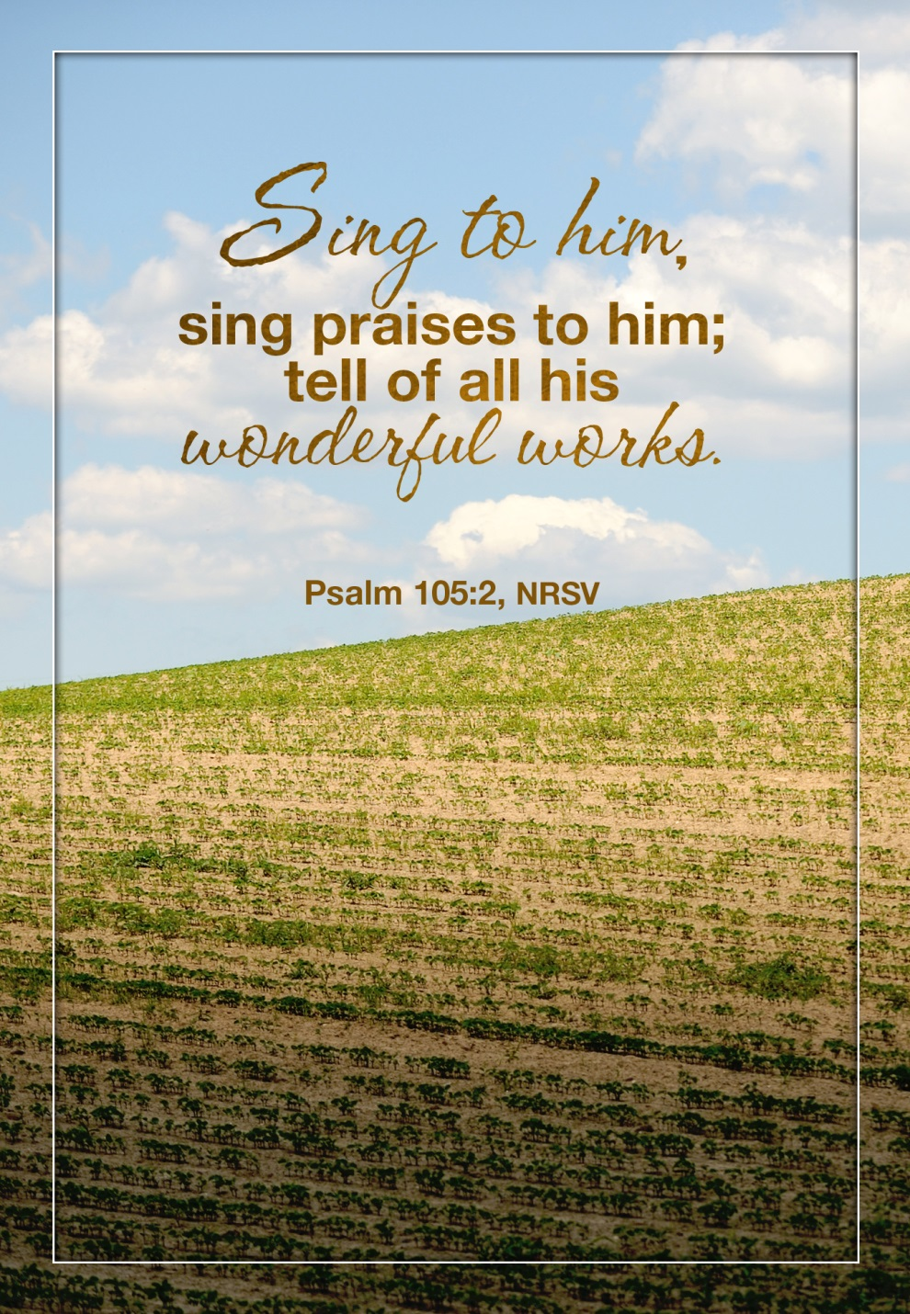

***Great Hymns of Faith with Great Stories of Faith***

***Hymnfest Sunday***

**15th Sunday in Pentecost**

**September 6, 2015**

**Trinity Lutheran Church, Truman MN**

**Trinity Lutheran Church**

Office Phone 776-4781, Fax 776-7888, Summer Office Hours: Mon, Wed & Fri-7-11 am

 Email: [trinitytruman@frontier.com](mailto:trinitytruman@frontier.com), Website: [www.trinity-truman.org](http://www.trinity-truman.org)

Trinity President: Laurie Wille (507-776-3098) Cell-(507-848-7187)

**GATHERING**

*Congregation reads* ***bold print****.*

**PRELUDE**

**GATHERING REFLECTION**

Great Hymns of Faith with Great Stories of Faith. You can’t have one without the other. What is your favorite hymn? There is probably a special comfort that comes with that and some experience joined to it. **Thank you Lord for the great hymns and song writers of time who give us your comfort. Amen.**

**BELL**

**WELCOME & ANNOUNCEMENTS**

**CONFESSION & FORGIVENESS** *Softly and Tenderly Jesus is Calling* **ELW #608**

**GATHERING HYMN** *A Mighty Fortress is Our God*  **ELW #504**

**GREETING**

**HYMN OF PRAISE** *Joyful, Joyful We Adore Thee*  **ELW #836**

**\*PRAYER OF THE DAY:** Gracious God,

**Throughout the ages you transform sickness into health and death into life. Open us to the power of your presence, and make us a people ready to proclaim your promises to the whole world, through Jesus Christ, our healer and Lord. Amen.**

**WORD**

**FIRST READING:** **Isaiah 35:4-7 (NRSV)**

4Say to those who are of a fearful heart, “Be strong, do not fear! Here is your God. He will come with vengeance, with terrible recompense. He will come and save you.” 5Then the eyes of the blind shall be opened, and the ears of the deaf unstopped; 6then the lame shall leap like a deer, and the tongue of the speechless sing for joy. For waters shall break forth in the wilderness, and streams in the desert; 7the burning sand shall become a pool, and the thirsty ground springs of water; the haunt of jackals shall become a swamp, the grass shall become reeds and rushes.

The Word of the Lord.  **C: Thanks be to God.**

**HYMN** *Lead On, O King Eternal*  **ELW #805**

**PSALM: 146**  *(read responsively the* ***bold print****)*

L: Hallelujah!

**C: Praise the Lord, O my soul!**

L: I will praise the Lord as long as I live;

**C: I will sing praises to my God while I have my being.**

L: Put not your trust in rulers,

**C: in mortals in whom there is no help.**

L: When they breathe their last, they return to earth,

**C: and in that day their thoughts perish.**

L: Happy are they who have the God of Jacob for their help,

**C: whose hope is in the Lord their God;**

L: who made heaven and earth, the seas, and all that is in them;

**C: who keeps promises forever;**

L: who gives justice to those who are oppressed, and food to those who hunger.

**C: The Lord sets the captive free.**

L: The Lord opens the eyes of the blind, the Lord lifts up those who are bowed down;

**C: The Lord loves the righteous**

L: The Lord cares for the stranger;

**C: the Lord sustains the orphan and widow, but frustrates the way of the wicked.**

L: The Lord shall reign forever,

**C: your God, O Zion, throughout all generations. Hallelujah!**

**HYMN**  *Precious Lord, Take My Hand*  **ELW #773**

**SECOND READING** **James 2:1-10 [11-13] 14-17 (NRSV)**

My brothers and sisters, do you with your acts of favoritism really believe in our glorious Lord Jesus Christ? 2 For if a person with gold rings and in fine clothes comes into your assembly, and if a poor person in dirty clothes also comes in, 3 and if you take notice of the one wearing the fine clothes and say, “Have a seat here, please,” while to the one who is poor you say, “Stand there,” or, “Sit at my feet,” 4 have you not made distinctions among yourselves, and become judges with evil thoughts? 5 Listen, my beloved brothers and sisters. Has not God chosen the poor in the world to be rich in faith and to be heirs of the kingdom that he has promised to those who love him? 6 But you have dishonored the poor. Is it not the rich who oppress you? Is it not they who drag you into court? 7 Is it not they who blaspheme the excellent name that was invoked over you? 8 You do well if you really fulfill the royal law according to the scripture, “You shall love your neighbor as yourself.” 9 But if you show partiality, you commit sin and are convicted by the law as transgressors. 10 For whoever keeps the whole law but fails in one point has become accountable for all of it. 1For the one who said, “You shall not commit adultery,” also said, “You shall not murder.” Now if you do not commit adultery but if you murder, you have become a transgressor of the law. 12So speak and so act as those who are to be judged by the law of liberty. 13For judgment will be without mercy to anyone who has shown no mercy; mercy triumphs over judgment. 14What good is it, my brothers and sisters, if you say you have faith but do not have works? Can faith save you? 15If a brother or sister is naked and lacks daily food, 16and one of you says to them, “Go in peace; keep warm and eat your fill,” and yet you do not supply their bodily needs, what is the good of that? 17So faith by itself, if it has no works, is dead.

The Word of the Lord.  **C: Thanks be to God.**

**HYMN** *Amazing Grace, How Sweet the Sound* **ELW #779**

**\*GOSPEL ACCLAMATION** *This Little Light of Mine* **ELW #677**

**\*GOSPEL: Mark 7:31-37 C: Glory to you, O Lord.**

31Then he returned from the region of Tyre, and went by way of Sidon towards the Sea of Galilee, in the region of the Decapolis. 32They brought to him a deaf man who had an impediment in his speech; and they begged him to lay his hand on him. 33He took him aside in private, away from the crowd, and put his fingers into his ears, and he spat and touched his tongue. 34Then looking up to heaven, he sighed and said to him, “Ephphatha,” that is, “Be opened.” 35And immediately his ears were opened, his tongue was released, and he spoke plainly. 36Then Jesus ordered them to tell no one; but the more he ordered them, the more zealously they proclaimed it. 37They were astounded beyond measure, saying, “He has done everything well; he even makes the deaf to hear and the mute to speak.”

L: The Word of the Lord. **C: Praise to you, O Christ.**

**HYMNS OF THE DAY** *Lift High the Cross* **ELW #660**

*Beautiful Savior*  **ELW #838**

**THE APOSTLES’ CREED**       *Faith of Our Fathers* **ELW #812**

*Shine Jesus Shine* **ELW #671**

*On Eagles Wings***ELW #787**

**PRAYERS OF INTERCESSION**

L: Holy Spirit, you gather our church into an ever-widening community of faith. Release our tongues to proclaim your saving deeds to the world.

L: Lord in your mercy. **C: Hear our prayer.**

L: God of the universe, you made heaven and earth, the seas, and all that in in them. We pray for the well-being of springs and deserts, forests and mountains, creatures and plants. L: Lord in your mercy.  **C: Hear our prayer.**

L: God of mercy and healing, you open the eyes of the blind and lift up the lowly. Sustain all who are homebound, sick, grieving, or any need (*especially Bea Behrens, Agnes Carlson, Lisa Carlson & family, Donna Fisk, and Danny Lang)*, for you are their help and strength.

L: Lord in your mercy.  **C: Hear our prayer.**

L: Lord Jesus Christ, you command us to love our neighbors as ourselves. Open our hearts to care for the stranger and welcome everyone into your assembly with honor and dignity.

L: Lord in your mercy.  **C: Hear our prayer.**

L: Hear our prayers, faithful God, and renew us by your Spirit, that we may joyfully love and serve you and one another, through Jesus Christ, our Savior.

**C: Amen.**

**SHARING OF THE PEACE**

**THE LORD’S PRAYER** *sung*

**OFFERING**

**OFFERING HYMN** *Let Us Talents & Tongues Employ* **ELW #674**

**SENDING  
BLESSING** *Guide Me Ever Great Redeemer* **ELW #618**

**SENDING HYMN** *I’m So Glad, Jesus Lifted Me* **ELW #860**

**BELL**

**THE SENDING:** L:Go in peace. Let your life be a song. **C: Thanks be to God!**

**+++++++++++++++++++++++++++++++++++++++++++++++++++++++++++++++++**

*Copyright 2013 Augsburg Fortress. All rights reserved. Reprinted by permission under Augsburg Fortress Liturgies Annual License#15562-ELW*

Readings for Next Sunday: Isaiah 50:4-9, Ps 116:1-9, James 3:1-12, Mark 8:27-38

**

*We remember in our prayers…all who face catastrophic illness, surgery, and bindings of all kinds as well as the homebound:* ***Bea Behrens, Agnes Carlson, Lisa******Carlson & family, Donna Fisk, and Danny Lang.***  *Be present with your Spirit, Lord, and lead us to be your presence to all. Amen.*

**ANNOUNCEMENTS**

**MONDAY, SEPTEMBER 7**-The church office will be closed in observance of Labor Day.

**WEDNESDAY, SEPTEMBER 9**-Trinity Church Council Meeting in Madelia at 6:30 pm.

**SUNDAY, SEPTEMBER 13-Worship at 10:30 AM (Communion)**

**9:00-10:30 Sunday School Begins!!!**

**10:10:30-Kid friendly snack**

**PASTOR KRISTA’S FIRST DAY AT TRINITY—WELCOME!**

****SUNDAY, SEPTEMBER 13 (Continued)**

***This will be Rally Sunday for Trinity Sunday School***

***They will be singing VBS songs in church.***

***It will also be Noisy Sunday.***

***(The Board of Ed will be serving root-beer floats after worship)***

*Reader: Clayton Duncanson, Comm. Server: Duke Drevlow*

*Ushers: *Wayne Maloney, Gene Mager, Mike Taylor and Brian Nickerson*

**UPCOMING EVENTS**

**MONDAY, SEPTEMBER 14**-Martha Circle will be at 1:30 pm at the church. Connie Selnes is the hostess.



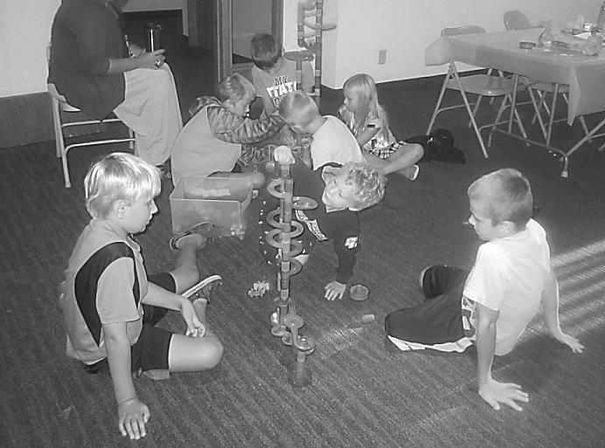 **THANK YOU TO ALL WHO HELPED OUT WITH VBS!**

Look for more pictures on our Facebook page: Trinity Lutheran Church-Truman

Or go to: <https://www.facebook.com/pages/Trinity-Lutheran-Church-Truman/137166749780180?sk=timeline>

Deepest s ympathy to the Kent Hyndman family on the death of Kent’s mother, Mildred Hyndman of Cherokee, Iowa. She passed away on August 24th. Her funeral was held on August 27th at the Memorial Presbyterian Church in Cherokee.

Our sincere sympathy to Joyce Jorgenson on the death of her sister, Dorothy Anderson of Willmar who died on September 1st. Her funeral will be on September 8th at Calvary Lutheran Church in Willmar.