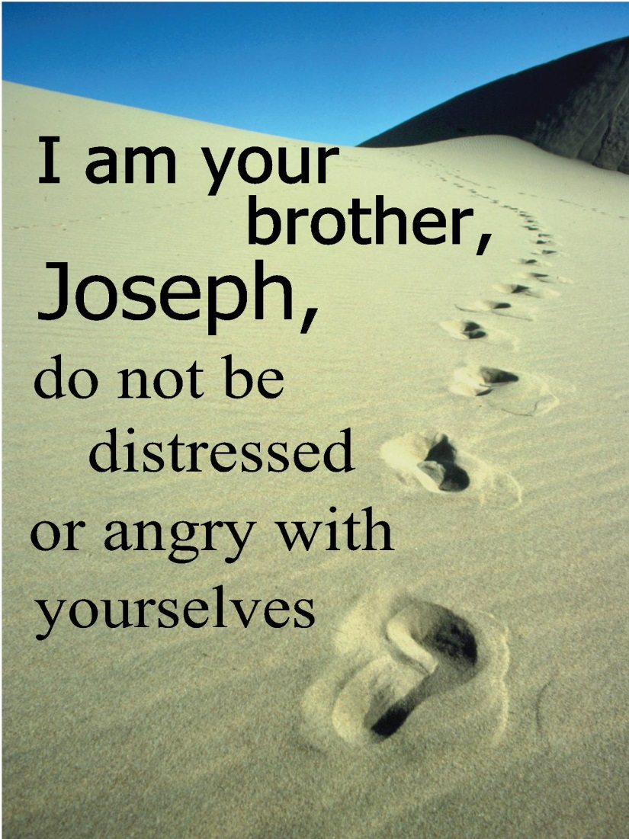

19th Sunday after Pentecost
September 25, 2016
Evangelical Lutheran Worship

Trinity Lutheran Church

Office Phone 776-4781, Fax 776-7888, Office Hours: Mon-8-11, Wed 8-11 & 1-4, Fri. 8-11
Email: trinitytruman@frontier.com, Website: www.trinity-truman.org
PASTOR KRISTA STRUM
Cell-(507)995-1233, Email: pkstrumom@me.com
Pastor Krista’s Office Hours: Wed. 8:30-2:30 pm & Thurs. 10:30-2:00 pm

GATHERING

Congregation reads bold print *Please stand

PRELUDE
BELL
ANNOUNCEMENTS
INVOCATION
In the name of the Father, and of the † Son, and of the Holy Spirit. Amen.

CONFESSION AND FORGIVENESS:
God,
We confess that we do not always understand Your ways.
We are easily discouraged when life takes unexpected turns
and our carefully laid plans and dreams come to nothing.
We confess that we are quick to give up when things get difficult,
and quick to question Your presence and Your power.
Forgive us.
Grant us patience to wait for Your good timing.
Open our eyes to recognize Your leading in our lives—
to listen for Your gentle whisper when we least expect it.
And then give us courage to step out in faith and obedience,
trusting in Your leading even when we cannot yet see the outcome.

PASTOR:
In the mercy of Almighty God, Jesus Christ was given to die for us and for our sake was given to die for us and for his sake God forgives us all our sins, Through the Holy Spirit, God, cleanses us and gives us the power to live as people called out of the darkness and into the his marvelous light. By grace you have been saved… In the name of + Jesus Christ your sins are forgiven. Amen.

GATHERING SONG Guide Me Ever, Great Redeemer ELW #618
*GREETING
The grace of our Lord Jesus Christ, the love of God, and the communion of the Holy Spirit be with you all. And also with you.

SONG OF PRAISE God, Whose Almighty Word

God, whose almighty word
chaos and darkness heard

and took their flight:
hear us, we humbly pray,
and where the gospel day
sheds not its glorious ray,
let there be light.

Holy and blessed three,
glorious Trinity,
Wisdom, Love, Might:
boundless as ocean's tide,
rolling in fullest pride,
through the earth, far and wide,
let there be light.

*PRAYER OF THE DAY L: The Lord be with you. C: And also with you.
L: Let us pray,
Loving God, you welcome all the dreamers, as well as the doubters: the worriers and wanderers can call on you by name. Help us to remember all the ways you have graced us: and that you are always with us. Encourage and empower us to be daring enough to step out of comfort into the unknown… that we may have faith and courage to cry out to you in all situations of our lives. Amen

THE GREATEST STORY
CHILDREN’S TIME

SERMON
*HYMN OF THE DAY Lord, Speak to Us, That We May Speak ELW #676
*CREED (found on the salmon sheet in the back cover of the red hymnal or) ELW p. 105
*PRAYERS OF INTERCESSSION
L: Lord, in your mercy, C: Hear our prayer.
PEACE The peace of Christ be with you always. And also with you.

OFFERING
OFFERING SONG Create in Me a Clean Heart… ELW #188
OFFERING PRAYER
God of all creation, all you have made is good, and your love endures forever. You bring forth bread from the earth and fruit from the vine. Nourish us with these gifts, that we might be for the world signs of your gracious presence in Jesus Christ, our Savior and Lord. Amen.

*LORD’S PRAYER - found on the salmon sheet in the back cover of the red hymnal

SENDING
*BLESSING Three fold Amen…
*SENDING SONG Go, My Children, with My Blessing ELW #543
*DISMISSAL Go in peace. Serve the Lord. Thanks be to God.
BELL/POSTLUE
+++++++++++++++++++++++++++++++++++++++++++++++++++++++++++++++++
Copyright © 2016 Augsburg Fortress. All rights reserved. Reprinted by permission under Augsburg Fortress Liturgies Annual License #SAS103469. New Revised Standard Version Bible, copyright © 1989, Division of Christian Education of the National Council of the Churches of Christ in the United States of America. Used by permission. All rights reserved.
We remember in our prayers…all who face catastrophic illness, surgery, and bindings of all kinds as well as the homebound: Bea Behrens, Lisa Carlson & family, Danny Lang, and Deloris Strehlo.

THIS WEEK IN OUR PARISH

SUNDAY-TUESDAY-SEPT 25-27-Pastor Krista gone to the Fall Theological Conference
WEDNESDAY, SEPTEMBER 28- 9 am Messenger Assembly
THURS, SEPTEMBER 30-OCT 1- Pat Jones Scrapbooking at the church
Pastor Krista will be gone at Continuing Ed. from Thurs, Sept. 29 through Saturday, Oct. 1st.
SUNDAY, OCTOBER 2
10 AM POLKA WORSHIP
Division B is in charge of setting up the pot-luck lunch that will be served after the service.
Ushers: *Mark Durkee, Tim Cook, Jaiden Cook and Troy Harder
Choir practice begins October 5th at 6pm.

THE GREATEST STORY

Devotional Readings for the week: September 25 -
Weekly Readings for September 25-Oct. 2 | Whirl Story Bible  For Families with Young Children | Weekly Reading | For Deeper Study
God’s Dreamer | p. 34-45 | Genesis 32:22-31  Genesis 37:1-28  Genesis 39:20 | Genesis 32 -39
Moses | p. 46-53 | Exodus 2:1-10  Exodus 3:1-15 | Exodus 2-3
Let Go Pharaoh- | p. 54-57 | Exodus 7:14-12:32 | Exodus 7- 12
I am the Lord Your God | p. 58-65 | Exodus 14:1-30  Exodus 20:1-17 | Exodus 14- 20

OTHER EVENTS

The volunteer caregivers organization “CREST” will be hosting the Carlson Pillow Cleaning Service on Thursday, September 29th from 7:30 am-3:30 pm at the Evangelical Covenant Church, located at 901 Woodland Avenue in Fairmont. Pillows will be cleaned, deodorized, sanitized and fluffed for a charge while you wait. You can also drop your pillows off at the site and come back to pick them up later in the day. All proceeds from this fundraiser will go to benefit the volunteer caregiving service of CREST in Martin County.

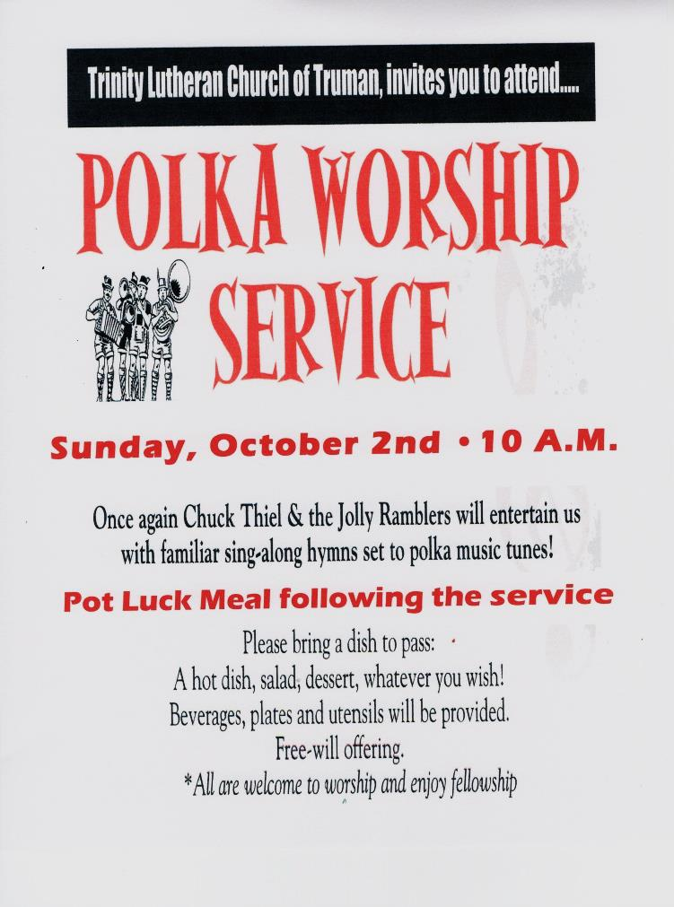

OCTOBER 15, 2016
Women of the ELCA

Trinity Lutheran Church
217 Brackenridge St. SW, Sleepy Eye, MN

“A Time to Dance”

Registration and Coffee – 8:30 AM – served by the ladies of Trinity, Sleepy Eye
Meeting – 9:15 AM
Cost - $7.00 per attendee

Speaker – Marge Lundeen will share how dancing can be the opposite of mourning. Her stories about her attempts to learn to dance will make you laugh, and she will challenge you to respond to the assurance that in God’s plan there is a time for everything. Please join us to hear her great message!

Offering – ½ to the Synod, ½ to World Hunger
Lunch – served by the ladies of Trinity, Sleepy Eye

WELCA members who would like to attend the Fall Gathering should let Barb Shoen or Barb Mager know so they can make reservations.

