Trinity Lutheran Church

Office Phone 776-4781, Fax 776-7888, Office Hours: Mon-8-11, Wed 8-11 & 1-4, Fri. 8-11
Email: trinitytruman@frontier.com, Website: www.trinity-truman.org
PASTOR KRISTA STRUM
Cell-(507)995-1233, Email: pkstrumom@me.com
Pastor Krista’s Office Hours: Wed. 8:30-2:30 pm & Thurs. 10:30-2:00 pm

18th Sunday after Pente4cost
September 18, 2016
Evangelical Lutheran Worship, Setting 4

GATHERING

Congregation reads bold print *Please stand

PRELUDE
BELL
ANNOUNCEMENTS
INVOCATION
In the name of the Father, and of the † Son, and of the Holy Spirit. Amen.

CONFESSION AND FORGIVENESS:
Gracious God, you reached into Abraham and Sarah's lives and asked them to dream the impossible dream—that you would transform what appears to have been a barren and lifeless situation into one overflowing with promise and hope—and, through faith in you, they believed your promises.
Forgive us, O God,
if we never get beyond thinking of your call on our lives as an impossible dream or even as an unwelcome interruption.

Faithful God, The apostle Paul emphasizes Abraham's complete trust and faith in your promises and how he grew ever stronger in faith, fully convinced of your ability to fulfil what had been promised.
Forgive us, O God,
when we find it hard even to hear your promises above commercial assurances of transformation—promises tempting us to trust the newest and trendiest product to realize our dreams.

Merciful God, Jesus revealed the great depth of your love in his determination to defeat evil even when this meant giving up his own life.
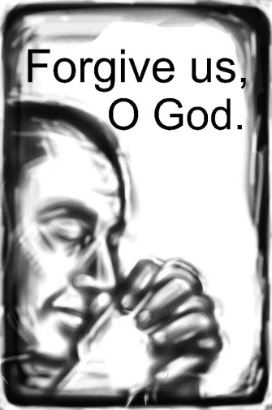
Forgive us, O God,
when we allow the power of sin to flourish because we fear that taking up one's cross would be just too costly an exercise.

Silent reflection on these words

Gracious and loving God, forgive our lack of trust in you;
Have mercy on us and forgive us.
Help us when we hesitate,
and strengthen us when we are weak
Breathe your Spirit afresh into our hearts and minds—our lives—so that we have the courage to follow Jesus wherever he takes us. Amen.
Assurance of Forgiveness
Hear and believe these words about God's amazing grace, grace experienced through Jesus' sacrificial love, his life, his death, his resurrection. In Jesus name you sins are forgiven. Amen. Thanks be to God!

GATHERING SONG Morning Has Broken ELW #556
*GREETING
The grace of our Lord Jesus Christ, the love of God, and the communion of the Holy Spirit be with you all. And also with you.

SONG OF PRAISE God, Whose Almighty Word

God, whose almighty word
chaos and darkness heard
and took their flight:
hear us, we humbly pray,
and where the gospel day
sheds not its glorious ray,
let there be light.

Holy and blessed three,
glorious Trinity,
Wisdom, Love, Might:
boundless as ocean's tide,
rolling in fullest pride,
through the earth, far and wide,
let there be light.

*PRAYER OF THE DAY L: The Lord be with you. C: And also with you.
L: Let us pray,
Lord God, Your design of creation is unflawed. Yet we continue to litter your creation with defects and imperfections. Show us how not to destroy, but to create, not to
demean, but to uplift, not to hate, but to love, so that your creation may be made
perfect once again. Amen.

THE GREATEST STORY
CHILDREN’S TIME
WORD

SCRIPTURE READING Genesis 2:4b-7, 15-17; 3:1-8
In the day that the Lord God made the earth and the heavens, 5 when no plant of the field was yet in the earth and no herb of the field had yet sprung up — for the Lord God had not caused it to rain upon the earth, and there was no one to till the ground; 6 but a stream would rise from the earth, and water the whole face of the ground— 7 then the Lord God formed man from the dust of the ground, and breathed into his nostrils the breath of life; and the
man became a living being.
15 The Lord God took the man and put him in the garden of Eden to till it and keep it. 16 And
the Lord God commanded the man, "You may freely eat of every tree of the garden;17 but of
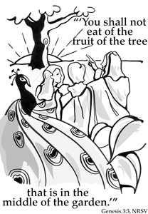
the tree of the knowledge of good and evil you shall not eat, for in the day that you eat of it you shall die."
3:1 Now the serpent was more crafty than any other wild animal that the Lord God had made. He said to the woman, "Did God say, "You shall not eat from any tree in the garden'?" 2 The woman said to the serpent, "We may eat of the fruit of the trees in the garden; 3 but God said, "You shall not eat of the fruit of the tree that is in the middle of the garden, nor shall you touch it, or you shall die.' " 4 But the serpent said to the woman, "You will not die; 5 for God knows that when you eat of it your eyes will be opened, and you will be like God, knowing good and evil." 6 So when the woman saw that the tree was good for food, and that it was a delight to the eyes, and that the tree was to be desired to make one wise, she took of its fruit and ate; and she also gave some to her husband, who was with her, and he ate. 7 Then the eyes of both were opened, and they knew that they were naked; and they sewed fig leaves together and made loincloths for themselves. 8They heard the sound of the Lord God walking in the garden at the time of the evening breeze, and the man and his wife hid themselves from the presence of the Lord God among the trees of the garden.

The word of the Lord C: Thanks be to God.

SERMON
*HYMN OF THE DAY How Great Thou Art ELW #856
*CREED (found on the salmon sheet in the back cover of the red hymnal or) ELW p. 105
*PRAYERS OF INTERCESSSION
L: Hear us, O God C: Your mercy is great.
PEACE The peace of Christ be with you always. And also with you.

OFFERING
OFFERING SONG Create in Me a Clean Heart… ELW #188
OFFERING PRAYER
God of all creation, all you have made is good, and your love endures forever. You bring forth bread from the earth and fruit from the vine. Nourish us with these gifts, that we might be for the world signs of your gracious presence in Jesus Christ, our Savior and Lord. Amen.

*LORD’S PRAYER - found on the salmon sheet in the back cover of the red hymnal

SENDING
*BLESSING Three fold Amen…
*SENDING SONG I Love to Tell the Story ELW #661

*DISMISSAL Go in peace. Serve the Lord. Thanks be to God.
BELL/POSTLUE
+++++++++++++++++++++++++++++++++++++++++++++++++++++++++++++++++
Copyright © 2016 Augsburg Fortress. All rights reserved. Reprinted by permission under Augsburg Fortress Liturgies Annual License #SAS103469. New Revised Standard Version Bible, copyright © 1989, Division of Christian Education of the National Council of the Churches of Christ in the United States of America. Used by permission. All rights reserved.
We remember in our prayers…all who face catastrophic illness, surgery, and bindings of all kinds as well as the homebound: Bea Behrens, Lisa Carlson & family, Danny Lang, and Deloris Strehlo.

TODAY: Sunday school begins at 10 am.

THIS WEEK IN OUR PARISH

THURSDAY, SEPTEMBER 22- Learn about the OsteoArthritis Program from the Center for Specialty Care. The seminar to be held at Trinity Lutheran-Truman from 10:00-11:00 am Refreshments will be served. Please RSVP at 507-238-3383.
SUNDAY, SEPTEMBER 25
8:45 AM WORSHIP
10 AM SUNDAY SCHOOL
Reader: Brenda Hansen, Acolyte: Tallin Cook
Ushers: *Mark Durkee, Tim Cook, Jaiden Cook and Troy Harder
UPCOMING EVENTS

Chicken & Biscuit Dinner today at Fairmont United Methodist Church (119 East 2nd Street) Fairmont from 11:00 am – 1:00 pm. This is the famous East Chain Recipe! Adults $8.00, Children 5-12 yrs, $5.00, children 4 & under are free.
Includes 2 salads, vegetables, beverages and homemade pies!! Take-outs available.

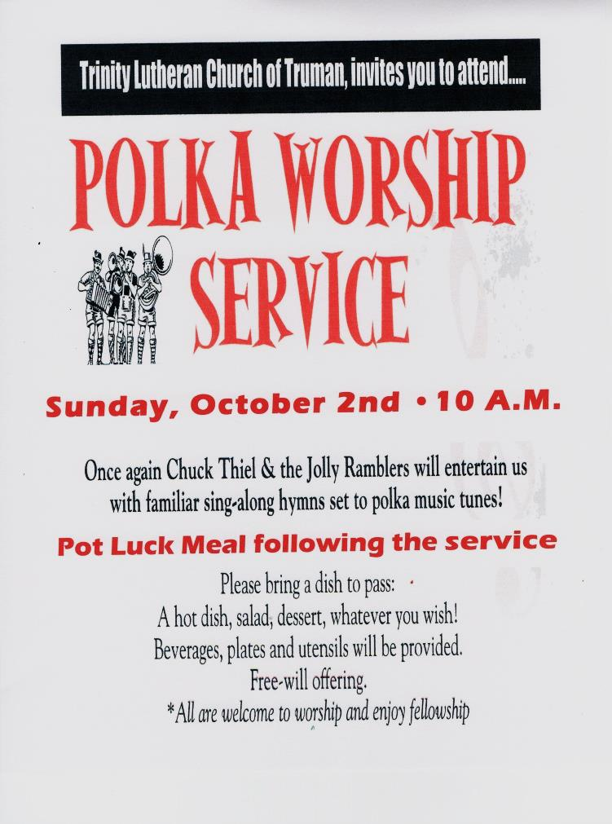

THE GREATEST STORY

Preaching Texts beginning September 18th - Beginnings - Genesis 1: 1-2:4

Devotional Readings for the week: Sept. 18

Weekly Readings for September 18 - 24 |  | Whirl Story Bible  For Families with Young Children | Weekly Reading | For Deeper Study
In the Beginning | p. 2 -5 |  | Genesis 1- 2:4 | Genesis 1-2
Adam and Eve | p. 6 - 9 |  | Genesis 3 | Genesis 3-4
Do Over | p. 10 -13 |  | Genesis 6–9 | Genesis 6-9
Jacob | p. 26-33 |  | Genesis 25:19-28, Genesis 27:1-40  Genesis 32:22-31 | Genesis 25:19-36:43

September 25 -
Weekly Readings for September 25-Oct. 2 | Whirl Story Bible  For Families with Young Children | Weekly Reading | For Deeper Study
God’s Dreamer | p. 34-45 | Genesis 32:22-31  Genesis 37:1-28  Genesis 39:20 | Genesis 32 -39
Moses | p. 46-53 | Exodus 2:1-10  Exodus 3:1-15 | Exodus 2-3
Let Go Pharaoh- | p. 54-57 | Exodus 7:14-12:32 | Exodus 7- 12
I am the Lord Your God | p. 58-65 | Exodus 14:1-30  Exodus 20:1-17 | Exodus 14- 20

