

**16th Sunday after Pentecost**

**September 13, 2015**

**Holy Communion, *Bread of Life*, Setting 5**

**With One Voice (WOV) p. 28**

**Trinity Lutheran Church**

Office Phone 776-4781, Fax 776-7888, Summer Office Hours: Mon, Wed & Fri-700-11:00 am

 Email: [trinitytruman@frontier.com](mailto:trinitytruman@frontier.com), Website: [www.trinity-truman.org](http://www.trinity-truman.org)

Trinity President: Laurie Wille (507-776-3098) Cell-(507-848-7187)

**GATHERING**

*Congregation reads* ***bold print****. *Please stand*

**BELL**

**WELCOME & ANNOUNCEMENTS**

**\*CONFESSION & FORGIVENESS (*right column)* WOV p. 10**

**\*GATHERING HYMN *Borning Cry*  WOV #770**

**GREETING WOV p. 28**

**KYRIE**

**HYMN OF PRAISE *Glory to God*  WOV p. 29**

**\*PRAYER OF THE DAY:** L: The Lord be with you. **C: And also with you.**

L: Let us pray. *Silence* O God,

**C:** **through suffering and rejection you bring forth our salvation, and by the glory of the cross you transform our lives. Grant that for the sake of the gospel we may turn from the lure of evil, take up our cross, and follow your Son, Jesus Christ, our Savior and Lord. Amen.**

**WORD**

**FIRST READING**: Isaiah 50:4-9a

4 The Lord God has given me the tongue of a teacher, that I may know how to sustain the weary with a word. Morning by morning he wakens—wakens my ear to listen as those who are taught. 5 The Lord God has opened my ear, and I was not rebellious, I did not turn backward. 6 I gave my back to those who struck me, and my cheeks to those who pulled out the beard; I did not hide my face from insult and spitting. 7 The Lord God helps me; therefore I have not been disgraced; therefore I have set my face like flint, and I know that I shall not be put to shame; 8 he who vindicates me is near. Who will contend with me? Let us stand up together. Who are my adversaries? Let them confront me. 9 It is the Lord God who helps me; who will declare me guilty?

The Word of the Lord. **C: Thanks be to God.**

**PSALM 116:1-9** *Congregation will read the* ***bold*** *print.*

1 I love the Lord, because he has heard the voice of my supplication, because he has inclined his ear to me whenever I called upon him.

2 **The cords of death entangled me; the grip of the grave took hold of me;**      **I came to grief and sorrow.**

3 Then I called upon the name of the Lord: “O Lord, I pray you, save my life.”

4 **Gracious is the Lord and righteous; our God is full of compassion.**

5 The Lord watches over the innocent; I was brought very low, | and he helped me.

6 **Turn again to your rest, O my soul. for the Lord has treated you well.**

7 For you have rescued my life from death, my eyes from tears, and my |feet from stumbling.

8 **I will walk in the presence of the Lord in the land of the living.**

**SECOND READING: James 3:1-12 (NRSV)**

1 Not many of you should become teachers, my brothers and sisters, for you know that we who teach will be judged with greater strictness. 2 For all of us make many mistakes. Anyone who makes no mistakes in speaking is perfect, able to keep the whole body in check with a bridle. 3 If we put bits into the mouths of horses to make them obey us, we guide their whole bodies. 4 Or look at ships: though they are so large that it takes strong winds to drive them, yet they are guided by a very small rudder wherever the will of the pilot directs. 5 So also the tongue is a small member, yet it boasts of great exploits. How great a forest is set ablaze by a small fire! 6 And the tongue is a fire. The tongue is placed among our members as a world of iniquity; it stains the whole body, sets on fire the cycle of nature, and is itself set on fire by hell. 7 For every species of beast and bird, of reptile and sea creature, can be tamed and has been tamed by the human species, 8 but no one can tame the tongue—a restless evil, full of deadly poison. 9 With it we bless the Lord and Father, and with it we curse those who are made in the likeness of God. 10 From the same mouth come blessing and cursing. My brothers and sisters, this ought not to be so. 11 Does a spring pour forth from the same opening both fresh and brackish water? 12 Can a fig tree, my brothers and sisters, yield olives, or a grapevine figs? No more can salt water yield fresh.

The Word of the Lord. **C: Thanks be to God.**

**\* GOSPEL ACCLAMATION** *Lord, Let My Heart Be Good Soil*  **WOV #713**

**\*GOSPEL: Mark 8:27-38 C: Glory to you, O Lord.**

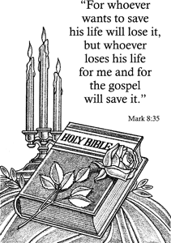27 Jesus went on with his disciples to the villages of Caesarea Philippi; and on the way he asked his disciples, “Who do people say that I am?” 28 And they answered him, “John the Baptist; and others, Elijah; and still others, one of the prophets.” 29 He asked them, “But who do you say that I am?” Peter answered him, “You are the Messiah.” 30 And he sternly ordered them not to tell anyone about him. 31 Then he began to teach them that the Son of Man must undergo great suffering, and be rejected by the elders, the chief priests, and the scribes, and be killed, and after three days rise again. 32 He said all this quite openly. And Peter took him aside and began to rebuke him. 33 But turning and looking at his disciples, he rebuked Peter and said, “Get behind me, Satan! For you are setting your mind not on divine things but on human things.” 34 He called the crowd with his disciples, and said to them, “If any want to become my followers, let them deny themselves and take up their cross and follow me. 35 For those who want to save their life will lose it, and those who lose their life for my sake, and for the sake of the gospel, will save it. 36 For what will it profit them to gain the whole world and forfeit their life? 37 Indeed, what can they give in return for their life? 38 Those who are ashamed of me and of my words in this adulterous and sinful generation, of them the Son of Man will also be ashamed when he comes in the glory of his Father with the holy angels.”

L: The Word of the Lord. **C: Praise to you, O Christ.**

**RALLY DAY/CHILDREN’S TIME**

**SERMON**

**\*HYMN OF THE DAY** *Shine, Jesus, Shine* **WOV #651**

**\*NICENE CREED** **WOV p. 32**

**OFFERING**

**\*OFFERTORY** *Create in Me*  **WOV #732**

**\*OFFERING PRAYER** (*right column)* **WOV p. 35**

**\*PRAYERS OF INTERCESSION** L: Hear us, O God, **C: Your mercy is great.**

**\*SHARING OF THE PEACE**

L: The peace of the Lord be with you always. **C: And also with you.**

**MEAL**

**\*GREAT THANKSGIVING** **WOV p. 36**

**\*PREFACE & RESPONSE** *Holy, Holy, Holy Lord*

**\*COMMUNION PRAYER & WORDS OF INSTITUTION WOV p. 37**

**\*THE LORD’S PRAYER** *right column* **WOV p. 39**

*Lamb of God*

**THE INVITATION *All are welcome to join us at the altar to receive the body and blood of our risen Lord.***

**POST-COMMUNION PRAYER WOV p.41**

**SENDING**

**\*BLESSING** Almighty God, Father, + Son and Holy Spirit, bless you now and forever.

***Three-Fold Amen.***

**\*SENDING HYMN** *Go, My Children, with My Blessing* **WOV #721**

**\*BELL**

**\*SENDING** L: Go in peace. Serve the Lord. **C: Thanks be to God!**

**+++++++++++++++++++++++++++++++++++++++++++++++++++++++++++++++++++++++++++++++++++++++++++++++++**

*Copyright 2013 Augsburg Fortress. All rights reserved. Reprinted by permission under Augsburg Fortress Liturgies Annual License#15562-ELW*

**Readings for Next Sunday: Matthew 5:13-16, Psalm 139, Matthew 1:18-23**

Prayer requests

*We remember in our prayers…all who face catastrophic illness, surgery, and bindings of all kinds as well as the homebound:* ***Bea Behrens, Agnes Carlson, Lisa******Carlson & family, Donna Fisk, and Danny Lang.*** *Be present with your Spirit, Lord, and lead us to be your presence to all. Amen.*

**ANNOUNCEMENTS**

**TODAY: WELCOME PASTOR KRISTA STRUM!!**

*** This will be Rally Sunday for Trinity Sunday School***

***They will be singing VBS songs in church.***

***It is also be Noisy Sunday.***

***(The Board of Ed will be serving root-beer floats after worship)***

**THIS WEEK IN OUR PARISH**

**MONDAY, SEPTEMBER 14**-Martha Circle will be at 1:30 pm at the church. Connie Selnes is the hostess.

**THURSDAY, SEPTEMBER 17**-Birthday Party at 2 pm at Luther Mem. Home in Madelia.

**FRIDAY, SEPTEMBER 18**-Messenger Deadline

**SUNDAY, SEPTEMBER 20**

9:00-10:00 Sunday School, 10-10:30 kid friendly snacks

10:30 Communion Worship

*Reader: Dave Sorenson, Comm. Server: Marilyn Duncanson*

*Ushers: *Wayne Maloney, Gene Mager, Mike Taylor and Brian Nickerson*

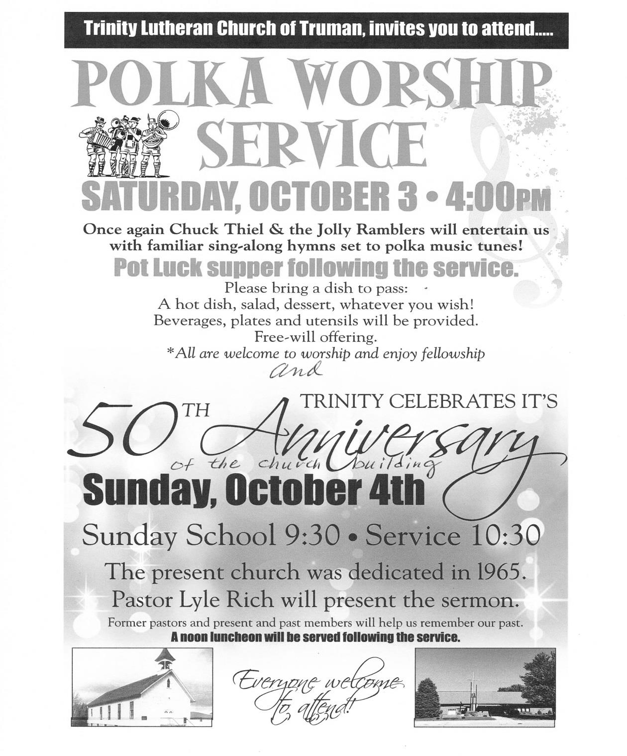

**UPCOMING EVENTS**