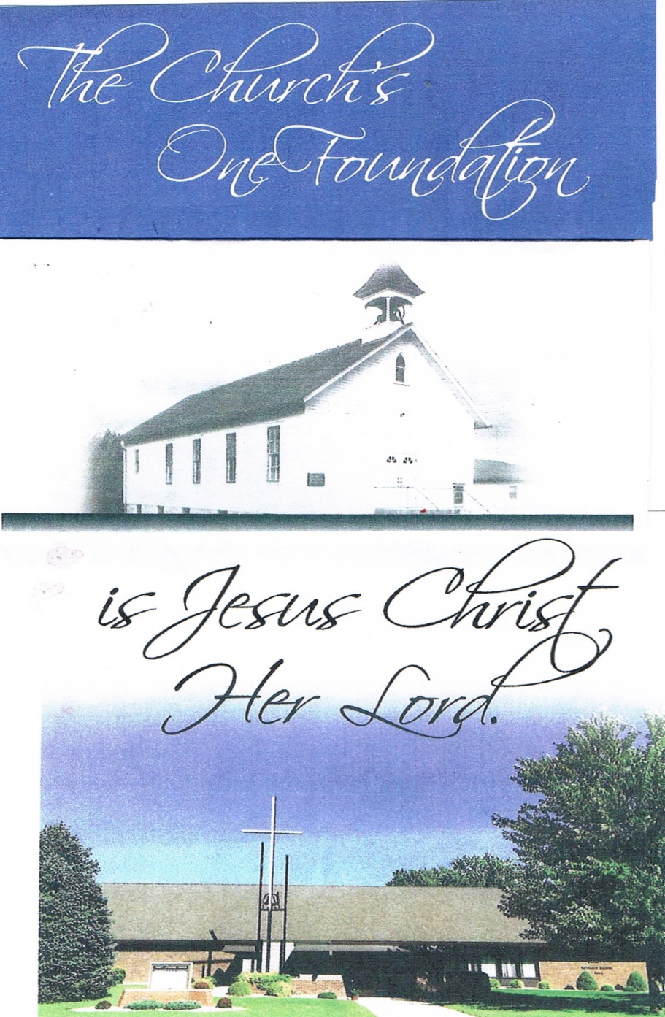

**50th Anniversary of Trinity Church Building**

**October 4, 2015**

**Trinity Lutheran Church, Truman MN**

**GATHERING**

*Congregation reads* ***bold print****. *Please stand*

**PRELUDE—Trinity Choir “*Blest Are They”***

**BELL**

**\*PROCESSIONAL HYMN Holy, Holy, Holy**

***Many of us have fond memories of singing this hymn as an opening hymn every Sunday.)***

**1 Holy, holy, holy! Lord God Almighty!  
Early in the morning our song shall rise to thee;  
holy, holy, holy! merciful and mighty,  
God in three persons, blessed Trinity!**

**2 Holy, holy, holy! All the saints adore thee,  
casting down their golden crowns around the glassy sea;  
cherubim and seraphim falling down before thee,  
who wert and art and evermore shalt be.**

**3 Holy, holy, holy! Though the darkness hide thee,  
though the eye of sinfulness thy glory may not see,  
only thou art holy; there is none beside thee,  
perfect in power, in love, and purity.**

**4 Holy, holy, holy! Lord God Almighty!  
All thy works shall praise thy name, in earth and sky and sea;  
holy, holy, holy! merciful and mighty,  
God in three persons, blessed Trinity!**

**WELCOME & ANNOUNCEMENTS-Pastor Krista**

**GREETING**

In the name of the Father, and of the ☩ Son, and of the Holy Spirit.

**Amen.**

God of all mercy and consolation, come to the aid of your people, turning us from our sin to live for you alone. Give us the power of your Holy Spirit that, attentive to your Word, we may confess our sins, receive your forgiveness, and grow into the fullness of your Son, Jesus Christ our Lord.

**Amen.**

Let us confess our sin in the presence of God and of one another. Gracious God,

**have mercy on us. In your compassion forgive us our sins, known and unknown, things done and left undone. Uphold us by your Spirit so that we may live and serve you in newness of life, to the honor and glory of your holy name; through Jesus Christ our Lord. Amen**

Almighty God have mercy on you, forgive you all your sins through our Lord Jesus Christ, strengthen you in all goodness, and by the power of the Holy Spirit keep you in eternal life.

**Amen**

The grace of our Lord Jesus Christ, the love of God, and the communion of the Holy Spirit be with you all.

**And also with you.**

**KYRIE-Cantor Matt Strum**

**Kyrie eleison:**

**Lord, have mercy:**

**Christe eleison:**

**Christ, have mercy:**

**Kyrie eleison:**

**Lord, have mercy:**

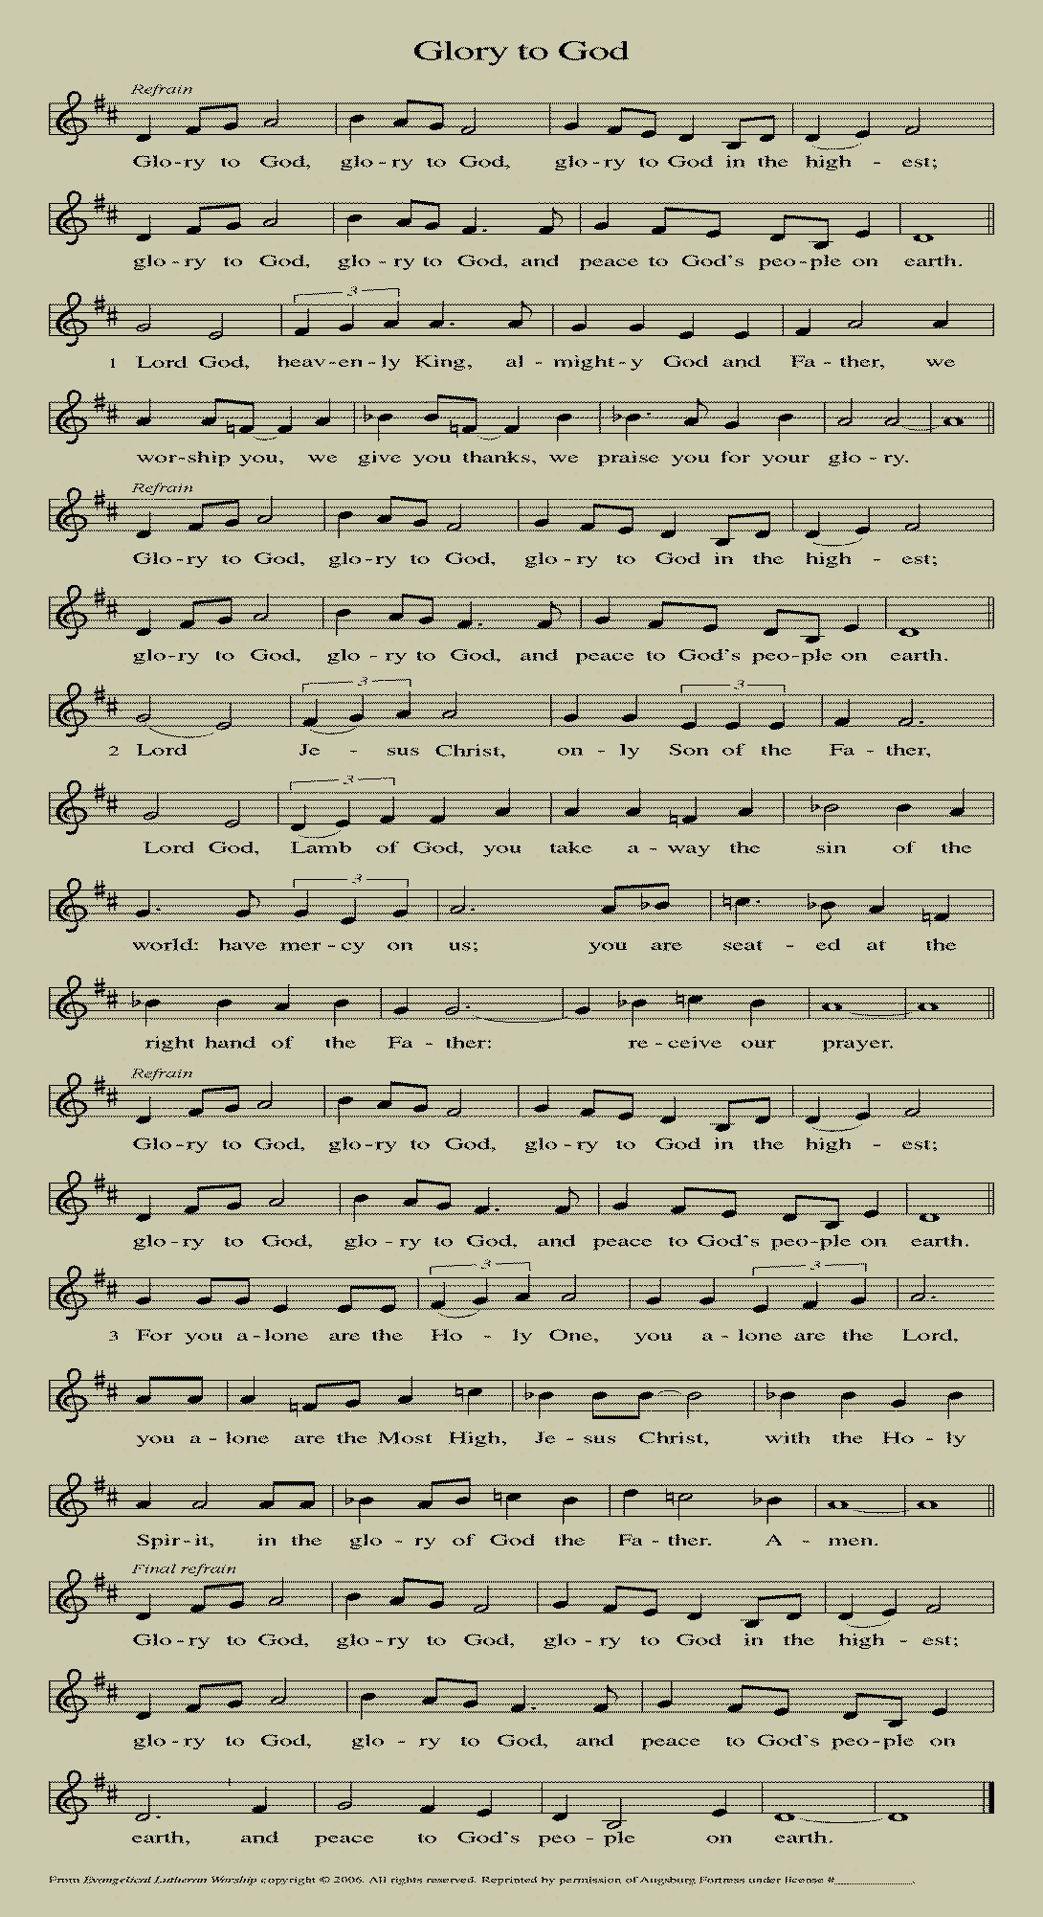

**HYMN OF PRAISE**

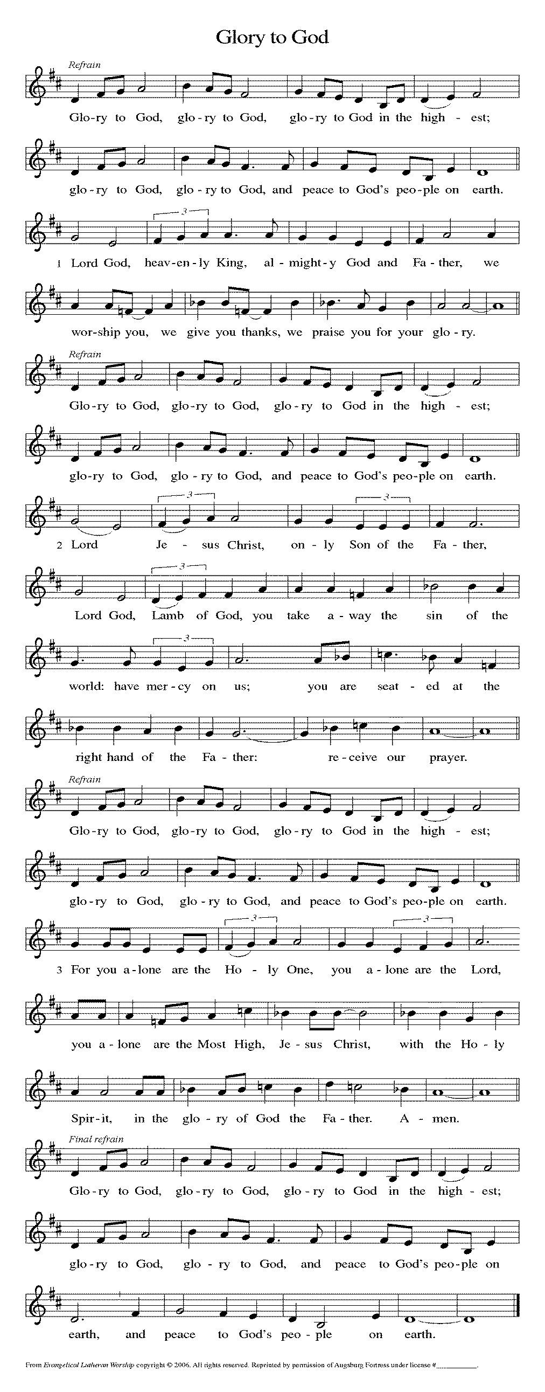

**\*PRAYER OF THE DAY:** L: The Lord be with you. **C: And also with you.**

L: Let us pray. *Silence* O God,

**You have promised through your Son to be with your church forever. We give you thanks for those who founded this community of believers and for the signs of your presence in our congregation. Increase in us the spirit of faith and love, and make our fellowship an example to all believers and to all nations. We pray through Jesus Christ, our Savior and Lord, who lives and reigns with you and the Holy Spirit, one God, now and forever.**  **Amen.**

**THEME HYMN:** *The Church's One Foundation*  (vs 1)

**The church's one foundation  
is Jesus Christ, her Lord;  
she is his new creation  
by water and the word.  
From heav'n he came and sought her  
to be his holy bride;  
with his own blood he bought her,  
and for her life he died.**

**WORD**

**FIRST READING**: **Philippians 1:1-5, 4:4-11**

1Paul and Timothy, servants of Christ Jesus, To all the saints in Christ Jesus who are in Philippi, with the bishops and deacons: 2Grace to you and peace from God our Father and the Lord Jesus Christ. 3I thank my God every time I remember you, 4constantly praying with joy in every one of my prayers for all of you, 5because of your sharing in the gospel from the first day until now.

4Rejoice in the Lord always; again I will say, Rejoice. 5Let your gentleness be known to everyone. The Lord is near. 6Do not worry about anything, but in everything by prayer and supplication with thanksgiving let your requests be made known to God. 7And the peace of God, which surpasses all understanding, will guard your hearts and your minds in Christ Jesus. 8Finally, beloved, whatever is true, whatever is honorable, whatever is just, whatever is pure, whatever is pleasing, whatever is commendable, if there is any excellence and if there is anything worthy of praise, think about these things. 9Keep on doing the things that you have learned and received and heard and seen in me, and the God of peace will be with you. 10I rejoice in the Lord greatly that now at last you have revived your concern for me; indeed, you were concerned for me, but had no opportunity to show it. 11Not that I am referring to being in need; for I have learned to be content with whatever I have.

The Word of the Lord. **C: Thanks be to God.**

**CHILDREN’S SERMON-**Pastor Krista

**Sunday School Children Sing**

**\* GOSPEL ACCLAMATION** *The Church's One Foundation*  (vs 2)

**Elect from ev'ry nation,  
yet one o'er all the earth,  
her charter of salvation  
one Lord, one faith, one birth:  
one holy name she blesses,  
partakes one holy food,  
and to one hope she presses,  
with ev'ry grace endued.**

**\*GOSPEL: John 17:20-26 C: Glory to you, O Lord. Pastor Lyle Rich**

20I ask not only on behalf of these, but also on behalf of those who will believe in me through their word, 21that they may all be one. As you, Father, are in me and I am in you, may they also be in us, so that the world may believe that you have sent me. 22The glory that you have given me I have given them, so that they may be one, as we are one, 23I in them and you in me, that they may become completely one, so that the world may know that you have sent me and have loved them even as you have loved me. 24Father, I desire that those also, whom you have given me, may be with me where I am, to see my glory, which you have given me because you loved me before the foundation of the world.  
25Righteous Father, the world does not know you, but I know you; and these know that you have sent me. 26I made your name known to them, and I will make it known, so that the love with which you have loved me may be in them, and I in them."

L: The Word of the Lord. **C: Praise to you, O Christ.**

**SERMON-**Pastor Lyle Rich *“For the Church-a prayer and a letter”*

**\*HYMN OF THE DAY** *The Church’s One Foundation* (vs 3-4, 6)

**3 The Church shall never perish!**

**Her dear Lord to defend,**

**To guide, sustain, and cherish,**

**Is with her to the end:**

**Though there be those who hate her,**

**And false sons in her pale,**

**Against both foe or traitor  
She ever shall prevail.**

**4 Through with a scornful wonder**

**Men see her sore oppressed,**

**By schisms rent asunder,**

**By heresies distressed:**

**Yet saints their watch are keeping,**

**Their cry goes up, “How on?”**

**And soon the night of weeping**

**Shall be the morn of sing!**

**6 Yet she on earth hath union**

**With God the Three in One,**

**And mystic sweet communion**

**With those who rest is won,**

**With all her sons and daughters**

**Who, by the Master’s hand**

**Led through the deathly waters,**

**Repose in Eden Land.**

**\*APOSTLES’ CREED**

**I believe in God, the Father almighty, creator of heaven and earth.**

**I believe in Jesus Christ, his only Son, our Lord.**

**He was conceived by the power of the Holy Spirit**

**and born of the virgin Mary.**

**He suffered under Pontius Pilate, was crucified, died, and was buried.**

**He descended into hell.\***

**On the third day he rose again.**

**He ascended into heaven, and is seated at the right hand of the Father.**

**He will come again to judge the living and the dead.**

**I believe in the Holy Spirit,**

**the holy catholic Church,**

**the communion of saints,**

**the forgiveness of sins,**

**the resurrection of the body,**

**and the life everlasting. Amen**

**OFFERING—**Trinity Choir “*Here We Stand”*

**\*OFFERTORY** *We Give Thee but Thine Own*

*(This song was sung each Sunday in our early years)*

**We give thee but thine own,  
whate'er the gift may be;  
all that we have is thine alone,  
a trust, O Lord, from thee.**

**\*OFFERING PRAYER**

Merciful God, as grains of wheat scattered upon the hills were gathered together to become one bread, so let your church be gathered together from the ends of the earth into your kingdom, for yours in the glory through Jesus Christ, now and forever.

**Amen.**

**\*PRAYERS OF INTERCESSION** L: Lord in your mercy, **C: Hear our prayer.**

**\*SHARING OF THE PEACE**

L: The peace of the Lord be with you always. **C: And also with you.**

**MEAL**

**\*GREAT THANKSGIVING**

The Lord be with you. C: **And also with you.**

Lift up your hearts. C: **We lift them to the Lord.**

Let us give thanks to the Lord our God. C: **It is right to give our thanks and praise.**

**\*COMMUNION PRAYER & WORDS OF INSTITUTION**

**\*THE LORD’S PRAYER (sung)**

**Our Father, which art in heaven,**

**hallowed be thy name,**

**thy kingdom come, thy will be done,**

**on earth as it is in heaven.**

**Give us this day our daily bread;**

**and forgive us our debts, as we forgive our debtors,**

**and lead us not into temptation, but deliver us from evil.**

**For thine is the kingdom, and the power, and the glory,**

**forever and ever. Amen.**

**THE INVITATION (*Continuous Communion) All are welcome to join us to receive the body and blood of our risen Lord.***

**POST-COMMUNION PRAYER**

Almighty God, we give you thanks that you have fed us with this heavenly food. In your grace and by your Spirit, help us to be what we celebrate, the body of Christ in the world. Send us out, renewed by this sacramental meal, to do the work you have given us to do: to witness for Christ, to love you with singleness of heart, and to serve you with clarity of purpose; through Jesus Christ, our Savior and Lord**. Amen.**

**SENDING**

**\*BLESSING**

Go forth in peace and with the courage of faith. Love God with all your heart, with all your soul, and with all your mind, and love your neighbors as yourself. Whatever you do in word or deed, do everything in the name of the Lord Jesus, giving thanks to God through him. The God of hope fill you with joy and peace in believing, so that you may abound in hope by the power of the Holy Spirit. Almighty God, Father, Son, and Holy Spirit. Bless you now and forever. ***Three-Fold Amen.***

**\*SENDING HYMN** *The Church's One Foundation*  (vs 7)

**O happy ones and holy!**

**Lord give us grace that we**

**Like them, the meek and lowly,**

**On high may dwell with Thee:**

**There, past the border mountains,**

**Where in sweet vales the Bride**

**With Thee by living fountains**

**Forever shall abide!**

**\*BELL**

**\*SENDING** L: Go in peace. Serve the Lord. **C: Thanks be to God!**

**+++++++++++++++++++++++++++++++++++++++++++++++++++++++++++++++++++++++++++++++++++++++++++++++++**

*Copyright 2013 Augsburg Fortress. All rights reserved. Reprinted by permission under Augsburg Fortress Liturgies Annual License#15562-ELW*

**ANNOUNCEMENTS**

**Readings for Next Sunday: Genesis 28:10-17,1 John 4:7-12a, Matthew 5-Beatitudes**

Prayer requests

*We remember in our prayers…all who face catastrophic illness, surgery, and bindings of all kinds as well as the homebound:* ***Bea Behrens, Agnes Carlson, Lisa******Carlson & family, Donna Fisk, and Danny Lang.*** *Be present with your Spirit, Lord, and lead us to be your presence to all. Amen.*

**THIS WEEK IN OUR PARISH**

**MONDAY, OCTOBER 5**-Martha Circle will be at 1:30 pm at Arlene Peterson’s.

**SUNDAY, OCTOBER 11**

9:00-10:00 Sunday School (Classroom) 10-10:30 kid friendly snacks

10:30 Communion Worship

*Reader: Margaret Durkee, Comm. Server: Tammy Wokasch*

*Ushers: *Duane Heckman, Chris Hiller, Doug Schwanz and Brad Nickerson*

Confirmation yoU! Classes will be held on October 11th at Trinity in Truman. It begins with a meal at 12:15 and the class goes until 3:30 pm. This month’s topic is Sacraments: Baptism.

**UPCOMING EVENTS**

1st Communion Class will be held on Sunday, October 18th from 1-4 pm for 5th graders and their parents. This will be held in Truman and celebrated on Reformation Sunday (October 25th).

**Current Trinity Living**

**Charter Members:**

Eleanor Lubitz

Arlene Darmer

Veryle Williamson

**Current Trinity Living Building**

**Committee Members:**

Bea Behrens

Agnes Carlson

Butch Ratike

Veryle Williamson

## For Every House

## is built by someone,

## But GOD

## Is the

## BUILDER

## Of Everything

## *Hebrews 3:4*

**Trinity Lutheran Church**

Office Phone 776-4781, Fax 776-7888, Summer Office Hours: Mon, Wed & Fri-700-11:00 am

 Email: [trinitytruman@frontier.com](mailto:trinitytruman@frontier.com), Website: [www.trinity-truman.org](http://www.trinity-truman.org)

**Pastor Krista Strum-**Cell –(507)995-1233, Email: [pkstrumom@me.com](mailto:pkstrumom@me.com)

Pastor Krista’s Hours: Wed. 11-2:30 pm & Thurs. 8:30-2:30 pm

**SERVICE PARTICIPANTS**

Presiding Minister……………..………………………………………….Pastor Krista Strum

Processing Ministers and Lay Ministers…… …………… ………..Pastor Eugene Anderson,

Pastor Robert Onkka, Pastor Lyle Rich, Pastor Rebecca Sullivan

Liturgical Cantor……………………………………………………………….. Matt Strum

Acolytes ………………………………………………... Kylee Harder and Chloe Hartman

Ushers ………………Duane Heckman, Gene Mager, Brad Nickerson and Brian Nickerson

Trumpet Players …………... Kim Breamer, Zach Hansen, Kylee Harder, Jackson Maloney

Organist ……….……………………………………………..…………………. Barb Mager

Piano Accompanist.……………………………………………………..…… Linda Howard

Trinity Choir…………………………………………….……..…… Kim Breamer, Director

Trinity Sunday School ………………………………….….. Beth Kotewa, Music Director

Power-Point Creator …………………………………………….………………Tom Dodge

Bulletins………………………..…Linnea Huss, and Brenda Hansen, Office Administrator

Anniversary Planning Committee………………Yvonne Noorlun, Dave & Cathy Sorenson,

Pam Rode, Dean Gulbranson, Barb Mager and Pastor Krista

**Thank you for coming to our service today!**

Thank you to those who helped plan today’s service, sent invitations, decorated, served the meal and helped out in any way. **A special** **thank you also to the Waverly congregation** for the beautiful arrangement of flowers on the altar.

**Please join us for the celebration luncheon in the fellowship hall** immediately following the service. There is no charge for the meal which includes:

Barbecues, Baked Beans, Chips, Cole Slaw, Cake, Punch and Coffee