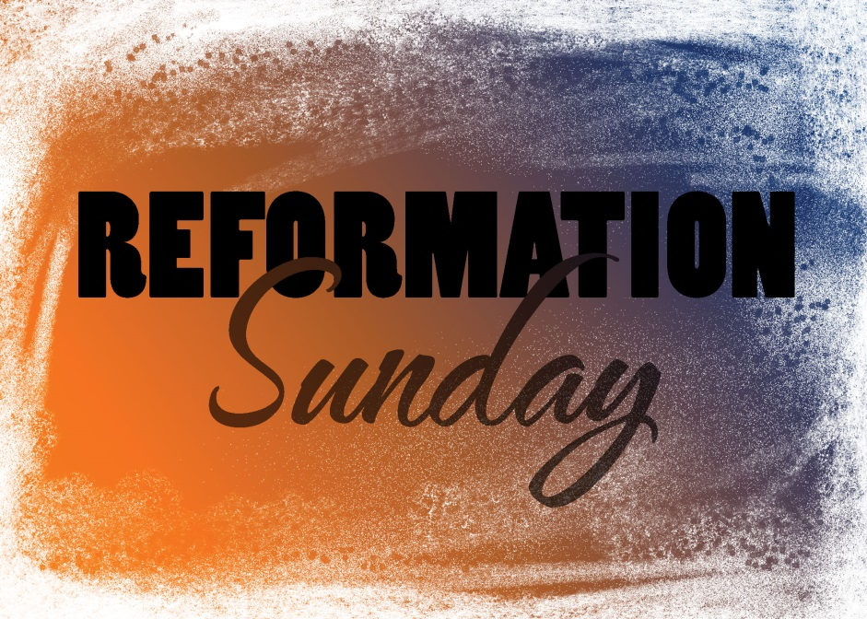

***Reformation Sunday***

***Rite of First Holy Communion***

**October 30, 2016**

**Evangelical Lutheran Worship, Setting 4**

**Trinity Lutheran Church**

Office Phone 776-4781, Fax 776-7888, Office Hours: Mon-8-11, Wed 8-11 & 1-4, Fri. 8-11

Email: [trinitytruman@frontier.com](mailto:trinitytruman@frontier.com), Website: [www.trinity-truman.org](http://www.trinity-truman.org)

 **PASTOR KRISTA STRUM**

Cell-(507)995-1233, Email: pkstrumom@me.com

Pastor Krista’s Office Hours: Tues. 9:00-1:00 pm & Fri. 9:00-1:00 pm

(*Please call Pastor on her cell if you need to contact her any other time of the*

*week. If she doesn’t answer, leave a message and she will call you back)*

**GATHERING**

*Congregation reads* ***bold print*** *\*Please stand*

**PRELUDE**

**BELL**

**ANNOUNCEMENTS**

**INVOCATION**

In the name of the Father, and of the Son, and of the Holy Spirit. **Amen.**

**CONFESSION AND FORGIVENESS**

Holy One, **what a blessing and privilege we share here in this sacred space and among this loving community.  But, like Jonah, we sometimes are jealous of what we share here.  We know that others are longing and thirsting for what we know and experience.  Forgive us our reluctance to open our doors, open our hearts to others; some like us, some not.  We repent of our hesitations and unwillingness to witness to those we have considered strangers and even enemies for fear they just might become friends**. **Amen.**

**WORDS OF ASSURANCE**

The one who calls us to this place calls us to reconciliation through grace.  God will not deny a repentant heart or an open spirit.  In Jesus' name know that you are forgiven and walk in the new way that is made known to you in God’s love.  **Amen**

**\*GATHERING SONG*A Mighty Fortress Is Our God* ELW #504**

**\*GREETING**

The grace of our Lord Jesus Christ, the love of God, and the communion of the Holy Spirit be with you all. **And also with you.**

**SONG OF PRAISE ----*God, Whose Almighty Word* *(vs. 1 & 4)***

1 God, whose almighty word

chaos and darkness heard

and took their flight:

hear us, we humbly pray,

and where the gospel day

sheds not its glorious ray,

let there be light.

4 Holy and blessed three,

glorious Trinity,

Wisdom, Love, Might:

boundless as ocean's tide,

rolling in fullest pride,

through the earth, far and wide,

let there be light.

* **PRAYER OF THE DAY** L: The Lord be with you. **C: And also with you.**

L: Let us pray,

**God of the seas, sky, and land,**

**When Jonah turned to run from you, you showed him that nothing and no one could hide from your presence. You are in all things, and you love all things. Show us the gift of your presence, and help us to carry your word of compassion and grace to all the world, in the name of the one who carried out your love flawlessly, Jesus Christ our redeemer. Amen.**

**THE GREATEST STORY**

**CHILDREN’S TIME-JONAH**

**WORD**

**Scripture Reading: Jonah 4:1-10**

1But this was very displeasing to Jonah, and he became angry. 2He prayed to the LORD and said, "O LORD! Is not this what I said while I was still in my own country? That is why I fled to Tarshish at the beginning; for I knew that you are a gracious God and merciful, slow to anger, and abounding in steadfast love, and ready to relent from punishing. 3And now, O LORD, please take my life from me, for it is better for me to die than to live." 4And the LORD said, "Is it right for you to be angry?" 5Then Jonah went out of the city and sat down east of the city, and made a booth for himself there. He sat under it in the shade, waiting to see what would become of the city. 6The Lord GOD appointed a bush, and made it come up over Jonah, to give shade over his head, to save him from his discomfort; so Jonah was very happy about the bush. 7But when dawn came up the next day, God appointed a worm that attacked the bush, so that it withered. 8When the sun rose, God prepared a sultry east wind, and the sun beat down on the head of Jonah so that he was faint and asked that he might die. He said, "It is better for me to die than to live." 9But God said to Jonah, "Is it right for you to be angry about the bush?" And he said, "Yes, angry enough to die." 10Then the LORD said, "You are concerned about the bush, for which you did not labor and which you did not grow; it came into being in a night and perished in a night.

L: the word of the Lord. **C: Thanks be to God.**

**SERMON**

**HYMN OF THE DAY*Rise Up, O Saints of God!* ELW #669**

**\*CREED** (*found on the salmon sheet in the back cover of the red hymnal)*

**\*PRAYERS OF INTERCESSSION**

L: Hear us, O God **C: Your mercy is great.**

**PEACE**The peace of Christ be with you always. **And also with you.**

**MEAL**

**OFFERING**

**OFFERING SONG *Let the Vineyards Be Fruitful…* ELW #184**

**OFFERING PRAYER**

God of all creation, all you have made is good, and your love endures forever. You bring forth bread from the earth and fruit from the vine. Nourish us with these gifts, that we might be for the world signs of your gracious presence in Jesus Christ, our Savior and Lord. **Amen.**

**GREAT THANKSGIVING ELW p. 152**

**THANKSGIVING AT THE TABLE ELW p. 153   
*LORD’S PRAYER  -** *found on the salmon sheet in the back cover of the red hymnal*

**IVITATION TO COMMUNION** *Come to the banquet, for all is now ready*

**COMMUNION**

**PRAYER AFTER COMMUNION** Let us pray,

We come again to you, O God, giving you thanks that in this feast of mercy you have embraced us and healed us, making us one in the body of Christ. Go with us on our way.

Equip us for every good work, that we may continue to give you thanks by embracing others with mercy and healing; through Jesus Christ, our Savior and Lord. **Amen.**

**SENDING**

**\*BLESSING**

God Almighty send your light and truth to keep you all the days of your life.

The hand of God protect you; the holy angels accompany you; and the blessing of almighty God, the Father, the ☩ Son, and the Holy Spirit, be with you now and forever. ***Three fold Amen…***

**\*SENDING SONG *What a Fellowship, What a Joy Divine* ELW #774**

**\*DISMISSAL** Go in peace. Serve the Lord. **Thanks be to God.**

**BELL/POSTLUE**

+++++++++++++++++++++++++++++++++++++++++++++++++++++++++++++++++

Copyright © 2016 Augsburg Fortress. All rights reserved. Reprinted by permission under Augsburg Fortress Liturgies Annual License #SAS103469. New Revised Standard Version Bible, copyright © 1989, Division of Christian Education of the National Council of the Churches of Christ in the United States of America. Used by permission. All rights reserved.

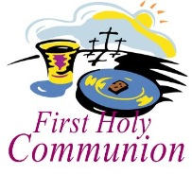

**Congratulations to our seven students who will receive their First Holy Communion today at Trinity: Jordan Carlson, Jonah Carlson, Keegan Hastad, Carter Brudelie, Carson Hastad, Luke Kester and Cali Cross.**

 *We remember in our prayers…all who face catastrophic illness, surgery, and bindings of all kinds as well as the homebound:* ***Bea Behrens, Lisa******Carlson & family, Danny Lang, and the family of Marlys Ehlert .***

**Date Devotion goes out …. October 30**

|  |  |  |  |
| --- | --- | --- | --- |
|  | Whirl Story Bible | Reading Plan | Deeper Study |
| When God Speaks | Daniel | Daniel 6 |  |
|  | Jonah | Jonah 1; 2:1-2, 10;  3:1-5, 10 |  |
|  | Isaiah’s Words | Isaiah 2:1-5 |  |
|  | Annunciation | Luke 1:26-38 | Luke 1 |
|  | Mary visits Elizabeth | Luke 1:39-55 |  |

**THIS WEEK IN OUR PARISH**

**TUESDAY, NOVEMBER 1-**Pastor Krista gone for convention.

**WEDNESDAY,NOVEMBER 2-**Choir practice at 6 pm.

**THURSDAY, NOVEMBER 3**-Open Bible Study/Lois Circle meets - 9 am at Truman Café.

**NOVEMBER 3-6**-Pastor Krista gone for continuing education

**SUNDAY, NOVEMBER 6**

**8:45 AM COMMUNION WORSHIP** –**All Saints Sunday**

**On All Saints Sunday we will recognize all those of your loved ones who have departed. We will again have a candle lighting area in which you may come up and light a candle in your loved ones memory.**

**10 AM SUNDAY SCHOOL**

*Reader: Brytni Drevlow, Comm. Server: Chad Hastad, Acolytes: Karsan Davis*

*Ushers: *Norman Anderson, Brian Nickerson, John Zaharia and Dan Smith*



**Once again the Trinity Stewardship Campaign will begin on November 6th. We will again use the Pony Express.**

**Please keep the packets moving to the next one on the list.**



**THE NOVEMBER MESSENGER IS HERE!** Check your mailbox at the church for the gold newsletter.

**UPCOMING EVENTS**



**NOVEMBER 6TH — DAYLIGHT SAVINGS TIME ENDS**



***Don’t forget your right to vote on Tuesday, November 8th.***



**Trinity’s Youth Group Hosts**

**ANNUAL ELECTION DAY SOUP SUPPER**

**Tuesday, November 8th from 5:30-7:30 pm. *Serving—Chicken noodle soup & Chili,***

***plus sandwiches and bars***

***Free will offering***

**THANKOFFERING SUNDAY**

**November 13, 2016**

**We will be collecting non-perishable food items for the local food shelf. For monetary donations, be sure to check your mailbox for your Thankoffering envelopes.**

