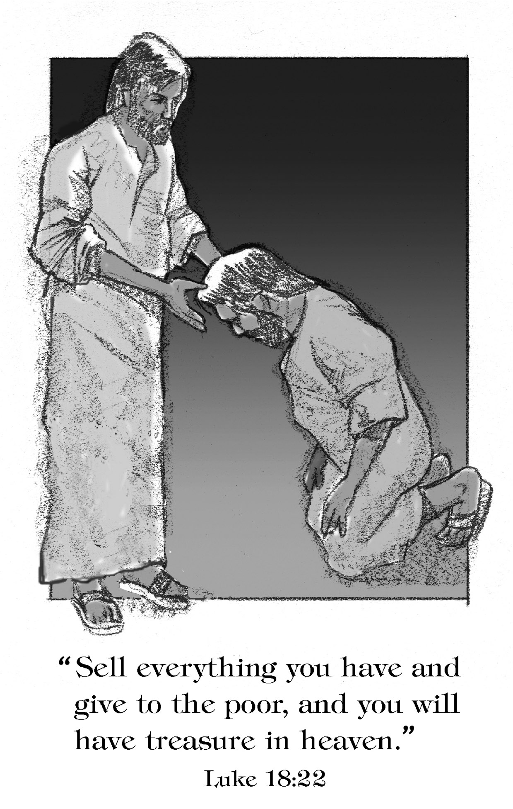

***Reformation Sunday***

**22nd Sunday after Pentecost**

**October 25, 2015**

**Evangelical Lutheran Worship, Setting 4**

**Trinity Lutheran Church**

Office Phone 776-4781, Fax 776-7888, Office Hours: Mon 8-11, Wed 8-11, 1-4, Fri. 8-11 am

 Email: [trinitytruman@frontier.com](mailto:trinitytruman@frontier.com), Website: [www.trinity-truman.org](http://www.trinity-truman.org)

**Pastor Krista Strum**-Cell-(507) 995-1233, Email: [pkstrumom@me.com](mailto:pkstrumom@me.com)

Pastor Krista’s Hours: Wed. 11-2:30 pm & Thurs. 8:30-2:30 pm

**GATHERING**

*Congregation reads* ***bold print*** *\*Please stand*

**PRELUDE**

**BELL**

**WELCOME & ANNOUNCEMENTS**

**\*CONFESSION & FORGIVENESS**

Blessed be the holy Trinity, ☩ one God, whose name is majestic in all the earth,

who rescues and heals in every time of trouble, who does all things well. **Amen.**

Let us come before God, seeking forgiveness and life.

Steadfast and saving God,

**Have mercy on us.**

**We confess to you all the ways we turn from you and harm one another.**

**In your compassion, forgive our sins and heal our hurts. Bring forth from us a harvest of righteousness, the fruits of gentleness and peacemaking, the sheaves of wisdom and justice; through Jesus Christ, our Savior and Lord. Amen.**

In the name of ☩ Jesus, the Son of God,

receive mercy and find grace in your time of need. Your transgressions are forgiven;

God’s love is healing balm for your wounds. Rejoice, for God raises you up to new life in Christ. **Amen.**

**\*GATHERING HYMN** *A Mighty Fortress Is Our God* **ELW# 504**

**\*GREETING ELW p. 147**

**\*KYRIE**

**\*HYMN OF PRAISE** *Holy, Holy, Holy, Lord God Almighty!**(vs. 1)***ELW #413**

**\*PRAYER OF THE DAY** L: The Lord be with you. **C: And also with you.**

L: Let us pray,

**Eternal light, shine in our hearts. Eternal wisdom, scatter the darkness of our ignorance. Eternal compassion, have mercy on us. Turn us to seek your face, and enable us to reflect your goodness, through Jesus Christ, our Savior and Lord. Amen.**

**WORD**

**FIRST READING: Micah 6:6-8**

 6"With what shall I come before the LORD,  and bow myself before God on high? Shall I come before him with burnt offerings,  with calves a year old? 7Will the LORD be pleased with thousands of rams, with ten thousands of rivers of oil? Shall I give my firstborn for my transgression, the fruit of my body for the sin of my soul?" 8He has told you, O mortal, what is good; and what does the LORD require of you but to do justice, and to love kindness, and to walk humbly with your God?

Word of God, Word of Life. **C: Thanks be to God.**

**SECOND READING: Matthew 4:18-20**

18As he walked by the Sea of Galilee, he saw two brothers, Simon, who is called Peter, and Andrew his brother, casting a net into the sea — for they were fishermen. 19And he said to them, "Follow me, and I will make you fish for people." 20Immediately they left their nets and followed him.

Word of God, Word of Life. **C: Thanks be to God.**

**CHILDREN’S TIME**

**\*GOSPEL ACCLAMATION** *Lord, Let My Heart Be Good Soil* **ELW # 512**

\***GOSPEL: Luke 18:18-22**

The holy gospel according to Luke. **Glory to you, O Lord.**

18A certain ruler asked him, "Good Teacher, what must I do to inherit eternal life?" 19Jesus said to him, "Why do you call me good? No one is good but God alone. 20You know the commandments: 'You shall not commit adultery; You shall not murder; You shall not steal; You shall not bear false witness; Honor your father and mother.'" 21He replied, "I have kept all these since my youth." 22When Jesus heard this, he said to him, "There is still one thing lacking. Sell all that you own and distribute the money to the poor, and you will have treasure in heaven; then come, follow me."

The gospel of the Lord. **C: Praise to you, O Christ.**

SERMON: Follow Me….

* **HYMN OF THE DAY**  *Here I Am, Lord* **ELW #574**

**\*APOSTLES’ CREED** *Found in the back cover of the hymnal, SALMON sheet*

**\* PRAYERS OF INTERCESSION** *Lord, Listen to Your Children Praying* **ELW #752**

**\*SHARING OF THE PEACE**

L: The peace of the Lord be with you always. **C: And also with you.**

**OFFERING**

**\*OFFERING HYMN** *Create in Me a Clean Heart***ELW #188**

**\*OFFERING PRAYER**

**\*LORD’S PRAYER ELW p. 154****SENDING**

**BLESSING-*Love Does***

Wherever you go this week, know this:

God knows you better than you know yourself.

No matter where you go or what you do,

God is already there,

surrounding you with mercy

and guiding you with love.

So go with joy and confidence,

knowing that God goes with you.

***Three-Fold Amen.***

**\*SENDING HYMN** *We Are Marching in the Light* (Siyahamba) **ELW #866**

**BELL SENDING** L: Go in peace. Serve the Lord. **C: Thanks be to God!**

**POSTLUDE +++++++++++++++++++++++++++++++++++++++++++++++++++++++++++++++++**Reprinted from Evangelical Lutheran Worship, copyright © 2006 Augsburg Fortress. All rights reserved. Used by permission of Augsburg Fortress license #SB107041 New Revised Standard Version Bible, copyright © 1989, Division of Christian Education of the National Council of the Churches of Christ in the United States of America. Used by permission. All rights reserved.

**Readings for next Sunday: Isaiah 25:6-9, Psalm 24, Rev. 21:1-6, John 11:32-44**

*We remember in our prayers…all who face catastrophic illness, surgery, and bindings of all kinds as well as the homebound:* ***Bea Behrens, Agnes Carlson, Lisa******Carlson & family, Donna Fisk, and Danny Lang.*** *Be present with your Spirit, Lord, and lead us to be your presence to all. Amen.*

**ANNOUNCEMENTS**

**TODAY:** Pastor Krista will be gone later today until Wednesday, October 28th to a leadership conference.

 Would anyone be willing to help with the 2nd Harvest

program in 2016, please talk to Cathy Sorenson.

It involves meeting the truck 3-4 times a year.

**THIS WEEK IN OUR PARISH**

**WEDNESDAY, OCTOBER 28**

9 am Messenger Assembly

**SUNDAY, NOVEMBER 1-All Saints Sunday-Rite of 1st Holy Communion**

9-10:00 Sunday School

10-10:30 Gathering time w/kid friendly snacks

10:30 Communion Worship

*Reader: Carolyn Drevlow, Comm. Server: Donna Kotewa*

*Ushers: *Ron Kelley, John Zaharia, Norman Anderson and Grant Hartman*



Once again the Trinity Stewardship campaign will begin next Sunday, November 1st. We will again use the Pony Express. Please keep the packets moving along. They are due back to the torch bearers by November 15th. Thank you for supporting our church, our committees, youth and many other projects.

** UPCOMING EVENTS**

**Trinity’s Youth Group Hosts**

**Annual Election Day Soup Supper**

**on Tuesday, November 3rd from 5:30-7:30 pm.**

*Serving—Chicken noodle soup & Chili,*

*plus sandwiches and bars*

*Free will offering*

Don’t forget to get out and vote. Vote “**Yes**” for Truman Public Schools operating Levy election at the Truman High School on November 3rd.

|  |
| --- |
| **Building God’s kingdom** |
| On Reformation Sunday, as we think about Martin Luther, the 16th-century reformer of the church, we rejoice that God raises men and women in every era to lead movements which serve the kingdom of God. According to Luther, “Faith is a living, daring confidence in God’s grace, so sure and certain that a man could stake his life on it a thousand times.”   It was faith that helped Luther become such a daring and courageous leader. Columnist Walter Lippmann once wrote: “The final test of a leader is that he leaves behind him, in other men, the conviction and the will to carry on.”   Of course, that applies to both men and women — and it certainly applied to Luther.   God calls men and women out of the world to learn the meaning of commitment, love and service. God then sends those men and women back into the world to put their commitment, love and service to work. That’s how the kingdom of God is spread and how God’s church remains alive and healthy. |