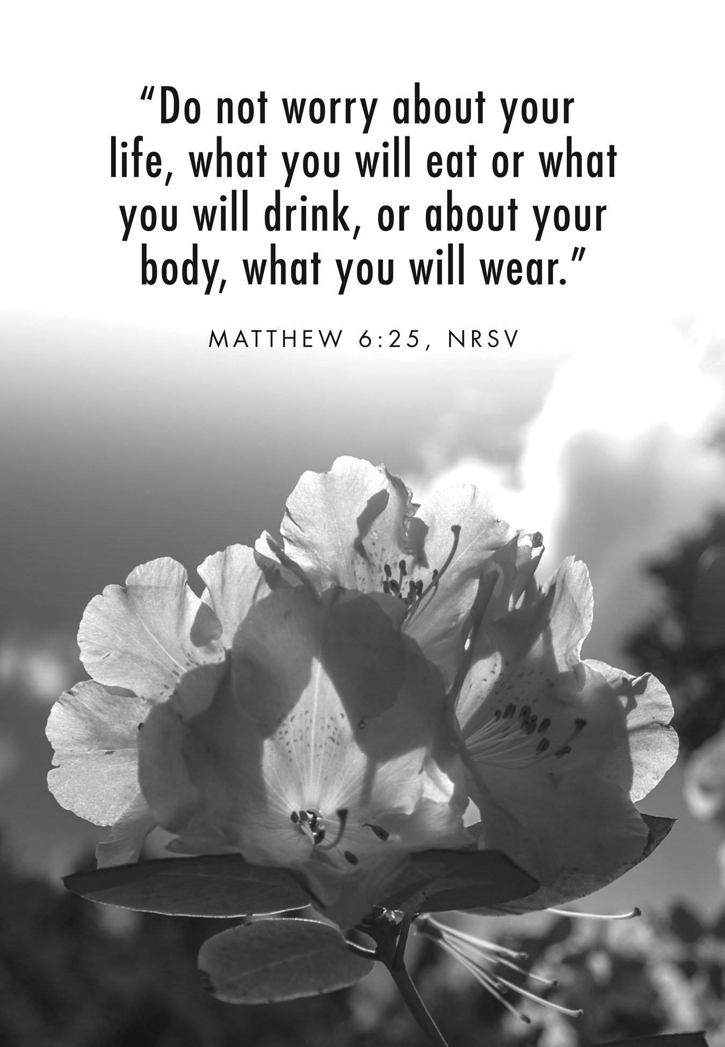

**21st Sunday after Pentecost**

**October 18, 2015**

**Evangelical Lutheran Worship, Setting 4**

**Trinity Lutheran Church**

Office Phone 776-4781, Fax 776-7888, Office Hours: Mon 8-11, Wed 8-11, 1-4, Fri. 8-11 am

 Email: [trinitytruman@frontier.com](mailto:trinitytruman@frontier.com), Website: [www.trinity-truman.org](http://www.trinity-truman.org)

**Pastor Krista Strum**-Cell-(507) 995-1233, Email: [pkstrumom@me.com](mailto:pkstrumom@me.com)

Pastor Krista’s Hours: Wed. 11-2:30 pm & Thurs. 8:30-2:30 pm

**GATHERING**

*Congregation reads* ***bold print*** *\*Please stand*

**PRELUDE**

**BELL**

**WELCOME & ANNOUNCEMENTS**

**\*CONFESSION & FORGIVENESS**

Blessed be the holy Trinity, ☩ one God, whose name is majestic in all the earth,

who rescues and heals in every time of trouble, who does all things well. **Amen.**

Let us come before God, seeking forgiveness and life.

Steadfast and saving God,

**Have mercy on us.**

**We confess to you all the ways we turn from you and harm one another.**

**In your compassion, forgive our sins and heal our hurts. Bring forth from us a harvest of righteousness, the fruits of gentleness and peacemaking, the sheaves of wisdom and justice; through Jesus Christ, our Savior and Lord. Amen.**

In the name of ☩ Jesus, the Son of God,

receive mercy and find grace in your time of need. Your transgressions are forgiven;

God’s love is healing balm for your wounds. Rejoice, for God raises you up to new life in Christ. **Amen.**

**\*GATHERING HYMN** *What a Friend We Have in Jesus***ELW #742**

**\*GREETING ELW p. 147**

**\*KYRIE**

**\*HYMN OF PRAISE** *Holy, Holy, Holy, Lord God Almighty!**(vs. 1)***ELW #413**

**\*PRAYER OF THE DAY** L: The Lord be with you. **C: And also with you.**

L: Let us pray,

**Almighty and ever-living God, increase in us your gift of faith, that, forsaking what lies behind and reaching out to what lies ahead, we may follow the way of your commandments and receive the crown of everlasting joy, through Jesus Christ, our Savior and Lord. Amen.**

**WORD**

**FIRST READING: Isaiah 43:1-7, 11-12**

1But now thus says the LORD, he who created you, O Jacob, he who formed you, O Israel: Do not fear, for I have redeemed you; I have called you by name, you are mine.  2When you pass through the waters, I will be with you; and through the rivers, they shall not overwhelm you; when you walk through fire you shall not be burned,  and the flame shall not consume you. 3For I am the LORD your God, the Holy One of Israel, your Savior. I give Egypt as your ransom, Ethiopia and Seba in exchange for you.  4Because you are precious in my sight, and honored, and I love you, I give people in return for you, nations in exchange for your life. 5Do not fear, for I am with you; I will bring your offspring from the east,  and from the west I will gather you; 6I will say to the north, "Give them up," and to the south, "Do not withhold; bring my sons from far away and my daughters from the end of the earth — 7everyone who is called by my name, whom I created for my glory, whom I formed and made." 11I, I am the LORD, and besides me there is no savior. 12I declared and saved and proclaimed, when there was no strange god among you; and you are my witnesses, says the LORD.

Word of God, Word of Life. **C: Thanks be to God.**

**SECOND READING: Mark 4:35-41**

On that day, when evening had come, he said to them, "Let us go across to the other side." 36And leaving the crowd behind, they took him with them in the boat, just as he was. Other boats were with him. 37A great windstorm arose, and the waves beat into the boat, so that the boat was already being swamped. 38But he was in the stern, asleep on the cushion; and they woke him up and said to him, "Teacher, do you not care that we are perishing?" 39He woke up and rebuked the wind, and said to the sea, "Peace! Be still!" Then the wind ceased, and there was a dead calm. 40He said to them, "Why are you afraid? Have you still no faith?" 41And they were filled with great awe and said to one another, "Who then is this, that even the wind and the sea obey him?"

Word of God, Word of Life. **C: Thanks be to God.**

**CHILDREN’S TIME**

**\*GOSPEL ACCLAMATION** *Lord, Let My Heart Be Good Soil* **ELW # 512**

\***GOSPEL: Matthew 6:25-34**

The holy gospel according to Matthew **C: Glory to you, O Lord.**

5“Therefore I tell you, do not worry about your life, what you will eat or what you will drink, or about your body, what you will wear. Is not life more than food, and the body more than clothing? 26Look at the birds of the air; they neither sow nor reap nor gather into barns, and yet your heavenly Father feeds them. Are you not of more value than they? 27And can any of you by worrying add a single hour to your span of life? 28And why do you worry about clothing? Consider the lilies of the field, how they grow; they neither toil nor spin, 29yet I tell you, even Solomon in all his glory was not clothed like one of these. 30But if God so clothes the grass of the field, which is alive today and tomorrow is thrown into the oven, will he not much more clothe you—you of little faith? 31Therefore do not worry, saying, ‘What will we eat?’ or ‘What will we drink?’ or ‘What will we wear?’ 32For it is the Gentiles who strive for all these things; and indeed your heavenly Father knows that you need all these things. 33But strive first for the kingdom of God and his righteousness, and all these things will be given to you as well. 34“So do not worry about tomorrow, for tomorrow will bring worries of its own. Today’s trouble is enough for today.

The gospel of the Lord. **C: Praise to you, O Christ.**

SERMON: Be Not Afraid….

* **HYMN OF THE DAY**  *Great Is Thy Faithfulness***ELW #733**

**\*APOSTLES’ CREED** *Found in the back cover of the hymnal, SALMON sheet*

**\* PRAYERS OF INTERCESSION** *Lord, Listen to Your Children Praying* **ELW #752**

**\*SHARING OF THE PEACE**

L: The peace of the Lord be with you always. **C: And also with you.**

**OFFERING**

**\*OFFERING HYMN** *Create in Me a Clean Heart***ELW #188**

**\*OFFERING PRAYER**

**\*LORD’S PRAYER ELW p. 154****SENDING**

**BLESSING-*Love Does***

***Three-Fold Amen.***

**\*SENDING HYMN** *Blessed Assurance* **ELW# 638**

**BELL SENDING** L: Go in peace. Serve the Lord. **C: Thanks be to God!**

**POSTLUDE +++++++++++++++++++++++++++++++++++++++++++++++++++++++++++++++++**Reprinted from Evangelical Lutheran Worship, copyright © 2006 Augsburg Fortress. All rights reserved. Used by permission of Augsburg Fortress license #SB107041 New Revised Standard Version Bible, copyright © 1989, Division of Christian Education of the National Council of the Churches of Christ in the United States of America. Used by permission. All rights reserved.

**Readings for next Sunday:** Matt. 4:18-20, Micah 6:6-8, Luke 18:18-22, Matthew 7:24-27

*We remember in our prayers…all who face catastrophic illness, surgery, and bindings of all kinds as well as the homebound:* ***Bea Behrens, Agnes Carlson, Lisa******Carlson & family, Donna Fisk, and Danny Lang.*** *Be present with your Spirit, Lord, and lead us to be your presence to all. Amen.*

**ANNOUNCEMENTS**

**TODAY:**  There will be a 1st Communion Class TODAY from 1-4 pm for 5th graders and their parents. This will be held in Truman and celebrated on Reformation Sunday which is next Sunday.

**THIS WEEK IN OUR PARISH**

**SUNDAY, OCTOBER 25-Reformation Sunday**

9-10:00 Sunday School (**Christmas program**),

10-10:30 Gathering time w/kid friendly snacks

10:30 Worship

*Reader: Marilyn Duncanson,*

*Ushers: *Duane Heckman, Doug Schwanz and Brad Nickerson*

**UPCOMING EVENTS**



Once again the Trinity Stewardship campaign will begin on November 1st. We will again use the Pony Express. Please keep the packets moving along. All are due back to the torch bearers by November 15th. Thank you for supporting our church, our committees, youth and many other projects.



**Trinity’s Youth Group Hosts**

**Annual Election Day Soup Supper**

**on Tuesday, November 3rd from 5:30-7:30 pm.**

*Serving—Chicken noodle soup & Chili, plus sandwiches and bars*

*Free will offering*

Don’t forget to get out and vote. Vote “**Yes**” for Truman Public Schools operating Levy election at the Truman High School on November 3rd.

**CREST New Volunteer Training…**Please join us on Thursday, October 22nd at 6:30 pm in the fellowship hall of the Lakeview Methodist Health Care Center to receive training on how to be a volunteer for the CREST program that serves Martin County. We are looking for people with a willing heart to serve others! Refreshments will be served. The training will last approximately 90 minutes. For more information about become a volunteer or receiving CREST services, please call 235-2833

**SOUPS, SLALDS & SWEETS**

Benefit Luncheon on **Saturday, October 24th from 11 am-2 pm at the Red rock Center for the Arts**-222 E Blue Earth Ave. Fairmont. (a benefit for Jeremy Jay Breitbarth). There will be Silent Auction, Bake Sale and Live Music. A suggested Donation of $5 per person, $10 per family and is open to the public. Contributions can also be made to the Breitbarth Benefit Fund at Bank Midwest, 301 S. State St. Fairmont, MN 56031.

*Jay was born with cystic fibrosis a life-threatening, genetic disease that causes persistent lung infections and progressively limits the ability to breathe. He has been at St. Mary’s Hospital in Rochester since May, and in need of a double lung transplant at the age of 44.*

++++++++++++++++++++++++++++++++++++++++++++++++++++++++

**THE BEAUTY OF GROWING OLD**

“How beautifully leaves grow old,” wrote 19th-century essayist John Burroughs. “How full of light and color are their last days.”

Society doesn’t think highly of old age. Beauty products tout the supposed virtues of maintaining a youthful appearance. Older adults’ wisdom, born of much life experience, is often disparaged, ignored or not sought. But God says this about the righteous, whose lives are rooted in him: “In old age they still produce fruit; they are always green and full of sap, showing that the LORD is upright” (Psalm 92:14-15, NRSV).   
  
The aging leaves of autumn can prompt us to look for beauty in the seniors among us, to notice the light and color that still abound. From all the fruit they still produce — service, prayer, love — may we learn about living faithfully until our own last days

—Heidi Man