

**1st Sunday in Advent**

**November 29, 2015**

**Evangelical Lutheran Worship, Setting 8**

**Trinity Lutheran Church**

Office Phone 776-4781, Fax 776-7888, Office Hours: Mon 8-11, Wed & 8-11 & 1-4, Fri-8-11 am

 Email: [trinitytruman@frontier.com](mailto:trinitytruman@frontier.com), Website: [www.trinity-truman.org](http://www.trinity-truman.org)

**Pastor Krista Strum-**Cell: (507)995-1233, Email: pkstrumom@me.com

Pastor Krista’s Hours: Wed. 11-2:30 pm, Thurs. 8:30-2:30 pm

**GATHERING**

*Congregation reads* ***bold print****. *Please stand*

**PRELUDE**

**BELL**

**WELCOME & ANNOUNCEMENTS**

**LIGHTING THE ADVENT WREATH**

L: “Today we light the first candle of the Advent wreath. Each candle has a meaning. This first candle is HOPE.”

*The candle is lit.*

L:Let us read Psalm 33:20 together.

C: **We wait in hope for the LORD; he is our help and our shield.**

L: Let us pray together:

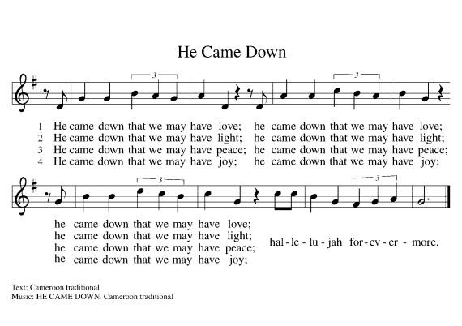**C: Almighty and eternal God, as we await the coming of our savior, give us the courage to hope. Help us to see your plans of redemption for our lives, for this community, and for the world. Through Jesus Christ, who is the source of our redemption and hope. Amen.**

hope

peace joy love

hope

peace joy love

hope

peace joy love

**\*CONFESSION AND FORGIVENESS**

Blessed be the holy Trinity, ☩ one God, the Lord of Israel who comes to set us free,

the mighty Savior who comes to show mercy, the Dawn from on high who guides us into peace. **Amen.**

Let us come before God in confession.

To you, O God,

**we lift up our souls.**

**You know us through and through;**

**we confess our sins to you.**

**Remember not our sins;**

**remember us with your steadfast love.**

**Show us your ways;**

**teach us your paths;**

**and lead us in justice and truth,**

**for the sake of your goodness**

**in Jesus Christ our Savior. Amen.**

Sisters and brothers, come with joy and draw water from the well of salvation. Remember the gift of baptism: your sin is washed away in the name of ☩ Jesus; you belong to Christ;

you are anointed to serve. Stand up and raise your heads! The reign of God is near.

**Amen.**

**\*GATHERING SONG***My Lord, What a Morning***ELW #438**

**\*GREETING ELW p. 184**

**CHILDREN’S MESSAGE**

**\*KYRIE ELW p. 184 PRAYER OF THE DAY**Let us pray.

**Stir up your power, Lord Christ, and come. By your merciful protection alert us to the threatening dangers of our sins, and redeem us for your life of justice, for you live and reign with the Father and the Holy Spirit, one God, now and forever. Amen.**

**WORD**

**FIRST READING: Jeremiah 33:14-16**

14The days are surely coming, says the Lord, when I will fulfill the promise I made to the house of Israel and the house of Judah. 15In those days and at that time I will cause a righteous Branch to spring up for David; and he shall execute justice and righteousness in the land. 16In those days Judah will be saved and Jerusalem will live in safety. And this is the name by which it will be called: “The Lord is our righteousness.

The Word of the Lord. **C: Thanks be to God.**

**PSALM: Psalm 25:1-10** *please read responsively the* ***bold*** *print*

 1To you, O Lord, I lift up my soul.

 2**My God, I put my trust in you; let me not be put to shame, nor let my**

**enemies triumph over me.**

 3Let none who look to you be put to shame; rather let those be put to shame who are   
 treacherous.

  4**Show me your ways, O Lord, and teach me your paths.**

 5Lead me in your truth and teach me, for you are the God of my salvation; in you have I

trusted all the day long.

 6**Remember, O Lord, your compassion and love, for they are from**

**everlasting.**

 7Remember not the sins of my youth and my transgressions; remember me according to

your steadfast love and for the sake of your goodness, O Lord.

 8**You are gracious and upright, O Lord; therefore you teach sinners in your**

**way.**

 9You lead the lowly in justice and teach the lowly your way.

 10**All your paths, O Lord, are steadfast love and faithfulness to those who keep your covenant and your testimonies.**

**SECOND READING: 1 Thessalonians 3:9-13**

9How can we thank God enough for you in return for all the joy that we feel before our God because of you? 10Night and day we pray most earnestly that we may see you face to face and restore whatever is lacking in your faith. 11Now may our God and Father himself and our Lord Jesus direct our way to you. 12And may the Lord make you increase and abound in love for one another and for all, just as we abound in love for you. 13And may he so strengthen your hearts in holiness that you may be blameless before our God and Father at the coming of our Lord Jesus with all his saints.

The word of the Lord. **Thanks be to God.**

**\*GOSPEL ACCLAMATION** *Alleluia Lord, to whom shall we go* **ELW p. 188**

**\*GOSPEL: Luke 21:25-36** The holy gospel according to Luke. **Glory to you, O Lord.**

[Jesus said:] 25“There will be signs in the sun, the moon, and the stars, and on the earth distress among nations confused by the roaring of the sea and the waves. 26People will faint from fear and foreboding of what is coming upon the world, for the powers of the heavens will be shaken. 27Then they will see ‘the Son of Man coming in a cloud’ with power and great glory. 28Now when these things begin to take place, stand up and raise your heads, because your redemption is drawing near.” 29Then he told them a parable: “Look at the fig tree and all the trees; 30as soon as they sprout leaves you can see for yourselves and know that summer is already near. 31So also, when you see these things taking place, you know that the kingdom of God is near. 32Truly I tell you, this generation will not pass away until all things have taken place. 33Heaven and earth will pass away, but my words will not pass away. 34“Be on guard so that your hearts are not weighed down with dissipation and drunkenness and the worries of this life, and that day does not catch you unexpectedly, 35like a trap. For it will come upon all who live on the face of the whole earth. 36Be alert at all times, praying that you may have the strength to escape all these things that will take place, and to stand before the Son of Man.”

The Gospel of the Lord. **Praise to you, O Christ.**

**SERMON**

**\*HYMN OF THE DAY** *Rejoice, Rejoice, Believers***ELW #244**

**\*APOSTLES’ CREED (*on the salmon sheet in the back of the red hymnal) or* ELW p. 189**

**\*PRAYERS OF INTERCESSION**

**PEACE** L: The peace of the Lord be with you always. **C: And also with you.**

**OFFERING**

**\*OFFERTORY** *Create in Me*  **ELW #188**

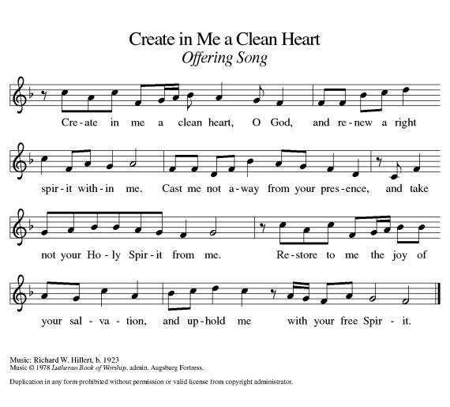

**\*OFFERING PRAYER** God of grace,

God of abundance, we bring before you the precious fruits of your creation, and with them our very lives. Teach us patience and hope as we care for all those in need until the coming of your Son, our Savior and Lord.

**Amen.**

**\*THE LORD’S PRAYER ELW p. 191**

**SENDING**

**\*BLESSING:** May God direct your ways in peace, make you abound in love for one another and for all, and strengthen your hearts until the coming of our Lord Jesus. Almighty God, Father, ☩ Son, and Holy Spirit, bless you now and forever.

***Three-Fold Amen.***

**\*SENDING HYMN** *Soon and Very Soon* **ELW #439**

**\*BELL**

**\*SENDING** L: Go in peace and serve the Lord. **C: Thanks be to God!**

**+++++++++++++++++++++++++++++++++++++++++++++++++++++++++++++++++++++++++++++++++++++++++++++++++**

*Copyright 2013 Augsburg Fortress. All rights reserved. Reprinted by permission under Augsburg Fortress Liturgies Annual License#15562-ELW*

**Readings for Next Sunday: Malachi 3:1-4, Luke 1:68-79, Phil. 1:3-11, Luke 3:1-6**

Prayer requests

*We remember in our prayers…all who face catastrophic illness, surgery, and bindings of all kinds as well as the homebound:* ***Bea Behrens, Agnes Carlson, Lisa******Carlson & family, Donna Fisk, and Danny Lang.*** *Be present with your Spirit, Lord, and lead us to be your presence to all. Amen.*

**ANNOUNCEMENTS**



**TODAY IS THE LAST DAY TO SIGN UP TO PURCHASE A POINSETTIA. Please help beautify Trinity for the Advent/**

**Christmas season. Find the red inserts in your bulletin.**

We need families to Sign up to read the Advent Litanies and light the Advent candle on 12/6, 12/13 and 12/20. The readings are underneath the sign-up sheet. Please volunteer!!

**THIS WEEK IN OUR PARISH**

**MONDAY,NOVEMBER 30**- 9 AM Messenger Assembly

**THURSDAY, DECEMBER 3**-There will be **NO** Bible study at the Truman Café

**SATURDAY, DECEMBER 5**- Trinity’s Annual Cookie Walk is from 8-10 am. Don’t forget to bake your cookies this coming week!!! We still need people to sign up to help work at the church from 7-10:30 am.

**SUNDAY, DECEMBER 6-Trinity Choir Concert**

9-10:00 Sunday School-Christmas program practice

10-10:30 Gathering time w/kid friendly snacks

10:30 Communion Worship

*Reader: Tom Dodge, Comm. Server: Cathy Sorenson*

*Ushers: *Dave Kahler, Tommy Kotewa, Denny Jahnz and Zach Jahnz*

**UPCOMING EVENTS**



The Sunday School Christmas Program is December 13 during worship time. The theme this year is “For God So Loved the World” Telling the real Christmas story at an orphanage. They will be taking donations for toys to give to the needy.

**The Christmas Eve Candlelight Service will be held on**

**December 24th at 5:30 pm**

STEP Inc. has once again brought its green recycle bin in the hallway at the church. Please bring in your old broken light sets, cords, even phone cords to be recycled by the guys over at STEP Inc.

|  |
| --- |
| **THE BEGINNING OF ADVENT** |
| November is the month of Thanksgiving, but it often also includes the beginning of a new church year. This year, November 29 is the first Sunday of Advent. The season of Advent is about Jesus, the Word, “coming.” It’s about anticipating and preparing for Christ’s arrival.   God comes to us in many and various ways. He speaks to us through the prophets and saints. He comes and speaks to us when we are listening. He comes in the beauty and mysteries of nature. Most of all, God comes in the person of Christ, speaking to his listeners face to face.   Pastor Edmund Steimle put it this way: “The Christian story is a story of God coming into the middle of life, of our lives, opening the dialogue with us.”   That’s what Advent is really all about: God visiting the earth in person to speak with anyone and everyone who is ready to do so. |



**Advent Wreath**   
  
The Advent wreath is a symbol of watchfulness and increasing joy as we anticipate Jesus’ birth. The wreath’s circular shape symbolizes eternity, or life without end. The candles remind us that Jesus is the Light of the World — he brought light and life to a dark world (see John 1:4-5). On each of the four Sundays of Advent, we light a new candle. As the light grows, so do our hope and joy.