

***First Sunday in Advent***

**November 27, 2016**

**Evangelical Lutheran Worship, Setting 4**

**Trinity Lutheran Church**

Office Phone 776-4781, Fax 776-7888, Office Hours: Mon-8-11, Wed 8-11 & 1-4, Fri. 8-11

Email: [trinitytruman@frontier.com](mailto:trinitytruman@frontier.com), Website: [www.trinity-truman.org](http://www.trinity-truman.org)

 **PASTOR KRISTA STRUM**

Cell-(507)995-1233, Email: pkstrumom@me.com

Pastor Krista’s Office Hours: Tues. 9:00-1:00 pm & Fri. 9:00-1:00 pm

(*Please call Pastor on her cell if you need to contact her any other time of the*

*week. If she doesn’t answer, leave a message and she will call you back)*

**GATHERING**

*Congregation reads* ***bold print*** *\*Please stand*

**PRELUDE**

**BELL**

**ANNOUNCEMENTS**

**INVOCATION**

**LIGHTING OF THE ADVENT WREATH**

The first week of Advent is all about hope.

Think about hope as you hear Lamentations 3: 21-24:

“But this I call to mind, and therefore I have hope:

The steadfast love of the Lord never ceases, God’s mercies never come to an end;

they are new every morning; great is your faithfulness.

“The Lord is my portion,” says my soul, “therefore I will hope in the Lord.”

*One candle is lit.*

Gracious God, **As the Advent season begins, we cry out to you. We come to you looking for hope. When everything else we rely on fails us, our only hope is in you. When we do not understand what has happened, we hope in you. We can hope for better days because we trust you. We know you and we know you are here with us no matter what we are facing. Some of us see only darkness this time of year. Some of us find life overwhelming. Some of us are filled with joy. Wherever we find ourselves today, Loving God, remind us that our hope is in you. Amen.**

**ADVENT SONG *He Came Down***

He came down that we may have hope;

he came down that we may have hope;

he came down that we may have hope;

hallelujah forevermore.

**CONFESSION AND FORGIVENESS**

Blessed be the holy Trinity, ☩ one God, who comes to wake us from sleep,

who leads us into the light of grace. **Amen.**

Let us prepare the way of the Lord by confessing our sin against God and neighbor.

God of all time,

**we confess that we have not prepared for your merciful reign among us.**

**We ignore our neighbors in need and fail in the labor of justice and peace. In your mercy forgive us. Grant us wisdom to welcome your light and to seek the things that will endure until Christ comes again in glory. Amen.**

Comfort, O comfort my people, says your God. In ☩ Jesus Christ your sins are forgiven

and all things are made new. Rejoice in this good news! **Amen.**

**\*GATHERING SONG*Comfort, Comfort Now My People*  ELW #256**

**\*GREETING**

The grace of our Lord Jesus Christ, the love of God, and the communion of the Holy Spirit be with you all. **And also with you.**

**\* KYRIE  *O Come, O Come, Emmanuel* (vs. 1 & 2) ELW# 257** \***PRAYER OF THE DAY** Let us pray.

**Stir up your power, Lord Christ, and come. By your merciful protection save us from the threatening dangers of our sins, and enlighten our walk in the way of your salvation, for you live and reign with the Father and the Holy Spirit, one God, now and forever. Amen.**

**WORD**

**First Reading: Isaiah 2:1-5**

1The word that Isaiah son of Amoz saw concerning Judah and Jerusalem. 2In days to come

the mountain of the Lord’s house shall be established as the highest of the mountains,   and shall be raised above the hills; all the nations shall stream to it. 3Many peoples shall come and say, “Come, let us go up to the mountain of the Lord, to the house of the God of Jacob; that he may teach us his ways and that we may walk in his paths.” For out of Zion shall go forth instruction, and the word of the Lord from Jerusalem. 4He shall judge between the nations, and shall arbitrate for many peoples; they shall beat their swords into plowshares, and their spears into pruning hooks; nation shall not lift up sword against nation, neither shall they learn war any more. 5O house of Jacob, come, let us walk in the light of the Lord!

Word of God, word of life. **Thanks be to God.**

**CHILDRENS TIME**

**GOSPEL ACCLAMATION *Alleluia. Lord, to whom shall we go…* ELW p. 151**

**\*GOSPEL:  Matthew 24:36-44**  **Glory to you, O Lord.**

[Jesus said to the disciples,] 36“About that day and hour no one knows, neither the angels of heaven, nor the Son, but only the Father. 37For as the days of Noah were, so will be the coming of the Son of Man. 38For as in those days before the flood they were eating and drinking, marrying and giving in marriage, until the day Noah entered the ark, 39and they knew nothing until the flood came and swept them all away, so too will be the coming of the Son of Man. 40Then two will be in the field; one will be taken and one will be left. 41Two women will be grinding meal together; one will be taken and one will be left. 42Keep awake therefore, for you do not know on what day your Lord is coming. 43But understand this: if the owner of the house had known in what part of the night the thief was coming, he would have stayed awake and would not have let his house be broken into. 44Therefore you also must be ready, for the Son of Man is coming at an unexpected hour.”

The gospel of the Lord. **Praise to you, O Christ.**

**SERMON**

**HYMN OF THE DAY*Rejoice, Rejoice, Believers*  ELW# 244**

**CREED** *(found on the salmon sheet in the back cover of the red hymnal)*

**PRAYERS OF INTERCESSION** L: Let us pray.

Response: **C: Have mercy O God.**

**PEACE**The peace of Christ be with you always. **And also with you.**

**OFFERING**

**OFFERING SONG**  ***Create in Me a Clean Heart…* ELW #186**

**OFFERING PRAYER**

God of abundance, we bring before you the precious fruits of your creation, and with them our very lives. Teach us patience and hope as we care for all those in need until the coming of your Son, our Savior and Lord. **Amen.**

**\*LORD’S PRAYER (sung) -** *found on the salmon sheet in the back cover of the red hymnal*

**SENDING**

**\*BLESSING**

May Christ, the Sun of righteousness, shine upon you and scatter the darkness from before your path. Almighty God, Father, ☩ Son, and Holy Spirit, bless you now and forever.

***Three fold Amen…***

**\*SENDING SONG  *Soon and Very Soon*  ELW #439**

**\*DISMISSAL** Go in peace. Prepare the way of the Lord. **Thanks be to God.**

**BELL/POSTLUE**

+++++++++++++++++++++++++++++++++++++++++++++++++++++++++++++++++

Copyright © 2016 Augsburg Fortress. All rights reserved. Reprinted by permission under Augsburg Fortress Liturgies Annual License #SAS103469. New Revised Standard Version Bible, copyright © 1989, Division of Christian Education of the National Council of the Churches of Christ in the United States of America. Used by permission. All rights reserved.

 *We remember in our prayers…all who face catastrophic illness, surgery, and bindings of all kinds as well as the homebound:* ***Bea Behrens, Lisa******Carlson & family, Oakley Selnes, and Danny Lang.***

**TODAY:** Is the last day to sign up to purchase a Poinsettia plant for Trinity’s Sanctuary for the Advent and Christmas Season. Find the red sign-up sheet in your bulletin.

**THIS WEEK IN OUR PARISH**

**MONDAY, NOVEMBER 28**- 9 AM Messenger Assembly  
**WEDNESDAY,NOVEMBER 30-** Bingo at Truman Senior Living Center at 1:45 pm.

6 pm Choir practice

**THURSDAY, DECEMBER 1**-9 AM Open Bible Study at the Truman Café.

**FRIDAY, DECEMBER 2-**The church office will be closed, Brenda will be in the office on Thursday; so any information for the bulletin need to be in by Thursday morning, Dec. 1st.

**SUNDAY, DECEMBER 4-Second Sunday in Advent**

**8:45 AM COMMUNION WORSHIP**

**10 AM SUNDAY SCHOOL**

*Reader: Clayton Duncanson, Acolytes: Karson Davis*

*Ushers: *Ricky Davis, Brad Nickerson, Dave Kahler and Doug Schwanz*

**Date Devotion goes out …. November 27**

|  |  |  |  |
| --- | --- | --- | --- |
|  | Whirl Story Bible | Reading Plan | Deeper Study |
| Letters of Paul | Many Bodies One Parts | 1 Corinthians 12:12-31 | 1st and 2nd Corinthians |
|  | Night and Day Prayers | 1 Thessalonians 3:9-13 | 1 Thessalonians |
|  | Working Together | 2 Thessalonians 3:6-13 | 2 Thessalonians |
|  | Pray for Everyone | 1 Timothy 2:1-7 | 1 Timothy |
|  | Faith Passed Down | 2 Timothy 1:1-14 | 2 Timothy |
|  | Rejoice in the Lord Always | Philippians 4:1-9 | Philippians |
|  | Blessings in Christ | Ephesians 1:3-14 | Ephesians |

 **UPCOMING EVENTS**

Truman Blood Drive to be held on Monday, November 28th from 12-6 pm at the Truman Community Center. Call Yvonne to make an appointment.

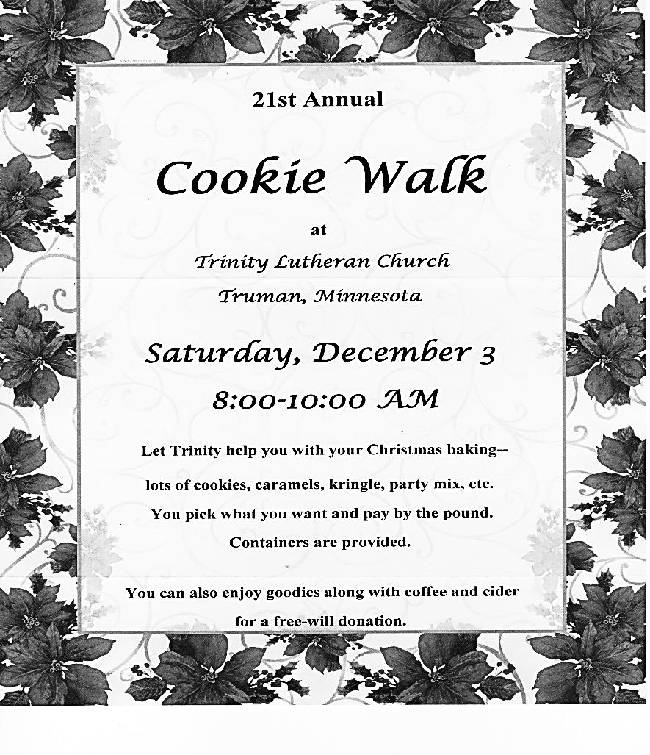

**The Cookie Walk is coming on Saturday, December 3rd.**

**Are you thinking of your fanciest cookies to donate this year?**

**We also need persons to sign up to help work at the church from 7-10:30 a.m.**

**The sign-up sheet is on the table.**

**Tell your family and friends to attend.**

Augustana Lutheran Church in St. James is celebrating St. Lucia Day on Saturday, December 10th . A breakfast served from 6:30-9:00 am. Free will offering. *(see blue poster)*

**FOR YOUR INFORMATION**



STEP Inc. of Fairmont is once again collecting your old Christmas lights. They will accept electric cords, holiday lights, telephone cords, and appliance cords. They do NOT accept cord adaptors, battery packs, plastic rope lights or CFL lights. Just drop off your items in the green receptacle bin in the entrance.



The Truman Senior Living would like to offer a wonderful lunch service Monday-Friday for the noon meal. We deliver to your home No charge (*must live in the Truman city limits*). The cost per meal is only $4.50. For more information, or to get signed up call 507-776-2031 ask for the Dietary Director. *We are also looking for volunteers to deliver meals to our Community members.*