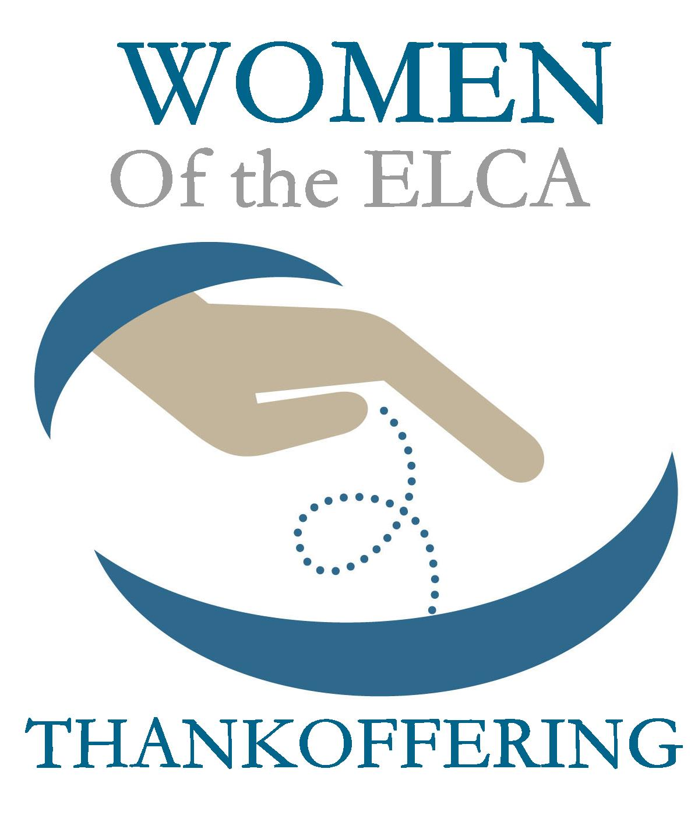

Thankoffering Sunday
November 13, 2016
Evangelical Lutheran Worship, Setting 4

Trinity Lutheran Church
Office Phone 776-4781, Fax 776-7888, Office Hours: Mon-8-11, Wed 8-11 & 1-4, Fri. 8-11
Email: trinitytruman@frontier.com, Website: www.trinity-truman.org
PASTOR KRISTA STRUM
Cell-(507)995-1233, Email: pkstrumom@me.com
Pastor Krista’s Office Hours: Tues. 9:00-1:00 pm & Fri. 9:00-1:00 pm

(Please call Pastor on her cell if you need to contact her any other time of the
week. If she doesn’t answer, leave a message and she will call you back)
GATHERING

Congregation reads bold print *Please stand

PRELUDE
BELL
ANNOUNCEMENTS
INVOCATION
In the name of the Father, and of the Son, and of the Holy Spirit. Amen.

LITANY FOR GATHERING
L: Bless the Lord, O my soul.
C: O Lord my God, you are very great.
L: Today brings all we need to praise our loving God.
C: Creator, you have made us in your image.
L: Today brings all we need to live in peace and purpose.
C: Redeemer, you have called us to new life.
L: Today brings all we need to live abundantly.
C: Renewer, you have brought us together to sing your praise.
L: Today brings women of many generations who grow together in faith
and affirm and support one another.
C: Companion, you guide us to your beloved community.
L: Today brings a world in need of healing and wholeness.
C: Healer, you inspire us to ministry and action.
L: For the church, the society and the world,
C: Lord our God, we humbly enter into worship.
L: Prepare our hearts.
C: Amen.

*GATHERING SONG My Faith Looks Up to Thee ELW# 759

*GREETING
The grace of our Lord Jesus Christ, the love of God, and the communion of the Holy Spirit be with you all. And also with you.

SONG OF PRAISE ----God, Whose Almighty Word (vs. 1 & 4)

1 God, whose almighty word
chaos and darkness heard
and took their flight:
hear us, we humbly pray,
and where the gospel day
sheds not its glorious ray,
let there be light.

4 Holy and blessed three,
glorious Trinity,
Wisdom, Love, Might:
boundless as ocean's tide,
rolling in fullest pride,
through the earth, far and wide,
let there be light.

* PRAYER OF THE DAY L: The Lord be with you. C: And also with you.
L: Let us pray,
Holy God, because without you we would not be able to serve you, mercifully grant that your Holy Spirit may in all things direct and guide our hearts and minds; through Jesus Christ our Lord, who lives and reigns with you and the Holy Spirit, one God, now and forever. Amen.

THE GREATEST STORY

CHILDREN’S TIME
WORD
Scripture Reading: John 1:1-14
1In the beginning was the Word, and the Word was with God, and the Word was God. 2He was in the beginning with God. 3All things came into being through him, and without him not one thing came into being. What has come into being 4in him was life, and the life was the light of all people. 5The light shines in the darkness, and the darkness did not overcome it. 6There was a man sent from God, whose name was John. 7He came as a witness to testify to the light, so that all might believe through him. 8He himself was not the light, but he came to testify to the light. 9The true light, which enlightens everyone, was coming into the world. 10He was in the world, and the world came into being through him; yet the world did not know him. 11He came to what was his own, and his own people did not accept him. 12But to all who received him, who believed in his name, he gave power to become children of God, 13who were born, not of blood or of the will of the flesh or of the will of man, but of God. 14And the Word became flesh and lived among us, and we have seen his glory, the glory as of a father's only son, full of grace and truth.

L: the word of the Lord. C: Thanks be to God.

SERMON
HYMN OF THE DAY Beautiful Savior ELW# 838

CREED (found on the salmon sheet in the back cover of the red hymnal)

PRAYERS OF INTERCESSION - THANK OFFERING SERVICE
Response: L: We pray in abundance, C: Creator, draw us in.
PEACE The peace of Christ be with you always. And also with you.

THANKOFFERING
As we give our Thankofferings today, we share in a tradition that goes back at least to the 1800s, when Christian women formed “mite” or “cent” societies to support the mission of the church. When others said there was not enough money to carry out the church’s work, the women believed otherwise and acted together. In these societies, each woman collected offerings at home. On occasion, they would gather as we do today to worship and make their offerings with thanks and praise. When Women of the ELCA was formed 30 years ago, we committed to continue this tradition of giving in gratitude for blessings. Each year, in thousands of congregations, Thankofferings are given to support the life-changing ministries of Women of the ELCA. Together, we do more than we could ever do apart. In gratitude for all God has given to us, and with hope for all that is to come, let us now give our Thankoffering.

The Thankoffering Envelopes (your monetary donation) go in the wicker baskets upfront, the non-perishable food items go in the bigger baskets upfront (the items will be sent to Heaven’s Table Food Shelf-in Fairmont). Your regular offering will go into the offering plates brought around by the ushers

OFFERING

THANK OFFERING PRAYER
God of grace,
You have showered us with abundance and entrusted to us the ministries of Women of the ELCA. Accept these offerings to further your mission. Help us to grow in faith, affirm our gifts, support one another in our callings, engage in ministry and action and promote healing and wholeness in the church, the society and the world. Accept these gifts and this prayer that, nurtured by your Word, called with your Spirit, and fed at your table, we may share with gladness all that you have shared with us until all creation is satisfied. Amen.

MEAL

GREAT THANKSGIVING ELW p. 152
THANKSGIVING AT THE TABLE ELW p. 153
*LORD’S PRAYER - found on the salmon sheet in the back cover of the red hymnal

IVITATION TO COMMUNION Come to the banquet, for all is now ready
PRAYER AFTER COMMUNION Let us pray,
We come again to you, O God, giving you thanks that in this feast of mercy you have embraced us and healed us, making us one in the body of Christ. Go with us on our way.
Equip us for every good work, that we may continue to give you thanks by embracing others with mercy and healing; through Jesus Christ, our Savior and Lord. Amen.

SENDING
*BLESSING - THANKOFFERING
God bless you with courage, with peace, and with love, that you may freely live for God and freely give for others.
Three fold Amen…

*SENDING SONG I Love to Tell the Story ELW# 661

*DISMISSAL Go in peace. Serve the Lord. Thanks be to God.
BELL/POSTLUE
+++++++++++++++++++++++++++++++++++++++++++++++++++++++++++++++++
Copyright © 2016 Augsburg Fortress. All rights reserved. Reprinted by permission under Augsburg Fortress Liturgies Annual License #SAS103469. New Revised Standard Version Bible, copyright © 1989, Division of Christian Education of the National Council of the Churches of Christ in the United States of America. Used by permission. All rights reserved.

We remember in our prayers…all who face catastrophic illness, surgery, and bindings of all kinds as well as the homebound: Bea Behrens, Lisa Carlson & family, and Danny Lang.

TODAY: Remember to check your mailboxes before worship to find your Thankoffering Envelopes! Your cookie walk letter is also in your mailbox.

The flowers on the Thankoffering table are in loving memory of his wife, Ramona and his mother, Viola Barge from Jerry Teig.

Please consider Making Trinity Beautiful during the Advent Season and purchase a Poinsettia plant. Find the red sign-up sheet in your bulletin.

The Trinity Stewardship Campaign is on and again we are using the Pony Express.
Please keep the packets moving to the next one on the list. The deadline is next Sunday, November 20th.

Date Devotion goes out …. November 13
 | Whirl Story Bible | Reading Plan | Deeper Study
Who Do You Say That I Am | Jesus Calms the Storm | Mark 4:35-41 | Luke 8:22-25
 | The Beatitudes  The Prodigal Son  The Greatest Commandment | Matthew 5:1-12  Luke 15:11-32  Matt. 22:34-40 | Matthew 5:1-12  Matthew 22:34-40  Luke 15:11-32
 | Jesus Raises Lazarus | John 11:1-45 | John 11:1-44
 | Lukes Holy Week | Luke 22:14-23;23:26-56 | Mark 8:27-9:1  Luke 19:28-40
 | Matthews Holy Week | Matthew 21:1-11; 27:27-66 | Luke 22:1-65  Luke 22:6ki-23:56
 | Jesus is Risen | John 20:1-18 | Luke 24, John 20-21, Matt. 28:16-20
THIS WEEK IN OUR PARISH

MONDAY, NOVEMBER 14-WELCA Meeting at 1:30 pm. Thurs Am. serves

ATTENTION WELCA LADIES…There will be NO Mending this Tuesday at TSL

WEDNESDAY,NOVEMBER 9-Choir practice at 6 pm.
THURSDAY, NOVEMBER 17-Truman Early Childhood Screening at Trinity 8 am – 2:30
FRIDAY, NOVEMBER 11- Last day to submit news items to the Messenger.
SUNDAY, NOVEMBER 20
8:45 AM WORSHIP- Kids sing at worship
10 AM SUNDAY SCHOOL
12:15-3:30 pm Confirmation class at Madelia.
Reader: Marilyn Duncanson, Acolytes: Colby Cross
Ushers: *Norman Anderson, Brian Nickerson, John Zaharia and Dan Smith
UPCOMING EVENTS

The Cookie Walk is coming on December 3rd. Are you thinking of your fanciest cookies to donate this year? We also need persons to sign up to help work at the church from 7-10:30 am; the sign-up sheet is on the table.

