

*All Saints Sunday/First Holy Communion*

**23rd Sunday after Pentecost**

**November 1, 2015**

**Holy Communion, *Bread of Life*, Setting 5**

**With One Voice (WOV) p. 28**

**Trinity Lutheran Church**

Office Phone 776-4781, Fax 776-7888, Office Hours: Mon 8-11, Wed & 8-11 & 1-4, Fri-8-11 am

 Email: [trinitytruman@frontier.com](mailto:trinitytruman@frontier.com), Website: [www.trinity-truman.org](http://www.trinity-truman.org)

**Pastor Krista Strum-**Cell: (507)995-1233, Email: pkstrumom@me.com

Pastor Krista’s Hours: Wed. 11-2:30 pm, Thurs. 8:30-2:30 pm

**GATHERING**

*Congregation reads* ***bold print****. *Please stand*

**PRELUDE *Trinity Choir: “****My Vision, My Shepherd”*

**BELL**

**WELCOME & ANNOUNCEMENTS**

**\*CONFESSION & FORGIVENESS**

Blessed be the holy Trinity, ☩ one God, clothed in majesty ever since the world began,

who loves us and frees us from our sins, who leads us with all the saints to everlasting life. **Amen.**

Let us draw near with a true heart and confess our sins to God.

God our maker and redeemer,

**we confess that we have sinned against you in thought, word, and deed.**

**We come for refuge to your infinite mercy. You have given your only Son to die for us;**

**have mercy on us, and for his sake, forgive us all our sin. By your Holy Spirit, increase in us true knowledge of you and your will, and true obedience to your word, that by your grace we may come to everlasting life; through Jesus Christ our Lord. Amen.**

Almighty God has had mercy on us, and God’s only Son has been given to die for us, and for his sake God ☩ forgives us all our sin. Believing in Jesus’ name, you have received power to become the children of God; you have received the gift of the Holy Spirit. **Amen.**

**\*GATHERING HYMN** *Shall We Gather at the River* **WOV #690**

**\*GREETING WOV p. 12**

**\*KYRIE WOV p. 28**

**\*HYMN OF PRAISE *Glory to God*  WOV p. 29**

**\*PRAYER OF THE DAY:** L: The Lor d be with you. **C: And also with you.**

L: Let us pray. *Silence* Almighty God,

**You have taught us in your Son that love fulfills the law. Inspire us to love you with all our heart, our soul, our mind, and our strength, and teach us how to love our neighbor as ourselves, through Jesus Christ, our Savior and Lord. Amen.**

**WORD**

**FIRST READING: Hebrews 12:1-3**

Therefore, since we are surrounded by so great a cloud of witnesses, let us also lay aside every weight and the sin that clings so closely, and let us run with perseverance the race that is set before us, 2looking to Jesus the pioneer and perfecter of our faith, who for the sake of the joy that was set before him endured the cross, disregarding its shame, and has taken his seat at the right hand of the throne of God. 3Consider him who endured such hostility against himself from sinners, so that you may not grow weary or lose heart.

The Word of the Lord. **C: Thanks be to God.**

**CHILDREN’S MESSAGE**

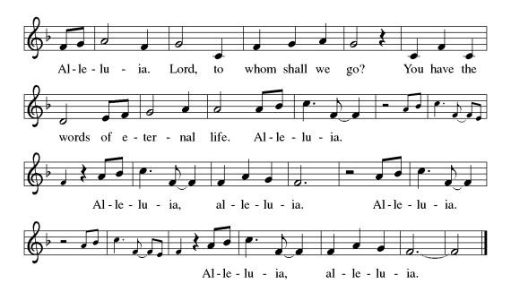**\* GOSPEL ACCLAMATION**

**\*GOSPEL: John 11:32-44 Glory to you, O Lord.**

When Mary came where Jesus was and saw him, she knelt at his feet and said to him, "Lord, if you had been here, my brother would not have died." 33When Jesus saw her weeping, and the Jews who came with her also weeping, he was greatly disturbed in spirit and deeply moved. 34He said, "Where have you laid him?" They said to him, "Lord, come and see." 35Jesus began to weep. 36So the Jews said, "See how he loved him!" 37But some of them said, "Could not he who opened the eyes of the blind man have kept this man from dying?" 38Then Jesus, again greatly disturbed, came to the tomb. It was a cave, and a stone was lying against it. 39Jesus said, "Take away the stone." Martha, the sister of the dead man, said to him, "Lord, already there is a stench because he has been dead four days." 40Jesus said to her, "Did I not tell you that if you believed, you would see the glory of God?" 41So they took away the stone. And Jesus looked upward and said, "Father, I thank you for having heard me. 42I knew that you always hear me, but I have said this for the sake of the crowd standing here, so that they may believe that you sent me." 43When he had said this, he cried with a loud voice, "Lazarus, come out!" 44The dead man came out, his hands and feet bound with strips of cloth, and his face wrapped in a cloth. Jesus said to them, "Unbind him, and let him go."

The Gospel of the Lord. **Praise to you, O Christ.**

**SERMON**

**\*HYMN OF THE DAY *For All the Saints***

1 For all the saints who from their labors rest,

who thee by faith before the world confessed,

thy name, O Jesus, be forever blest.

Alleluia! Alleluia!

3 Oh, blest communion, fellowship divine,

we feebly struggle, they in glory shine;

yet all are one in thee, for all are thine.

Alleluia! Alleluia!

5 The golden evening brightens in the west;

soon, soon to faithful servants cometh rest;

sweet is the calm of paradise the blest.

Alleluia! Alleluia!

6 But then there breaks a yet more glorious day:

the saints triumphant rise in bright array;

the King of glory passes on his way.

Alleluia! Alleluia!

**REMEMBERANCE OF THE SAINTS--A RITE OF REMEMBERANCE**

P: Blessed be the God and Father of our Lord Jesus Christ, The source of all mercy and the

God of all consolation.

**C: He comforts us in all our sorrows so that we can comfort others in their sorrows**

**with the consolation we ourselves have received from God.**

P: When we were baptized in Christ Jesus, we were baptized into His death.

**C: We were buried therefore with Him by baptism into death, so that as Christ was**

**raised from the dead by the glory of the Father, we too might live a new life.**

P: For if we have been united with Him in a death like His, we shall certainly be united with

him in a resurrection like His.

**C: Thanks be to God!**

P: Let us pray. Almighty God, those who die in the Lord shall live with you in joy and

blessedness.

**C: We give you heartfelt thanks for the grace you have bestowed upon your servants**

**who have finished their course in faith and now rest from their labors.**

***(Pastor Krista will read our members who passed away this past year)***

P: We remember on this day also all our beloved faithful departed not named here, but

whom we now name in our hearts…

P: Into your hands we commend them, O Merciful Savior, sheep of your own fold, lambs of

your own flock, sinners of your own redeeming.

**C: Rest eternal grant to them, O Lord, and let perpetual light shine upon them.**

**\*THE PRAYERS - *Lord, Listen to Your Children Praying***

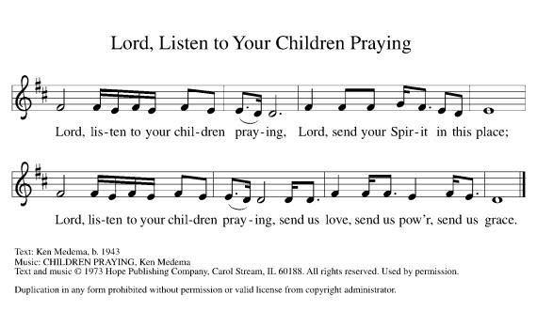**\*SHARING OF THE PEACE**

L: The peace of the Lord be with you always. **C: And also with you.**

**OFFERING**

**\*OFFERTORY** *Trinity Choir “The Church is One Foundation”*

**\*OFFERING PRAYER**

**Merciful God, as grains of wheat scattered upon the hills were gathered together to become one bread, so let your church be gathered together from the ends of the earth into your kingdom, for yours is the glory through Jesus Christ, now and forever.**

**Amen.**

**\*THE LORD’S PRAYER** *right column* **WOV p. 25**

**MEAL**

**COMMUNION  WOV p. 25**

**COMMUNION HYMN  WOV p. 39**

**POST-COMMUNION PRAYER  WOV p. 41**

**SENDING**

**\*BLESSING** Almighty God, Father, + Son and Holy Spirit, bless you now and forever.

***Three-Fold Amen.***

**\*SENDING HYMN** *What A Fellowship, What a Joy Divine* **WOV #780**

**\*BELL**

**\*SENDING** L: Go in peace. Serve the Lord. **C: Thanks be to God!**

**+++++++++++++++++++++++++++++++++++++++++++++++++++++++++++++++++++++++++++++++++++++++++++++++++**

*Copyright 2013 Augsburg Fortress. All rights reserved. Reprinted by permission under Augsburg Fortress Liturgies Annual License#15562-ELW*

**Readings for Next Sunday: 1 Kings 17:8-16, Ps 146, Heb. 9:24-28, Mark 12:38-44**

Prayer requests

*We remember in our prayers…all who face catastrophic illness, surgery, and bindings of all kinds as well as the homebound:* ***Bea Behrens, Agnes Carlson, Lisa******Carlson & family, Donna Fisk, and Danny Lang.*** *Be present with your Spirit, Lord, and lead us to be your presence to all. Amen.*

**ANNOUNCEMENTS**



**TODAY:** Congratulations to our four students who will receive their First Holy Communion today: Peyton Franzen, Katherine Strum, Gracie Zaharia and Johnnie Zaharia.

**Once again the Trinity Stewardship campaign will begin today. We will again use the Pony Express. Please keep the packets moving along. They are due back to the torch bearers by November 15th.**

**THIS WEEK IN OUR PARISH**

**MONDAY,NOVEMBER 2**-Martha Circle meets at 1:30 at LuElla Kautz’s

**TUESDAY, NOVEMBER 3**

**Trinity’s Youth Group Hosts**

**Annual Election Day Soup Supper**

**on Tuesday, November 3rd from 5:30-7:30 pm.**

***Serving—Chicken noodle soup & Chili,***

***plus sandwiches and bars***

***Free will offering***



*Don’t forget to get out and vote. Vote “Yes” for Truman Public Schools operating Levy election at the Truman High School on November 3rd.*

**THURSDAY, NOVEMBER 5**- Open Bible Study/Lois Circle meets at 9:00 am at the Truman Café

**SUNDAY, NOVEMBER 8**

9-10:00 Sunday School

10-10:30 Gathering time w/kid friendly snacks

10:30 Communion Worship

*Reader: Barb Shoen, Comm. Server: Jan Ringeisen*

*Ushers: *Ron Kelley, John Zaharia, Norman Anderson and Grant Hartman*

**UPCOMING EVENTS**



***NOVEMBER 15th****. Our guest speaker is Drew Cambell from Mankato. We are also collecting non-perishable food items for Heaven’s Table Food Shelf in Fairmont. For monetary donations, be sure to check your mailbox for your Thankoffering envelopes.*

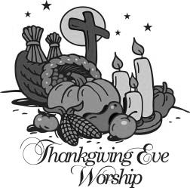

**THANKSGIVING EVE SERVICE WILL BE HELD ON NOVEMBER 25TH AT 7:00 PM**



**TRINITY WILL BE SELLING POINSETTIA’S FOR THE ADVENT/CHRISTMAS SEASON.**