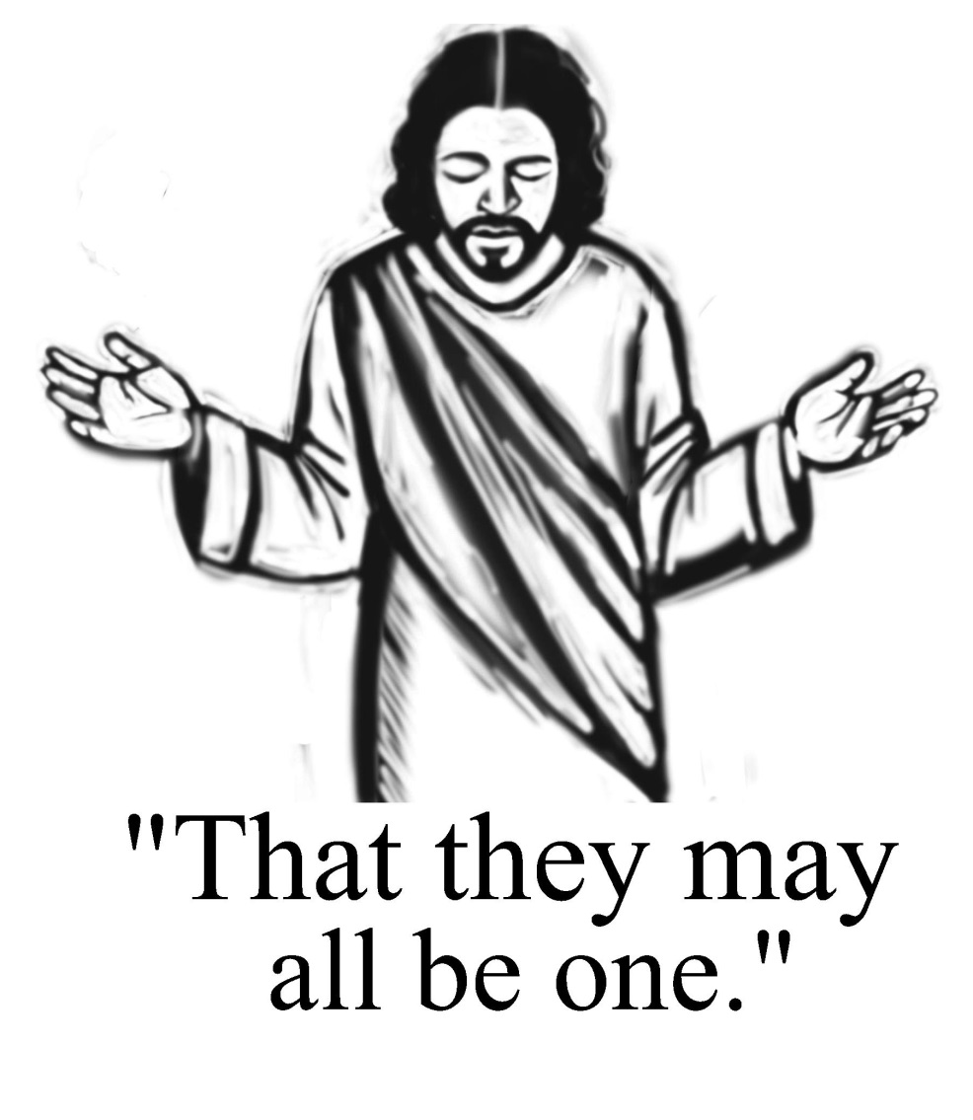

Seventh Sunday of Easter
May 8, 2016

Evangelical Lutheran Worship, Setting 4

Trinity Lutheran Church

Office Phone 776-4781, Fax 776-7888, Office Hours: Mon-8-11, Wed 8-11 & 1-4, F-8-11 am
Email: trinitytruman@frontier.com, Website: www.trinity-truman.org
Pastor Krista Strum-Cell-(507)995-1233, Email: pkstrumom@me.com
Pastor Krista’s Hours: Wed. 8:30-3:00 pm & Thurs. 10:30-2:00 pm

GATHERING

Congregation reads bold print *Please stand

PRELUDE
BELL
*CONFESSION AND FORGIVENESS
Blessed be the holy Trinity, ☩ one God,
the fountain of living water, the rock who gave us birth, our light and our salvation.
Amen.

Let us come into the light, the revealing and healing light of God.
God of grace and glory,
you have brought us through the night of sin
into the light of Jesus’ resurrection.
Yet our lives are still shadowed by sin.
Make us alive in Christ, O God.
Make us new as you make all things new.
Rescue us from evil and the gloom of sin, renew us in grace,
and restore us to living in your holiness,
through Jesus Christ, our risen Lord. Amen.

Rejoice with all creation around God’s throne!
The light of the risen Christ puts to flight all evil deeds, washes away sin,
restores innocence to the fallen, casts out hate, brings peace, and humbles earthly pride. Jesus Christ loves you and ☩ frees you from your sins by his blood.
To him be glory and dominion forever and ever! Amen.

ANNOUNCEMENTS

*GATHERING SONG Blest Be the Tie That Binds ELW #656

GREETING
The grace of our Lord Jesus Christ, the love of God, and the communion of the Holy Spirit be with you all. And also with you.

*KYRIE ELW p. 147
*HYMN OF PRAISE Glory to God... ELW p. 148

* PRAYER OF THE DAY L: The Lord be with you. C: And also with you.
L: Let us pray,
O God, form the minds of your faithful people into your one will. Make us love what you command and desire what you promise, that, amid all the changes of this world, our hearts may be fixed where true joy is found, your Son, Jesus Christ our Lord, who lives and reigns with you and the Holy Spirit, one God, now and forever. Amen.

FIRST READING: Acts 16:16-34
16One day, as we were going to the place of prayer, we met a slave-girl who had a spirit of divination and brought her owners a great deal of money by fortune-telling. 17While she followed Paul and us, she would cry out, “These men are slaves of the Most High God, who proclaim to you a way of salvation.” 18She kept doing this for many days. But Paul, very much annoyed, turned and said to the spirit, “I order you in the name of Jesus Christ to come out of her.” And it came out that very hour. 19But when her owners saw that their hope of making money was gone, they seized Paul and Silas and dragged them into the marketplace before the authorities. 20When they had brought them before the magistrates, they said, “These men are disturbing our city; they are Jews 21and are advocating customs that are not lawful for us as Romans to adopt or observe.” 22The crowd joined in attacking them, and the magistrates had them stripped of their clothing and ordered them to be beaten with rods. 23After they had given them a severe flogging, they threw them into prison and ordered the jailer to keep them securely. 24Following these instructions, he put them in the innermost cell and fastened their feet in the stocks. 25About midnight Paul and Silas were praying and singing hymns to God, and the prisoners were listening to them. 26Suddenly there was an earthquake, so violent that the foundations of the prison were shaken; and immediately all the doors were opened and everyone’s chains were unfastened. 27When the jailer woke up and saw the prison doors wide open, he drew his sword and was about to kill himself, since he supposed that the prisoners had escaped. 28But Paul shouted in a loud voice, “Do not harm yourself, for we are all here.” 29The jailer called for lights, and rushing in, he fell down trembling before Paul and Silas. 30Then he brought them outside and said, “Sirs, what must I do to be saved?” 31They answered, “Believe on the Lord Jesus, and you will be saved, you and your household.” 32They spoke the word of the Lord to him and to all who were in his house. 33At the same hour of the night he took them and washed their wounds; then he and his entire family were baptized without delay. 34He brought them up into the house and set food before them; and he and his entire household rejoiced that he had become a believer in God.

The word of the Lord. Thanks be to God.

PSALM: Psalm 97 (please read responsively the bold print)

1The Lord reigns; let the earth rejoice; let the multitude of the isles be glad.
2Clouds and darkness surround the Lord, righteousness and justice are the
foundations of God’s throne.

3Fire goes before the Lord, burning up enemies on every side.
4Lightnings light up the world; the earth sees and trembles.

5The mountains melt like wax before the Lord of all the earth.
6The heavens declare your righteousness, O Lord, and all the peoples see your glory.

7Confounded be all who worship carved images and delight in false gods! Bow down
before the Lord, all you gods.
8Zion hears and is glad, and the cities of Judah rejoice, because of your judg-
ments, O Lord.

9For you are the Lord, most high over all the earth; you are exalted far above all gods.
10You who love the Lord, hate evil! God guards the lives of the saints and
rescues them from the hand of the wicked.

11Light dawns for the righteous, and joy for the honest of heart.
12Rejoice in the Lord, you righteous, and give thanks to God’s holy name.

CHILDREN’S TIME
SUNDAY SCHOOL SING-TEACHER RECOGNITION

* GOSPEL ACCLAMATION Lord, Let My Heart Be Good Soil ELW #512

*GOSPEL John 17:20-26 C: Glory to you O Lord.
[Jesus prayed:] 20“I ask not only on behalf of these, but also on behalf of those who will believe in me through their word, 21that they may all be one. As you, Father, are in me and I am in you, may they also be in us, so that the world may believe that you have sent me. 22The glory that you have given me I have given them, so that they may be one, as we are one, 23I in them and you in me, that they may become completely one, so that the world may know that you have sent me and have loved them even as you have loved me. 24Father, I desire that those also, whom you have given me, may be with me where I am, to see my glory, which you have given me because you loved me before the foundation of the world.
25“Righteous Father, the world does not know you, but I know you; and these know that you have sent me. 26I made your name known to them, and I will make it known, so that the love with which you have loved me may be in them, and I in them.”

The gospel of the Lord. Praise to you, O Christ.
SERMON

*HYMN OF THE DAY My Hope is Built on Nothing Less ELW #597
*THE CREED (SALMON sheet inside the back cover of the red hymnal)

*THE PRAYERS OF INTERCESSION Dona Nobis Pacem ELW #753

*PEACE L: The peace of Christ be with you always. C: And also with you.

OFFERING
OFFERING HYMN Create in Me a Clean Heart ELW #188
OFFERING PRAYER Let us pray,
Blessed are you, O God, ruler of heaven and earth. Day by day you shower us with blessings. As you have raised us to new life in Christ, give us glad and generous hearts, ready to praise you and to respond to those in need, through Jesus Christ, our Savior and Lord. Amen.

*THE LORD’S PRAYER (SALMON sheet inside the back cover of the red hymnal)

SENDING
*BLESSING
The God of steadfastness and encouragement grants you to live in harmony with one another, in accordance with Christ Jesus. The God of hope fill you with all joy and peace in believing, so that you may abound in hope by the power of the Holy Spirit.
The God of all grace ☩ bless you now and forever.
Three fold Amen

SENDING SONG Go, My Children, with My Blessing ELW #543

*BELL/SENDING L: Go in peace. Serve the Lord. C: Thanks be to God.

POSTLUDE
+++++++++++++++++++++++++++++++++++++++++++++++++++++++++++++++++
Copyright © 2016 Augsburg Fortress. All rights reserved. Reprinted by permission under Augsburg Fortress Liturgies Annual License #SAS103469. New Revised Standard Version Bible, copyright © 1989, Division of Christian Education of the National Council of the Churches of Christ in the United States of America. Used by permission. All rights reserved.

TODAY: HAPPY MOTHER’S DAY!
We want to recognize our Sunday School Teachers today: Logan Davis, Courtney Zaharia, Natalie Splinter, Brytni Drevlow, Nicole Ebert, Beth Kotewa, Raquel Harder and Hailey Harder.
Readings for next Sunday: Acts 2:1-21, Ps. 104:24-34, 35b, Rom 8:14-17, John 14:8-17[25-27]
We remember in our prayers…all who face catastrophic illness, surgery, and bindings of all kinds as well as the homebound: Bea Behrens, Agnes Carlson, Lisa Carlson & family, Donna Fisk, Danny Lang and Kent Hyndman.

THIS WEEK IN OUR PARISH

TUESSDAY, MAY 10- WELCA Meeting at the church at 1:30 am-Martha serves
WEDNESDAY, MAY 11-Church Council Meeting at Madelia at 7 pm
SUNDAY, MAY 15-Confirmation Sunday
10:30 am Communion Worship
Reader: Carolyn Drevlow, Comm. Server: Linda Meyer, Acolyte: Carson Peters
Ushers: *Gene Mager, Dean Gulbranson, Doug & Tanner Mammenga

UPCOMING EVENTS

SUNDAY, MAY 22-Graduates Recognition and Reception-We have 9 Trinity and 2 foreign exchange students who will be recognized. Please stay for the reception to be held after the worship service to have cake & punch and fellowship with our graduates.

SUNDAY, MAY 29-PATRIOTIC SUNDAY—Please join us at worship when we recognize Memorial Day hymns for our worship service.

A Mother’s Day Hymnic Phrase

Sing praise to our Creator God!
Earth prospers from the way
God “mothers” each new child into
This world day after day.
God fabricates in motherhood
A channel from above
That longs to share with every child
God’s Comfort, Grace and Love!
Sing praise to our Creator God,
Who “mothers” us from birth!
Providing what we truly need
Throughout our lives on earth.
—Peggy Ferrell

