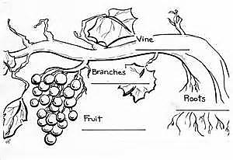

***Creation Care***

***Service of the Blessing of the Seeds Sunday***

**May 3rd, 2015**

**Hymns from the Evangelical Lutheran Worship (ELW)**

**Trinity Lutheran Church**

Office Phone 776-4781, Fax 776-7888, Office Hours: Mon-8-11, Wed 8-11 & 1-4, F-8-11 am

 Email: [trinitytruman@frontier.com](mailto:trinitytruman@frontier.com), Website: [www.trinity-truman.org](http://www.trinity-truman.org)

**Interim Kent Krumwiede-**Cell #: (507) 848-7192, Email: vicarkent@gmail.com

Office Hours Mon—Thurs 9:00-1:00 pm **GATHERING**

*Congregation reads* ***bold print*** *\*Please stand*

**PRELUDE**

**GATHERING REFLECTION**

*Today is what is called is a “Lay-led” worship. This does not make this worship any less significant than any other worship led by me or another pastor. As with any worship, it is Spirit-led reality. In the same vein, the prayers today, though pre-written and lay-prayed, are legitimate prayers of faith. In the same way that your individual prayers are truly heard by God. I invite you today, as you corporately pray, to immerse yourself in the words of the prayers and how God is hearing the words and is preparing to answer them, and in fact, God may already be in the process of answering them before you pray. Then consider how the Holy Spirit may be at work through our prayers to bring healing, restoration and new life to our world, our communities and ourselves.* **Lord of the Harvest, hear my thoughts as prayers and lead me to always worship in truth and Spirit. Amen.**

**BELL**

**WELCOME**

**GREETING** L: In the name of the Father, and of the + Son, and of the Holy Spirit.

**C: Amen.**

**\*GATHERING HYMN** *All Things Bright and Beautiful*

|  |  |
| --- | --- |
| **Refrain:**  **All things bright and beautiful,**  **all creatures great and small,**  **all things wise and wonderful:**  **the Lord God made them all.**  **1. Each little flower that opens,**  **each little bird that sings,**  **God made their glowing colors,**  **God made their tiny wings.**  **(Refrain)** | **2. The purple-headed mountains,**  **the river running by,**  **the sunset and the morning**  **that brightens up the sky.**  **(Refrain)**  **3. The cold wind in the winter,**  **the pleasant summer sun,**  **the ripe fruits in the garden:**  **God made them every one.**  **(Refrain)**  **4. God gave us eyes to see them,**  **and lips that we might tell**  **how great is God Almighty,**  **who has made all things well.**  **(Refrain)** |

**\*PRAYER OF THE DAY** L: The Lord be with you. **C: And also with you.**

L:Let us praise God, who plants the seeds and reaps the harvest and call upon him for his blessing.

L: **:** Almighty and everlasting God, Creator of all things and giver of all life,

**C: You give us your Son as the vine apart from whom we cannot live. Nourish our life in his resurrection, that we may bear the fruit of love and know the fullness of your joy; let your blessing be upon all seed, livestock, plow, forest, orchard, field, and private and community garden, and grant that all may serve to your glory and the welfare of your people; through Jesus Christ our Lord.** **Amen.**

**\*HYMN OF PRAISE *This is My Father’s World*  ELW #824**

**WORD**

****FIRST READING Genesis 1:27-31 (NRSV)** *Man’s Role in Creation*

27So God created humankind in his image, in the image of God he created them; male and female he created them. 28God blessed them, and God said to them, “Be fruitful and multiply, and fill the earth and subdue it; and have dominion over the fish of the sea and over the birds of the air and over every living thing that moves upon the earth.” 29God said, “See, I have given you every plant yielding seed that is upon the face of all the earth, and every tree with seed in its fruit; you shall have them for food. 30And to every beast of the earth, and to every bird of the air, and to everything that creeps on the earth, everything that has the breath of life, I have given every green plant for food.” And it was so. 31God saw everything that he had made, and indeed, it was very good. And there was evening and there was morning, the sixth day.

Word of God, Word of Life. **C: Praise to you, O Christ.**

**PSALM 65** *psalms begin on ELW p. 338. The assembly will read the indented portions.*

**SECOND READING 2 Corinthians 9:6-10 (NRSV)** *God and the Steward*

6The point is this: the one who sows sparingly will also reap sparingly, and the one who sows bountifully will also reap bountifully. 7Each of you must give as you have made up your mind, not reluctantly or under compulsion, for God loves a cheerful giver. 8And God is able to provide you with every blessing in abundance, so that by always having enough of everything, you may share abundantly in every good work. 9As it is written, “He scatters abroad, he gives to the poor; his righteousness endures forever.” 10He who supplies seed to the sower and bread for food will supply and multiply your seed for sowing and increase the harvest of your righteousness.

Word of God, Word of Life. **C: Praise to you, O Christ.**

**\*GOSPEL ACCLAMATION** *Lord, Let My Heart Be Good Soil* **ELW #512**

* **GOSPEL Mark 4:26-29** *– The seed and the kingdom of God.*

**C: Glory to you, O Lord**

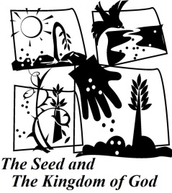26He also said, “The kingdom of God is as if someone would scatter seed on the ground, 27and would sleep and rise night and day, and the seed would sprout and grow, he does not know how. 28The earth produces of itself, first the stalk, then the head, then the full grain in the head. 29But when the grain is ripe, at once he goes in with his sickle, because the harvest has come.”

Word of God, Word of Life. **C: Praise to you, O Christ.**

**CHILDREN’S MESSAGE/NOISY SUNDAY**-Kim Hastad

**PRESENTATION-“A Celebration of Seasons”**  *by Tom Dodge*

**\*HYMN OF THE DAY**  *I, the Lord of Sea and Sky* **ELW #574**

\***APOSTLES’ CREED** *Salmon sheet in the back cover of the hymnal*

**THANKSGIVING**

**OFFERING**

**\*OFFERING HYMN** *For the Fruit of All Creation***ELW #679**

**LITANY OF DELIVERANCE** *Congregation will respond:* **Deliver us, O Lord.**

The Lord of the harvest sustains us, let us call upon him:

**Deliver us, O Lord.**

From despair in times of drought that turns into worry, anger and loss of faith.

**Deliver us, O Lord.**

From wastefulness in times of plenty: poor and absent stewardship, from gluttony and misuse.

**Deliver us, O Lord.**

From neglect of those in need: for the hospitalized and home-bound, for the hungry and homeless, the rejected and oppressed.

**Deliver us, O Lord**

From blindness to your presence in our work: in fields and gardens, in schools and homes, in governments and communities.

**Deliver us, O Lord.**

From our hunger and thirst: physically, mentally and spiritually.

**Deliver us, O Lord.**

**PRAYER OF BLESSING OF THE SEEDS**

L: Lord of the harvest,

**C: you placed the gifts of creation in our hands and called us to till the earth and make**

**it fruitful.**

*Over the seeds*  
L: We ask your blessing as we prepare to place these seeds & seedlings in the earth.  
**C: May the care we show these seeds & seedlings remind us of your tender love for**

**your people.**  
*Over the tools*

L: We ask your blessing as we prepare to use these tools and ones like these to plant our

seeds & seedlings in the earth.  
**C: May these remind us of your tender love for your people by your giving of your**

**Word to make us wise unto life.**

*For those who plant and tend to the care of crops for our use.*

L: We ask for your blessing over all whose vocation it is to till the soil and tend to crops.

**C: May they be a reminder that, like the farmer and the gardener, you are never far**

**from our nurturing so, like the crops, we may produce the fruits of faith.**

L: We ask this through Christ our Lord, who taught us to pray**:**

**\*THE LORD’S PRAYER**  *Bottom of salmon sheet in back cover of hymnal or* **ELW p. 221**

**SENDING**

**BLESSING**

L: May God nourish you and care for you and bless you, now and forever. In the name of the Father, and the + Son, and the Holy Spirit.  **C:** *Three-Fold Amen*

**SENDING HYMN** *You are the Seed*

**1** You are the seed that will grow a new sprout;  
you’re a star that will shine in the night;  
you are the yeast and a small grain of salt,  
a beacon to glow in the dark.  
You are the dawn that will bring a new day;  
you’re the wheat that will bear golden grain;  
you are a sting and a soft, gentle touch,

My witnesses wherever you go. **Refrain**

**Refr ain:**  
**Go, my friends, go to the world, proclaiming love to all,messengers of my forgiving peace, eternal love.Be, my friends, a loyal witness, from the dead I arose;"Lo, I’ll be with you forever, till the end of the world."**

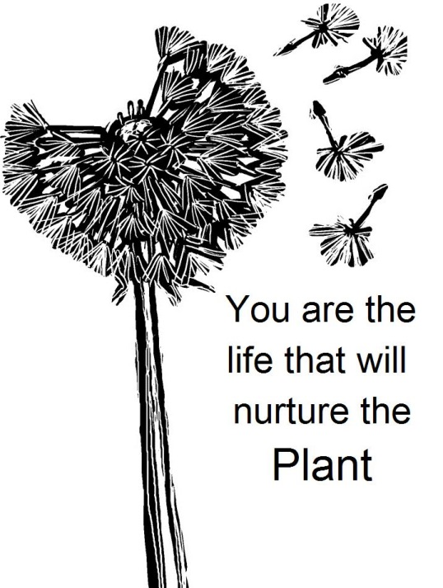**2** You are the flame that will lighten the dark,  
so resplendent with hope, faith, and love;  
you are the shepherds to lead the whole world  
to waters and pastures of peace.   
You are the friends that I chose for myself,  
you’re the word that I want to proclaim.  
You are the new reign of God built on a rock  
where justice and truth are at home. **Refrain**

**3** You are the life that will nurture the plant;  
you’re the waves in a turbulent sea;  
yesterday’s yeast is beginning to rise,  
a new loaf of bread it will yield.  
There is no place for a city to hide,  
there’s no mountain can cover its might;  
let your light shine so your loving works  
give honor and glory to God. **Refrain**

**BELL SENDING** L: Plant your seeds in peace and wait for God’s blessing. **C: Thanks be to God!**

**POSTLUDE +++++++++++++++++++++++++++++++++++++++++++++++++++++++++++++++++** *This service was adapted from The Book of Blessings © 1987, International Committee on English in the Liturgy, Inc. All rights reserved. Subscribers to RW may reproduce this service for church or school use. For more information on this collection of services see pp. 2-3.*

All Things Bright and Beautiful and You Are the Seed from With One Voice © 1995 Augsburg Fortress.

*With every deed, you are sowing a seed, though the harvest you may not see.*

**~ Ella Wheeler Wilcox**

**Readings for next Sunday:** Acts 10:44-48; Psalm 98; 1 John 5:1-6; John 15:9-17.

Prayer requests*We remember in our prayers…all who face catastrophic illness, surgery, and bindings of all kinds as well as the homebound:* ***Bea Behrens, Vi Benoy, Agnes Carlson, Lisa******Carlson & family, Donna Fisk, Danny Lang, and Darrell & Janice Buhmann’s daughter, Roxanne.*** *Be present with your Spirit, Lord, and lead us to be your presence to all. Amen.*

**THANK YOU!** To Tom Dodge and the Worship Committee who put this Sunday Worship together and did a great job!

**TODAY**: **IS NOISY** **SUNDAY & KIDS SING IN CHURCH!** Also it is Community Day –All members are invited after to attend and help the S/S students with a community project.

**THIS WEEK IN OUR PARISH**

**MONDAY & TUESDAY, MAY 4 & 5**-Vicar Kent will be @ Luther Seminary from Mondays PM until Tuesdays AM.

1:30 Martha Circle meets at Cathy Sorenson’s

**WEDNESDAY, MAY 6-**Choir Practice at 6 pm

**THURSDAY, MAY 7-** Open Bible Study/Lois Circle meets at Truman Café at 9 am

**SUNDAY, MAY 10**

9 AM Communion Worship

10 AM Sunday School-Mom’s are invited to stay after for a special pampering!

*Reader: Brytni Drevlow, Comm. Server: Jan Ringeisen Acolyte: Kylee Harder*

*Ushers: *Gary Meyer, Mike Wiederhoeft, Darrell Buhmann and Dennis Rode*



The movie **"Do You Believe?"** is showing at the Fairmont Theatre beginning on April 24th and will be staying for a minimum of two weeks. This movie is from the same people that made "God's Not Dead" and it is just as powerful. The trailer is on "You Tube" if you would like to preview it.

**UPCOMING EVENTS**



**EVENTS IN MAY AT TRINITY…**

May 10th-Mother’s Day

May 17th-Last Day of Sunday School/Teacher Appreciation

May 24-Patriotic Sunday

May 31-High School Graduates Recognition Sunday

 **Open House Reception/Shower will be in honor of**

**Mr. & Mrs. Shaun Miller**

**on Saturday, May 16th**

**from 2-4 pm in the fellowship hall**

**at Trinity Lutheran.**

Shaun & Yaneth were married on Thursday, October 16, 2014 at Canton Lutheran Church in Canton, South Dakota with Pastor Tim Thies officiating. Shaun is the son of Eloise Miller and grandson to Agnes Carlson



**Come & Go**

**Bridal Shower**

**in honor of Amber Davis,**

**on May 17th**

**at Trinity Lutheran Church, Truman**

**from 2-4 pm**

The couple is registered at Kohls and Target

*Amber is bride to be of Taylor Menke, and their wedding will be held on June 20th at The Flying Goose Campground in rural Fairmont.*

**CREST Alzheimer’s Education**

The volunteer caregivers organization “CREST” and Lakeview United Methodist Health Services are sponsoring an Alzheimer’s Education program on **Thursday, May 14th** at 1:30pm & 7:00pm in the chapel at the Lakeview Methodist Health Care Center in Fairmont. The speaker will be Kielyn Simonson from the Minnesota Alzheimer’s Association. She will be speaking on the importance of knowing the 10 warning signs of Alzheimer’s Disease. There is no charge for this event and the public is invited to attend this interactive workshop.