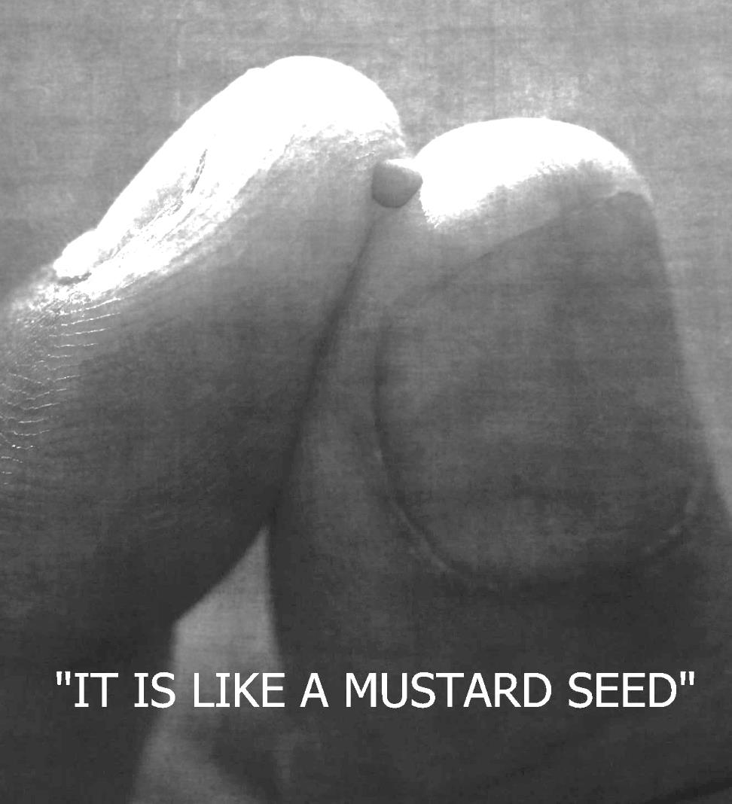

***Sixth Sunday of Easter***

**May 1, 2016**

**Evangelical Lutheran Worship**

**Holy Communion, Setting 4**

**Trinity Lutheran Church**

Office Phone 776-4781, Fax 776-7888, Office Hours: Mon-8-11, Wed 8-11 & 1-4, F-8-11 am

Email: [trinitytruman@frontier.com](mailto:trinitytruman@frontier.com), Website: [www.trinity-truman.org](http://www.trinity-truman.org)

**Pastor Krista Strum-**Cell-(507)995-1233, Email: pkstrumom@me.com

Pastor Krista’s Hours: Wed. 8:30-3:00 pm & Thurs. 10:30-2:00 pm

**GATHERING**

*Congregation reads* ***bold print*** *\*Please stand*

**PRELUDE**

**BELL**

**\*SEEDS CONFESSION**

Lord Jesus Christ,

we remember with gratitude those people who generously sowed the seeds of faith in our lives.  Above all. we recognize how you have blessed our lives with the gift of the Holy Spirit so that our faith has miraculously and mysteriously grown.

**We confess the times we fail to involve ourselves**

**in planting any seeds of faith in the lives of others;**

**the times when our personal agendas become more important than yours;**

**the times when we have denied others the opportunity to expand their faith**

**through our lack of interest or involvement;**

**the times when our lives become so entangled with the values of the world**

**that we forget what you have said and done and promised.**

**Bless and renew our lives, we pray, so that we remain connected to you at all times and in all places, strengthening our faith to expand and, growing strongly and vigorously, to bear the fruit of your mercy, your love, your undying life.  Amen.**

Fear not, for our creator, the loving maker of all reality, forgives us, and redeems us from violence and oppression. God sows the good news in tiny seeds, inviting us to tend the soil of community, and marvel as they grow.

In the name of Jesus, who is the Christ, you are forgiven. **Amen.**

**ANNOUNCEMENTS-**

**\*GATHERING SONG***This Is My Father's World*   **ELW #824**

**GREETING  ELW p. 147**

\***SEEDS PRAYER OF THE DAY**

Mighty God**, to you belong the mysteries of the universe. You transform shepherds into kings, the smallest seeds into magnificent trees, and hardened hearts into loving ones. Bless us with your life-giving Spirit, re-create us in your image, and shape us to your purposes, through Jesus Christ. Amen.**

**FIRST READING: 2 Corinthians 9:6-10**

6Remember this: Whoever sows sparingly will also reap sparingly, and whoever sows generously will also reap generously. 7Each of you should give what you have decided in your heart to give, not reluctantly or under compulsion, for God loves a cheerful giver. 8And God is able to bless you abundantly, so that in all things at all times, having all that you need, you will abound in every good work. 9As it is written: “They have freely scattered their gifts to the poor; their righteousness endures forever.” 10Now he who supplies seed to the sower and bread for food will also supply and increase your store of seed and will enlarge the harvest of your righteousness.

The word of the Lord. **Thanks be to God.**

**CHILDREN’S TIME**

* **GOSPEL ACCLAMATION *Lord, Let My Heart Be Good Soil*  ELW #512**

\***GOSPEL Mark 4:26-32 C: Glory to you O Lord.**

He also said, "The kingdom of God is as if someone would scatter seed on the ground, 27and would sleep and rise night and day, and the seed would sprout and grow, he does not know how. 28The earth produces of itself, first the stalk, then the head, then the full grain in the head. 29But when the grain is ripe, at once he goes in with his sickle, because the harvest has come." 30He also said, "With what can we compare the kingdom of God, or what parable will we use for it? 31It is like a mustard seed, which, when sown upon the ground, is the smallest of all the seeds on earth; 32yet when it is sown it grows up and becomes the greatest of all shrubs, and puts forth large branches, so that the birds of the air can make nests in its shade."

The gospel of the Lord. **Praise to you, O Christ.**

**SERMON**

**\*HYMN OF THE DAY**  *For the Beauty of the Earth***ELW #879**

**PRAYERS OF THE PEOPLE—BLESSING OF THE SEEDS**

**Blessing of the Garden**

L: Let us pray a blessing upon our gardens:

         Divine Vinegardener,

      In the beginning, your fingernails got dirty as you planted that first garden.

      You have always been the God of gardens, the God of a fruitful and abundant creation.

       It was in a garden that Jesus rose from the dead, the gardener of a New Creation.

       And so we pray for our gardens and those who labor in them.

       May the soil be rich, may the plants be rich in abundance,

       may our gardens be a place of joyful labor, of time for reflection,

        of good food, and of loving relationship

**All:  Lord, we ask you to shower down your blessings on your creation.**

**Blessing the Fields**

  L:  Let us pray a blessing on our fields:

       The earth is yours, O Lord, and the fullness thereof.

        You are the Creator of grass and grain, so shine down on our fields

         and give the wisdom to those charged with their care,

          that our fields will provide food for your creation,

          habitats for other creatures, and a sight of beauty for all who behold them.

          Let the fields exult everything that is in them.

          May all be safe in the fields and sheds of our community.

**All:  Lord, we ask you to shower down your blessings on your creation.**

**Blessings on the Farm Machinery**

  L:  Let us pray a blessing on our farm machinery:

        Our tractors, plows, and planters

         and all other equipment used in crop production.

             May our farm equipment serve the common good,

             May down time be minimal and repairs be few.

             Help us to become better stewards of the land.

**All:  Lord, we ask you to shower down your blessings on and through the machinery**

**and tools and instruments of our labor.**

**Blessings on all who Labor in Agriculture**

  L:  Let us pray a blessing on seed dealers, grain elevator workers

        and all who make a living in agriculture.

        May they earn a fair wage for their labors,

        may there be safety in the agri-business of our community.

**All:  Lord, we ask you to shower down your blessings on all agricultural laborers.**

**Blessings on all Members of our Agriculture Community**

  L:  Let us pray a blessing on our community.

        May the Word of Christ dwell richly in the lives of this farm community.

        May the peace of Christ rule    in their minds and hearts and guide our actions.

        May our farming community be a place of renewal and hope,

       A site of education and spiritual growth, a place of justice and love.

        And so we ask you, O Lord, to bless each who work the land

        and those who work alongside our neighbors in their chosen vocations.

        Give all wisdom and patience, a spirit of hospitality and love

        and grow as people who love you and your creation and their neighbors.

**All:  Lord, we ask you to shower down your blessings on these sisters and brothers, friends and neighbors. In the name of God the Father, and the Son and the Holy Spirit.  Amen.**

**PEACE:** The peace of Christ be with you always. **And also with you.**

**MEAL**

**OFFERING**

**OFFERING HYMN** *For the Fruit of All Creation* **ELW #679**

**THANKSGIVING AT THE TABLE  ELW p. 153**

**LORD’S PRAYER**(*SALMON sheet inside the back cover of the red hymnal*)

**COMMUNION  ELW p. 154**

***Lamb of God***

**SENDING**

**\*BLESSING**

May God nourish and care for you as you to continue to grow in faith. As you plant and nurture seeds for others - may God bless you and keep you now and forever.

***Three fold Amen***

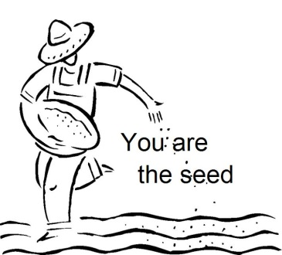**SENDING SONG*You Are The Seed***

**1** You are the seed that will grow a new sprout;

you’re a star that will shine in the night;

you are the yeast and a small grain of salt,

a beacon to glow in the dark.

You are the dawn that will bring a new day;

you’re the wheat that will bear golden grain;

you are a sting and a soft, gentle touch,

My witnesses wherever you go.***Refrain***

**REFRAIN:**

**Go, my friends, go to the world, proclaiming love to all,**

**messengers of my forgiving peace, eternal love.**

**Be, my friends, a loyal witness, from the dead I arose;**

**"Lo, I’ll be with you forever, till the end of the world."**

**2** You are the flame that will lighten the dark,

so resplendent with hope, faith, and love;

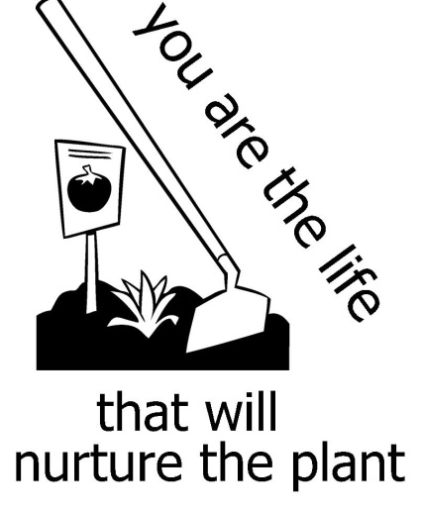you are the shepherds to lead the whole world

to waters and pastures of peace.

You are the friends that I chose for myself,

you’re the word that I want to proclaim.

You are the new reign of God built on a rock

where justice and truth are at home.     ***Refrain***

**3** You are the life that will nurture the plant;

you’re the waves in a turbulent sea;

yesterday’s yeast is beginning to rise,

a new loaf of bread it will yield.

There is no place for a city to hide,

there’s no mountain can cover its might;

let your light shine so your loving works

give honor and glory to God.     ***Refrain***

**\*BELL/SENDING** L: God in peace. Serve the Lord.

**C: Thanks be to God.**

**POSTLUDE**

**+++++++++++++++++++++++++++++++++++++++++++++++++++++++++++++++++**

Copyright © 2016 Augsburg Fortress. All rights reserved. Reprinted by permission under Augsburg Fortress Liturgies Annual License #SAS103469. New Revised Standard Version Bible, copyright © 1989, Division of Christian Education of the National Council of the Churches of Christ in the United States of America. Used by permission. All rights reserved.

**Readings for next Sunday:** Acts 16:16-34, Ps 97, Rev. 22:12-14, 16-17, 20-21, Prayer requests

*We remember in our prayers…all who face catastrophic illness, surgery, and bindings of all kinds as well as the homebound:* ***Bea Behrens, Agnes Carlson, Lisa******Carlson & family, Donna Fisk, Danny Lang and Kent Hyndman.***

I would like to thank everyone for their thoughts, prayers and cards that I received before and after my surgery. I feel it is a big part of the healing process to have love & support from friends and family.

 Kent Hyndman

**Check your mailboxes…the May Messenger Newsletter is here!!**

**THIS WEEK IN OUR PARISH**

**MONDAY, MAY 2**- Martha Circle meets at Barb Mager’s at 1:30 pm.

**THURSDAY, MAY 5**-Bible Study/Lois Circle at the Truman Café at 9 am.



**ON MAY 5TH**

**SUNDAY, MAY 8-Mother’s Day/Last Day of Sunday School/Teacher Recognition**

9-10 am Group Sunday School *(****We Are Singing In Church!!)***

10:30 am Worship

*Reader: Jan Ringeisen , Acolyte: Miah Krebs*

*Ushers: *Gene Mager, Dean Gulbranson, Doug & Tanner Mammenga*

**UPCOMING EVENTS**

**SUNDAY, MAY 15**-CONFIRMATION two students will affirm their baptism

**SUNDAY, MAY 22**-Graduates Recognition and Reception-We have 9 Trinity and 2 foreign exchange students who will be recognized. Please stay for the reception also to be held after the worship service and talk with our graduates.

**SUNDAY, MAY 29**-Please join us at worship when we recognize those who’ve given their lives for our earthly freedom with patriotic songs for Memorial Day.

|  |
| --- |
| **For use in printed publications, Right-Click on the filename below to download and choose "Save Target As" or "Save Link As"Concerning trees … and us**  **Have deep roots,**  **branch out,**  **be flexible,**  **keep growing on the inside,**  **bloom often,**  **show your colors,**  **point your trunk upward,**  **raise your limbs to heaven,**  **and bring forth good fruit, as long as you live.**  **OUR FAITH CAN GROW**  **The suspension bridge over Niagara Falls was begun by a thread attached to a kite. When the wind blew, the kite floated across the water to the other side. Workers then attached a string to the thread and pulled it across. To the string, they attached a rope and pulled it back. By this slow-but-sure method, the bridge was built.**  **Our faith may be just a little thread or no larger than a mustard seed, but we must act on it (see James 2:14-18). Through action, our faith will be strengthened (Colossians 1:23) as it moves us to do even greater works of faith for our Lord (2 Thessalonians 1:3). And in this slow-but-sure way, our faith can grow exceedingly (Ephesians 4:15-16).** |