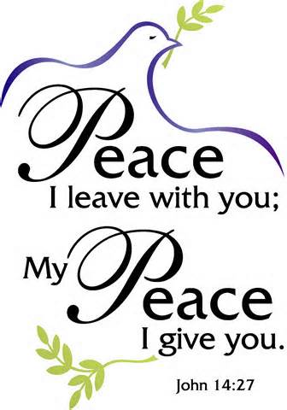

Mother’s Day
6th Sunday of Easter
May 10th, 2015

Holy Communion, Setting 10
Evangelical Lutheran Worship (ELW) p. 203

Trinity Lutheran Church
Office Phone 776-4781, Fax 776-7888, Office Hours: Mon-8-11, Wed 8-11 & 1-4, F-8-11 am

Email: trinitytruman@frontier.com, Website: www.trinity-truman.org
Interim Kent Krumwiede-Cell #: (507) 848-7192, Email: vicarkent@gmail.com
Office Hours Mon—Thurs 9:00-1:00 pm
GATHERING

Congregation reads bold print *Please stand

PRELUDE
GATHERING REFLECTION
This is the 101st official celebration of Mother’s Day. Ann Jarvis began the campaign to make this a recognized holiday in the United States in 1905. She did it to honor her mother. A mother, she said, is “the one person who has done more for you than anyone in the world.” Perhaps that is why some people think of mother as an image of God. Jean Janzen, in her hymn “Mothering God, You Gave Me Birth” [ELW # 735], describes God as the birther in creation…the source of breath…the rain, the wind, the sun…who nurtures and holds us close. This is the image of God in mothers that we recognize today. O Mothering God, bless our earthly mothers and give us new life every day. Amen.

BELL
WELCOME & ANNOUNCEMENTS
*CONFESSION & FORGIVENESS right column ELW p. 94
*GATHERING HYMN Beautiful Savior ELW #838
*HYMN OF PRAISE Now the Green Blade Rises ELW #379
* PRAYER OF THE DAY: L: O God,
C: you have prepared for those who love you joys beyond understanding. Pour into our hearts such love for you that, loving you above all things, we may obtain your promises, which exceed all we can desire; through Jesus Christ, your Son and our Lord, who lives and reigns with you and the Holy Spirit, one God, now and forever. Amen.
WORD


FIRST READING Acts 10:44-48 (NRSV)
Gentiles Receive the Holy Spirit
⁴⁴ While Peter was still speaking, the Holy Spirit fell upon all who heard the word. ⁴⁵ The circumcised believers who had come with Peter were astounded that the gift of the Holy Spirit had been poured out even on the Gentiles, ⁴⁶ for they heard them speaking in tongues and extolling God. Then Peter said, ⁴⁷ “Can anyone withhold the water for baptizing these people who have received the Holy Spirit just as we have?” ⁴⁸ So he ordered them to be baptized in the name of Jesus Christ. Then they invited him to stay for several days.

Word of God, Word of Life. C: Thanks be to God.

PSALM 98 (the psalms begin on ELW p. 338, assembly reads the indented lines)

SECOND READING 1 John 5:1-6 (NRSV)
Everyone who believes that Jesus is the Christ has been born of God, and everyone who loves the parent loves the child. ² By this we know that we love the children of God, when we love God and obey his commandments. ³ For the love of God is this, that we obey his commandments. And his commandments are not burdensome, ⁴ for whatever is born of God conquers the world. And this is the victory that conquers the world, our faith. ⁵ Who is it that conquers the world but the one who believes that Jesus is the Son of God? ⁶ This is the one who came by water and blood, Jesus Christ, not with the water only but with the water and the blood. And the Spirit is the one that testifies, for the Spirit is the truth.

Word of God, Word of Life. C: Thanks be to God.

* GOSPEL ACCLAMATION Lord, Let My Heart Be Good Soil ELW #512

*GOSPEL John 15:9-17 C: Glory to you O Lord.
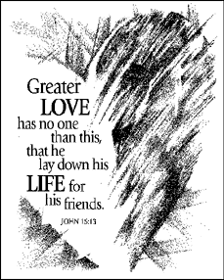
⁹ As the Father has loved me, so I have loved you; abide in my love. ¹⁰ If you keep my commandments, you will abide in my love, just as I have kept my Father’s commandments and abide in his love. ¹¹ I have said these things to you so that my joy may be in you, and that your joy may be complete. ¹² “This is my commandment, that you love one another as I have loved you. ¹³ No one has greater love than this, to lay down one’s life for one’s friends. ¹⁴ You are my friends if you do what I command you. ¹⁵ I do not call you servants any longer, because the servant does not know what the master is doing; but I have called you friends, because I have made known to you everything that I have heard from my Father. ¹⁶ You did not choose me but I chose you. And I appointed you to go and bear fruit, fruit that will last, so that the Father will give you whatever you ask him in my name. ¹⁷ I am giving you these commands so that you may love one another.

Word of God, Word of Life. C: Praise to you, O Christ.

CHILDREN’S SERMON

SERMON
*HYMN OF THE DAY Thine is the Glory ELW # 376
*NICENE CREED purple sheet in back cover of the hymnal
OFFERING
*OFFERTORY HYMN Faith of our Fathers (vs 2 & 4) ELW #813
* PRAYERS OF INTERCESSION L: Lord in your mercy, C: hear our prayer.
SHARING OF THE PEACE
L: The peace of the Lord be with you. C: And also with you.

THANKSGIVING

*THE GREAT THANKSGIVING ELW p. 206
*PREFACE & RESPONSE L: It is our duty and our joy…evermore praising you and singing…Holy, Holy, Holy ELW p. 207
*WORDS OF INSTITUTION
*THE LORD’S PRAYER ELW p. 208
DISTRIBUTION All who believe Jesus is Savior and Lord are invited to receive Christ’s meal.
L: Come for all is ready. Christ has prepared this meal for you. Amen.
COMMUNION HYMN O Lamb of God ELW p. 208
POST-COMMUNION PRAYER
SENDING

*BLESSING L: The Lord bless and keep you.
The Lord make his face shine on you and be gracious to you.
The Lord look on you with favor and give you peace.
In the name of the Father, and the Son and the Holy Spirit.
C: Three-Fold Amen.

*SENDING HYMN When Peace Like a River ELW #785
*BELL/SENDING L: Go in peace. Love one another and serve the Lord. C: Thanks be to God!
POSTLUDE
++++++++++++++++++++++++++++++++++++++++++++++++++++++++++++++++
Reprinted from Evangelical Lutheran Worship, copyright © 2006 Augsburg Fortress. All rights reserved. Used by permission of
Augsburg Fortress license #SB107041

Mothers are the way God chose to continue to create life. ~Anonymous

Readings for next Sunday: Acts 1:15-17, 21-26; Psalm 1, 1 John 5:9-13; John 17:6-19

We remember in our prayers…all who face catastrophic illness, surgery, and bindings of all kinds as well as the homebound: Bea Behrens, Vi Benoy, Agnes Carlson, Lisa Carlson & family, Donna Fisk, Danny Lang, and Darrell & Janice Buhmann, Jeff & LeAnn Maloney Family. Be present with your Spirit, Lord, and lead us to be your presence to all. Amen.
TODAY: HAPPY MOTHER’S DAY! Moms are invited to stay after for a special pampering from the Sunday school.

THIS WEEK IN OUR PARISH

MONDAY MAY 11-WELCA Meeting at 1:30 pm. Martha Circle serves
WEDNESDAY, MAY 13-Choir Practice at 6 pm
Church Council meeting at 7 pm
SATURDAY, MAY 16

Open House Reception/Shower will be in honor of
Mr. & Mrs. Shaun Miller
on Saturday, May 16th
from 2-4 pm in the fellowship hall
at Trinity Lutheran.

The couple is registered at JC Penny, Kohl’s, Target and Wal-Mart. Shaun & Yaneth were married on Thursday, October 16, 2014 at Canton Lutheran Church in Canton, South Dakota with Pastor Tim Thies officiating. Shaun is the son of Eloise Miller and grandson to Agnes Carlson
SUNDAY, MAY 17
9 AM Communion Worship-Teacher Appreciation
10 AM Sunday School-LAST DAY
The Sunday school will be giving their money donations for the year to the Humane Society. Feel free to bring extra items to share—cat & dog food, cat litter, blankets, pillows, or anything else you can add!
Reader: Zach Hansen, Comm. Server: Donna Kotewa, Acolyte: TBA
Ushers: *Gary Meyer, Mike Wiederhoeft, Darrell Buhmann and Dennis Rode

Come & Go
Bridal Shower
in honor of Amber Davis,
on May 17th
at Trinity Lutheran Church, Truman
from 2-4 pm

The couple is registered at Kohls and Target. Amber is bride to be of Taylor Menke, and their wedding will be held on June 20th at The Flying Goose Campground in rural Fairmont.
UPCOMING EVENTS

CREST Alzheimer’s Education—The volunteer caregivers organization “CREST” and Lakeview United Methodist Health Services are sponsoring an Alzheimer’s Education program on Thursday, May 14th at 1:30pm & 7:00pm in the chapel at the Lakeview Methodist Health Care Center in Fairmont.


Our Deepest Sympathy to the Jeff Maloney family on the death of Jeff’s father, Darrel who passed away on Thursday, May 7th.

Heartfelt Sympathy to Darrell & Janice Buhmann on the death of their daughter, Roxann Engel who passed away on Friday, May 8th.
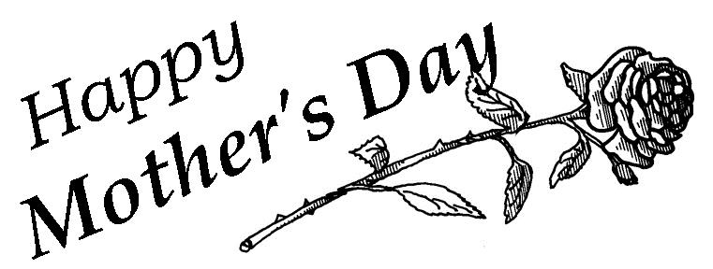

REMEMBER YOUR MOTHER
Whoever you are, wherever you are, on Mother’s Day, remember your mother. Without her and your father, you would only have been a dream and a hope, never a reality. No wonder God gave us the commandment: “Honor your father and your mother ...” (Exodus 20:12, nrsv). God gave us life through them.
—Charles Ferrell
BREAKFAST IN BED

Two children ordered their mother to stay in bed one Mother’s Day morning. As she lay there looking forward to being brought breakfast in bed, the smell of bacon floated up from the kitchen. Finally, the children called her to come downstairs. She found them both sitting at the table eating bacon and eggs. “As a surprise for Mother’s Day,” one explained, “we decided to cook our own breakfast.”

