

Family Relations
2nd Sunday after Pentecost
June 7th, 2015

Holy Communion, Setting 4
Evangelical Lutheran Worship (ELW) p. 147

Trinity Lutheran Church
Office Phone 776-4781, Fax 776-7888, Office Hours: Mon-8-11, Wed 8-11 & 1-4, F-8-11 am

Email: trinitytruman@frontier.com, Website: www.trinity-truman.org
Interim Kent Krumwiede-Cell #: (507) 848-7192, Email: vicarkent@gmail.com
Office Hours Mon—Thurs 9:00-1:00 pm

GATHERING

Congregation reads bold print *Please stand

PRELUDE
GATHERING REFLECTION
Commandments 4th – 6th - Life with Intimate Connections
As we continue our journey of review of Luther’s Small Catchism, we turn to Commandments 4, 5, & 6. These have to do with those with whom we share an intimate relationship. In Luther’s day, and even still today, this family community would have been the extended family of mom, dad, sister, brother, grandpa & grandma, maybe even aunts and/or uncles. Let’s not forget husband and wife. Last we reflected on Table One and our relationship with God, this week it is about Table Two, part one. To have proper relationships with family, we need to first have a proper relationship with God and abide by it. When our relationship with God is splintered or severed, then so is our relationship with our family members. God our Father, strengthen our reverence, love and trust in you so we might also have better relationships with the members of our family. Amen.

BELL
WELCOME & ANNOUNCEMENTS
*CONFESSION & FORGIVENESS left column ELW p. 94
*GATHERING HYMN Holy, Holy, Holy, Lord God Almighty ELW # 413
*GREETING
*KYRIE ELW p. 147
*HYMN OF PRAISE “This is the feast of victory for our God…” ELW p. 149 * PRAYER OF THE DAY: L: The Lord be with you. C: And also with you.
L: We pray together Silence All-powerful God,
C: In Jesus Christ you turned death into life and defeat into victory. Increase our faith and trust in him, that we may triumph over all evil in the strength of the same Jesus Christ, our Savior and Lord. Amen.
WORD

FIRST READING Genesis 3:8-15 (NRSV)

They heard the sound of the Lord God walking in the garden at the time of the evening breeze, and the man and his wife hid themselves from the presence of the Lord God among the trees of the garden. ⁹ But the Lord God called to the man, and said to him, “Where are you?” ¹⁰ He said, “I heard the sound of you in the garden, and I was afraid, because I was naked; and I hid myself.” ¹¹ He said, “Who told you that you were naked? Have you eaten from the tree of which I commanded you not to eat?” ¹² The man said, “The woman whom you gave to be with me, she gave me fruit from the tree, and I ate.” ¹³ Then the Lord God said to the woman, “What is this that you have done?” The woman said, “The serpent tricked me, and I ate.” ¹⁴ The Lord God said to the serpent, “Because you have done this, cursed are you among all animals and among all wild creatures; upon your belly you shall go, and dust you shall eat all the days of your life. ¹⁵ I will put enmity between you and the woman, and between your offspring and hers; he will strike your head, and you will strike his heel.”

Word of God, Word of Life. C: Thanks be to God.

PSALM 130 (the psalms begin on ELW p. 338, assembly reads the indented lines)


SECOND READING 2 Corinthians 4:13-5:1 (NRSV)
¹³ But just as we have the same spirit of faith that is in accordance with scripture—“I believed, and so I spoke”—we also believe, and so we speak, ¹⁴ because we know that the one who raised the Lord Jesus will raise us also with Jesus, and will bring us with you into his presence. ¹⁵ Yes, everything is for your sake, so that grace, as it extends to more and more people, may increase thanksgiving, to the glory of God. Living by Faith ¹⁶ So we do not lose heart. Even though our outer nature is wasting away, our inner nature is being renewed day by day. ¹⁷ For this slight momentary affliction is preparing us for an eternal weight of glory beyond all measure, ¹⁸ because we look not at what can be seen but at what cannot be seen; for what can be seen is temporary, but what cannot be seen is eternal. 5 For we know that if the earthly tent we live in is destroyed, we have a building from God, a house not made with hands, eternal in the heavens.

Word of God, Word of Life. C: Thanks be to God.

* GOSPEL ACCLAMATION Lord, Let My Heart Be Good Soil ELW #512

*GOSPEL Mark 3:20-35 C: Glory to you O Lord.
and the crowd came together again, so that they could not even eat. ²¹ When his family heard it, they went out to restrain him, for people were saying, “He has gone out of his mind.” ²² And the scribes who came down from Jerusalem said, “He has Beelzebul, and by the ruler of the demons he casts out demons.” ²³ And he called them to him, and spoke to them in parables, “How can Satan cast out Satan? ²⁴ If a kingdom is divided against itself, that kingdom cannot stand. ²⁵ And if a house is divided against itself, that house will not be able to stand. ²⁶ And if Satan has risen up against himself and is divided, he cannot stand, but his end has come. ²⁷ But no one can enter a strong man’s house and plunder his property without first tying up the strong man; then indeed the house can be plundered. ²⁸ “Truly I tell you, people will be forgiven for their sins and whatever blasphemies they utter; ²⁹ but whoever blasphemes against the Holy Spirit can never have forgiveness, but is guilty of an eternal sin”— ³⁰ for they had said, “He has an unclean spirit.” ³¹ Then his mother and his brothers came; and standing outside, they sent to him and called him. ³² A crowd was sitting around him; and they said to him, “Your mother and your brothers and sisters are outside, asking for you.” ³³ And he replied, “Who are my mother and my brothers?” ³⁴ And looking at those who sat around him, he said, “Here are my mother and my brothers! ³⁵ Whoever does the will of God is my brother and sister and mother.”

Word of God, Word of Life. C: Praise to you, O Christ.

CHILDREN’S SERMON

SERMON
*HYMN OF THE DAY Children of the Heavenly Father ELW # 781
*APOSTLES’ CREED Found in the back cover of the hymnal, SALMON sheet
OFFERING
*OFFERTORY HYMN Create in Me a Clean Heart ELW# 188
*OFFERING PRAYER
*PRAYERS OF INTERCESSION L: Lord, in your mercy C: Hear our prayer.
SHARING OF THE PEACE
L: The peace of the Lord be with you always. C: And also with you.

THANKSGIVING
*THE GREAT THANKSGIVING ELW p. 152
*PREFACE & RESPONSE
Holy, Holy, Holy Lord ELW p. 153
*THE LORD’S PRAYER ELW p. 154
*THE WORDS OF INSTITUTION
*THE INVITATION
All are welcome to join us at the altar to receive the body and blood of our risen Lord.
Lamb of God ELW p. 154
POST-COMMUNION PRAYERC: Amen.

SENDING

*BLESSING Almighty God, Father, + Son and Holy Spirit, bless you now and forever.
Three-Fold Amen.
*SENDING HYMN On Our Way Rejoicing ELW # 537
*BELL/SENDING L: Go in peace. Serve the Lord C: Thanks be to God!
POSTLUDE
++++++++++++++++++++++++++++++++++++++++++++++++++++++++++++++++
Reprinted from Evangelical Lutheran Worship, copyright © 2006 Augsburg Fortress. All rights reserved. Used by permission of
Augsburg Fortress license #SB107041

You don't choose your family. They are God's gift to you, as you are to them.
~ Desmond Tutu

Readings for next Sunday: Ezek 17:22-24; Ps 92:1-4, 12-15; 2 Cor 5:6-10, 14-17; Mark 4:26-34

We remember in our prayers…all who face catastrophic illness, surgery, and bindings of all kinds as well as the homebound: Bea Behrens, Vi Benoy, Agnes Carlson, Lisa Carlson & family, Donna Fisk, Danny Lang, and Delores (Didi) Strehlo. . Be present with your Spirit, Lord, and lead us to be your presence to all. Amen.



Please keep up with your pledged giving.
We have had a deficit lately.

THIS WEEK IN OUR PARISH


MONDAY JUNE 8-
TRUMAN BLOOD DRIVE at the Truman Community Center on Monday, June 8th from 1-7 pm. To schedule your appt. call Yvonne at 776-8555 or online @ www.redcrossblood.org, enter code: TRUMANMN. We NEED donations of cookies for the blood drive! (About 11 doz.)
WEDNESDAY, JUNE 10-Church Council Meeting 7 pm
THURSDAY, JUNE 11-South African Bishop Visits Waverly
A meet and greet, Thursday evening at Waverly, rural Trimont with Bishop Buthelezi, our partner bishop from South Africa. This is our opportunity to meet with him. Waverly is providing the meal so please notify Rebecca Sullivan (507 380 6180) if you plan on coming so that we have an accurate count for food. We hope to have him there by 5:30... so plan on arriving around then... meal at 6PM.
SUNDAY, JUNE 14
9 AM Communion Worship
Reader: Jerry Teig, Comm. Server: Margaret Durkee
Ushers: *Dean Gulbranson, Doug Mammenga, Tanner Mammenga and Jerome Wille

UPCOMING EVENTS
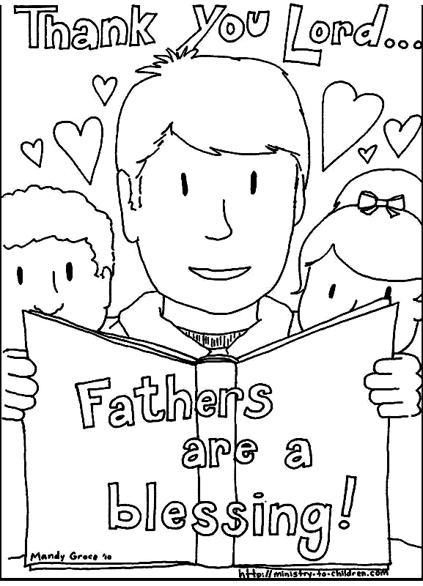

On June 14, bring to church a photo of your dad and they will be displayed in the social hall at coffee time. We will have sheets to label with the names. Also, look for a mailing of a coloring sheet that children or grandchildren can bring on the 14th. Those who bring it to church will receive a treat.

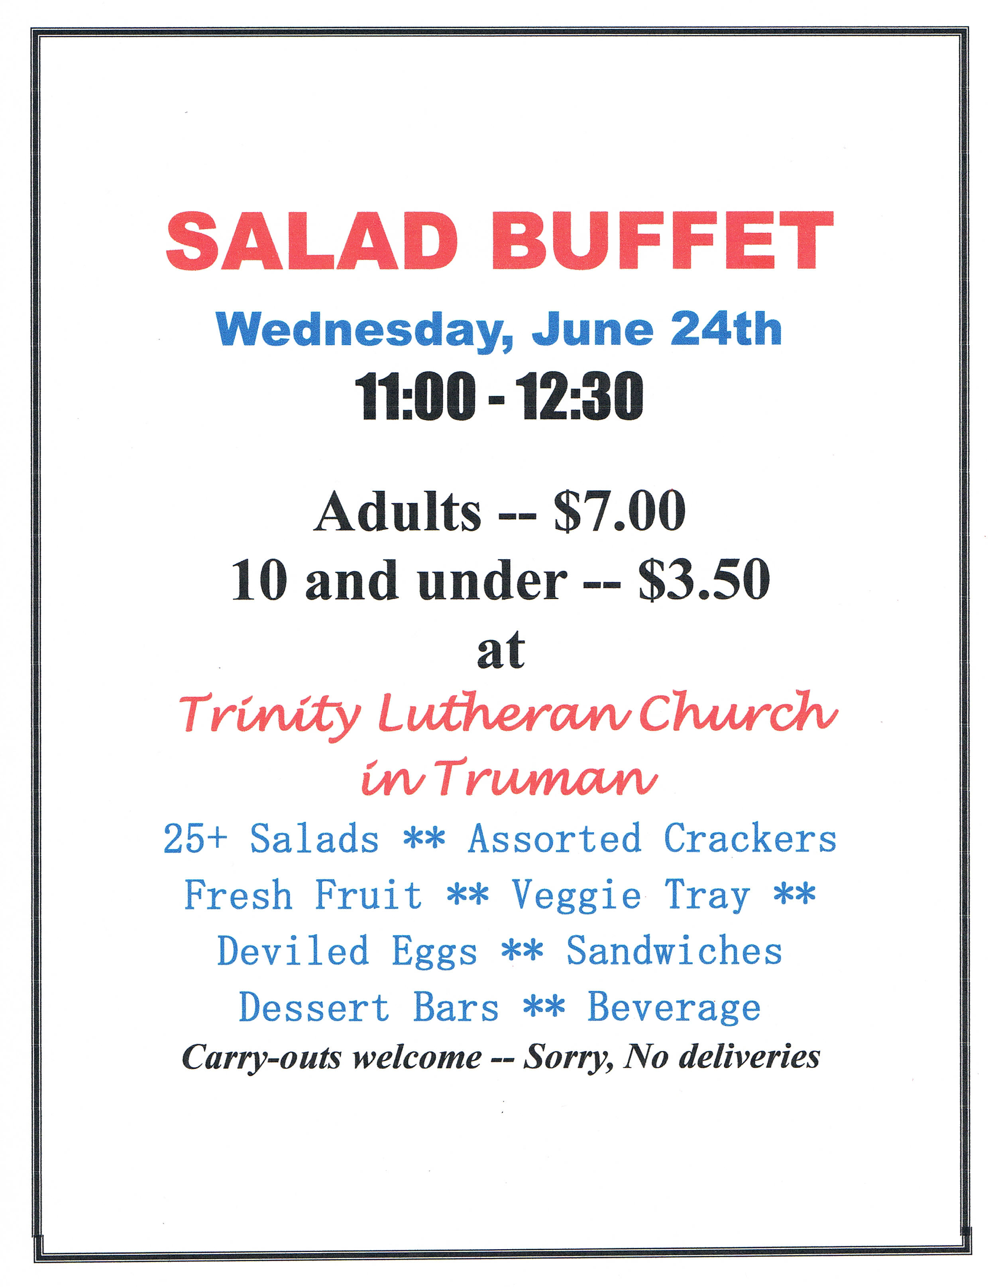

Sign-up sheets are on the table in the Narthex of the church for you to sign up for furnishing salads, money, or other needed food supplies. Every family is asked to donate.

