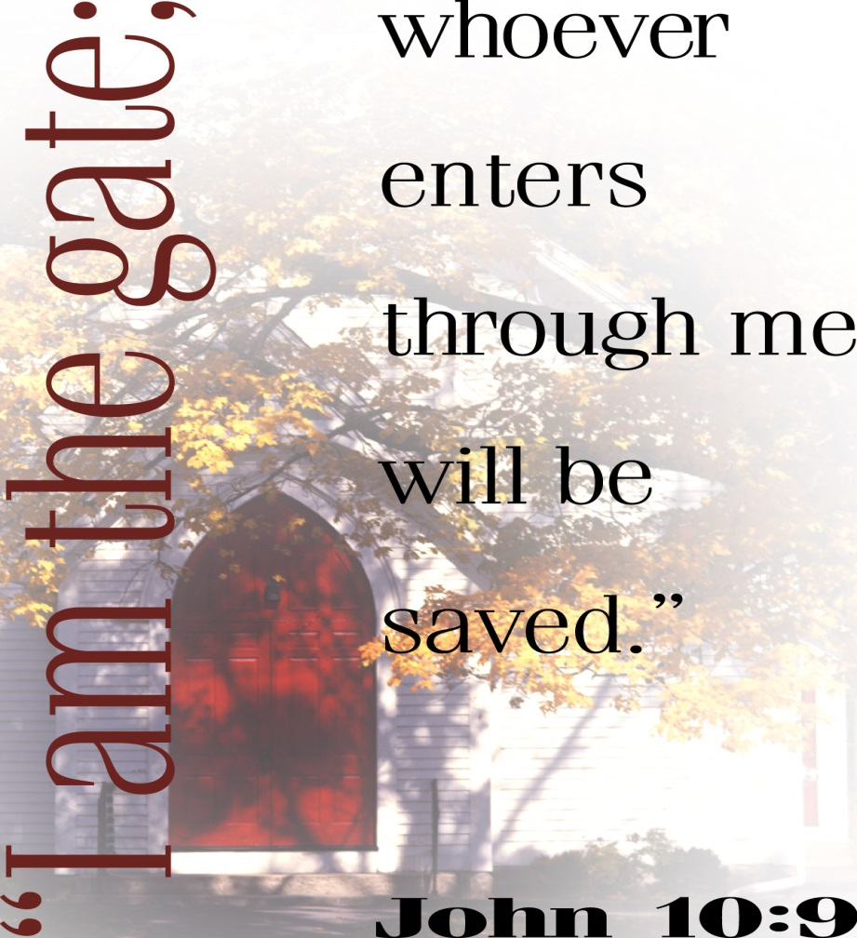

3rd Sunday after Pentecost
June 5, 2016

Evangelical Lutheran Worship, Setting 10

Trinity Lutheran Church

Office Phone 776-4781, Fax 776-7888, Sumer Office Hours: Mon, Wed & Fri. 7:00-11:00 am
Email: trinitytruman@frontier.com, Website: www.trinity-truman.org
Pastor Krista Strum-Cell-(507)995-1233, Email: pkstrumom@me.com
Pastor Krista’s Hours: Wed. 8:30-3:00 pm & Thurs. 10:30-2:00 pm

GATHERING

Congregation reads bold print *Please stand

PRELUDE
BELL
ANNOUNCEMENTS

*CONFESSION AND FORGIVENESS—Prayer of Confession
Loving God,
We confess that we have sinned.
Even though we want to do what is right, we did not always succeed this week.
Not only did we fail to do what was right, but at times we consciously chose to think and act in ways we knew were wrong.
We are truly sorry, and we ask for your forgiveness.

WORDS OF ASSURANCE
Friends, hear this:
Through the life, death and resurrection of Jesus Christ, we have been set free from the power of sin! It no longer needs to control us. So be at peace: your sins are forgiven!
Go out, and live in the light of Christ.
Thanks be to God!

*GATHERING SONG Oh, for a Thousand Tongues to Sing ELW #886

*GREETING
The grace of our Lord Jesus Christ, the love of God, and the communion of the Holy Spirit be with you all. And also with you.

*KYRIE ELW p. 203
*CANTICLE OF PRAISE – (VERSE 3) ELW p. 204

* PRAYER OF THE DAY L: The Lord be with you. C: And also with you.
L: Let us pray,
Compassionate God, you have assured the human family of eternal life through Jesus Christ. Deliver us from the death of sin, and raise us to new life in your Son, Jesus Christ, our Savior and Lord.
Amen.
WORD

FIRST READING: Romans 1:7-17
7To all God's beloved in Rome, who are called to be saints: Grace to you and peace from God our Father and the Lord Jesus Christ. 8First, I thank my God through Jesus Christ for all of you, because your faith is proclaimed throughout the world. 9For God, whom I serve with my spirit by announcing the gospel of his Son, is my witness that without ceasing I remember you always in my prayers, 10asking that by God's will I may somehow at last succeed in coming to you. 11For I am longing to see you so that I may share with you some spiritual gift to strengthen you — 12or rather so that we may be mutually encouraged by each other's faith, both yours and mine. 13I want you to know, brothers and sisters, that I have often intended to come to you (but thus far have been prevented), in order that I may reap some harvest among you as I have among the rest of the Gentiles. 14I am a debtor both to Greeks and to barbarians, both to the wise and to the foolish 15— hence my eagerness to proclaim the gospel to you also who are in Rome. 16For I am not ashamed of the gospel; it is the power of God for salvation to everyone who has faith, to the Jew first and also to the Greek. 17For in it the righteousness of God is revealed through faith for faith; as it is written, "The one who is righteous will live by faith."

Word of God, word of life. Thanks be to God.

CHILDREN'S MESSAGE
*GOSPEL ACCLAMATION Alleluia! Lord and Savior… ELW p. 205

*GOSPEL John 10:1-21 C: Glory to you O Lord.
1Very truly, I tell you, anyone who does not enter the sheepfold by the gate but climbs in by another way is a thief and a bandit. 2The one who enters by the gate is the shepherd of the sheep. 3The gatekeeper opens the gate for him, and the sheep hear his voice. He calls his own sheep by name and leads them out. 4When he has brought out all his own, he goes ahead of them, and the sheep follow him because they know his voice. 5They will not follow a stranger, but they will run from him because they do not know the voice of strangers." 6Jesus used this figure of speech with them, but they did not understand what he was saying to them. 7So again Jesus said to them, "Very truly, I tell you, I am the gate for the sheep. 8All who came before me are thieves and bandits; but the sheep did not listen to them. 9I am the gate. Whoever enters by me will be saved, and will come in and go out and find pasture. 10The thief comes only to steal and kill and destroy. I came that they may have life, and have it abundantly. 11I am the good shepherd. The good shepherd lays down his life for the sheep. 12The hired hand, who is not the shepherd and does not own the sheep, sees the wolf coming and leaves the sheep and runs away — and the wolf snatches them and scatters them. 13The hired hand runs away because a hired hand does not care for the sheep. 14I am the good shepherd. I know my own and my own know me, 15just as the Father knows me and I know the Father. And I lay down my life for the sheep. 16I have other sheep that do not belong to this fold. I must bring them also, and they will listen to my voice. So there will be one flock, one shepherd. 17For this reason the Father loves me, because I lay down my life in order to take it up again. 18No one takes it from me, but I lay it down of my own accord. I have power to lay it down, and I have power to take it up again. I have received this command from my Father." 19Again the Jews were divided because of these words. 20Many of them were saying, "He has a demon and is out of his mind. Why listen to him?" 21Others were saying, "These are not the words of one who has a demon. Can a demon open the eyes of the blind?"

The gospel of the Lord. Praise to you, O Christ.

SERMON

*HYMN OF THE DAY My Hope Is Built on Nothing Less ELW #597

*CREED (SALMON sheet in the back of the red hymnal) or ELW p. 206
*PRAYERS OF THE PEOPLE
PEACE
The peace of Christ be with you always. And also with you.

MEAL
OFFERING
OFFERING SONG Let the Vineyards be fruitful Lord… ELW #184
OFFERING PRAYER
God of mercy and grace, the eyes of all wait upon you, and you open your hand in blessing.
Fill us with good things at your table, that we may come to the help of all in need,
through Jesus Christ, our redeemer and Lord. Amen.

GREAT THANKSGIVING
DIALOGUE
The Lord be with you.
And also with you.
Lift up your hearts.
We lift them to the Lord.
Let us give thanks to the Lord our God.
It is right to give our thanks and praise.

*PREFACE Holy, holy, holy Lord… ELW p. 207
*THANKSGIVING AT THE TABLE
*LORD’S PRAYER ELW p. 208
INVITATION TO COMMUNION Come to the banquet, for all is now ready.
COMMUNION ELW p. 208
Lamb of God
PRAYER AFTER COMMUNION
Let us pray.
Gracious God, in this meal you have drawn us to your heart, and nourished us at your table with food and drink, the body and blood of Christ. Now send us forth to be your people in the world, and to proclaim your truth this day and evermore, through Jesus Christ, our Savior and Lord. Amen.

*BLESSING
*SENDING SONG Go, My Children, with My Blessing ELW #543
*DISMISSAL
Go in peace. Serve the Lord.
Thanks be to God.

BELL/POSTLUE
+++++++++++++++++++++++++++++++++++++++++++++++++++++++++++++++++
Copyright © 2016 Augsburg Fortress. All rights reserved. Reprinted by permission under Augsburg Fortress Liturgies Annual License #SAS103469. New Revised Standard Version Bible, copyright © 1989, Division of Christian Education of the National Council of the Churches of Christ in the United States of America. Used by permission. All rights reserved.

Readings for next Sunday: The Sermon Series on the Book of Romans
We remember in our prayers…all who face catastrophic illness, surgery, and bindings of all kinds as well as the homebound: Bea Behrens, Lisa Carlson & family, Donna Fisk, and Danny Lang.
TODAY: Join us for coffee hour every Sunday in June before church from 9:00-10:15 am. In July & August coffee hour will be after services.

THIS WEEK IN OUR PARISH
MONDAY, JUNE 6-Martha Circle will be dining out at 1:30 pm

The Truman Blood Drive will be held on June 6th at the Truman Community Center from 1-7 pm. Contact Yvonne Noorlun for more information.
TUESDAY, JUNE 7-Mending at Truman Senior Living
WEDNESDAY, JUNE 8-Church Council Meeting in Madelia at 7 pm.
FRIDAY & SATURDAY JUNE 10 & 11-Synod Assembly in St. Peter
SUNDAY, JUNE 12
9:00-10:15 Coffee Hour
10:30 am Worship.
Reader: Dean Gulbranson, Comm. Server: Margaret Durkee,
Ushers: *Jerry Teig, Darrell Buhmann, Doyle Peterson, Howard Kautz

UPCOMING EVENTS

TRINITY’S ANNUAL SALAD LUNCHEON
Wednesday, July 29th
11:00-12:30 pm
Adults $7, Children- 10 & under $3.50

Trinity ladies & gentleman:
It is time to sign up to donate food or a monetary donation for the salad luncheon. They also need helpers to work or set up. The sign-up sheets are on the table in the narthex. This is a very good fundraiser for Trinity and we need all your help!!!

Unshakable faith
No one wishes for crises, but Christians who’ve endured them often speak of the faith benefits that result. Here are two examples:

Author and Bible teacher Nancy Guthrie, who lost two babies to a rare genetic disorder, writes: “Trusting God when the miracle does not come, when the urgent prayer gets no answer, when there is only darkness … this is the kind of faith that cannot be shaken because it is the result of having been shaken” (Holding On to Hope, Tyndale).

Christian musician Danny Gokey, whose first wife died from congenital heart disease, writes: “Sometimes we don’t discover our purpose until the darkest moments strip us of everything and all we are left with is brokenness and heartache. It is in these moments, ironically, when hope becomes our strength and carries us” (Hope in Front of Me, NavPress).

