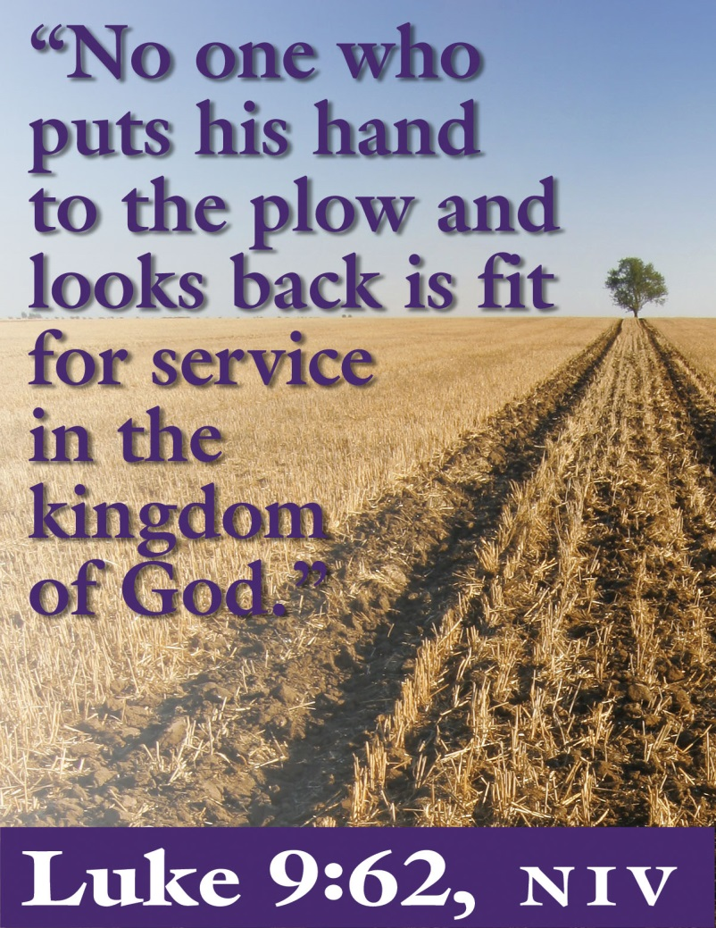

6th Sunday after Pentecost
June 26, 2016

Evangelical Lutheran Worship, Setting 10

Trinity Lutheran Church

Office Phone 776-4781, Fax 776-7888, Sumer Office Hours: Mon, Wed & Fri. 7:00-11:00 am
Email: trinitytruman@frontier.com, Website: www.trinity-truman.org
Pastor Krista Strum-Cell-(507)995-1233, Email: pkstrumom@me.com
Pastor Krista’s Summer Hours: Wed. 8:30-12:00 pm & Thurs. 8:30-12:00 pm
GATHERING

Congregation reads bold print *Please stand

PRELUDE
BELL
ANNOUNCEMENTS

*CONFESSION AND FORGIVENESS—Prayer of Confession
Loving God,
We confess that we have sinned.
Even though we want to do what is right, we did not always succeed this week.
Not only did we fail to do what was right, but at times we consciously chose to think and act in ways we knew were wrong.
We are truly sorry, and we ask for your forgiveness.

WORDS OF ASSURANCE
Friends, hear this:
Through the life, death and resurrection of Jesus Christ, we have been set free from the power of sin! It no longer needs to control us. So be at peace: your sins are forgiven!
Go out, and live in the light of Christ.
Thanks be to God!

*GATHERING SONG Lord, Take My Hand and Lead Me ELW #767
*GREETING
The grace of our Lord Jesus Christ, the love of God, and the communion of the Holy Spirit be with you all. And also with you.

*KYRIE ELW p. 203
*CANTICLE OF PRAISE – (VERSE 3) ELW p. 204
* PRAYER OF THE DAY L: The Lord be with you. C: And also with you.
L: Let us pray,
Sovereign God, ruler of all hearts, you call us to obey you, and you favor us with true freedom. Keep us faithful to the ways of your Son, that, leaving behind all that hinders us, we may steadfastly follow your paths, through Jesus Christ, our Savior and Lord.
Amen.

WORD

FIRST READING: 1 Kings 19:15-16, 19-21
Then the Lord said to [Elijah,] “Go, return on your way to the wilderness of Damascus;
when you arrive, you shall anoint Hazael as king over Aram. ¹⁶Also you shall anoint Jehu
son of Nimshi as king over Israel; and you shall anoint Elisha son of Shaphat of Abel-meholah as prophet in your place. ¹⁹So he set out from there, and found Elisha son of Shaphat, who was plowing. There were twelve yoke of oxen ahead of him, and he was with the twelfth. Elijah passed by him and threw his mantle over him. ²⁰He left the oxen, ran after Elijah, and said, “Let me kiss my father and my mother, and then I will follow you.” Then Elijah said to him, “Go back again; for what have I done to you?” ²¹He returned from following him, took the yoke of oxen, and slaughtered them; using the equipment from the oxen, he boiled their flesh, and gave it to the people, and they ate. Then he set out and followed Elijah, and became his servant.

Word of God, word of life. Thanks be to God.

Psalm: Psalm 16 (Please read responsively the bold print)

¹Protect me, O God, for I take refuge in you; I have said to the Lord, “You are my Lord,
my good above all other.”
²All my delight is in the godly that are in the land, upon those who are noble
among the people.

³But those who run after other gods shall have their troubles multiplied.
⁴I will not pour out drink offerings to such gods, never take their names upon
my lips.

⁵O Lord, you are my portion and my cup; it is you who up hold my lot.
⁶My boundaries enclose a pleasant land; indeed, I have a rich inheritance.

⁷I will bless the Lord who gives me counsel; my heart teaches me night after night.
⁸I have set the Lord always before me; because God is at my right hand, I shall
not be shaken.

⁹My heart, therefore, is glad, and my spirit rejoices; my body also shall rest in hope.
¹⁰For you will not abandon me to the grave, nor let your holy one see the pit.

¹¹You will show me the path of life; in your presence there is fullness of joy,
ALL: and in your right hand are pleasures forevermore.

SECOND READING: Galatians 5:1, 13-25
¹For freedom Christ has set us free. Stand firm, therefore, and do not submit again to a yoke of slavery. ¹³For you were called to freedom, brothers and sisters; only do not use your freedom as an opportunity for self-indulgence, but through love become slaves to one another. ¹⁴For the whole law is summed up in a single commandment, “You shall love your neighbor as yourself.” ¹⁵If, however, you bite and devour one another, take care that you are not consumed by one another. ¹⁶Live by the Spirit, I say, and do not gratify the desires of the flesh. ¹⁷For what the flesh desires is opposed to the Spirit, and what the Spirit desires is opposed to the flesh; for these are opposed to each other, to prevent you from doing what you want. ¹⁸But if you are led by the Spirit, you are not subject to the law. ¹⁹Now the works of the flesh are obvious: fornication, impurity, licentiousness, ²⁰idolatry, sorcery, enmities, strife, jealousy, anger, quarrels, dissensions, factions, ²¹envy, drunkenness, carousing, and things like these. I am warning you, as I warned you before: those who do such things will not inherit the kingdom of God. ²²By contrast, the fruit of the Spirit is love, joy, peace, patience, kindness, generosity, faithfulness, ²³gentleness, and self-control. There is no law against such things. ²⁴And those who belong to Christ Jesus have crucified the flesh with its passions and desires. ²⁵If we live by the Spirit, let us also be guided by the Spirit.

Word of God, word of life. Thanks be to God.

CHILDREN'S MESSAGE
*GOSPEL ACCLAMATION Alleluia! Lord and Savior… ELW p. 205

*GOSPEL: Luke 9:51-62 C: Glory to you O Lord.
⁵¹When the days drew near for [Jesus] to be taken up, he set his face to go to Jerusalem. ⁵²And he sent messengers ahead of him. On their way they entered a village of the Samaritans to make ready for him; ⁵³but they did not receive him, because his face was set toward Jerusalem. ⁵⁴When his disciples James and John saw it, they said, “Lord, do you want us to command fire to come down from heaven and consume them?” ⁵⁵But he turned and rebuked them. ⁵⁶Then they went on to another village. ⁵⁷As they were going along the road, someone said to him, “I will follow you wherever you go.” ⁵⁸And Jesus said to him, “Foxes have holes, and birds of the air have nests; but the Son of Man has nowhere to lay his head.” ⁵⁹To another he said, “Follow me.” But he said, “Lord, first let me go and bury my father.” ⁶⁰But Jesus said to him, “Let the dead bury their own dead; but as for you, go and proclaim the kingdom of God.” ⁶¹Another said, “I will follow you, Lord; but let me first say farewell to those at my home.” ⁶²Jesus said to him, “No one who puts a hand to the plow and looks back is fit for the kingdom of God.”

The gospel of the Lord. Praise to you, O Christ.

SERMON
*HYMN OF THE DAY Day by Day ELW #790
*CREED (SALMON sheet in the back of the red hymnal) or ELW p. 206
*PRAYERS OF THE PEOPLE

PEACE
The peace of Christ be with you always. And also with you.
OFFERING
OFFERING SONG Create in Me ELW #188
OFFERING PRAYER
God of mercy and grace, the eyes of all wait upon you, and you open your hand in blessing.
Fill us with good things at your table, that we may come to the help of all in need,
through Jesus Christ, our redeemer and Lord. Amen.

*LORD’S PRAYER ELW p. 208
*BLESSING
*SENDING SONG Be Thou My Vision ELW #793
*DISMISSAL
Go in peace. Serve the Lord. Thanks be to God.

BELL/POSTLUE
+++++++++++++++++++++++++++++++++++++++++++++++++++++++++++++++++
Copyright © 2016 Augsburg Fortress. All rights reserved. Reprinted by permission under Augsburg Fortress Liturgies Annual License #SAS103469. New Revised Standard Version Bible, copyright © 1989, Division of Christian Education of the National Council of the Churches of Christ in the United States of America. Used by permission. All rights reserved.

Readings for next Sunday: The Sermon Series on the Book of Romans
We remember in our prayers…all who face catastrophic illness, surgery, and bindings of all kinds as well as the homebound: Bea Behrens, Lisa Carlson & family, and Danny Lang.

HELP IS NEEDED…A Trinity family needs help with food items but there is also need for paper products like paper plates, toilet paper, paper towels, garbage bags etc. (Baked items would also be a BIG treat). There are two boxes in the front hall for your donations.

TODAY: Welcome! Our guest leader today, Calvin Hanson, from Madelia MN.
In July & August the coffee hours will be after worship services.

ATTENTION…Inventory Reduction Sale
½ price—Fruit Bars 50¢, Tea box--$1.50

No price reductions on coffee, but we have packages of coffee (whole bean) that are free!!!! See Connie Selnes
FAMILY MISSION TRIP—Will take place today, June 26 thru June 29 in Madison, WI. Please Bless Pastor Krista and all the families from Trinity who will be attending.

THIS WEEK IN OUR PARISH

MONDAY, JUNE 27- 9 AM Messenger Assembly
WEDNESDAY, JUNE 29-
TRINITY’S ANNUAL
SALAD LUNCHEON
Wednesday, June 29th
11:00-12:30 pm
Adults $7, Children- 10 & under $3.50

1:45 AM Bingo will be held at the Truman Senior Living Center
SUNDAY, JULY 3 ATTENTION!...Beginning July 3rd, Trinity’s Worship time will be at 8:45 am. This will be in effect for a full year.
8:45 AM WORSHIP
Coffee Hour will be held after worship
Reader: Marilyn Duncanson, Comm. Server: Dave Sorenson
Ushers: *Clayton Duncanson, Wayne Maloney, Terry Pettersen and Ross Ringeisen
FOR YOUR INFORMATION

The ladies of St. Paul’s Lutheran Church in Truman invite you to a “Salad Luncheon” including “New” this year “Walking Taco Bar” aka—“Taco in a Bag” to be held on Wednesday, July 13th, 2016 in the basement of the church from 11 am to 12:30 pm.

Men and Women are invited, the cost for adults is $8.00. Take-out containers will be available.

MARK YOUR CALENDARS!..TRINITY’S VBS WILL BE HELD AUGUST 21-24TH—More information to come

