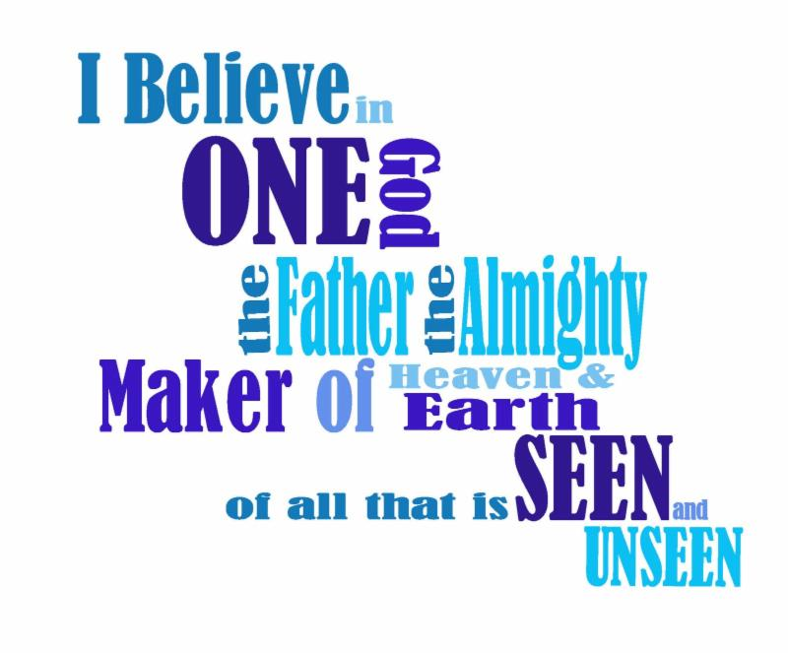

***God as Creator & Sustainer***

**4th Sunday after Pentecost**

**June 21st, 2015- Father’s Day**

**Service of the Word and Prayer**

**Evangelical Lutheran Worship, ELW p. 211**

**Trinity Lutheran Church**

Office Phone 776-4781, Fax 776-7888, Summer Office Hours: Mon, Wed & Fri-7-11 am

 Email: [trinitytruman@frontier.com](mailto:trinitytruman@frontier.com), Website: [www.trinity-truman.org](http://www.trinity-truman.org)

**Interim Kent Krumwiede-**Cell #: (507) 848-7192, Email: vicarkent@gmail.com

Office Hours Mon—Thurs 9:00-1:00 pm **GATHERING**

*Congregation reads* ***bold print*** *\*Please stand*

**PRELUDE**

**GATHERING REFLECTION**

**The Apostles’ Creed, First Article – *God the Father, Creator/Sustainer*** *– We now move to part two of our sermon series on Luther’s Small Catechism. Don’t you wish confirmati on had actually went this fast? But after all, we are only reviewing what you already know, right? So here we come to an artifact of faith, the confession of the faith of the church in the words of The Apostles’ Creed. Credo – “I believe…” With one simple one, our early church fathers handed down to our fathers and mothers the basics of the Christian faith. And those simple words in turn have been passed down to us by our fathers and mothers.* **God our Father in heaven, we give thanks for our fathers on earth and for the faith they have shown and taught to us. Amen.**

**BELL**

**WELCOME & ANNOUNCEMENTS**

**\*CONFESSION & FORGIVENESS (*left column)* ELW p. 211**

**\*GATHERING HYMN *Praise to the Lord, the almighty* ELW #858**

**\*GRETING ELW p. 213**

**\*KYRIE**

**\*HYMN OF PRAISE *Glory to God***

**\*PRAYER OF THE DAY** L: The Lord be with you. **C: And also with you.**

L: Let us pray. *Silence* O God of creation, eternal majesty,

C: **you preside over land and sea, sunshine and storm. By your strength pilot us, by your power preserve us, by your wisdom instruct us, and by your hand protect us, through Jesus Christ, our Savior and Lord. Amen.**

**WORD**

**FIRST READING Job 38:1-11 (NRSV)**

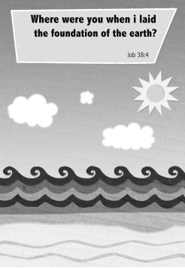**The Lord Answers Job**

Then the Lord answered Job out of the whirlwind: 2“Who is this that darkens counsel by words without knowledge? 3Gird up your loins like a man, I will question you, and you shall declare to me. 4“Where were you when I laid the foundation of the earth? Tell me, if you have understanding. 5Who determined its measurements—surely you know! Or who stretched the line upon it? 6On what were its bases sunk, or who laid its cornerstone 7when the morning stars sang together and all the heavenly beings shouted for joy? 8“Or who shut in the sea with doors when it burst out from the womb?—9when I made the clouds its garment, and thick darkness its swaddling band, 10and prescribed bounds for it, and set bars and doors, 11and said, ‘Thus far shall you come, and no farther, and here shall your proud waves be stopped’?

Word of God, Word of Life. **C: Thanks be to God.**

**PSALM**  *The psalm readings are in the front part of the hymnal, page 339*  **Psalm 107:1-3, 23-32**

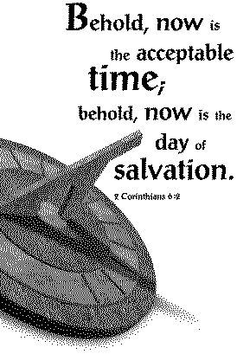**SECOND READING 2 Corinthians 6:1-13 (NRSV)**

As we work together with him, we urge you also not to accept the grace of God in vain. 2For he says, “At an acceptable time I have listened to you, and on a day of salvation I have helped you.” See, now is the acceptable time; see, now is the day of salvation! 3We are putting no obstacle in anyone’s way, so that no fault may be found with our ministry, 4but as servants of God we have commended ourselves in every way: through great endurance, in afflictions, hardships, calamities, 5beatings, imprisonments, riots, labors, sleepless nights, hunger; 6by purity, knowledge, patience, kindness, holiness of spirit, genuine love, 7truthful speech, and the power of God; with the weapons of righteousness for the right hand and for the left; 8in honor and dishonor, in ill repute and good repute. We are treated as impostors, and yet are true; 9as unknown, and yet are well known; as dying, and see—we are alive; as punished, and yet not killed; 10as sorrowful, yet always rejoicing; as poor, yet making many rich; as having nothing, and yet possessing everything. 11We have spoken frankly to you Corinthians; our heart is wide open to you. 12There is no restriction in our affections, but only in yours. 13In return—I speak as to children—open wide your hearts also.

Word of God, Word of Life. **C: Thanks be to God.**

**\*GOSPEL ACCLAMATION** *Lord, Let My Heart Be Good Soil* **ELW # 512**

\***GOSPEL: Mark 4:35-41 C: Glory to you O Lord.**

**Jesus Stills a Storm**

On that day, when evening had come, he said to them, “Let us go across to the other side.” 36And leaving the crowd behind, they took him with them in the boat, just as he was. Other boats were with him. 37A great windstorm arose, and the waves beat into the boat, so that the boat was already being swamped. 38But he was in the stern, asleep on the cushion; and they woke him up and said to him, “Teacher, do you not care that we are perishing?” 39He woke up and rebuked the wind, and said to the sea, “Peace! Be still!” Then the wind ceased, and there was a dead calm. 40He said to them, “Why are you afraid? Have you still no faith?” 41And they were filled with great awe and said to one another, “Who then is this, that even the wind and the sea obey him?”

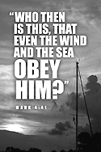

Word of God, Word of Life. **C: Praise to you, O Christ.**

CHILDREN’S SERMON

SERMON

* **HYMN OF THE DAY**  *How Great Thou Art* **ELW #856**

**\*APOSTLES’ CREED** *(salmon sheet on the back cover of the hymnal)*

**OFFERING**

**\*OFFERING HYMN** *Create in Me a Clean Heart***ELW# 188**

**\*OFFERING PRAYER**

**\* PRAYERS OF INTERCESSION** Hear us, O God, **C: Your mercy is great.**

**\*THANKSGIVING FOR THE WORD ELW p. 220,** *gray shaded*

**THE LORD’S PRAYER** *Sung (as found in the back cover of the hymnal, SALMON sheet)*

**SHARING OF THE PEACE** L: The peace of the Lord be with you always.

**C: And also with you.**

**SENDING**

**BLESSING** Almighty God, Father, + Son and Holy Spirit, bless you now and forever.

***Three-Fold Amen.***

**\*SENDING HYMN** *Faith of Our Fathers* **ELW #812**

**BELL SENDING** L: Go in peace. Serve the Lord. **C: Thanks be to God!**

**POSTLUDE +++++++++++++++++++++++++++++++++++++++++++++++++++++++++++++++++**Reprinted from Evangelical Lutheran Worship, copyright © 2006 Augsburg Fortress. All rights reserved. Used by permission of Augsburg Fortress license #SB107041

*There is a God shaped vacuum in the heart of every man which cannot be filled by any created thing, but only by God, the Creator, made known through Jesus.* ~**Blaise Pascal**

**Readings for next Sunday: Lamentations 3:22-33; Ps 30; 2 Cor 8:7-15; Mark 5:21-43**

***God – Jesus, God/Man, Redeemer & Savior***

*Prayer requests*

*We remember in our prayers…all who face catastrophic illness, surgery, and bindings of all kinds as well as the homebound:* ***Bea Behrens, Vi Benoy, Agnes Carlson, Lisa******Carlson & family, Donna Fisk, Danny Lang, and Deloris (Dede) Strehlo.*** *Be present with your Spirit, Lord, and lead us to be your presence to all. Amen.*



Please keep up with your pledged giving. We have had a deficit lately.

**Financial Status-Update for May:** May collections- $5,424

May expenses- $6,721

**May shortage- $1,302**



**TODAY: HAPPY FATHER’S DAY!**

The Sunday School kids and their Fathers (*or someone the kids would like to spend time with*) are invited after worship to come have donuts. See all the pictures and color drawings the kids have made of their fathers.

**THIS WEEK IN OUR PARISH**

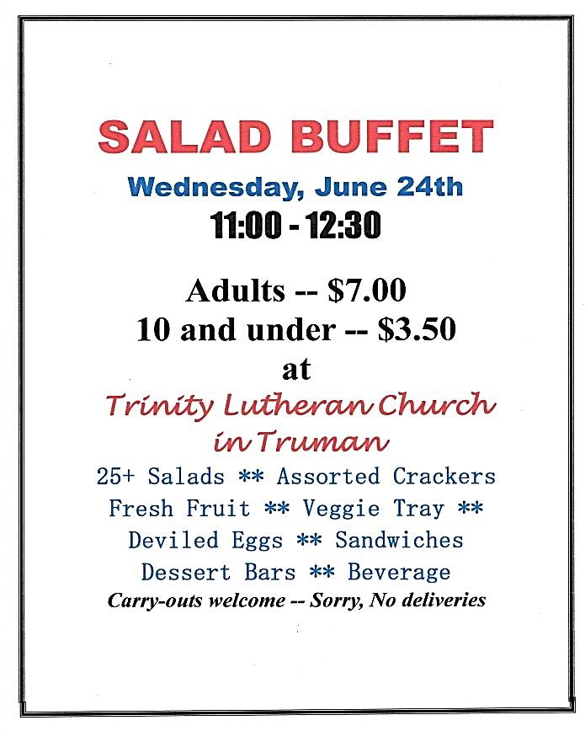

**WEDNESDAY, JUNE 24**

Sign-up sheets are on the table in the narthex, we need every family to help out either with a donation of a food item, or a monetary donation.

Please consider coming to the salad luncheon. Bring a friend and enjoy the many different salads, sandwiches and bars.

Take outs are available.

**SUNDAY, JUNE 28-Worship at 9 AM**

*Reader: Lisa Krumwiede*

*Ushers: *Dean Gulbranson, Doug Mammenga, Tanner Mammenga and Jerome Wille*

**Holy Humor**

**A father was approached by his small son who told him proudly, "I know what the Bible means!"  
His father smiled and replied, "What do you mean, you 'know' what the Bible means?  
The son replied, "I do know!"  
"Okay," said his father. "What does the Bible mean?"  
"That's easy, Daddy..." the young boy replied excitedly," It stands for 'Basic Information Before Leaving Earth.'

|  |
| --- |
| **What is a dad?** |
| A dad is someone who wants to  catch you before you fall  but instead picks you up, brushes you off,  and lets you try again.   A dad is someone who wants to  keep you from making mistakes  but instead lets you find your own way,  even though his heart breaks in silence when you get hurt.   A dad is someone who holds you when you cry,  scolds you when you break the rules,  shines with pride when you succeed,  and has faith in you even when you fail. |
| **Like father, like child** |
| As we celebrate Father’s Day, we likely see traits in our dads (or other father figures) that we hope to be known for ourselves: integrity, gentleness, a great sense of humor, a love of learning, and a humble spirit.  Amy Grant’s song “Father’s Eyes” tells of a young girl who wants nothing more than for others to recognize her father — and her heavenly Father — in her. “When people look inside my life, I want to hear them say, ‘She's got her father's eyes.’”  What characteristics of God your Father are reflected in your eyes, heart and life? And what godly qualities would you like to cultivate?  May others see our heavenly Father in us! |