

Community Relations
3rd Sunday after Pentecost
June 14th, 2015

Holy Communion, Setting 4
Evangelical Lutheran Worship (ELW) p. 147

Trinity Lutheran Church
Office Phone 776-4781, Fax 776-7888, Summer Office Hours: Mon, Wed & Fri-700-11:00 am

Email: trinitytruman@frontier.com, Website: www.trinity-truman.org
Interim Kent Krumwiede-Cell #: (507) 848-7192, Email: vicarkent@gmail.com
Office Hours Mon—Thurs 9:00-1:00 pm

GATHERING

Congregation reads bold print *Please stand

PRELUDE
GATHERING REFLECTION
Commandments 7-10 Life Connected with the Community
So far we have considered our relationship with God (God & Me -1st – 3rd Commandments) and our relationships with family and friends (Intimate Relationships – 4th – 6th Commandments). This week we widen the circle even greater as we consider the communities within which we live. In Part II of the Second Table of the Law, we want to see how God & Me can ripple through the entire neighborhood. Week one, we consider the First Commandment; week two, it was the middle commandment (the 5th); this third week, we will focus on the last commandment (actually the 9th & 10th) and how that comes into play with our treatment and/or mistreatment, even non-treatment (ignoring) of our community people. Creator of Society, let us go with you and be with you where you already are, with the neighbor. Amen.

BELL
WELCOME & ANNOUNCEMENTS
*CONFESSION & FORGIVENESS left column ELW p. 94
*GATHERING HYMN Thine is the Glory ELW #376
* GREETING L: The grace of our Lord Jesus Christ, the Love of God, and the Community of the Holy Spirit be with you all.
C: And also with you.
*KYRIE Spoken L: Lord, have mercy. C: Lord, have mercy. ELW p. 213
L: Christ, have mercy. C: Christ, have mercy.
L: Lord, have mercy. C: Lord, have mercy.
*HYMN OF PRAISE Glory to God * PRAYER OF THE DAY: L: The Lord be with you. C: And also with you.
L: We pray together Silence O God,
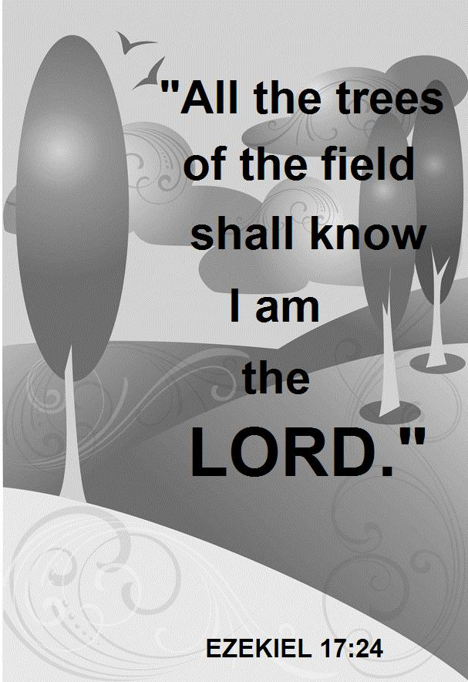
C: you are the tree of life, offering shelter to all the world. Graft us into yourself and nurture our growth, that we may bear your truth and love to those in need, through Jesus Christ, our Savior and Lord Amen.
WORD

FIRST READING Ezekiel 17:22-24 (NRSV)
Israel Exalted at Last
Thus says the Lord God: I myself will take a sprig from the lofty top of a cedar; I will set it out. I will break off a tender one from the topmost of its young twigs; I myself will plant it on a high and lofty mountain. ²³ On the mountain height of Israel I will plant it, in order that it may produce boughs and bear fruit, and become a noble cedar. Under it every kind of bird will live; in the shade of its branches will nest winged creatures of every kind. ²⁴ All the trees of the field shall know that I am the Lord. I bring low the high tree, I make high the low tree; I dry up the green tree and make the dry tree flourish. I the Lord have spoken; I will accomplish it.

Word of God, Word of Life. C: Thanks be to God.

PSALM 92:1-4, 12-15 (the psalms begin on ELW p. 338, assembly reads the indented lines)

SECOND READING 2 Corinthians 5:6-10, 14-17 (NRSV)
So we are always confident; even though we know that while we are at home in the body we are away from the Lord— ⁷ for we walk by faith, not by sight. ⁸ Yes, we do have confidence, and we would rather be away from the body and at home with the Lord. ⁹ So whether we are at home or away, we make it our aim to please him. ¹⁰ For all of us must appear before the judgment seat of Christ, so that each may receive recompense for what has been done in the body, whether good or evil. ⁴ For the love of Christ urges us on, because we are convinced that one has died for all; therefore all have died. ¹⁵ And he died for all, so that those who live might live no longer for themselves, but for him who died and was raised for them. ¹⁶ From now on, therefore, we regard no one from a human point of view; even though we once knew Christ from a human point of view, we know him no longer in that way. ¹⁷ So if anyone is in Christ, there is a new creation: everything old has passed away; see, everything has become new!

Word of God, Word of Life. C: Thanks be to God.

* GOSPEL ACCLAMATION Lord, Let My Heart Be Good Soil ELW #512

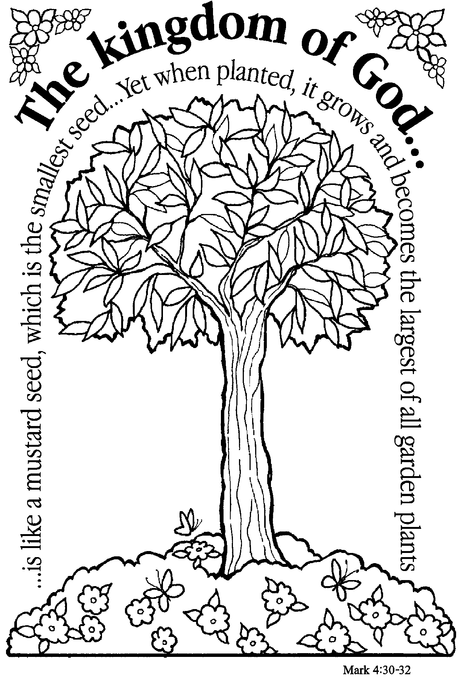
*GOSPEL Mark 4:26-34 C: Glory to you O Lord.
He also said, “The kingdom of God is as if someone would scatter seed on the ground, ²⁷ and would sleep and rise night and day, and the seed would sprout and grow, he does not know how. ²⁸ The earth produces of itself, first the stalk, then the head, then the full grain in the head. ²⁹ But when the grain is ripe, at once he goes in with his sickle, because the harvest has come.” ³⁰ He also said, “With what can we compare the kingdom of God, or what parable will we use for it? ³¹ It is like a mustard seed, which, when sown upon the ground, is the smallest of all the seeds on earth; ³² yet when it is sown it grows up and becomes the greatest of all shrubs, and puts forth large branches, so that the birds of the air can make nests in its shade.” ³³ With many such parables he spoke the word to them, as they were able to hear it; ³⁴ he did not speak to them except in parables, but he explained everything in private to his disciples.

Word of God, Word of Life. C: Praise to you, O Christ.

CHILDREN’S SERMON

SERMON
*HYMN OF THE DAY We All Are One in Mission ELW #576
*APOSTLES’ CREED Found in the back cover of the hymnal, SALMON sheet
OFFERING
*OFFERTORY HYMN Create in Me a Clean Heart ELW #188
*OFFERING PRAYER
*PRAYERS OF INTERCESSION L: Lord, in your mercy C: Hear our prayer.
SHARING OF THE PEACE
L: The peace of the Lord be with you always. C: And also with you.

THANKSGIVING

*THE GREAT THANKSGIVING ELW p. 152
*PREFACE & RESPONSE
Holy, Holy, Holy Lord ELW p. 153
*THE LORD’S PRAYER ELW p. 154
*THE WORDS OF INSTITUTION
*THE INVITATION
All are welcome to join us at the altar to receive the body and blood of our risen Lord.
Lamb of God ELW p. 154
POST-COMMUNION PRAYERC: Amen.

SENDING

*BLESSING Almighty God, Father, + Son and Holy Spirit, bless you now and forever.
Three-Fold Amen.
*SENDING HYMN Sent Forth By God’s Blessing ELW #547
*BELL/SENDING L: Go in peace. Serve the Lord C: Thanks be to God!
POSTLUDE
++++++++++++++++++++++++++++++++++++++++++++++++++++++++++++++++
Reprinted from Evangelical Lutheran Worship, copyright © 2006 Augsburg Fortress. All rights reserved. Used by permission of
Augsburg Fortress license #SB107041

Communication leads to community, that is, to understanding, intimacy and mutual valuing. ~ Rollo May
Readings for next Sunday: Job 38:1-11; Ps. 107:1-3, 23-32; 2 Cor. 6:1-13; Mark 4:35-41
The Apostles’ Creed, Article One – God the Father, Creator/Sustainer

We remember in our prayers…all who face catastrophic illness, surgery, and bindings of all kinds as well as the homebound: Bea Behrens, Vi Benoy, Agnes Carlson, Lisa Carlson & family, Donna Fisk, Danny Lang, and Delores (Dede) Strehlo. Be present with your Spirit, Lord, and lead us to be your presence to all. Amen.



Please keep up with your pledged giving. We have had a deficit lately.

Financial Status-Update for May: May collections- $5,424
May expenses- $6,721
May shortage- $1,302



TODAY: Everyone is invited to stay for coffee time today after worship. We also will have an update from the call committee.

THIS WEEK IN OUR PARISH

FRIDAY, JUNE 19-Last day to submit July/August news items to the Messenger
FRIDAY & SATURDAY JUNE 19 & 20-WELCA Convention at U of M-Morris
SUNDAY, JUNE 21-Worship at 9 AM
Reader: Jan Ringeisen,
Ushers: *Dean Gulbranson, Doug Mammenga, Tanner Mammenga and Jerome Wille

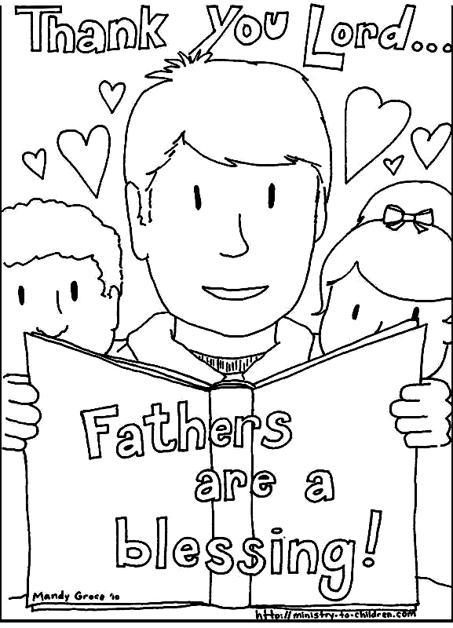
FATHER’S DAY CELEBRATION
Bring the coloring page you received from the Board of Ed, or ask Laurie Wille for a copy. Children (or grandchildren) who bring back the coloring sheet on Father’s Day will receive a treat. Also, bring a photo of your dad; there will be cards for you to write his name and yours to be displayed at the coffee hour after church in the social hall.

UPCOMING EVENTS

Sign-up sheets are on the table in the Narthex of the church for you to sign up for furnishing salads, money, or other needed food supplies. Every family is asked to donate.

