

God as Sanctifier
6th Sunday after Pentecost
July 5th, 2015

Holy Communion, Setting 4
Evangelical Lutheran Worship (ELW) p. 147

Trinity Lutheran Church
Office Phone 776-4781, Fax 776-7888, Summer Office Hours: Mon, Wed & Fri-700-11:00 am

Email: trinitytruman@frontier.com, Website: www.trinity-truman.org
Interim Kent Krumwiede-Cell #: (507) 848-7192, Email: vicarkent@gmail.com
Office Hours Mon—Thurs 9:00-1:00 pm

GATHERING

Congregation reads bold print *Please stand

PRELUDE
GATHERING REFLECTION
The Apostles’ Creed, Article Three – The Holy Spirit – Sanctifier
We come to the last article of the Apostles’ Creed, the Holy Spirit. Martin Luther, in the Large Catechism, begins teaching that “This article…I cannot relate better than to Sanctification, that through the same the Holy Spirit, with His office, is declared and depicted, namely, that He makes holy. He is the holy catholic church, that is, the one holy, the church universal. While we say “one nation under God,” God is God of all nations. It is his Spirit that speaks in all Christian churches, forgives all people’s sins, and it is he who calls, gathers, enlightens and makes the whole Christian church holy. There is nothing in us that can do any of this. It is up to God’s Holy Spirit. God, give me your Spirit so I may grow into the faithful person you want me to be. Protect my faith. Amen.

WELCOME & ANNOUNCEMENTS
OPENING SONG America the Beautiful (SEE p. 7) BELL
*CONFESSION & FORGIVENESS left column ELW p. 94
* GREETING
*KYRIE ELW p. 147
*HYMN OF PRAISE Glory to God * PRAYER OF THE DAY: L: The Lord be with you. C: And also with you.
L: We pray together Silence God of the covenant,
C: in our baptism you call us to proclaim the coming of your kingdom. Give us the courage you gave the apostles, that we may faithfully witness to your love and peace in every circumstance of life, in the name of Jesus Christ, our Savior and Lord. Amen.

WORD

FIRST READING Ezekiel 2:1-5 (NRSV)

The Vision of the Scroll
He said to me: O mortal, stand up on your feet, and I will speak with you. ² And when he spoke to me, the spirit entered into me and set me on my feet; and I heard him speaking to me. ³ He said to me, Mortal, I am sending you to the people of Israel, to a nation of rebels who have rebelled against me; they and their ancestors have transgressed against me to this very day. ⁴ The descendants are impudent and stubborn. I am sending you to them, and you shall say to them, “Thus says the Lord God.” ⁵ Whether they hear or refuse to hear (for they are a rebellious house), they shall know that there has been a prophet among them.

Word of God, Word of Life. C: Thanks be to God.

PSALM 123 (the psalms begin on ELW p. 338, assembly reads the indented lines)

SECOND READING 2 Corinthians 12:2-10 (NRSV)
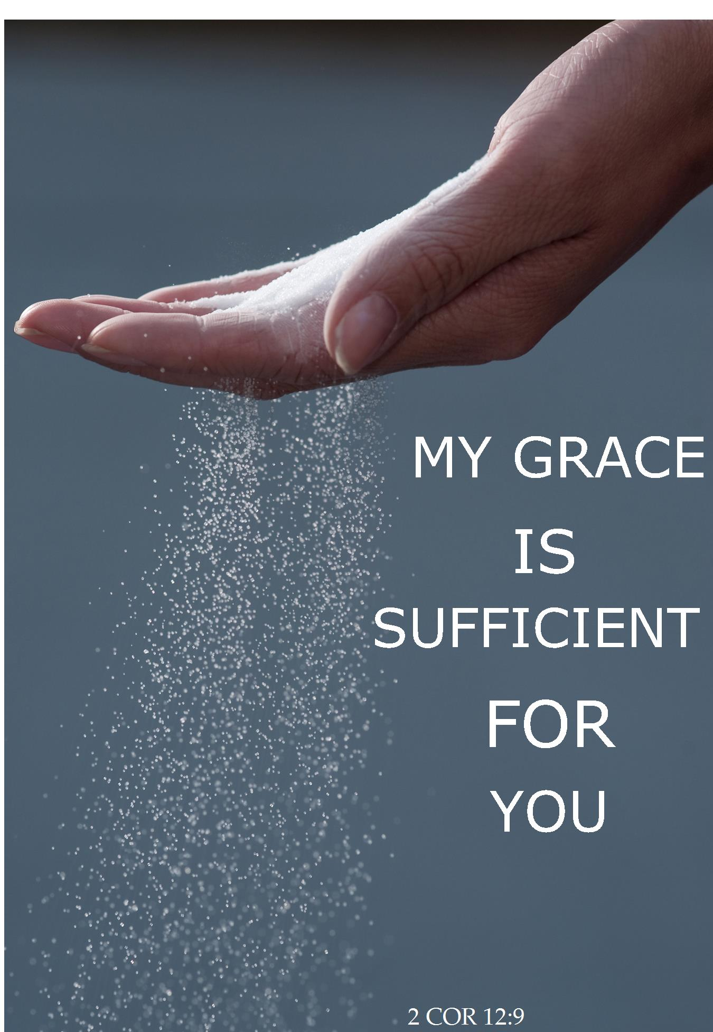
I know a person in Christ who fourteen years ago was caught up to the third heaven— whether in the body or out of the body I do not know; God knows. ³ And I know that such a person—whether in the body or out of the body I do not know; God knows— ⁴ was caught up into Paradise and heard things that are not to be told, that no mortal is permitted to repeat. ⁵ On behalf of such a one I will boast, but on my own behalf I will not boast, except of my weaknesses. ⁶ But if I wish to boast, I will not be a fool, for I will be speaking the truth. But I refrain from it, so that no one may think better of me than what is seen in me or heard from me, ⁷ even considering the exceptional character of the revelations. Therefore, to keep me from being too elated, a thorn was given me in the flesh, a messenger of Satan to torment me, to keep me from being too elated. ⁸ Three times I appealed to the Lord about this, that it would leave me, ⁹ but he said to me, “My grace is sufficient for you, for power is made perfect in weakness.” So, I will boast all the more gladly of my weaknesses, so that the power of Christ may dwell in me. ¹⁰ Therefore I am content with weaknesses, insults, hardships, persecutions, and calamities for the sake of Christ; for whenever I am weak, then I am strong.

Word of God, Word of Life. C: Thanks be to God.

*GOSPEL ACCLAMATION Lord, Let My Heart Be Good Soil ELW #512

*GOSPEL Mark 6:1-13 C: Glory to you O Lord.
The Rejection of Jesus at Nazareth
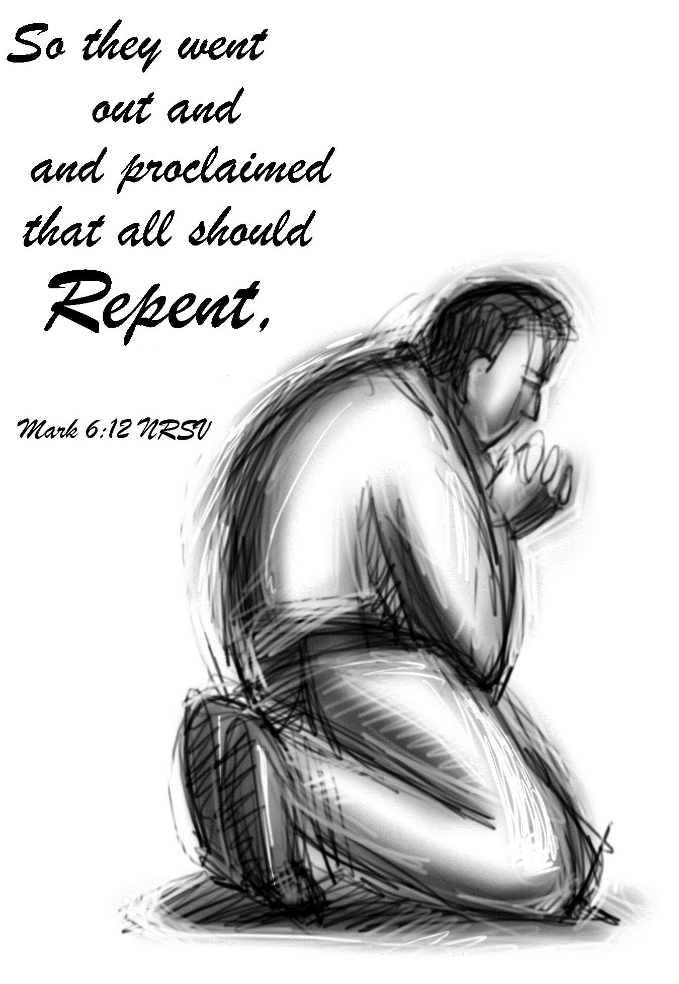
He left that place and came to his hometown, and his disciples followed him. ² On the sabbath he began to teach in the synagogue, and many who heard him were astounded. They said, “Where did this man get all this? What is this wisdom that has been given to him? What deeds of power are being done by his hands! ³ Is not this the carpenter, the son of Mary and brother of James and Joses and Judas and Simon, and are not his sisters here with us?” And they took offense at him. ⁴ Then Jesus said to them, “Prophets are not without honor, except in their hometown, and among their own kin, and in their own house.” ⁵ And he could do no deed of power there, except that he laid his hands on a few sick people and cured them. ⁶ And he was amazed at their unbelief. Then he went about among the villages teaching. ⁷ He called the twelve and began to send them out two by two, and gave them authority over the unclean spirits. ⁸ He ordered them to take nothing for their journey except a staff; no bread, no bag, no money in their belts; ⁹ but to wear sandals and not to put on two tunics. ¹⁰ He said to them, “Wherever you enter a house, stay there until you leave the place. ¹¹ If any place will not welcome you and they refuse to hear you, as you leave, shake off the dust that is on your feet as a testimony against them.” ¹² So they went out and proclaimed that all should repent. ¹³ They cast out many demons, and anointed with oil many who were sick and cured them.

Word of God, Word of Life. C: Praise to you, O Christ.

CHILDREN’S SERMON

SERMON
*HYMN OF THE DAY Faith of our Fathers ELW #812
*APOSTLES’ CREED Found in the back cover of the hymnal, SALMON sheet
OFFERING
*OFFERTORY HYMN Create in Me a Clean Heart ELW #188
*OFFERING PRAYER
*PRAYERS OF INTERCESSION L: Lord, in your mercy C: Hear our prayer.
SHARING OF THE PEACE
L: The peace of the Lord be with you always. C: And also with you.

THANKSGIVING

*THE GREAT THANKSGIVING ELW p. 152
*PREFACE & RESPONSE
Holy, Holy, Holy Lord ELW p. 153
*THE LORD’S PRAYER ELW p. 154
*THE WORDS OF INSTITUTION
*THE INVITATION
All are welcome to join us at the altar to receive the body and blood of our risen Lord.
Lamb of God ELW p. 154
POST-COMMUNION PRAYER C: Amen.

SENDING
*BLESSING Almighty God, Father, + Son and Holy Spirit, bless you now and forever.
Three-Fold Amen.

*SENDING HYMN Patriotic Medley (SEE p. 7 & 8)
Mine Eyes Have Seen The Glory
God Bless the U.S.A.
This Land is Your Land
God Bless America

*BELL/SENDING L: Go in peace. Serve the Lord C: Thanks be to God!
POSTLUDE
++++++++++++++++++++++++++++++++++++++++++++++++++++++++++++++++
Reprinted from Evangelical Lutheran Worship, copyright © 2006 Augsburg Fortress. All rights reserved. Used by permission of
Augsburg Fortress license #SB107041

Every time we say we believe in the Holy Spirit, we mean we believe that there is a living God able and willing to enter human personality and change it. ~John Owen

Readings for next Sunday: Amos 7:7-15; Psalm 85:8-13; Ephesians 1:3-14; Mark 6:14-29

We remember in our prayers…all who face catastrophic illness, surgery, and bindings of all kinds as well as the homebound: Bea Behrens, Agnes Carlson, Lisa Carlson & family, Donna Fisk, Danny Lang. Be present with your Spirit, Lord, and lead us to be your presence to all. Amen.



Please keep up with your pledged giving. We have had a deficit lately.


TODAY: Everyone is invited to stay for coffee time today after worship. Please sign up to serve coffee during the summer-there are several spots left.

Check your mailboxes…The July/August Messenger is here!!

THIS WEEK IN OUR PARISH

SUNDAY JULY 5—SATURDAY JULY 11
Vicar Kent on vacation
WEDNESDAY, JULY 8-Church Council Meeting at 7 pm
SUNDAY, JULY 12-Worship at 9 AM
Reader: Carolyn Drevlow,
Ushers: *Doyle Peterson, Howard Kautz, Jerry Teig and David Sorenson

UPCOMING EVENTS


Agnes Carlson will be 95 years old on July 16th. In honor of Agnes’ 95th birthday, her family will be having an Open House for her on Saturday, July 18th from 1:30-3:30 pm in the fellowship hall at Trinity. Everyone is cordially invited.

TRINITY’S ANNUAL WAFFLE BREAKFAST

On July 25th
(during Truman Days)
7:00-10:30 am
Truman Community Building

Sign-up sheets are on the table in the hall for work shifts. This is a big project that needs many volunteers. There are many sit-down jobs available and short work times available. All ages are urged to sign up for a job that you think you could do. This project is also a good community event. Please do your part to make it successful.
Holy Humor

A minister waited in line to have his car filled with gas just before the long holiday weekend. The attendant worked quickly, but there were many cars ahead of him. Finally, the attendant motioned him toward a vacant pump. “Reverend,” said the young man, “I’m so sorry about the delay. It seems as if everyone waits until the last minute to get ready for a long trip.” The minister chuckled, “I know what you mean. It’s the same in my business.”

America the Beautiful


O beautiful for spacious skies, for amber waves of grain,
For purple mountain majesties above the fruited plain!
America! America! God shed his grace on thee
And crown thy good with brotherhood from sea to shining sea!
O beautiful for pilgrim feet whose stern impassioned stress
A thoroughfare of freedom beat across the wilderness!
America! America! God mend thine every flaw,
Confirm thy soul in self-control, thy liberty in law!
O beautiful for heroes proved in liberating strife.
Who more than self their country loved and mercy more than life!
America! America! May God thy gold refine
Till all success be nobleness and every gain divine!
Mine Eyes Have Seen The Glory
1. Mine eyes have seen the glory
of the coming of the Lord;
he is trampling out the vintage
where the grapes of wrath are stored;
he hath loosed the fateful lightning
of his terrible swift sword;
his truth is marching on.
Refrain:
Glory, glory, hallelujah!
Glory, glory, hallelujah!
Glory, glory, hallelujah!
His truth is marching on.
3. He has sounded forth the trumpet
that shall never call retreat;
he is sifting out the hearts of men
before his judgment seat;
O be swift, my soul, to answer him;
be jubilant, my feet!
Our God is marching on. Refrain
God Bless the U.S.A.

If tomorrow all the things were gone
I worked for all my life
And I'd had to start again
Just my children and my wife
I thank my lucky stars
To be living here today
'Cause the flag still stands for freedom
And they can't take that away
Refrain
And I'm proud to be an American
Where at least I know I'm free
And I won't forget the ones who died
Who gave that right to me
And I gladly stand up next to you
And defend her still today
'Cause there ain't no doubt I love this land
God bless the U.S.A.

This Land is Your Land
Refrain
This land is your land, This land is my land,
From California to the New York island;
From the red wood forest to the Gulf Stream waters;
This land was made for you and Me.

As I went a-walking that ribbon of highway
I saw above me that endless skyway
I saw below me that golden valley
This land was made for you and me.
Refrain

God Bless America We will sing this twice.
God Bless America,
Land that I love.
Stand beside her, and guide her
Thru the night with a light from above.
From the mountains, to the prairies,
To the oceans, white with foam, God bless America, My home sweet home.

