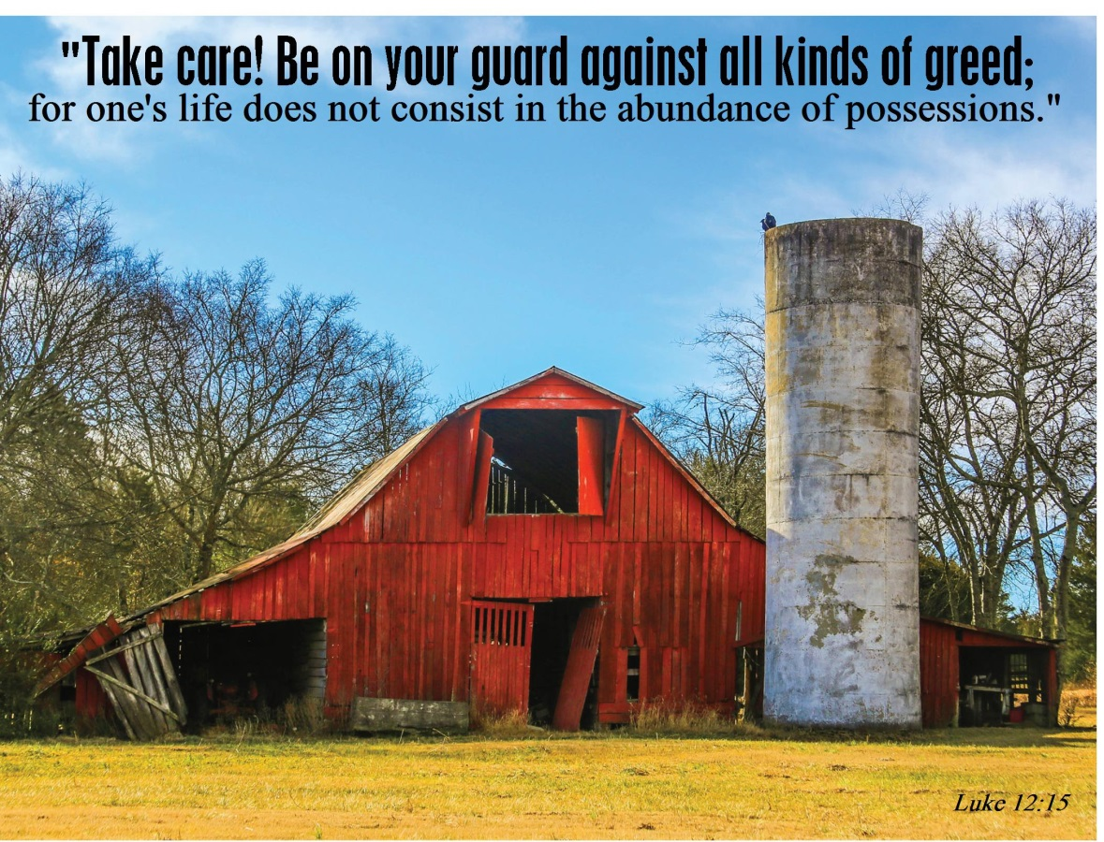

11th Sunday after Pentecost
July 31, 2016
Evangelical Lutheran Worship, Setting 10

Trinity Lutheran Church

Office Phone 776-4781, Fax 776-7888, Sumer Office Hours: Mon, Wed & Fri. 7:00-11:00 am
Email: trinitytruman@frontier.com, Website: www.trinity-truman.org
PASTOR KRISTA STRUM
Cell-(507)995-1233, Email: pkstrumom@me.com
Pastor Krista’s Summer Hours: Wed. 8:30-12:00 pm & Thurs. 8:30-12:00 pm

GATHERING

Congregation reads bold print *Please stand

PRELUDE
BELL
ANNOUNCEMENTS
*CONFESSION AND FORGIVENESS—Prayer of Confession
Loving God,
We confess that we have sinned.
Even though we want to do what is right, we did not always succeed this week.
Not only did we fail to do what was right, but at times we consciously chose to think and act in ways we knew were wrong.
We are truly sorry, and we ask for your forgiveness.

WORDS OF ASSURANCE
Friends, hear this:
Through the life, death and resurrection of Jesus Christ, we have been set free from the power of sin! It no longer needs to control us. So be at peace: your sins are forgiven!
Go out, and live in the light of Christ.
Thanks be to God!

*GATHERING SONG Blessed Assurance ELW #638

*GREETING
The grace of our Lord Jesus Christ, the love of God, and the communion of the Holy Spirit be with you all. And also with you.

*KYRIE ELW p. 203
*CANTICLE OF PRAISE – (VERSE 3) ELW p. 204
* PRAYER OF THE DAY L: The Lord be with you. C: And also with you.
L: Let us pray,
Benevolent God, you are the source, the guide, and the goal of our lives. Teach us to love what is worth loving, to reject what is offensive to you, and to treasure what is precious in your sight, through Jesus Christ, our Savior and Lord. Amen.

WORD
FIRST READING: Eccles 1:2, 12-14, 2:18-23
²Vanity of vanities, says the Teacher, vanity of vanities! All is vanity. ³What do people gain from all the toil at which they toil under the sun? ⁴A generation goes, and a generation comes, but the earth remains forever. ⁵The sun rises and the sun goes down,
and hurries to the place where it rises. ⁶The wind blows to the south, and goes around to the north; round and round goes the wind, and on its circuits the wind returns. ⁷All streams run to the sea, but the sea is not full; to the place where the streams flow, there they continue to flow. ⁸All things are wearisome; more than one can express; the eye is not satisfied with seeing, or the ear filled with hearing. ⁹What has been is what will be,
and what has been done is what will be done; there is nothing new under the sun. ¹⁰Is there a thing of which it is said, "See, this is new"? It has already been, in the ages before us. ¹¹The people of long ago are not remembered, nor will there be any remembrance of people yet to come by those who come after them. ¹²I, the Teacher, when king over Israel in Jerusalem, ¹³applied my mind to seek and to search out by wisdom all that is done under heaven; it is an unhappy business that God has given to human beings to be busy with. ¹⁴I saw all the deeds that are done under the sun; and see, all is vanity and a chasing after wind.
¹⁵What is crooked cannot be made straight, and what is lacking cannot be counted. ¹⁶I said to myself, "I have acquired great wisdom, surpassing all who were over Jerusalem before me; and my mind has had great experience of wisdom and knowledge." ¹⁷And I applied my mind to know wisdom and to know madness and folly. I perceived that this also is but a chasing after wind. ¹⁸For in much wisdom is much vexation, and those who increase knowledge increase sorrow.

Word of God, word of life. Thanks be to God.

Psalm Reading: Psalm 49:1-12 (read responsively the bold print)

¹Hear this, all you peoples; give ear, all inhabitants of the world,
²both low and high, rich and poor together.

³My mouth shall speak wisdom; the meditation of my heart shall be understanding.
⁴I will incline my ear to a proverb; I will solve my riddle to the music of the harp.

⁵Why should I fear in times of trouble, when the iniquity of my persecutors surrounds me,
⁶those who trust in their wealth and boast of the abundance of their riches?

⁷Truly, no ransom avails for one's life, there is no price one can give to God for it.
⁸For the ransom of life is costly, and can never suffice,

⁹that one should live on forever and never see the grave.
¹⁰When we look at the wise, they die; fool and dolt perish together and leave
their wealth to others.

¹¹Their graves are their homes forever, their dwelling places to all generations, though they named lands their own.
¹²Mortals cannot abide in their pomp; they are like the animals that perish.
CHILDREN'S MESSAGE
*GOSPEL ACCLAMATION Alleluia! Lord and Savior… ELW p. 205

*GOSPEL: Luke 12:13-21 C: Glory to you O Lord.
13Someone in the crowd said to [Jesus,] “Teacher, tell my brother to divide the family inheritance with me.” 14But he said to him, “Friend, who set me to be a judge or arbitrator over you?” 15And he said to them, “Take care! Be on your guard against all kinds of greed; for one’s life does not consist in the abundance of possessions.” 16Then he told them a parable: “The land of a rich man produced abundantly. 17And he thought to himself, ‘What should I do, for I have no place to store my crops?’ 18Then he said, ‘I will do this: I will pull down my barns and build larger ones, and there I will store all my grain and my goods. 19And I will say to my soul, Soul, you have ample goods laid up for many years; relax, eat, drink, be merry.’ 20But God said to him, ‘You fool! This very night your life is being demanded of you. And the things you have prepared, whose will they be?’ 21So it is with those who store up treasures for themselves but are not rich toward God.”

The gospel of the Lord. Praise to you, O Christ.

SERMON
*HYMN OF THE DAY Great Is Thy Faithfulness ELW #733

*CREED (SALMON sheet in the back of the red hymnal) or ELW p. 206
*PRAYERS OF THE PEOPLE
L: Lord in your mercy C: Hear our prayer
PEACE The peace of Christ be with you always. And also with you.

OFFERING
OFFERING SONG Create in Me… ELW #188
OFFERING PRAYER
God of mercy and grace, the eyes of all wait upon you, and you open your hand in blessing.
Fill us with good things at your table, that we may come to the help of all in need,
through Jesus Christ, our redeemer and Lord. Amen.

*LORD’S PRAYER (SUNG) - found on the salmon sheet in the back cover of the red hymnal
*BLESSING
Three fold Amen…
*SENDING SONG What a Fellowship, What a Joy Divine ELW #774

*DISMISSAL Go in peace. Serve the Lord. Thanks be to God.
BELL/POSTLUE
+++++++++++++++++++++++++++++++++++++++++++++++++++++++++++++++++
Copyright © 2016 Augsburg Fortress. All rights reserved. Reprinted by permission under Augsburg Fortress Liturgies Annual License #SAS103469. New Revised Standard Version Bible, copyright © 1989, Division of Christian Education of the National Council of the Churches of Christ in the United States of America. Used by permission. All rights reserved.

Readings for next Sunday: Genesis 15:1-6, Ps. 33:12-22, Heb 11:1-3, 8-16, Luke 12:32-40

We remember in our prayers…all who face catastrophic illness, surgery, and bindings of all kinds as well as the homebound: Bea Behrens, Lisa Carlson & family, Danny Lang, Deloris Strehlo, Clarice Noorlun (Mother to Lowell Noorlun).
TODAY: Please join us for coffee hour after worship services.

THIS WEEK IN OUR PARISH

SUNDAY, AUGUST 7—8:45 AM COMMUNION WORSHIP
Coffee Hour will be held after worship
Reader: Beth Kotewa, Comm. Server: Cathy Sorenson
Ushers: *Lowell Noorlun, Dave Sorenson, Dallas Wegner and Mike Taylor

FOR YOUR INFORMATION

Truman Senior Living Activities Department is hosting a Pie & Ice Cream Social today from 1:30-3:30 pm. Music by Bud Berhow will start at 2 PM. All the proceeds from this event will go for activities for the residents of TSL.
Pastor Krista will be on vacation from Tuesday, August 9th through Wednesday, August 17th

MARK YOUR CALENDARS!..TRINITY’S VBS WILL BE HELD AUGUST 21-24TH—More information to come later.

A month of Sundays

“August is like the Sunday of summer,” an online meme proclaims. But that means different things to different people.
If you see Sunday as the end of a week — a chance to sleep in, do “nothing,” relax and play — then August might be your downtime at the end of a busy summer. If Sunday feels heavy because the onslaught of the workweek is approaching, then August may carry the dread of falling leaves and falling temperatures.
But if you view Sunday as a fresh start to the week, then August, with a new school year and new church programming around the corner, can be exciting. And if you honor Sunday as the Sabbath, indeed “August is like the Sunday of summer.” God invites us to enjoy these holy days and give thanks to him, the Creator of all seasons.
—Heidi Mann

A small laugh
“God warned a man named Lot to take his wife and flee out of the city,” said the Sunday school teacher, “but Lot’s wife looked back and was turned to salt.”
A curious boy then asked, “What happened to the flea?”

