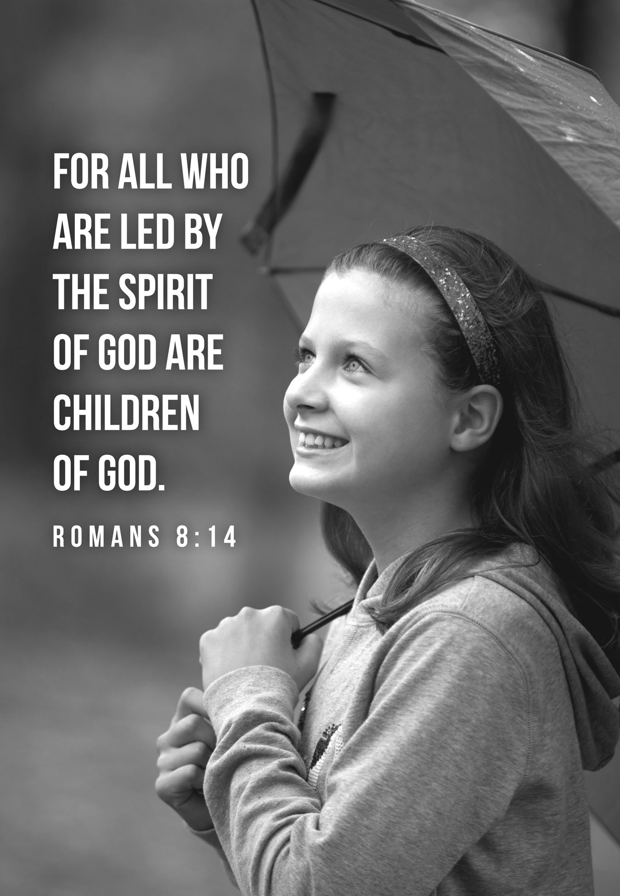

9th Sunday after Pentecost
Baptism of Grayson Reid Werner
July 17, 2016
Evangelical Lutheran Worship, Setting 10

Trinity Lutheran Church

Office Phone 776-4781, Fax 776-7888, Sumer Office Hours: Mon, Wed & Fri. 7:00-11:00 am
Email: trinitytruman@frontier.com, Website: www.trinity-truman.org
PASTOR KRISTA STRUM
Cell-(507)995-1233, Email: pkstrumom@me.com
Pastor Krista’s Summer Hours: Wed. 8:30-12:00 pm & Thurs. 8:30-12:00 pm

GATHERING

Congregation reads bold print *Please stand

PRELUDE
BELL
ANNOUNCEMENTS
*CONFESSION AND FORGIVENESS—Prayer of Confession
Loving God,
We confess that we have sinned.
Even though we want to do what is right, we did not always succeed this week.
Not only did we fail to do what was right, but at times we consciously chose to think and act in ways we knew were wrong.
We are truly sorry, and we ask for your forgiveness.

WORDS OF ASSURANCE
Friends, hear this:
Through the life, death and resurrection of Jesus Christ, we have been set free from the power of sin! It no longer needs to control us. So be at peace: your sins are forgiven!
Go out, and live in the light of Christ.
Thanks be to God!

*GATHERING SONG Children of the Heavenly Father ELW #781
BATISM OF GRAYSON REID WERNER ELW p. 227
PROFESSION OF FAITH: ELW p. 229
I believe in Jesus Christ, God’s only Son, our Lord,
who was conceived by the Holy Spirit,
born of the virgin Mary,
suffered under Pontius Pilate,
was crucified, died, and was buried;
he descended to the dead.*
On the third day he rose again;
he ascended into heaven,
he is seated at the right hand of the Father,
and he will come to judge the living and the dead.

Do you believe in God the Holy Spirit?
I believe in the Holy Spirit,
the holy catholic church,
the communion of saints,
the forgiveness of sins,
the resurrection of the body,
and the life everlasting.
THANKSGIVING AT THE FONT: ELW p. 230
The Lord be with you. C: And also with you.
Let us give thanks to the Lord our God. C: It is right to give our thanks and praise.
BAPTISM: ELW p. 230
Grayson Reid, I baptize you in the name of the Father,* and of the Son, and of the Holy Spirit. Amen.

C: You belong to Christ, in whom you have been baptized. Alleluia.

WELCOME: ELW p. 231
COUNCIL REPRESENTATIVE: Let your light so shine before others that they may see your good works and glorify your Father in heaven.
Let us welcome the newly baptized.

C: We welcome you into the body of Christ and into the mission we share:
join us in giving thanks and praise to God and bearing God's creative and redeeming word to all the world.
*GREETING
The grace of our Lord Jesus Christ, the love of God, and the communion of the Holy Spirit be with you all. And also with you.

*KYRIE ELW p. 203
*CANTICLE OF PRAISE – (VERSE 3) ELW p. 204
* PRAYER OF THE DAY L: The Lord be with you. C: And also with you.
L: Let us pray,
Eternal God, you draw near to us in Christ, and you make yourself our guest. Amid the cares of our lives, make us attentive to your presence, that we may treasure your word above all else, through Jesus Christ, our Savior and Lord. Amen.

WORD
FIRST READING: Romans 8:12- 37
So then, brothers and sisters, we are debtors, not to the flesh, to live according to the flesh — 13for if you live according to the flesh, you will die; but if by the Spirit you put to death the deeds of the body, you will live. 14For all who are led by the Spirit of God are children of God. 15For you did not receive a spirit of slavery to fall back into fear, but you have received a spirit of adoption. When we cry, "Abba! Father!" 16it is that very Spirit bearing witness with our spirit that we are children of God, 17and if children, then heirs, heirs of God and joint heirs with Christ — if, in fact, we suffer with him so that we may also be glorified with him. 18I consider that the sufferings of this present time are not worth comparing with the glory about to be revealed to us. 19For the creation waits with eager longing for the revealing of the children of God; 20for the creation was subjected to futility, not of its own will but by the will of the one who subjected it, in hope 21that the creation itself will be set free from its bondage to decay and will obtain the freedom of the glory of the children of God. 22We know that the whole creation has been groaning in labor pains until now; 23and not only the creation, but we ourselves, who have the first fruits of the Spirit, groan inwardly while we wait for adoption, the redemption of our bodies. 24For in hope we were saved. Now hope that is seen is not hope. For who hopes for what is seen? 25But if we hope for what we do not see, we wait for it with patience. 26Likewise the Spirit helps us in our weakness; for we do not know how to pray as we ought, but that very Spirit intercedes with sighs too deep for words. 27And God, who searches the heart, knows what is the mind of the Spirit, because the Spirit intercedes for the saints according to the will of God. 28We know that all things work together for good for those who love God, who are called according to his purpose. 29For those whom he foreknew he also predestined to be conformed to the image of his Son, in order that he might be the firstborn within a large family. 30And those whom he predestined he also called; and those whom he called he also justified; and those whom he justified he also glorified. 31What then are we to say about these things? If God is for us, who is against us? 32He who did not withhold his own Son, but gave him up for all of us, will he not with him also give us everything else? 33Who will bring any charge against God's elect? It is God who justifies. 34Who is to condemn? It is Christ Jesus, who died, yes, who was raised, who is at the right hand of God, who indeed intercedes for us. 35Who will separate us from the love of Christ? Will hardship, or distress, or persecution, or famine, or nakedness, or peril, or sword? 36As it is written, "For your sake we are being killed all day long; we are accounted as sheep to be slaughtered." 37No, in all these things we are more than conquerors through him who loved us.

Word of God, word of life. Thanks be to God.

CHILDREN'S MESSAGE
*GOSPEL ACCLAMATION Alleluia! Lord and Savior… ELW p. 205
*GOSPEL: Luke 10:38-42 C: Glory to you O Lord.
38Now as [Jesus and his disciples] went on their way, he entered a certain village, where a woman named Martha welcomed him into her home. 39She had a sister named Mary, who sat at the Lord’s feet and listened to what he was saying. 40But Martha was distracted by her many tasks; so she came to him and asked, “Lord, do you not care that my sister has left me to do all the work by myself? Tell her then to help me.” 41But the Lord answered her, “Martha, Martha, you are worried and distracted by many things; 42there is need of only one thing. Mary has chosen the
better part, which will not be taken away from her.”

The gospel of the Lord. Praise to you, O Christ.
SERMON
*HYMN OF THE DAY Amazing Grace, How Sweet the Sound ELW #779
*PRAYERS OF THE PEOPLE
PEACE The peace of Christ be with you always. And also with you.

MEAL

OFFERING
OFFERING SONG Let the Vineyards be fruitful Lord… ELW #184
OFFERING PRAYER
God of mercy and grace, the eyes of all wait upon you, and you open your hand in blessing.
Fill us with good things at your table, that we may come to the help of all in need,
through Jesus Christ, our redeemer and Lord. Amen.

Great Thanksgiving ELW p. 206
Dialogue
The Lord be with you. And also with you.
Lift up your hearts. We lift them to the Lord.
Let us give thanks to the Lord our God. It is right to give our thanks and praise.

*Preface Holy, holy, holy Lord… ELW p. 207
*THANKSGIVING AT THE TABLE
*LORD’S PRAYER ELW p. 208
invitation to Communion Come to the banquet, for all is now ready.
COMMUNION
COMMUNION SONG Eat This Bread: Jesus Christ, Bread of Life ELW #472
PRAYER AFTER COMMUNION Let us Pray,
Gracious God, in this meal you have drawn us to your heart, and nourished us at your table with food and drink, the body and blood of Christ. Now send us forth to be your people in the world, and to proclaim your truth this day and evermore, through Jesus Christ, our Savior and Lord. Amen.

*BLESSING
*SENDING SONG On Our Way Rejoicing ELW #537
*DISMISSAL Go in peace. Serve the Lord. Thanks be to God.
BELL/POSTLUE
+++++++++++++++++++++++++++++++++++++++++++++++++++++++++++++++++
Copyright © 2016 Augsburg Fortress. All rights reserved. Reprinted by permission under Augsburg Fortress Liturgies Annual License #SAS103469. New Revised Standard Version Bible, copyright © 1989, Division of Christian Education of the National Council of the Churches of Christ in the United States of America. Used by permission. All rights reserved.

Readings for next Sunday: The Sermon Series on the Book of Romans

We remember in our prayers…all who face catastrophic illness, surgery, and bindings of all kinds as well as the homebound: Bea Behrens, Lisa Carlson & family, Danny Lang, and Clarice Noorlun (Mother to Lowell Noorlun).
TODAY: Congratulations to Logan & Melissa Werner on the baptism of Grayson Reid Werner this morning. He was born on June 23, 2016 in Blue Earth. Grayson’s sponsors are Wayne & Shelly Walstead. He has two big brothers, Carter (6 yrs) & Liam (2 yrs).
Please join us for coffee hour after worship services.

ATTENTION…Inventory Reduction Sale on Fair Trade Items
½ price—Fruit Bars 50¢, Tea Box--$1.50

No price reductions on coffee, but we have packages of coffee (whole bean) that are free!!!! See Connie Selnes

THIS WEEK IN OUR PARISH

MONDAY, JULY 18- Pastor in the office, but will be gone on Wednesday & Thursday
SATURDAY, JULY 23-TRINITY’S ANNUAL TRUMAN DAYS WAFFLE BREAKFAST from 7:00-10:30 AM-We need workers to sign up to help at
the Waffle Breakfast. Everyone is to do their part as this is a Community
Fundraiser for our church. The youth group will be helping also.

SUNDAY, JULY 24—8:45 AM WORSHIP
Coffee Hour will be held after worship
Reader: Tom Dodge,
Ushers: *Clayton Duncanson, Wayne Maloney, Terry Pettersen and Ross Ringeisen
FOR YOUR INFORMATION

TRUMAN DAYS WILL BE HELD JULY 21-24TH ...Be sure to check out all the activities around the community next weekend.

MARK YOUR CALENDARS!..TRINITY’S VBS WILL BE HELD AUGUST 21-24TH—More information to come later.

CHECK IT OUT…The books in the Lounge Area are free to take home!
We are getting rid of the books, so take advantage now and take a book home today! We need help… selling the books during Truman Days; there is a sign-up sheet on the table in the narthex.

