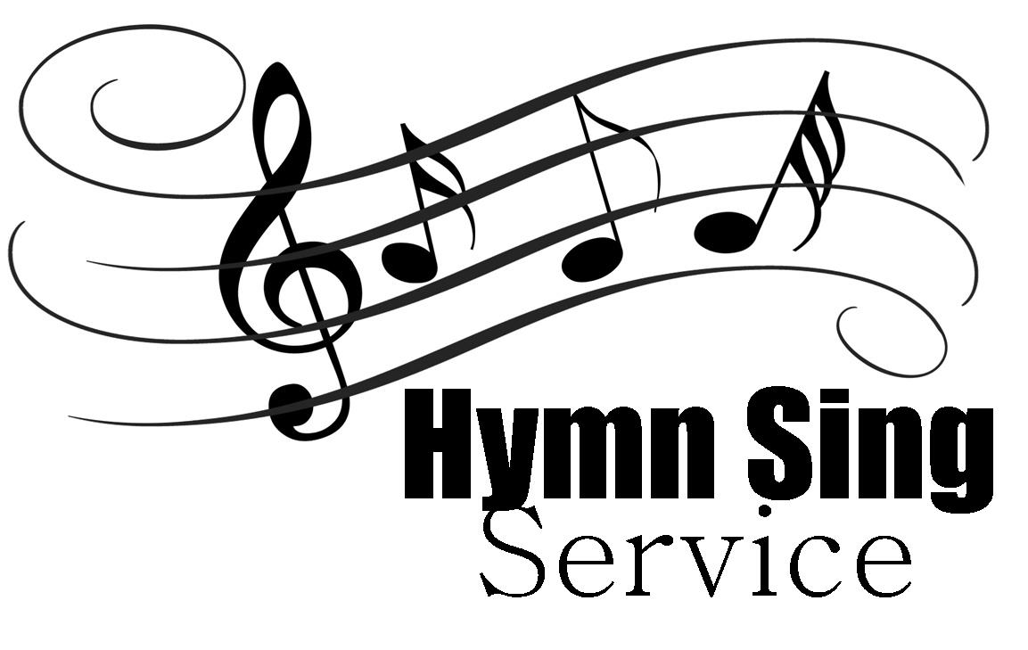

***4th Sunday after Epiphany***

***Hymn Sing***

**January 31st, 2016**

**Evangelical Lutheran Worship (ELW)**

**Trinity Lutheran Church**

Office Phone 776-4781, Fax 776-7888, Office Hours: Mon 8-11, Wed & 8-11 & 1-4, Fri-8-11 am

 Email: [trinitytruman@frontier.com](mailto:trinitytruman@frontier.com), Website: [www.trinity-truman.org](http://www.trinity-truman.org)

**Pastor Krista Strum-**Cell: (507)995-1233, Email: pkstrumom@me.com

Pastor Krista’s Hours: Wed. 11-2:30 pm, Thurs. 8:30-2:30 pm

**GATHERING**

*Congregation reads* ***bold print****.*

**PRELUDE**

**BELL**

**WELCOME & ANNOUNCEMENTS**

**\*GATHERING HYMN**  *Holy, Holy, Holy*  **ELW #413**

**CALL TO WORSHIP -**

L:Come, let us sing to God;

**C: Let us make a joyful noise to the rock of our salvation.**  
L:Let us come into God’s presence with thanksgiving;

**C:** **Let us make a joyful noise to God with songs of praise!**  
L:It is good to give you thanks, O God;

**C:** **To sing praises to your name, O Most High;**  
L:to declare your steadfast love in the morning,

**C:**  **and your faithfulness by night,**  
L:to the music of the lute and harp,

**C:** **to the melody of the lyre.**  
L:For you, O God, have made us glad by your work;

C:  **At the works of your hands we sing for joy!**

**HYMN** *Amazing Grace***ELW #779**

**PRAYER OF THE DAY**

L: Let us Pray

**Holy, Creating, Creative God,**

**We sing from the depths of our sorrow.**

**We sing from the abundance of our joy.**

**We sing in voices separate and unique.**

**We sing with one voice as your body.**

**May the words of our mouths, whether in speech or song,**

**and the meditations of our hearts, whether in prose or poetry,**

**be pleasing in your sight. Amen.**

**HYMNS** *Beautiful Savior***ELW #838**

*How Great Thou Art***ELW #856**

**MESSAGE**

**PSALM 100**

1Make a joyful noise to the Lord, all you lands!

**2Serve the Lord with gladness; come into God’s presence with a song.**

3Know that the Lord is God, our maker to whom we belong; we are God’s

people and the sheep of God’s pasture.

4**Enter the gates of the Lord with thanksgiving and the courts with**

**praise; give thanks and bless God’s holy name.**

5Good indeed is the Lord, whose steadfast love is everlasting, whose

faithfulness endures from age to age.

**DVD *- Rhythm***

**HYMNS OF THE DAY** *Blest Are They***ELW #728**

*What A Friend We Have in Jesus***ELW #742**

*Softly and Tenderly***ELW #608**

**OFFERING**

**HYMN***Leaning on the Everlasting Arms***ELW #774**

**\*THE LORD’S PRAYER** *(on the salmon sheet in the back of the red hymnal)*

**BLESSING**

*We came earnestly seeking God;*

*we go forth having known God in this place.*

*May you know, throughout the week,*

*God’s love that is better than life.*

*Praise God with singing lips.*

*Think of the Holy One through the watches of the night.*

*Sing joyfully in the shadow of her wings.* ***Amen.***

**HYMN** *Jesus Loves Me***ELW #595**

**BELL**

**THE SENDING:** L:Go in peace. Serve the Lord. **C: Thanks be to God!**

**+++++++++++++++++++++++++++++++++++++++++++++++++++++++++++++++++**

*Copyright 2013 Augsburg Fortress. All rights reserved. Reprinted by permission under Augsburg Fortress Liturgies Annual License#15562-ELW*

Readings for Next Sunday: Exod. 34:29-35, Ps 99, 2 Cor. 3:12—4:2, Luke 9:28:36[37-43a]

Prayer requests

*We remember in our prayers…all who face catastrophic illness, surgery, and bindings of all kinds as well as the homebound:* ***Bea Behrens, Agnes Carlson, Lisa******Carlson & family, Donna Fisk, and Danny Lang.*** *Be present with your Spirit, Lord, and lead us to be your presence to all. Amen.*

**ANNOUNCEMENTS**

**TODAY:** A BIG Thank you to Tom Dodge who is leading the worship today!



**Check your mailboxes for the February Messenger!!!**

**MONDAY, FEBRUARY 1-**Martha Circle meets at 1:30 at Barb Shoen’s

**THURSDAY, FEBRUARY 4**-9 AM Bible study/Lois Circle at the Truman café

**SUNDAY, FEBRUARY 7-CAMP WORSHIP**

9-10:00 Sunday School, 10-10:30 Gathering time w/kid friendly snacks

10:30 Communion Worship

*Reader: Brytni Drevlow, Comm Server: please volunteer*

*Ushers: *Duke Drevlow, Troy Harder, Ross Ringeisen and Ricky Davis*

**Now you can send & receive text messages from the church office!** You will know right away when church is cancelled or any other notification. Let Brenda know if you want to be included in this new exciting feature that Trinity has to offer! (*You just have to have the texting feature on your cell phone)*