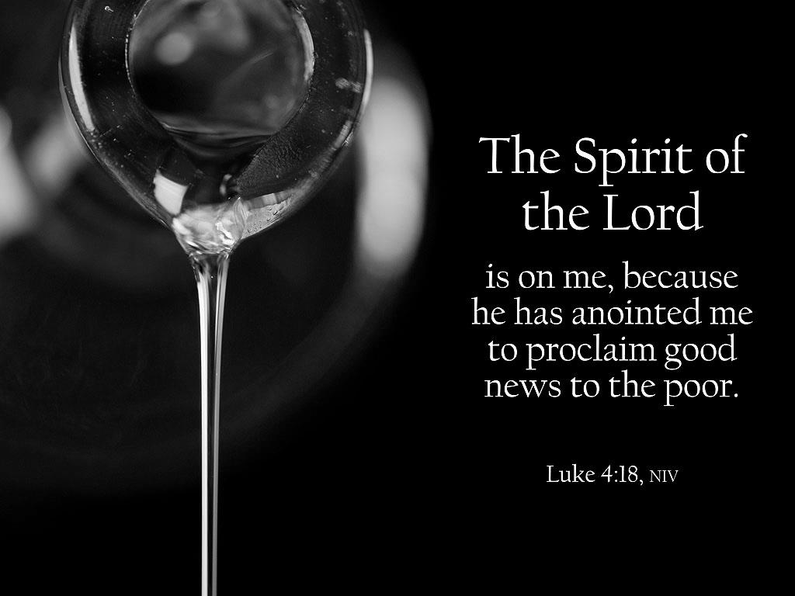

***Annual Congregational Meeting***

**3rd Sunday after Epiphany**

**January 24, 2016**

**Evangelical Lutheran Worship, Setting 4**

**Trinity Lutheran Church**

Office Phone 776-4781, Fax 776-7888, Office Hours: Mon 8-11, Wed 8-11 & 1-4, Fri. 8-11 am

 Email: [trinitytruman@frontier.com](mailto:trinitytruman@frontier.com), Website: [www.trinity-truman.org](http://www.trinity-truman.org)

**Pastor Krista Strum**-Cell-(507) 995-1233, Email: [pkstrumom@me.com](mailto:pkstrumom@me.com)

Pastor Krista’s Hours: Wed. 11-2:30 pm & Thurs. 8:30-2:30 pm

**GATHERING**

*Congregation reads* ***bold print*** *\*Please stand*

**PRELUDE**

**BELL**

**WELCOME & ANNOUNCEMENTS**

**\*CONFESSION & FORGIVENESS**

Blessed be the holy Trinity, ☩ one God, who creates us and forms us, who redeems us and calls us, who unites us and sends us. **Amen.**

Gathered in God’s presence, let us confess our sin.

Mighty and loving God,

**we confess that we are captive to sin and cannot free ourselves. We seek our own way.**

**We divide the body of Christ. In your mercy, cleanse us and heal us. Let the words of our mouths, the thoughts of our hearts, and everything that we do be filled with faith, hope, and love. Amen.**

Hear the voice of Jesus:

“The Spirit of the Lord is upon me to proclaim release to the captives.” In the name of ☩ Jesus Christ, I proclaim to you that your sins are forgiven and you are released. The joy of the Lord is your strength, and the gifts of the Holy Spirit are yours forever.

**Amen.**

**\*GATHERING HYMN** *The Church's One Foundation***ELW #654**

**\*GREETING ELW p. 147**

**\*KYRIE**

**\*HYMN OF PRAISE *Glory to God in the highest*  ELW p. 148**

**\*PRAYER OF THE DAY**

L: Let us pray,

**Blessed Lord God, you have caused the Holy Scriptures to be written for the nourishment of your people. Grant that we may hear them, read, mark, learn, and inwardly digest them, that, comforted by your promises, we may embrace and forever hold fast to the hope of eternal life, through your Son, Jesus Christ our Lord. Amen.**

**WORD**

**FIRST READING: Nehemiah 8:1-3, 5-6, 8-10**

1All the people [of Israel] gathered together into the square before the Water Gate. They told the scribe Ezra to bring the book of the law of Moses, which the Lord had given to Israel. 2Accordingly, the priest Ezra brought the law before the assembly, both men and women and all who could hear with understanding. This was on the first day of the seventh month. 3He read from it facing the square before the Water Gate from early morning until midday, in the presence of the men and the women and those who could understand; and the ears of all the people were attentive to the book of the law. 5And Ezra opened the book in the sight of all the people, for he was standing above all the people; and when he opened it, all the people stood up. 6Then Ezra blessed the Lord, the great God, and all the people answered, “Amen, Amen,” lifting up their hands. Then they bowed their heads and worshiped the Lord with their faces to the ground. 8So they read from the book, from the law of God, with interpretation. They gave the sense, so that the people understood the reading. 9And Nehemiah, who was the governor, and Ezra the priest and scribe, and the Levites who taught the people said to all the people, “This day is holy to the Lord your God; do not mourn or weep.” For all the people wept when they heard the words of the law. 10Then he said to them, “Go your way, eat the fat and drink sweet wine and send portions of them to those for whom nothing is prepared, for this day is holy to our Lord; and do not be grieved, for the joy of the Lord is your strength.”

Word of God, Word of Life. **C: Thanks be to God.**

**PSALM: Psalm 19**

1The heavens declare the glory of God, and the sky proclaims its maker’s handiwork.

2**One day tells its tale to another, and one night imparts knowledge to another.**

3Although they have no words or language, and their voices are not heard,

4**their sound has gone out into all lands, and their message to the ends of the world, where God has pitched a tent for the sun.**

5It comes forth like a bridegroom out of his chamber; it rejoices like a champion to run its course.

6**It goes forth from the uttermost edge of the heavens and runs about to the end of it again; nothing is hidden from its burning heat.**

7The teaching of the Lord is perfect and revives the soul; the testimony of the Lord is sure and gives wisdom to the simple.

8**The statutes of the Lord are just and rejoice the heart; the commandment of the Lord is clear and gives light | to the eyes.**

9The fear of the Lord is clean and endures forever; the judgments of the Lord are true and righteous altogether.

10**More to be desired are they than gold, more than much fine gold, sweeter far than honey, than honey in the comb.**

11By them also is your servant enlightened, and in keeping them there is great reward.

  12**Who can detect one’s own offenses? Cleanse me from my secret faults.**

13Above all, keep your servant from presumptuous sins; let them not get dominion over me;

then shall I be whole and sound, and innocent of a great offense.

14**Let the words of my mouth and the meditation of my heart be acceptable in your sight, O Lord, my strength and my redeemer.**

**SECOND READING: 1 Corinthians 12:12-31a**

12For just as the body is one and has many members, and all the members of the body, though many, are one body, so it is with Christ. 13For in the one Spirit we were all baptized into one body—Jews or Greeks, slaves or free—and we were all made to drink of one Spirit.

14Indeed, the body does not consist of one member but of many. 15If the foot would say, “Because I am not a hand, I do not belong to the body,” that would not make it any less a part of the body. 16And if the ear would say, “Because I am not an eye, I do not belong to the body,” that would not make it any less a part of the body. 17If the whole body were an eye, where would the hearing be? If the whole body were hearing, where would the sense of smell be? 18But as it is, God arranged the members in the body, each one of them, as he chose. 19If all were a single member, where would the body be? 20As it is, there are many members, yet one body. 21The eye cannot say to the hand, “I have no need of you,” nor again the head to the feet, “I have no need of you.” 22On the contrary, the members of the body that seem to be weaker are indispensable, 23and those members of the body that we think less honorable we clothe with greater honor, and our less respectable members are treated with greater respect; 24whereas our more respectable members do not need this. But God has so arranged the body, giving the greater honor to the inferior member, 25that there may be no dissension within the body, but the members may have the same care for one another. 26If one member suffers, all suffer together with it; if one member is honored, all rejoice together with it. 27Now you are the body of Christ and individually members of it. 28And God has appointed in the church first apostles, second prophets, third teachers; then deeds of power, then gifts of healing, forms of assistance, forms of leadership, various kinds of tongues. 29Are all apostles? Are all prophets? Are all teachers? Do all work miracles? 30Do all possess gifts of healing? Do all speak in tongues? Do all interpret? 31aBut strive for the greater gifts.

Word of God, Word of Life. **C: Thanks be to God.**

**\*GOSPEL ACCLAMATION** *Alleluia, Lord, to whom shall we go?*  **ELW p. 151**

\***GOSPEL: Luke 4:14-21**

The holy gospel according to Luke. **Glory to you, O Lord.**

14Then Jesus, filled with the power of the Spirit, returned to Galilee, and a report about him spread through all the surrounding country. 15He began to teach in their synagogues and was praised by everyone. 16When he came to Nazareth, where he had been brought up, he went to the synagogue on the sabbath day, as was his custom. He stood up to read, 17and the scroll of the prophet Isaiah was given to him. He unrolled the scroll and found the place where it was written: 18“The Spirit of the Lord is upon me, because he has anointed me    to bring good news to the poor. He has sent me to proclaim release to the captives and recovery of sight to the blind, to let the oppressed go free, 19to proclaim the year of the Lord’s favor.” 20And he rolled up the scroll, gave it back to the attendant, and sat down. The eyes of all in the synagogue were fixed on him. 21Then he began to say to them, “Today this scripture has been fulfilled in your hearing.”

The gospel of the Lord. **C: Praise to you, O Christ.**

SERMON—Calvin Hansen

* **HYMN OF THE DAY**  *Lord, Whose Love in Humble Service***ELW #712**

**\*APOSTLES’ CREED** *SALMON sheet on the back cover of the hymnal or* **ELW #152**

**\* PRAYERS OF INTERCESSION** L: Lord, in your mercy, **C: hear our prayer**

**\*SHARING OF THE PEACE**

L: The peace of the Lord be with you always. **C: And also with you.**

**OFFERING**

**\*OFFERING HYMN** *Create in Me a Clean Heart***ELW #188**

**\*OFFERING PRAYER**

Merciful God, as grains of wheat scattered upon the hills were gathered together to become one bread, so let your church be gathered together from the ends of the earth into your kingdom, for yours is the glory through Jesus Christ, now and forever. **Amen.**

**\*LORD’S PRAYER** *SALMON sheet on the back cover of the hymnal or*  **ELW p. 154**

**SENDING**

**BLESSING**

God Almighty send you light and truth to keep you all the days of your life. The hand of God protect you; the holy angels accompany you; and the blessing of almighty God, the Father, the ☩ Son, and the Holy Spirit, be with you now and forever.

***Three-Fold Amen.***

**\*SENDING HYMN** *What a Fellowship, What a Joy Divine* **ELW #774 or inside of Annual Report cover**

**BELL SENDING** L: Go in peace. Serve the Lord. **C: Thanks be to God!**

**ANNUAL CONGREGATIONAL MEETING**

Reprinted from Evangelical Lutheran Worship, copyright © 2006 Augsburg Fortress. All rights reserved. Used by permission of Augsburg Fortress license #SB107041 New Revised Standard Version Bible, copyright © 1989, Division of Christian Education of the National Council of the Churches of Christ in the United States of America. Used by permission. All rights reserved.

**Readings for next Sunday: Hymn Sing, Psalm 100**

*We remember in our prayers…all who face catastrophic illness, surgery, and bindings of all kinds as well as the homebound:* ***Bea Behrens, Agnes Carlson, Lisa******Carlson & family, Donna Fisk, and Danny Lang.*** *Be present with your Spirit, Lord, and lead us to be your presence to all. Amen.*

**ANNOUNCEMENTS**

**TODAY:** We welcome Calvin Hansen who will lead us in worship today.

**Our Deepest Sympathy to Janice Weiderhoeft (Mike) and family on the death of her brother, Jon Larsen of Armstrong, IA. He passed away on January 19th at the age of 63.**

**PASTOR KRISTA IS ON VACATION UNTIL THURSDAY, JANUARY 28TH**

**MONDAY & TUESDAY JANUARY 25-26**-Quilting Days begin at 9 AM

**SUNDAY, JANUARY 31**-HYMN SING

9-10:00 Sunday School, 10-10:30 Gathering time w/kid friendly snacks

10:30 Worship

*Reader: Margaret Durkee,*

*Ushers: *Vern Quade, Dave Baarson, Jim Hansen and Zach Hansen*

**UPCOMING EVENTS**

**The Gifts of Imperfection -**

**Let Go of Who You Think You’re Supposed to Be and Embrace Who You Are**

Description: **ADULT EDUCATION**

It is easy to get caught up in the rat race of life trying to be who you think or others think you are supposed to be. Author Brene' Brown challenges us to acknowledge the truth that we are all imperfect - but we are enough. In this class we will be guided through video clips and Brene’ Brown’s book *The Gifts of Imperfection.* We will identify practices that distract us from who we think we are supposed to be and spend time together around practical ways to embrace us as we are.

Topics include:

Letting Go of What People Think - Letting Go of Perfectionism - Cultivating Gratitude and Joy - Letting Go of Comparison - Letting Go of Exhaustion as a Status Symbol - Letting Go of Self-Doubts and “Supposed To’s”

Date of class -

February 1, 2016 - March 14, 2016

Time : 7:oo pm

Location - Trinity Lutheran Church, 406 W Main St, Madelia, MN