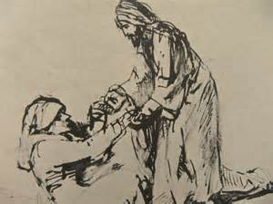

Restored to Serve
5th Sunday after Epiphany
February 8th, 2015
Trinity Lutheran Church, Truman MN

Holy Communion, Setting 10
Evangelical Lutheran Worship, ELW p. 203
GATHERING

Congregation reads bold print *Please stand

PRELUDE
GATHERING REFLECTION
The focus of Psalm 147 is God as both the agent of creation and the ongoing active (very active!) agent in the healing of the world. How amazing it is that the one who is the mighty and powerful creator (vs. 5) is also the one who heals the brokenhearted and binds up their wounds (vs. 3). The one who determines the number of the stars and calls them each by name (vs. 4) is also the one who builds up Jerusalem (the local community) and gathers the exiles of Israel (the faith community) (vs. 2). This incarnational revelation that began at Christmas continues into this season of Epiphany. Despite the creative power of this one (vs. 8-9), God’s pleasure is not in the usual ways the world expresses power (vs. 10). Instead, the Lord delights in those who fear him and who put their hope in his unfailing love (vs. 11). Creative God, We praise you who possesses such an intriguing and life-giving combination of characteristics. Heal us and our communities. Amen.

BELL
WELCOME & ANNOUNCEMENTS
*CONFESSION & FORGIVENESS
L: Let us make confession of our sins and receive God’s forgiveness. Silence for Reflection
L: God our Maker and Redeemer,
C: we are wounded and left for dead by the power of sin. Forgive us, heal us and restore us to the life you have intended for us. Take us by the hand and make us stand in your righteousness. In the name of Jesus Christ, our Savior and Lord, Amen.
L: God, in his love and compassion for us, does desire to make us whole. In his grace and mercy he redeems you and brings you back into a right relationship with him. In the stead of Christ, I declare the forgiveness of all your sins, in the name of the Father, and of the Son, and of the Holy Spirit.
C: Amen.

*GATHERING HYMN Thy Holy Wings ELW #613
*KYRIE ELW p. 203
*HYMN OF PRAISE ELW p. 204
* PRAYER OF THE DAY L: The Lord be with you. C: And also with you.
L: Everlasting God,
C: you give strength to the weak and power to the faint. Make us agents of your healing and wholeness, that your good news may be made known to the ends of your creation, through Jesus Christ, our Savior and Lord. Amen.
WORD

FIRST READING Isaiah 40:21-31 (NRSV)
Have you not known? Have you not heard? Has it not been told you from the beginning? Have you not understood from the foundations of the earth? ²² It is he who sits above the circle of the earth, and its inhabitants are like grasshoppers; who stretches out the heavens like a curtain, and spreads them like a tent to live in; ²³ who brings princes to naught, and makes the rulers of the earth as nothing. ²⁴ Scarcely are they planted, scarcely sown, scarcely has their stem taken root in the earth, when he blows upon them, and they wither,
and the tempest carries them off like stubble. ²⁵ To whom then will you compare me, or who is my equal? says the Holy One. ²⁶ Lift up your eyes on high and see: Who created these? He who brings out their host and numbers them, calling them all by name; because he is great in strength, mighty in power, not one is missing. ²⁷ Why do you say, O Jacob, and speak, O Israel, “My way is hidden from the Lord, and my right is disregarded by my God”?
²⁸ Have you not known? Have you not heard? The Lord is the everlasting God, the Creator of the ends of the earth. He does not faint or grow weary; his understanding is unsearchable.
²⁹ He gives power to the faint, and strengthens the powerless.
³⁰ Even youths will faint and be weary, and the young will fall exhausted; ³¹ but those who wait for the Lord shall renew their strength, they shall mount up with wings like eagles, they shall run and not be weary, they shall walk and not faint.

Word of God, Word of Life. C: Thanks be to God.

PSALM 147:1-11, 20c (read responsively bold type)
¹ Praise the Lord! How good it is to sing praises to our God;
for he is gracious, and a song of praise is fitting.

² The Lord builds up Jerusalem;
he gathers the outcasts of Israel.

³ He heals the brokenhearted,
and binds up their wounds.

⁴ He determines the number of the stars;
he gives to all of them their names.

⁵ Great is our Lord, and abundant in power;
his understanding is beyond measure.

⁶ The Lord lifts up the downtrodden;
he casts the wicked to the ground.
⁷ Sing to the Lord with thanksgiving;
make melody to our God on the lyre.

⁸ He covers the heavens with clouds,
prepares rain for the earth, makes grass grow on the hills.

⁹ He gives to the animals their food,
and to the young ravens when they cry.

¹⁰ His delight is not in the strength of the horse,
nor his pleasure in the speed of a runner;

¹¹ but the Lord takes pleasure in those who fear him,
in those who hope in his steadfast love.

²⁰ He has not dealt thus with any other nation;
they do not know his ordinances. Praise the Lord!

Choir Anthem: Amazing Grace/Pachelbel's Canon

SECOND READING 1 Corinthians 9:16-23 (NRSV)
If I proclaim the gospel, this gives me no ground for boasting, for an obligation is laid on me, and woe to me if I do not proclaim the gospel! ¹⁷ For if I do this of my own will, I have a reward; but if not of my own will, I am entrusted with a commission. ¹⁸ What then is my reward? Just this: that in my proclamation I may make the gospel free of charge, so as not to make full use of my rights in the gospel. ¹⁹ For though I am free with respect to all, I have made myself a slave to all, so that I might win more of them. ²⁰ To the Jews I became as a Jew, in order to win Jews. To those under the law I became as one under the law (though I myself am not under the law) so that I might win those under the law. ²¹ To those outside the law I became as one outside the law (though I am not free from God’s law but am under Christ’s law) so that I might win those outside the law. ²² To the weak I became weak, so that I might win the weak. I have become all things to all people, that I might by all means save some. ²³ I do it all for the sake of the gospel, so that I may share in its blessings.

Word of God, Word of Life. C: Thanks be to God.

* GOSPEL ACCLAMATION Jesus, Remember Me ELW #616

*GOSPEL Mark 1:29-39 C: Glory to you O Lord. As soon as they left the synagogue, they entered the house of Simon and Andrew, with James and John. ³⁰ Now Simon’s mother-in-law was in bed with a fever, and they told him about her at once. ³¹ He came and took her by the hand and lifted her up. Then the fever left her, and she began
To serve them. 32That evening at sunset, they brought to him all who were sick or possessed
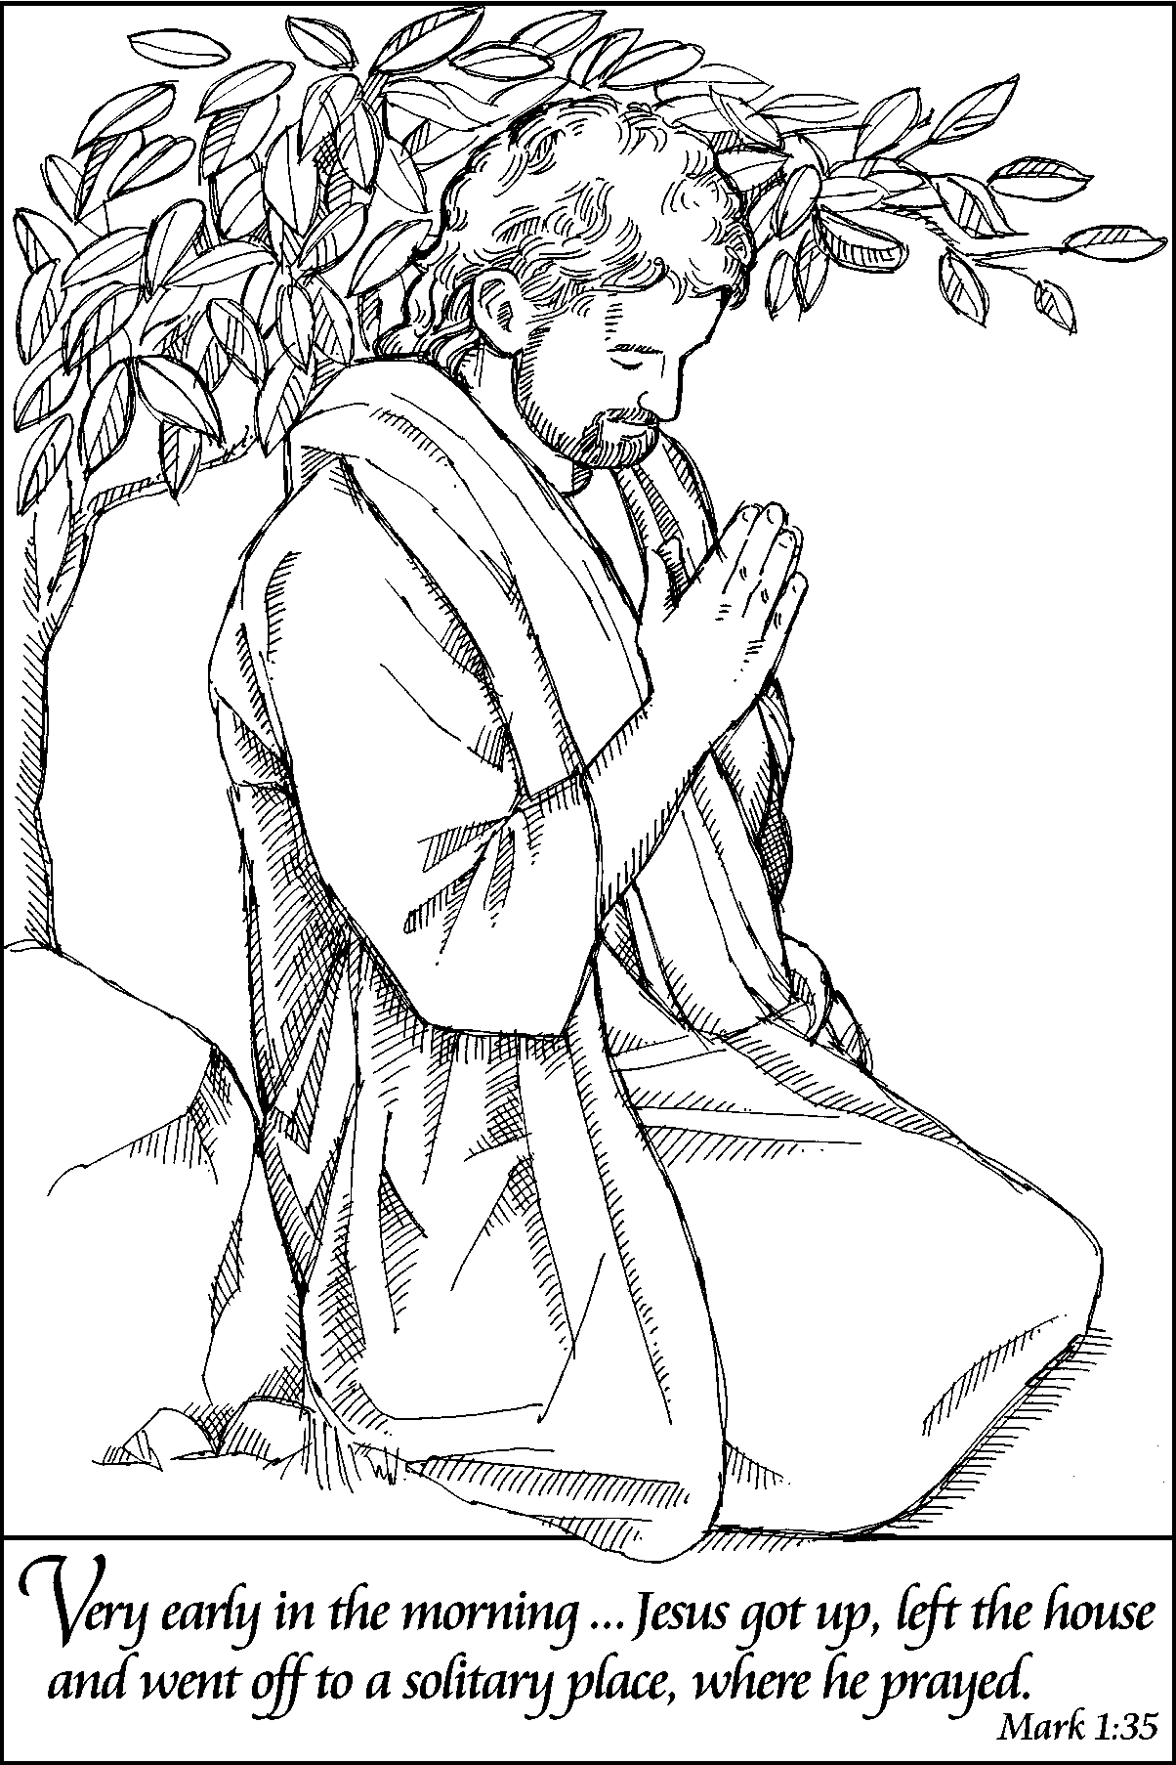
possessed with demons. ³³ And the whole city was gathered around the door. ³⁴ And he cured many who were sick with various diseases, and cast out many demons; and he would not permit the demons to speak, because they knew him. ³⁵ In the morning, while it was still very dark, he got up and went out to a deserted place, and there he prayed. ³⁶ And Simon and his companions hunted for him. ³⁷ When they found him, they said to him, “Everyone is searching for you.” ³⁸ He answered, “Let us go on to the neighboring towns, so that I may proclaim the message there also; for that is what I came out to do.” ³⁹ And he went throughout Galilee, proclaiming the message in their synagogues and casting out demons.

Word of God, Word of Life. C: Praise to you, O Christ.

CHILDREN’S SERMON

SERMON
*HYMN OF THE DAY There Is a Balm in Gilead ELW #614
*APOSTLES’ CREED ELW p. 105
*PRAYERS OF INTERCESSION L: Lord in your mercy, C: hear our prayer.
L: The peace of the Lord be with you always. C: And also with you.

MEAL
OFFERING
*OFFERING HYMN Create in Me a Clean Heart ELW# 188
OFFERING PRAYER
*THE GREAT THANKSGIVING ELW p. 206
Holy, Holy, Holy
*WORDS OF INSTITUTION
*THE LORD’S PRAYER Sung
LAMB OF GOD ELW p. 208
THE DISTRIBUTION
All who believe that Jesus Christ is Lord and Savior are welcome to receive Christ’s meal.

SENDING

*BLESSING L: The God of all grace bless you now and forever. In the name of the Father, and of the Son, and of the Holy Spirit.
Three-Fold Amen.

*SENDING HYMN Guide Me Ever, Great Redeemer ELW #618
*BELL/SENDING L: Go in peace. Serve the Lord C: Thanks be to God!
POSTLUDE
Reprinted from Evangelical Lutheran Worship, copyright © 2006 Augsburg Fortress. All rights reserved. Used by permission of Augsburg Fortress license #SB107041

The work of community, love, reconciliation, restoration is the work we cannot leave up to politicians. This is the work we are all called to do. ~ Shane Claiborne

Readings for next Sunday: 2 Kings 2:1-12; Psalm 50:1-6; 2 Corinthians 4:3-6; Mark 9:2-9


We remember in our prayers…all who face catastrophic illness, surgery, and bindings of all kinds as well as the homebound: Bea Behrens, Vi Benoy, Agnes Carlson, Butch Ratike, Lisa Carlson & family, Donna Fisk, Katherine Moeller (sister of Erin Krumwiede), Chris Mosloski, Rhonda Bonk, Oakley Selnes and family, and Danny Lang. Be present with your Spirit, Lord, and lead us to be your presence to all. Amen.
THIS WEEK IN OUR PARISH

MONDAY, FEBRUARY 9-WELCA Meeting at 1:30 pm. Lois Circle serves
TUESDAY, FEBRUARY 10 Vicar Kent at Luther Seminary for class
WEDNESDAY, FEBRUARY 11-6 pm Choir practice
Church Council Meeting at 7 pm

SUNDAY, FEBRUARY 15

9 AM Worship-Baptism of Tyler Michael Splinter

10 AM Sunday School
Reader: Amy Mohwinkel, Acolyte: TBA
Ushers: *Chad Hastad, Grant Hartman, Darrel Drevlow and John Zaharia
FOR YOUR INFORMATION

Equipping Congregations will be held on Saturday, February 28th from 8:30-3:30 pm, in Willmar. Complete online registration or mail payment by Feb. 13. As anyone who has ever attended will tell you, this is an amazing event that both empowers and informs. Anyone interested in attending, please sign up on the table in the narthex. More information is on the Kiosk.
ASH WEDNSDAY Communion Worship is February 18th at 7 PM. There are Lenten Schedules on the table in the narthex. They are purple colored.

rinity Lutheran Church
Office Phone 776-4781, Fax 776-7888,
Office Hours: Mon-8-11, Wed 8-11 & 1-4, F-8-11 am
Email: trinitytruman@frontier.com, Website: www.trinity-truman.org
Interim Kent Krumwiede-Cell #: (507) 848-7192, Email: vicarkent@gmail.com
Office Hours Mon—Thurs 9:00-1:00 pm

