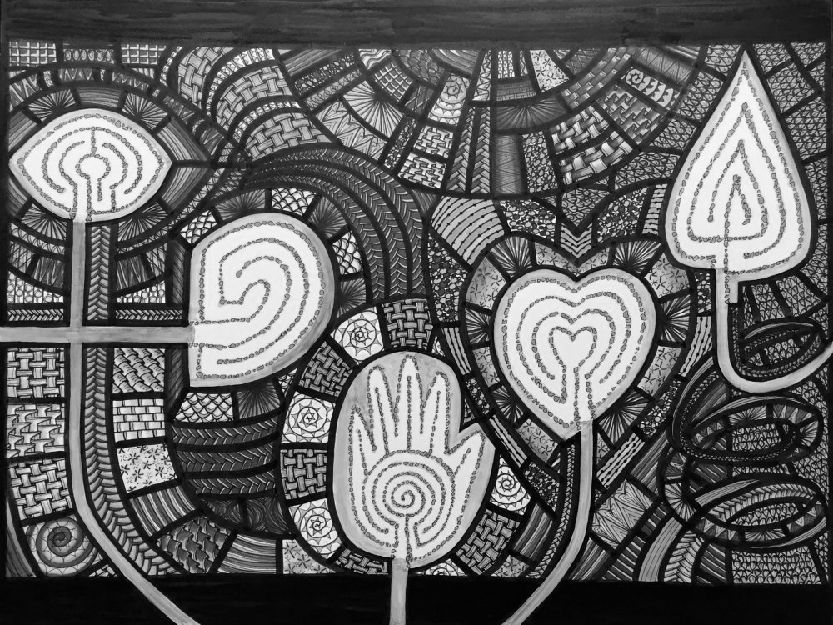

***Your Kingdom Come, Your will be done***

**2nd Sunday in Lent**

**February 21, 2016**

**Evangelical Lutheran Worship, Setting 4**

**Trinity Lutheran Church**

Office Phone 776-4781, Fax 776-7888, Office Hours: Mon 8-11, Wed 8-11 & 1-4, Fri. 8-11 am

 Email: [trinitytruman@frontier.com](mailto:trinitytruman@frontier.com), Website: [www.trinity-truman.org](http://www.trinity-truman.org)

**Pastor Krista Strum**-Cell-(507) 995-1233, Email: [pkstrumom@me.com](mailto:pkstrumom@me.com)

Pastor Krista’s Hours: Wed. 11-2:30 pm & Thurs. 8:30-2:30 pm

**GATHERING**

*Congregation reads* ***bold print*** *\*Please stand*

**PRELUDE**

**BELL**

**WELCOME & ANNOUNCEMENTS**

**\*CONFESSION & FORGIVENESS-Lenten Confession**

Gracious and merciful God, we confess to you our reluctance to enter the wilderness places where we are confronted with our true selves.  The places where we are tempted to put worldly values before our desire for you, and when our hunger for power and wealth is greater than our hunger for seeking and doing your will:

**Merciful God,save us from temptation and deliver us from** **evil.**

**Forgive us our sins and fill us with the joy and peace of your** **salvation.**

**So strengthen us with your Spirit during this Lenten season**

**that we put our whole trust in you as confidently as Jesus did.**

**This we pray in his name.  Amen**

**Words of Forgiveness**

Have faith be of good courage - your sins are forgiven in the name of Jesus. **Amen**

**GATHERING SONG***God of Grace and God of Glory* **ELW #705**

**\*GREETING ELW p. 147**

**\*KYRIE**

**\*PRAYER OF THE DAY**

L: Let us pray,

**God of the covenant, in the mystery of the cross you promise everlasting life to the world. Gather all peoples into your arms, and shelter us with your mercy, that we may rejoice in the life we share in your Son, Jesus Christ, our Savior and Lord, who lives and reigns with you and the Holy Spirit, one God, now and forever. Amen.**

**WORD**

**SCRIPTURE READINGS: Micah 6:6-8**

6"With what shall I come before the LORD,  and bow myself before God on high?  Shall I come before him with burnt offerings,  with calves a year old?  7Will the LORD be pleased with thousands of rams,  with ten thousands of rivers of oil? Shall I give my firstborn for my transgression,  the fruit of my body for the sin of my soul?"  8He has told you, O mortal, what is good;  and what does the LORD require of you  but to do justice, and to love kindness, and to walk humbly with your God?

**Luke 11:1-4** A reading from Luke.

He was praying in a certain place, and after he had finished, one of his disciples said to him,

"Lord, teach us to pray, as John taught his disciples." 2He said to them, "When you pray, say:  Father, hallowed be your name.

 Your kingdom come.

 3Give us each day our daily bread.

 4And forgive us our sins,

 for we ourselves forgive everyone indebted to us.

 And do not bring us to the time of trial."

Word of God, Word of Life. **C: Thanks be to God.**

**\*GOSPEL ACCLAMATION** *Return To the Lord…*  **ELW p. 151**

* **GOSPEL READINGS :  C: Glory to you O Lord.**

**Luke 17:20-21**

20Once Jesus was asked by the Pharisees when the kingdom of God was coming, and he answered, "The kingdom of God is not coming with things that can be observed; 21nor will they say, 'Look, here it is!' or 'There it is!' For, in fact, the kingdom of God is among you."

**Mark 14:32-36**

32They went to a place called Gethsemane; and he said to his disciples, "Sit here while I pray." 33He took with him Peter and James and John, and began to be distressed and agitated. 34And he said to them, "I am deeply grieved, even to death; remain here, and keep awake." 35And going a little farther, he threw himself on the ground and prayed that, if it were possible, the hour might pass from him. 36He said, "Abba, Father, for you all things are possible; remove this cup from me; yet, not what I want, but what you want."

The Gospel of our Lord. **Thanks be to God.**

**SERMON**

**HYMN OF THE DAY***In the Cross of Christ I Glory*   **ELW #324**

**\*PRAYERS OF INTERCESSION** *Lord, Listen to Your Children Praying* **ELW #752**

**\*SHARING OF THE PEACE**

L: The peace of the Lord be with you always. **C: And also with you.**

**OFFERING**

**\*OFFERING HYMN** *Create in Me a Clean Heart***ELW #188**

**\*OFFERING PRAYER** Let us pray.

**God our provider, you have not fed us with bread alone, but with words of grace and life. Bless us and these your gifts, which we receive from your bounty, through Jesus Christ our Lord. Amen.**

**\*LORD’S PRAYER** *SALMON sheet on the back cover of the hymnal or*  **ELW p. 154**

**SENDING**

**BLESSING**

The blessing of God Almighty, the wisdom and power of ☩ Christ Jesus,

and the light of the Holy Spirit be among you and remain with you always. **Amen.**

***Three-Fold Amen.***

**SENDING SONG***All Hail the Power of Jesus' Name!* **ELW #634**

**BELL SENDING** L: Go in peace. Serve the Lord. **C: Thanks be to God!**

**+++++++++++++++++++++++++++++++++++++++++++++++++++++++++++++++++++++++**

Reprinted from Evangelical Lutheran Worship, copyright © 2006 Augsburg Fortress. All rights reserved. Used by permission of Augsburg Fortress license #SB107041 New Revised Standard Version Bible, copyright © 1989, Division of Christian Education of the National Council of the Churches of Christ in the United States of America. Used by permission. All rights reserved.

**Readings for next Sunday: Isaiah 55:1-9, Ps. 63:1-8, 1 Cor. 10:1-13, Luke 13:1-9**

*We remember in our prayers…all who face catastrophic illness, surgery, and bindings of all kinds as well as the homebound:* ***Bea Behrens, Agnes Carlson, Lisa******Carlson & family, Donna Fisk, and Danny Lang.*** *Be present with your Spirit, Lord, and lead us to be your presence to all. Amen.*

**ANNOUNCEMENTS**

**F.Y.I.** Quilting Days are cancelled for Monday & Tuesday Feb. 22 & 23rd

**TUESDAY FEBRUARY 23**-Bingo at Luther Memorial Home at 1:30

**WEDNESDAY, FEBRUARY 24**-Lenten Worship at Madelia at 7:00 pm (A Community meal will be served at 5:30 before worship)

**FRIDAY & SATURDAY FEB. 26 & 27**-Pat Jones Scrapbooking at the church

**SUNDAY, FEBRUARY 28**-“Give Us This Day Our Daily Bread”

9-10:00 Sunday School, 10-10:30 Gathering time w/kid friendly snacks

10:30 Communion Worship

*Reader: Clayton Duncanson,*

*Ushers: *Duke Drevlow, Troy Harder, Ross Ringeisen and Ricky Davis*

**February 15-19th was National School Board Week** and we want to thank the Trinity Members who are on the Truman School Board for serving and doing this very important job. LeAnn Maloney, Paula Kester, Donna Kotewa, Britta Hartman and Darrell Drevlow.