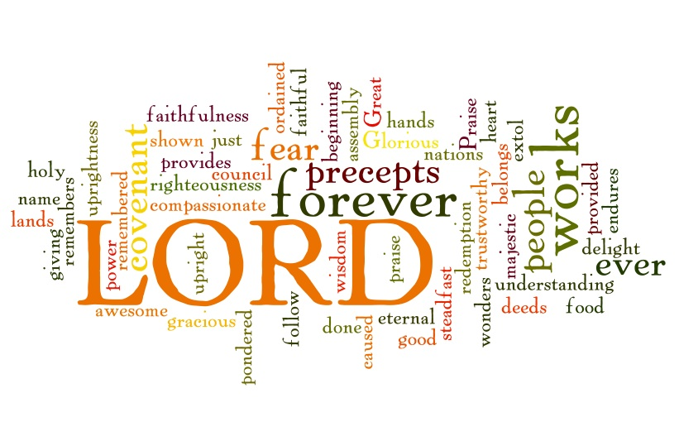
Jesus’ Authority
4th Sunday after Epiphany
February 1st, 2015
Trinity Lutheran Church, Truman MN

Holy Communion, Setting 10
Evangelical Lutheran Worship, ELW p. 203
GATHERING

Congregation reads bold print *Please stand

PRELUDE
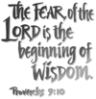
GATHERING REFLECTION
Everyone seems to have a different idea of what is meant by “wisdom.” Some might say it is being able to judge right, common sense. For others, it is knowledge. According to the Bible, it is a little of both. Wisdom in the Old Testament, "sakal," means "to be circumspect and hence intelligent" God in the Bible tells us where to get it: "The fear of the LORD is the beginning of wisdom; all who follow his precepts have good understanding. To him belongs eternal praise" [Psalm 111:10]. The proverbs of Solomon tell us: “For learning about wisdom and instruction, for understanding words of insight" [Proverbs 1:2]. So you get true wisdom by fearing God, which is showing respect for who He is by simply reading and obeying His precious Words. Reading the books of Psalms and Proverbs and taking their words to heart promises to fill a person with true wisdom. God of Wisdom, teach me to know you and gain wisdom for living. Amen.\

BELL
WELCOME & ANNOUNCEMENTS
*CONFESSION & FORGIVENESS
L: Let us make confession of our sins and receive God’s forgiveness.
Silence for Reflection
L: God and Father of our Lord and Savior, Jesus Christ,
C: we confess that we are enslaved by sin and fear, we trust what we see instead of you. Forgive us, renew us and free us from our demons so we might lead a life of dedication to you. In Jesus’ name, Amen.
L: In God’s great mercy, we are forgiven and restored to a new and whole life in Christ. In the name of the Triune God, be encouraged.
C: Amen.

*GATHERING HYMN Arise, Your Light has Come ELW #314
*KYRIE ELW p. 203
*HYMN OF PRAISE ELW p. 204
* PRAYER OF THE DAY L: The Lord be with you. C: And also with you.
L: Almighty and ever-living God,
C: your only-begotten Son was presented this day in the temple. May we be presented to you with clean and pure hearts by the same Jesus Christ, our great high priest, who lives and reigns with you and the Holy Spirit, one God, now and forever. Amen.
WORD

FIRST READING Deuteronomy 18:15-20 (NRSV)
The Lord your God will raise up for you a prophet like me from among your own people; you shall heed such a prophet. ¹⁶ This is what you requested of the Lord your God at Horeb on the day of the assembly when you said: “If I hear the voice of the Lord my God any more, or ever again see this great fire, I will die.” ¹⁷ Then the Lord replied to me: “They are right in what they have said. ¹⁸ I will raise up for them a prophet like you from among their own people; I will put my words in the mouth of the prophet, who shall speak to them everything that I command. ¹⁹ Anyone who does not heed the words that the prophet shall speak in my name, I myself will hold accountable. ²⁰ But any prophet who speaks in the name of other gods, or who presumes to speak in my name a word that I have not commanded the prophet to speak—that prophet shall die.”

Word of God, Word of Life. C: Thanks be to God.

PSALM 111 (read responsively bold type)
¹ Praise the Lord! I will give thanks to the Lord with my whole heart,
in the company of the upright, in the congregation.
² Great are the works of the Lord,
studied by all who delight in them.
³ Full of honor and majesty is his work,
and his righteousness endures forever.
⁴ He has gained renown by his wonderful deeds;
the Lord is gracious and merciful.
⁵ He provides food for those who fear him;
he is ever mindful of his covenant.
⁶ He has shown his people the power of his works,
in giving them the heritage of the nations.
⁷ The works of his hands are faithful and just;
all his precepts are trustworthy.
⁸ They are established forever and ever,
to be performed with faithfulness and uprightness.
⁹ He sent redemption to his people; he has commanded his covenant forever.
Holy and awesome is his name.
¹⁰ The fear of the Lord is the beginning of wisdom; all those who practice it have a good
understanding.
His praise endures forever.

SECOND READING 1 Corinthians 8:1-13 (NRSV)
Now concerning food sacrificed to idols: we know that “all of us possess knowledge.” Knowledge puffs up, but love builds up. ² Anyone who claims to know something does not yet have the necessary knowledge; ³ but anyone who loves God is known by him. ⁴ Hence, as to the eating of food offered to idols, we know that “no idol in the world really exists,” and that “there is no God but one.” ⁵ Indeed, even though there may be so-called gods in heaven or on earth—as in fact there are many gods and many lords— ⁶ yet for us there is one God, the Father, from whom are all things and for whom we exist, and one Lord, Jesus Christ, through whom are all things and through whom we exist. ⁷ It is not everyone, however, who has this knowledge. Since some have become so accustomed to idols until now, they still think of the food they eat as food offered to an idol; and their conscience, being weak, is defiled. ⁸ “Food will not bring us close to God.” We are no worse off if we do not eat, and no better off if we do. ⁹ But take care that this liberty of yours does not somehow become a stumbling block to the weak. ¹⁰ For if others see you, who possess knowledge, eating in the temple of an idol, might they not, since their conscience is weak, be encouraged to the point of eating food sacrificed to idols? ¹¹ So by your knowledge those weak believers for whom Christ died are destroyed. ¹² But when you thus sin against members of your family, and wound their conscience when it is weak, you sin against Christ. ¹³ Therefore, if food is a cause of their falling, I will never eat meat, so that I may not cause one of them to fall.

Word of God, Word of Life. C: Thanks be to God.

* GOSPEL ACCLAMATION Jesus, Remember Me ELW #616

*GOSPEL Mark 1:21-28 C: Glory to you O Lord.
²¹ They went to Capernaum; and when the sabbath came, he entered the synagogue and taught. ²² They were astounded at his teaching, for he taught them as one having authority, and not as the scribes. ²³ Just then there was in their synagogue a man with an unclean spirit, ²⁴ and he cried out, “What have you to do with us, Jesus of Nazareth? Have you come to destroy us? I know who you are, the Holy One of God.” ²⁵ But Jesus rebuked him, saying, “Be silent, and come out of him!” ²⁶ And the unclean spirit, convulsing him and crying with a loud voice, came out of him. ²⁷ They were all amazed, and they kept on asking one another, “What is this? A new teaching—with authority! He commands even the unclean spirits, and they obey him.” ²⁸ At once his fame began to spread throughout the surrounding region of Galilee.

Word of God, Word of Life. C: Praise to you, O Christ.

CHILDREN’S SERMON

SERMON
*HYMN OF THE DAY Songs of Thankfulness and Praise ELW #310
*APOSTLES’ CREED ELW p. 105
*PRAYERS OF INTERCESSION L: Lord in your mercy, C: hear our prayer.
L: The peace of the Lord be with you always. C: And also with you.

MEAL
OFFERING
*OFFERING HYMN Create in Me a Clean Heart ELW# 188
OFFERING PRAYER
*THE GREAT THANKSGIVING ELW p. 206
Holy, Holy, Holy
*WORDS OF INSTITUTION
*THE LORD’S PRAYER Sung
LAMB OF GOD ELW p. 208
THE DISTRIBUTION
All who believe that Jesus Christ is Lord and Savior are welcome to receive Christ’s meal.

SENDING

*BLESSING L: The God of all grace bless you now and forever. In the name of the Father, and of the Son, and of the Holy Spirit.
Three-Fold Amen.

*SENDING HYMN O Lord, Now Let Your Servant ELW #313
*BELL/SENDING L: Go in peace. Serve the Lord C: Thanks be to God!
POSTLUDE
++++++++++++++++++++++++++++++++++++++++++++++++++++++++
Reprinted from Evangelical Lutheran Worship, copyright © 2006 Augsburg Fortress. All rights reserved. Used by permission of Augsburg Fortress license #SB107041

If you want a love message to be heard, it has got to be sent out.
To keep a lamp burning, we have to keep putting oil in it. ~Mother Teresa

Readings for next Sunday: Isaiah 40:21-31; Ps 147:1-11, 20c; 1 Cor 9:16-23; Mark 1:29-39

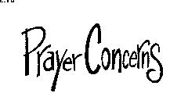
We remember in our prayers…all who face catastrophic illness, surgery, and bindings of all kinds as well as the homebound: Bea Behrens, Vi Benoy, Agnes Carlson, Butch Ratike, Lisa Carlson & family, Donna Fisk, Katherine Moeller (sister of Erin Krumwiede), Chris Mosloski, Rhonda Bonk, Oakley Selnes and family, and Danny Lang. Be present with your Spirit, Lord, and lead us to be your presence to all. Amen.

ANNOUNCEMENTS


Check your mailboxes for the February Messenger!

THIS WEEK IN OUR PARISH

MONDAY, FEBRUARY 2-Martha Circle meets at Barb Shoen’s at 1:30 pm
TUESDAY, FEBRUARY 3-WELCA is Gluing Cards at 9:30 am
Vicar Kent at Luther Seminary for class and Senior event.
WEDNESDAY, FEBRUARY 4-6 pm Choir practice
THURSDAY, FEBRUARY 5-Open Bible Study/Lois Circle meets at the Truman Café at 9 am.

SUNDAY, FEBRUARY 8

9 AM Communion Worship

10 AM Sunday School
Reader: Carolyn Drevlow, Comm. Server: Mark Durkee, Acolyte: Kylee Harder
Ushers: *Chad Hastad, Grant Hartman, Darrel Drevlow and John Zaharia
FOR YOUR INFORMATION
The church directory in the annual report (the purple section) had a lot of computer glitches in it. If you would like a revised version with cell and email addresses, please contact the church office and request a copy.

Equipping Congregations will be held on Saturday, February 28th from 8:30-3:30 pm, in Willmar. Complete online registration or mail payment by Feb. 13. As anyone who has ever attended will tell you, this is an amazing event that both empowers and informs. Anyone interested in attending, please sign up on the table in the narthex. More information is on the Kiosk.


rinity Lutheran Church
Office Phone 776-4781, Fax 776-7888,
Office Hours: Mon-8-11, Wed 8-11 & 1-4, F-8-11 am
Email: trinitytruman@frontier.com, Website: www.trinity-truman.org
Interim Kent Krumwiede-Cell #: (507) 848-7192, Email: vicarkent@gmail.com
Office Hours Mon—Thurs 9:00-1:00 pm

