

***Trinity Choir Concert***

**2nd Sunday in Advent**

**December 6, 2015**

**Holy Communion, Setting 8**

**Evangelical Lutheran Worship**

**Trinity Lutheran Church**

Office Phone 776-4781, Fax 776-7888, Office Hours: Mon 8-11, Wed 8-11, 1-4, Fri. 8-11 am

 Email: [trinitytruman@frontier.com](mailto:trinitytruman@frontier.com), Website: [www.trinity-truman.org](http://www.trinity-truman.org)

**Pastor Krista Strum**-Cell-(507) 995-1233, Email: [pkstrumom@me.com](mailto:pkstrumom@me.com)

Pastor Krista’s Hours: Wed. 11-2:30 pm & Thurs. 8:30-2:30 pm

**GATHERING**

*Congregation reads* ***bold print*** *\*Please stand*

**PRELUDE**

**BELL**

**WELCOME & ANNOUNCEMENTS**

**LIGHTING THE ADVENT WREATH-Second Sunday of Advent**

L: “Today we light the first and second candles of the Advent wreath. Each candle has a meaning. The first candle is HOPE, the second candle is PEACE.”

*The candles are lit.*

L: Let us read Isaiah 55:12 together.

**C; You will go out in joy and be led forth in peace; the mountains and hills will burst into song before you, and all the trees of the field will clap their hands.”**

L: Let us pray together:

**C: O God of grace and comfort, in you we find rest for our hearts and peace for our souls. In these times of uncertainty, grant us peace in our lives, peace in this community, and peace in the world. Through Jesus Christ, who is the prince of peace. Amen.**

hope

peace joy love

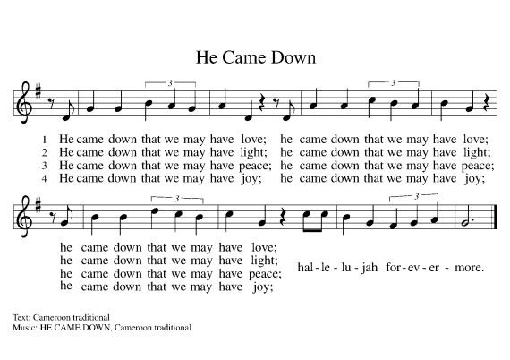

hope

peace joy love

hope

peace joy love

**\*CONFESSION & FORGIVENESS**

Blessed be the holy Trinity, ☩ one God, the Lord of Israel who comes to set us free,

the mighty Savior who comes to show mercy, the Dawn from on high who guides us into peace. **Amen.**

Let us come before God in confession.

To you, O God,

**we lift up our souls. You know us through and through; we confess our sins to you.**

**Remember not our sins; remember us with your steadfast love. Show us your ways;**

**teach us your paths; and lead us in justice and truth, for the sake of your goodness**

**in Jesus Christ our Savior. Amen.**

Sisters and brothers, come with joy and draw water from the well of salvation. Remember the gift of baptism: your sin is washed away in the name of ☩ Jesus; you belong to Christ;

you are anointed to serve. Stand up and raise your heads!

The reign of God is near. **Amen.**

**\*GATHERING HYMN** *Prepare A Royal Highway*  **ELW #264**

**\*GREETING ELW p. 184**

**CHOIR ANTHEM “Were You There”**

**\*PRAYER OF THE DAY** L: The Lord be with you. **C: And also with you.**

L: Let us pray,

**Stir up our hearts, Lord God, to prepare the way of your only Son. By his coming give to all the people of the world knowledge of your salvation; through Jesus Christ, our Savior and Lord, who lives and reigns with you and the Holy Spirit, one God, now and forever. Amen.**

**WORD**

**FIRST READING: Philippians 1:3-11**

3I thank my God every time I remember you, 4constantly praying with joy in every one of my prayers for all of you, 5because of your sharing in the gospel from the first day until now. 6I am confident of this, that the one who began a good work among you will bring it to completion by the day of Jesus Christ. 7It is right for me to think this way about all of you, because you hold me in your heart, for all of you share in God’s grace with me, both in my imprisonment and in the defense and confirmation of the gospel. 8For God is my witness, how I long for all of you with the compassion of Christ Jesus. 9And this is my prayer, that your love may overflow more and more with knowledge and full insight 10to help you to determine what is best, so that in the day of Christ you may be pure and blameless, 11having produced the harvest of righteousness that comes through Jesus Christ for the glory and praise of God.

Word of God, Word of Life. **C: Thanks be to God.**

**PSALM: Luke 1:68-79** (*Please read responsively the* ***bold*** *print)*

68“Blessed be the Lord God of Israel, for he has looked favorably on his people and

redeemed them.

**69He has raised up a mighty savior for us in the house of his servant David,**

70 as he spoke through the mouth of his holy prophets from of old,

**71that we would be saved from our enemies and from the hand of all who hate us.**

72 Thus he has shown the mercy promised to our ancestors, and has remembered his holy

covenant,

**73the oath that he swore to our ancestor Abraham, to grant us**

74that we, being rescued from the hands of our enemies, might serve him without fear,

**75 in holiness and righteousness before him all our days.**

76 And you, child, will be called the prophet of the Most High; for you will go before the

Lord to prepare his ways,

**77to give knowledge of salvation to his people by the forgiveness of their sins.**

78By the tender mercy of our God,the dawn from on high will break upon us,

**79to give light to those who sit in darkness and in the shadow of death, to guide**

**our feet into the way of peace.”**

**CHOIR ANTHEM – “Little Bitty Baby”**

**\*GOSPEL ACCLAMATION** *Alleluia Lord, to whom shall we go* **ELW p. 188**

\***GOSPEL: Luke 3:1-6**

The holy gospel according to Luke. **Glory to you, O Lord.**

1In the fifteenth year of the reign of Emperor Tiberius, when Pontius Pilate was governor of Judea, and Herod was ruler of Galilee, and his brother Philip ruler of the region of Ituraea and Trachonitis, and Lysanias ruler of Abilene, 2during the high priesthood of Annas and Caiaphas, the word of God came to John son of Zechariah in the wilderness. 3He went into all the region around the Jordan, proclaiming a baptism of repentance for the forgiveness of sins, 4as it is written in the book of the words of the prophet Isaiah, “The voice of one crying out in the wilderness:

‘Prepare the way of the Lord,

make his paths straight.

5Every valley shall be filled,

and every mountain and hill shall be made low,

and the crooked shall be made straight,

and the rough ways made smooth;

6and all flesh shall see the salvation of God.’ ”

Word of God, Word of Life. **C: Praise to you, O Christ.**

SERMON

\***HYMN OF THE DAY** ***On Jordan’s Bank the Baptist’s Cry***  **ELW #249**

**\*PEACE** L: The peace of Christ be with you always. **C: And also with you.**

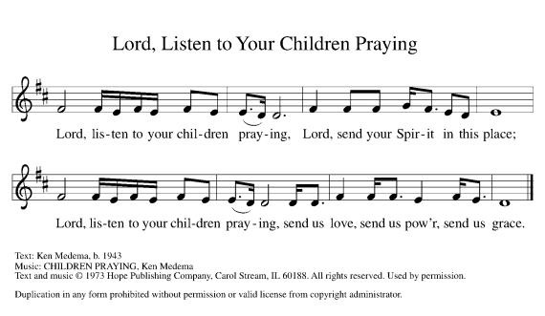**\* PRAYERS OF INTERCESSION *Lord, Listen to Your Children Praying***

**OFFERING ANTHEM-“The Little Drummer Boy”**

**\*OFFERING HYMN** *Create in Me a Clean Heart***ELW #186**

**\*OFFERING PRAYER** God of abundance,

**We bring before you the precious fruits of your creation, and with them our very lives.**

**Teach us patience and hope as we care for all those in need until the coming of your Son, our Savior and Lord. Amen.**

**MEAL**

**\*GREAT THANKSGIVING ELW p. 190**

**\*LORD’S PRAYER ELW p. 191****COMMUNION INVITATION** *all are welcome to join us to receive the body and blood of our risen Lord.*

**COMMUNION SONG**  *Eat This Bread* **ELW #472**

**POST COMMUNION PRAYER** Let us pray.

**God for whom we wait, in this meal you give us a foretaste of that day when the hungry will be fed with good things. Send us forth to make known your deeds and to proclaim the greatness of your name, through Jesus Christ, our Savior and Lord. Amen.**

**SENDING**

**BLESSING**

***Three-Fold Amen.***

**\*CHOIR ANTHEM/SENDING HYMN-“Festival of Carols”**

**BELL SENDING** L: Go in peace. Serve the Lord. **C: Thanks be to God!**

**POSTLUDE +++++++++++++++++++++++++++++++++++++++++++++++++++++++++++++++++**Reprinted from Evangelical Lutheran Worship, copyright © 2006 Augsburg Fortress. All rights reserved. Used by permission of Augsburg Fortress license #SB107041 New Revised Standard Version Bible, copyright © 1989, Division of Christian Education of the National Council of the Churches of Christ in the United States of America. Used by permission. All rights reserved.

**Readings for next Sunday: Sunday School Program**

*We remember in our prayers…all who face catastrophic illness, surgery, and bindings of all kinds as well as the homebound:* ***Bea Behrens, Agnes Carlson, Lisa******Carlson & family, Donna Fisk, and Danny Lang.*** *Be present with your Spirit, Lord, and lead us to be your presence to all. Amen.*

**ANNOUNCEMENTS**

Thank you to all those who baked cookies, donated money and volunteered to work for Trinity’s Cookie Walk. A big thank you to Pam Rode, Cathy Sorenson, JoAnn Quade for planning and organizing the event.

Thank you to those who donated the poinsettia’s for our Advent/Christmas season. Special thanks to Yvonne Noorlun and Jan Warrington for setting up the display of plants:

David & Tonia Kahler Howard & LuElla Kautz Connie Selnes

Tom Dodge David & Cathy Sorenson Veryle & Joan Williamson

Norman & Marilyn Anderson Barb Shoen Dorothy Graham

Dean & Bev Gulbranson Jerry Teig Doyle & Arlene Peterson

JoAnn Knutson Jim & Brenda Hansen Jan Warrington

Gene & Barb Mager Lowell & Yvonne Noorlun

**TODAY:** The Trinity Youth will be hauling more books from the School Library to the church. This should only take about a half an hour.

The December Messenger is here!! Check your mailboxes for the green newsletter

**THIS WEEK IN OUR PARISH**

**MONDAY,DECEMBER 7**- Martha Circle dines out at 1:30 pm

**WEDNESDAY, DECEMBER 9**-Church Council meeting at Truman at 7 PM

**SUNDAY, DECEMBER 13-Trinity Sunday School Program**

9-10:00 Sunday School-Christmas program practice

10-10:30 Gathering time w/kid friendly snacks

10:30 Worship- No communion

**The Sunday School Christmas Program will be during worship time.**

 The theme this year is “For God So Loved the World”

*Telling the real Christmas story at an orphanage.*

We will be taking donations for toys to give to the needy.

A light meal will be served afterwards

*Reader: LeAnn Maloney,*

*Ushers: *Dave Kahler, Tommy Kotewa, Denny Jahnz and Zach Jahnz*

**UPCOMING EVENTS**

The Trinity Youth Group will be having a movie night plus they will be decorating cookies on December 19th. Be checking your email for the details!

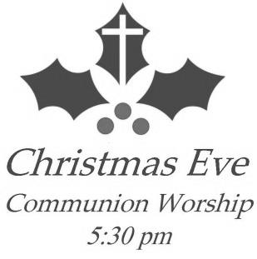

**The Christmas Eve Candlelight Service will be held on**

**December 24th at 5:30 pm**



STEP Inc. has once again brought its green recycle bin in the hallway at the church. Please bring in your old broken light sets, cords, even phone cords.

**OTHER EVENTS**

American Lutheran church of Windom presents a “Living Nativity” on Wednesday, December 9th from 5:30 to 7:30 pm. View the Living Nativity by foot or by car on 10th street East and turn south on Prospect Ave. ride the Horse drawn carriage, Pet the animals (inside and out). In the Skylight court: Holiday Bake Sale by the ALC Youth, Listen to the Music of the Season, Enjoy cider & popcorn. Please bring food or cash donations for our local Sharing Center! Soup and Chili Supper 5-7 pm in the Fellowship Hall-$5 suggested donation—served by ALC Youth.

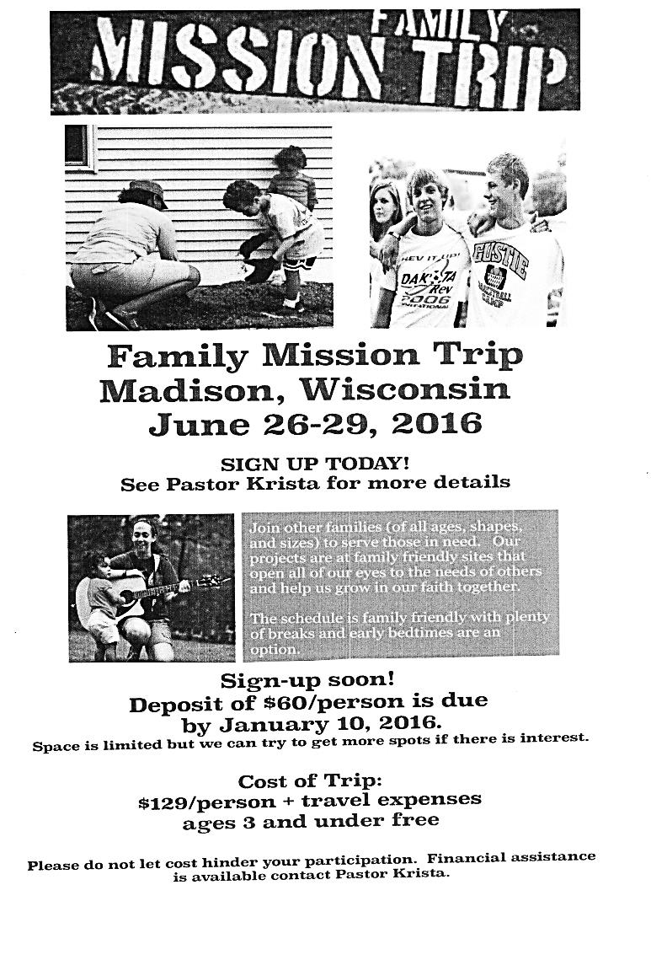****Augustana Lutheran Church in St. James is celebrating St. Lucia Day on Saturday, December 12. This Is a yearly event put on by Augustana for the community to share the Swedish celebration of the Holidays. A Breakfast will be held 6:30-9:00 am. Free will offering. The Christmas Shoppe will be open from 6:30-9:00 am.