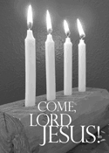

**4th Sunday in Advent**

**December 20, 2015**

**Evangelical Lutheran Worship &**

**Holden Evening Prayer Booklet**

**Trinity Lutheran Church**

Office Phone 776-4781, Fax 776-7888, Office Hours: Mon 8-11, Wed 8-11, 1-4, Fri. 8-11 am

 Email: [trinitytruman@frontier.com](mailto:trinitytruman@frontier.com), Website: [www.trinity-truman.org](http://www.trinity-truman.org)

**Pastor Krista Strum**-Cell-(507) 995-1233, Email: [pkstrumom@me.com](mailto:pkstrumom@me.com)

Pastor Krista’s Hours: Wed. 11-2:30 pm & Thurs. 8:30-2:30 pm

**GATHERING**

*Congregation reads* ***bold print*** *\*Please stand*

**PRELUDE**

**BELL**

**WELCOME & ANNOUNCEMENTS**

**LIGHTING THE ADVENT WREATH-Fourth Sunday of Advent**

L: “Today we light the first, second, third, and fourth candles of the Advent wreath. Each candle has a meaning. The first candle is HOPE, the second candle is PEACE, the third candle is JOY, and the fourth candle is LOVE.”

*The candles are lit.*

L: Let us read Isaiah 55:12 together.

**C: “John 13:34 - Jesus said to them, I give you a new commandment, that you love one another. Just as I have loved you, you also should love one another. By this everyone will know that you are my disciples, if you have love for one another."**

L: Let us pray together:

**C: Loving God, you are the source of all goodness and compassion. Grant that we may see and accept your love, and, following in the footsteps of our Lord Jesus Christ, spread that love to this love-starved world. In the name of the Father, and of the Son, and of the Holy Spirit. Amen.**

hope

peace joy love

hope

peace joy love

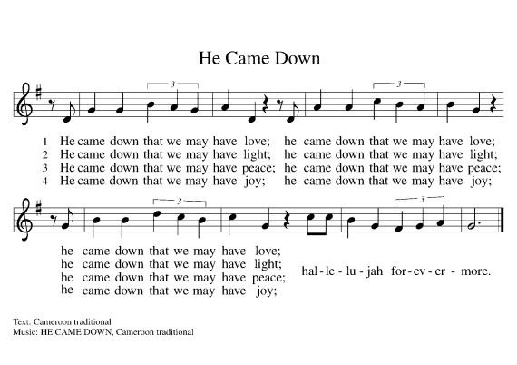

hope

peace joy love

**\*CONFESSION & FORGIVENESS**

Blessed be the holy Trinity, ☩ one God, the Lord of Israel who comes to set us free,

the mighty Savior who comes to show mercy, the Dawn from on high who guides us into peace. **Amen.**

Let us come before God in confession.

To you, O God,

**We lift up our souls. You know us through and through; we confess our sins to you.**

**Remember not our sins; remember us with your steadfast love. Show us your ways;**

**teach us your paths; and lead us in justice and truth, for the sake of your goodness**

**in Jesus Christ our Savior. Amen.**

Sisters and brothers, come with joy and draw water from the well of salvation. Remember the gift of baptism: your sin is washed away in the name of ☩ Jesus; you belong to Christ;

you are anointed to serve. Stand up and raise your heads!

The reign of God is near. **Amen.**

**\*GATHERING HYMN  *O Come, O Come, Emmanuel*** *(verse 5-8)* **ELW #257**

**\*GREETING**

The grace of our Lord Jesus Christ, the love of God, and the communion of the Holy Spirit be with you all. **And also with you.**

**\*PRAYER OF THE DAY** L: The Lord be with you. **C: And also with you.**

L: Let us pray,

**Stir up your power, Lord Christ, and come. With your abundant grace and might, free us from the sin that binds us, that we may receive you in joy and serve you always, for you live and reign with the Father and the Holy Spirit, one God, now and forever. Amen.**

**PSALM - Sung - Holden Evening Prayer page 8**

Luke 1:26-32, 38, 46-55

**CHILDREN'S TIME**

**\*GOSPEL ACCLAMATION ELW p. 188**

\***GOSPEL: Luke 1:39-45 [46-55]**

The holy gospel according to Luke. **Glory to you, O Lord.**

39In those days Mary set out and went with haste to a Judean town in the hill country, 40where she entered the house of Zechariah and greeted Elizabeth. 41When Elizabeth heard Mary’s greeting, the child leaped in her womb. And Elizabeth was filled with the Holy Spirit 42and exclaimed with a loud cry, “Blessed are you among women, and blessed is the fruit of your womb. 43And why has this happened to me, that the mother of my Lord comes to me? 44For as soon as I heard the sound of your greeting, the child in my womb leaped for joy. 45And blessed is she who believed that there would be a fulfillment of what was spoken to her by the Lord.”

Word of God, Word of Life. **C: Praise to you, O Christ.**

SERMON

\***HYMN OF THE DAY** ***O Little Town of Bethlehem* ELW #279**

**\*CREED**

**\* PRAYERS OF INTERCESSION Holden Evening Prayer page 10**

**\*PEACE** L: The peace of Christ be with you always. **C: And also with you.**

**OFFERING**

**\*OFFERING HYMN** *Create in Me a Clean Heart***ELW #186**

**\*OFFERING PRAYER** God of abundance,

**We bring before you the precious fruits of your creation, and with them our very lives.**

**Teach us patience and hope as we care for all those in need until the coming of your Son, our Savior and Lord. Amen.**

**\*LORD’S PRAYER ELW p. 191****SENDING**

**BLESSING**

May God direct your ways in peace, make you abound in love for one another and for all,

and strengthen your hearts until the coming of our Lord Jesus.

Almighty God, Father, ☩ Son, and Holy Spirit, bless you now and forever.

***Three-Fold Amen.***

**SENDING SONG*Joy to the World*  ELW #267**

**DISMISSAL** L: Go in peace. Serve the Lord. **C: Thanks be to God!**

**POSTLUDE +++++++++++++++++++++++++++++++++++++++++++++++++++++++++++++++++**Reprinted from Evangelical Lutheran Worship, copyright © 2006 Augsburg Fortress. All rights reserved. Used by permission of Augsburg Fortress license #SB107041 New Revised Standard Version Bible, copyright © 1989, Division of Christian Education of the National Council of the Churches of Christ in the United States of America. Used by permission. All rights reserved.

**Readings for next Sunday:** 1 Sam 2: 2:18-20,26, Ps. 148, Col. 3:12-17, Luke 2:41-52

*We remember in our prayers…all who face catastrophic illness, surgery, and bindings of all kinds as well as the homebound:* ***Bea Behrens, Agnes Carlson, Lisa******Carlson & family, Donna Fisk, and Danny Lang.*** *Be present with your Spirit, Lord, and lead us to be your presence to all. Amen.*

**ANNOUNCEMENTS**

Thank you to those who donated the poinsettia’s for our Advent/Christmas season. Special thanks to Yvonne Noorlun and Jan Warrington for setting up the display of plants:

David & Tonia Kahler Howard & LuElla Kautz Connie Selnes

Tom Dodge David & Cathy Sorenson Veryle & Joan Williamson

Norman & Marilyn Anderson Barb Shoen Dorothy Graham

Dean & Bev Gulbranson Jerry Teig Doyle & Arlene Peterson

JoAnn Knutson Jim & Brenda Hansen Jan Warrington

Gene & Barb Mager Lowell & Yvonne Noorlun

**THIS WEEK IN OUR PARISH**

**TODAY:** The Youth will be decorating cookies and watching a movie after worship today.

**A Big Thank You! to Agnes Carlson who donated 4 beautiful statuettes to Trinity.**

**CHURCH OFFICE HOURS**: The church office will be open next week on Monday &, Tuesday from 8-11 am and Wednesday morning from 7-11 am.

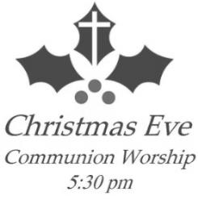

**The Christmas Eve Candlelight Service**

**with Communion**

**will be held December 24th at 5:30 pm**

**SUNDAY, DECEMBER 27-Hymn Sing**

9-10:00 Sunday School- **NO SUNDAY SCHOOL**

10:30 Worship- No communion

*Reader: Margaret Durkee*

*Ushers: *Dave Kahler, Tommy Kotewa, Denny Jahnz and Zach Jahnz*

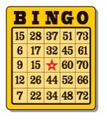1:45 pm Trinity will be helping with Bingo at Truman Senior Living on Wednesday, December 30.



STEP Inc. has once again brought its green recycle bin in the hallway at the church. Please bring in your old broken light sets, cords, even phone cords.

Are you looking for a way to help people and show love during the winter season? Then CREST may be what you’re looking for. Through volunteerism, CREST provides non-professional services such as transportation, friendly visiting, telephone reassurance, and light housekeeping among other services. We are currently seeking volunteers to help those that need assistance. Don’t let the winter blues get you down—reach out and help someone! For more information on CREST, you can call 507-235-3833.

**UPCOMING EVENTS**

