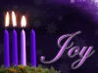

***Trinity Sunday School***

***Proclaims the Good News***

***“Christmas in Genesis: How can that be?”***

**3rd Sunday in Advent**

**December 14th, 2014**

**Trinity Lutheran Church, Truman, MN**

*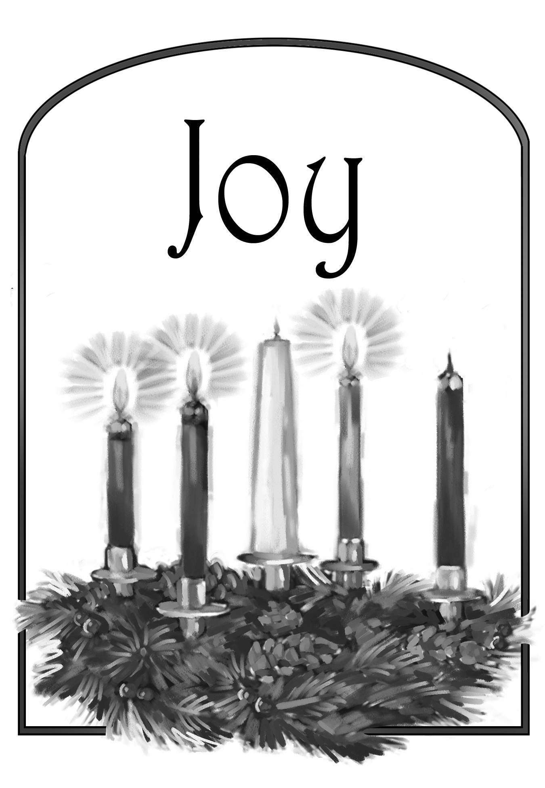***GATHERING REFLECTION**

*The idea of joy is expressed in the Old Testament by a wealth of synonymous terms that cannot easily be differentiated: "joy," "gladness," and "mirth." In Hebrew, it literally means "to be bright" or "to shine." Other nouns, of Hebrew origin, are "to spring," "leap," "exult," "rejoice," "shouting," "joy,” "be excited" (dancing around for joy)" In the New Testament, "joy," and "to rejoice." Joy is repeatedly shown to be the natural outcome of fellowship with God. "In thy presence is fullness of joy; in thy right hand there are pleasures for evermore" (Psalm 16:11). God is at once the source and the object of religious joy. But joy is a Divine, as well as a human, emotion; for God Himself is represented in the Old Testament, not as a rigid, impassible Being, but as susceptible to pleasure and pain. Many aspects of the Divine character call forth this emotion, such as His loving-kindness (Psalm 21:6, 7; Psalm 31:7), His salvation (Psalm 21:1 Isaiah 25:9 Habakkuk 3:18), His laws and statutes (Psalms 12; 119), His judgments (Psalm 48:11), His words of comfort in dark days (Jeremiah 15:15, 16). The fundamental fact of the sovereignty of God, of the equity of the Divine government of the world, gives to the pious a joyous sense of security in life (Psalm 93:1; Psalm 96:10; Psalm 97:1) which breaks forth into songs of praises in which even inanimate Nature is poetically called upon to join (Psalm 96:11-13; Psalm 98:4-9). The element of joy in religion is still more prominent in the New Testament. It is the appropriate response of the believer to the "good tidings of great joy" which constitute all four gospels but is conspicuous in the gospel of Luke (2:10). It is this joy that we grab onto in the harder times. Even our Lord Himself "for the joy that was set before him endured the cross, despising its shame" (Hebrews 12:2).* **My God and Father, give me that joy, joy, joy, joy down in my heart for you. Amen.**

**PRELUDE**

**GATHERING**

**BELL**

**WELCOME & ANNOUNCEMENTS**

**Lighting Candle & Reading *Light One Candle to Watch for Messiah* WOV #630, vs. 1-3**

**\*CONFESSION & FORGIVENESS *right column* WOV p. 10**

**\*PRAYER OF THE DAY**

L: Stir up the wills of your faithful people, Lord God,

**C: and open our ears to the words of your prophets that, anointed by your Spirit, we may testify to your light; through Jesus Christ, our Savior and Lord, who lives and reigns with you and the Holy Spirit, one God, now and forever. Amen.**

**Trinity Sunday School Proclaims the Good News:**

***“Christmas in Genesis: How can that be?”***

Narrator – #1 Reese Goeringer, #2 Kylee Harder

Angel – #1 Reese Goeringer / Kylee Harder, #2 Addison Splinter, #3 Abby Hinton

Mary – Miah Krebs

Joseph – Carson Peters

Cow – #1 Gracie Zaharia, #2 Gavin Kester

Donkey – #1 Johnnie Zaharia, #2 Carter Werner

Chicken – Carter Brudelie

Duck – #1 Mason White, #2 Peyton Franzen

Pig – #1 Keegan Hastad, #2 Carson Hastad

Rat – Luke Kester

Horse –Addison Smith

Shepherd #1 – Jonah Carlson; #2 – Jordan Carlson

Lamb – Cali Cross

Wisemen #1 – Colby Brudelie; #2 – Mason Peters; #3 – Colby Cross

Camels – Jack Goeringer, Christian Hiller, Luke Hinton

Christian Ed. board – Sadie Mosloski, Nikki Smith, and Lisa Krumwiede. Sunday School teachers Julie Brudelie, Kelle Goeringer, Kim Hastad, Connie Selnes and Beth Kotewa, with the abundant help of Laurie Wille and numerous volunteers.

____________________________________________________________________________

**OPENING SONG: O Holy Night**--*Congregation sings as Sun. Sch. enters*

1. O Holy Night! The stars are brightly shining, 2. Led by the light of faith serenely beaming,

It is the night of the dear Savior’s birth. With glowing hearts by His cradle we stand.

Long lay the world in sin and error pining. O'er the world a star is sweetly gleaming,

Till He appeared and the Spirit felt its worth. Now come the wisemen from out of the Orient land

A thrill of hope the weary world rejoices, The King of kings lay thus in lowly manger;

For yonder breaks a new and glorious morn. In all our trials born to be our friends.

Fall on your knees! Oh, hear the angel voices! He knows our need, our weakness is no stranger,

O night divine, the night when Christ was born Behold your King! Before him lowly bend!

O night, O Holy Night, O night divine! Behold your King! Before him lowly bend!

**3.** Truly He taught us to love one another, His law is love and His gospel is peace.   
 Chains he shall break, for the slave is our brother. And in his name all oppression shall cease.   
 Sweet hymns of joy in grateful chorus raise we, With all our hearts we praise His holy name.   
 Christ is the Lord! Then ever, ever praise we, His power and glory ever more proclaim!

His power and glory ever more proclaim!

**Scene 1**

**SONG: Angels We Have Heard on High**--*Sun. Sch. vs 1, Cong. vs 2-3*

**2.** Shepherds, why this jubilee? **3.** Come to Bethlehem and see  
Why your joyous strains prolong? Christ Whose birth the angels sing;  
What the gladsome tidings be Come, adore on bended knee,  
Which inspire your heav’nly song? Christ the Lord, the newborn King. **Refrain**

**REFRAIN:**  
Gloria, in excelsis Deo!  
Gloria, in excelsis Deo!

**Scene 2**

**SONG: O Little Town of Bethlehem**—*Sun. Sch. vs 1, Cong. Vs 2-4*

**2.** For Christ is born of Mary **3.** How silently, how silently  
 And gathered all above The wondrous gift is given!  
 While mortals sleep, the angels keep So God imparts to human hearts  
 Their watch of wondering love The blessings of His heaven.  
 O morning stars together No ear may hear His coming,  
 Proclaim the holy birth But in this world of sin,  
 And praises sing to God the King Where meek souls will receive him still,  
 And Peace to men on earth The dear Christ enters in.

**4.** O holy Child of Bethlehem  
 Descend to us, we pray  
 Cast out our sin and enter in  
 Be born to us today  
 We hear the Christmas angels  
 The great glad tidings tell  
 O come to us, abide with us  
 Our Lord Emmanuel

**SONG: Away in the Manger**—*Sun. Sch. vs 1, Cong. Vs 2-3*

**2.** The stars in the sky looked down where he lay, **3.** The cattle are lowing, the baby awakes,  
 The little Lord Jesus asleep in the hay. But little Lord Jesus no crying he makes

**Scene 3**

**SOLO “Mary Did You Know”**  *By Vicar Kent Krumwiede*

**Scene 4**

**SONG:**  **Silent Night**—*Cong. sings*

**1.** Silent night, holy night! **2.** Silent night, holy night!  
All is calm, all is bright. Shepherds quake at the sight.  
Round yon Virgin, Mother and Child. Glories stream from heaven afar  
Holy infant so tender and mild, Heavenly hosts sing Alleluia,  
Sleep in heavenly peace, Christ the Savior is born!  
Sleep in heavenly peace Christ the Savior is born  
 **3.** Silent night, holy night!  
 Son of God love's pure light.  
 Radiant beams from Thy holy face  
 With dawn of redeeming grace,  
 Jesus Lord, at Thy birth  
 Jesus Lord, at Thy birth

**Scene 5**

**SONG: We Three Kings**—*Cong sings vs 1-5*

**1.** We three kings of Orient are **3.** Frankincense to offer have I.

Bearing gifts we traverse afar. Incense owns a Deity nigh.  
 Field and fountain, moor and mountain, Prayer and praising all men raising,  
 Following yonder star. Worship Him, God on high. **Refrain**  
**REFRAIN:**   
 O star of wonder, star of night, **4.** Myrrh is mine: it's bitter perfume   
 Star with royal beauty bright, Breaths a life of gathering gloom.

Westward leading, still proceeding, Sorrowing, sighing, bleeding dying,   
 Guide us to thy perfect Light. Sealed in the stone-cold tomb. **Refrain**

**2.** Born a king on Bethlehem's plain, **5.** Glorious now behold Him arise,  
 Gold I bring to crown Him againKing and God and Sacrifice.

King forever, ceasing neverAlleluia, alleluia!

Over us all to reign. **Refrain** Sounds through the earth and skies. **Refrain**

**Offering**

**Scene 6**

**SONG: Happy Birthday to You (to Jesus)**—*Sun. Sch. Sings*

**SENDING PRAYER**

**SENDING HYMN: Go Tell It On the Mountain**

*Sun. Sch. vs 1, congregation 2nd refrain & vs 2-3*

**Refrain:** Go, tell it on the mountain, over the hills and everywhere;  
 go, tell it on the mountain that Jesus Christ is born!

*1 While shepherds kept their watching o’er silent flocks by night,  
 behold, throughout the heavens there shone a holy light.* **[Refrain]**

**2** The shepherds feared and trembled when lo! above the earth  
 rang out the angel chorus that hailed our Savior’s birth. **[Refrain]**

**3** Down in a lowly manger the humble Christ was born,  
 and God sent us salvation that blessed Christmas morn. **[Refrain]**

*\*\*The Sunday school children will walk out during the final song “Go Tell It on the Mountain” and then they will go to the Gathering room to put their costumes away. The Trinity Youth group will give them a goody bag when their costume is put away. Then the parents should come to the Gathering room to pick up their children before they get into line for the brunch.*

**____________________________________________________________________________**

*The script for the program is from ministry-to-children.com. It is a free Christmas play for children written by Meketa Swords of Lighthouse World Outreach Center in Monroe, GA.*

“Thank you to the parents for bringing their children to Sunday School practices for this program, and the program itself.  The parents are the ones who have to lead the children to church.

**Reminder that there ***will*** be Sunday School on Dec. 21. ***NONE*** on December 28th

There will be Sunday school after that from January to May 2015.

___________________________________________________________________________

*Today I choose life. Every morning when I wake up I can choose joy, happiness, negativity, pain... To feel the freedom that comes from being able to continue to make mistakes and choices - today I choose to feel life, not to deny my humanity but embrace it. ~***Kevyn Aucoin**

Readings for Advent Sunday 4:2 Sam. 7:1-11, 16; Ps. 89:1-4, 19-26; Rom. 16:25-27; Luke 1:26-38

 *We remember in our prayers…all who face catastrophic illness, surgery, and bindings of all kinds as well as the homebound:* **Bea Behrens, Vi Benoy, Agnes Carlson, Leland Carlson, Lisa** **Carlson & family, Donna Fisk, Chris Mosloski, Butch Ratike, Rhonda Bonk, Oakley Selnes and family and Danny Lang.** *Be present with your Spirit, Lord, and lead us to be your presence to all. Amen.*

**ANNOUNCEMENTS**

**TODAY:** The Trinity Youth Group will be decorating and delivering cookies today right after the brunch.



**The December Church council meeting will be this afternoon at 4 pm.**

Congratulations to Dustin & Natalie Splinter on the birth of their son, Tyler Michael. He was born in Albert Lea on November 20th, 2014. Welcoming Tyler home is his big sister, Addison (4 yrs.)

**THIS WEEK IN OUR PARISH**

**WEDNESDAY, DECEMBER 17**-Choir practice at 6:00 pm

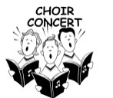**SUNDAY, DECEMBER 21-4th Sunday in Advent**

9 AM Worship (No Communion) Choir Concert 🎜🎜

**10 AM Sunday School**

*Reader: Carolyn Drevlow, Acolytes: Kylee & Reese*

*Ushers: *Gene Mager, Terry Pettersen, Ricky Davis, Denny & Zach Jahnz*

**FOR YOUR INFORMATION**

A new **T**rinity **P**astoral **C**all **C**ommittee has been formed to explore future pastoral options. Please contact any of the call committee members with your concerns or thoughts! Members are: Yvonne Noorlun, Marlene Breitbarth, Tom Dodge, Grant Hartman, Barb Mager, Sadie Mosloski, Dave Sorenson. More details will be appearing soon in The Messenger.

The Cookie Walk was again successful.   A big thank you to those who brought cookies/candy and worked.  We were down on cookies this year but we had MANY generous monetary contributions.  There is still time to contribute if you haven't done so.  The profit so far is **$2616.30**.

Recycle your old Christmas lights and cords and bring them to Trinity Church. There is a marked green bin in the entry way. STEP Inc. disassembles them.

**UPCOMING EVENTS**



**TRINITY’S CANDLELIGHT**

**CHRISTMAS EVE COMMUNION SERVICE**

**DECEMBER 24TH**

**5:00 PM**



**rinity Lutheran Church**

Office Phone 776-4781, Fax 776-7888,

**Office Hours: Mon-8-11, Wed-8-11 & 1-4, Fri 8-11**

Email: [trinitytruman@frontier.com](mailto:trinitytruman@frontier.com), Website: [www.trinity-truman.org](http://www.trinity-truman.org)

**Interim Kent Krumwiede-**Cell #: (507) 848-7192, Email: vicarkent@gmail.com

Office Hours: Mon-Thurs—9:00-1:00 pm