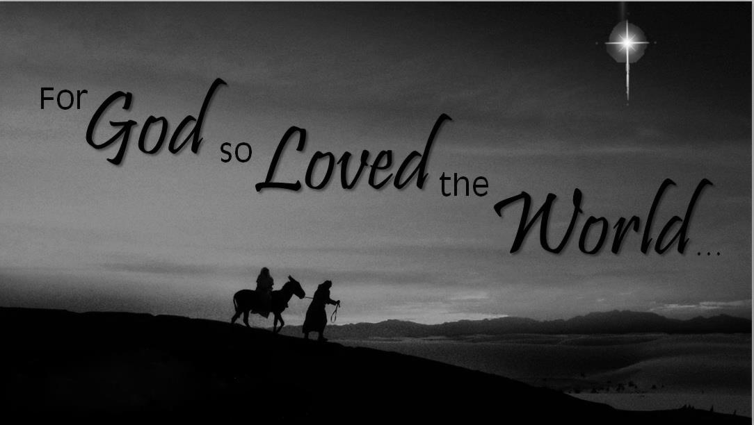

***Sunday School Program***

**3rd Sunday in Advent**

**December 13, 2015**

**Evangelical Lutheran Worship**

**Trinity Lutheran Church**

Office Phone 776-4781, Fax 776-7888, Office Hours: Mon 8-11, Wed 8-11, 1-4, Fri. 8-11 am

 Email: [trinitytruman@frontier.com](mailto:trinitytruman@frontier.com), Website: [www.trinity-truman.org](http://www.trinity-truman.org)

**Pastor Krista Strum**-Cell-(507) 995-1233, Email: [pkstrumom@me.com](mailto:pkstrumom@me.com)

Pastor Krista’s Hours: Wed. 11-2:30 pm & Thurs. 8:30-2:30 pm

**GATHERING**

*Congregation reads* ***bold print*** *\*Please stand*

**PRELUDE**

**BELL**

**WELCOME & ANNOUNCEMENTS**

**LIGHTING THE ADVENT WREATH-Third Sunday of Advent**

L: “Today we light the first, second, and third candles of the Advent wreath. Each candle has a meaning. The first candle is HOPE, the second candle is PEACE, and the third candle is JOY.”

*The candles are lit.*

L: Let us read Romans 15:13 together.

**C: May the God of hope fill you with all joy and peace as you trust in him, so that you may overflow with hope by the power of the Holy Spirit.”**

L: Let us pray together:

**C: God of glory, we thank you for the gift of your presence. You came to us in the life of Jesus Christ, and you abide with us in the Holy Spirit. Fill us with the joy that comes from knowing and experiencing you in our lives, that we may shine forth to the world around us, rejoicing as your children. Amen.**

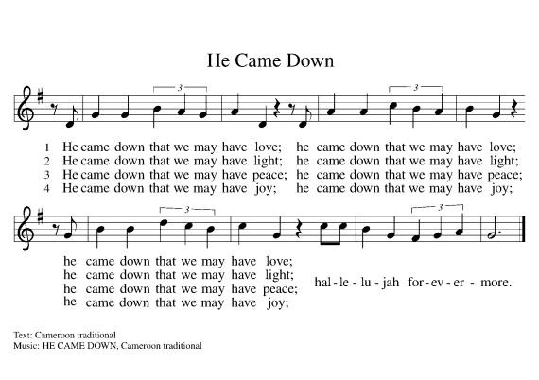

hope

peace joy

love

hope

peace joy

love

hope

peace joy

love

**\*CONFESSION & FORGIVENESS**

Blessed be the holy Trinity, ☩ one God, the Lord of Israel who comes to set us free,

hope

peace joy love

the mighty Savior who comes to show mercy, the Dawn from on high who guides us into peace. **Amen.**

Let us come before God in confession.

To you, O God,

**we lift up our souls. You know us through and through; we confess our sins to you.**

**Remember not our sins; remember us with your steadfast love. Show us your ways;**

**teach us your paths; and lead us in justice and truth, for the sake of your goodness**

**in Jesus Christ our Savior. Amen.**

Sisters and brothers, come with joy and draw water from the well of salvation. Remember the gift of baptism: your sin is washed away in the name of ☩ Jesus; you belong to Christ;

you are anointed to serve. Stand up and raise your heads! The reign of God is near.

**Amen.**

**\*GATHERING HYMN** *O Come, O Come, Emmanuel* **ELW #257**

**\*GREETING**

The grace of our Lord Jesus Christ, the love of God, and the communion of the Holy Spirit be with you all. **And also with you.**

**\*PRAYER OF THE DAY** L: The Lord be with you. **C: And also with you.**

L: Let us pray,

**Stir up the wills of your faithful people, Lord God, and open our ears to the preaching of John, that, rejoicing in your salvation, we may bring forth the fruits of repentance; through Jesus Christ, our Savior and Lord, who lives and reigns with you and the Holy Spirit, one God, now and forever. Amen.**

**\*OFFERING HYMN** *Create in Me a Clean Heart***ELW #186**

**Create in me a clean heart, O God,  
and renew a right spirit within me.  
Cast me not away from your presence,  
and take not your Holy Spirit from me.  
Restore to me the joy of your salvation,  
and uphold me with your free Spirit.**

**CHRISTMAS PROGRAM - FOR GOD SO LOVED THE WORLD**

**Sunday School children will sing 1st verse please join in singing the remaining verses.**



**AWAY IN A MANGER**

1 Away in a manger, no crib for his bed,   
the little Lord Jesus laid down his sweet head;  
the stars in the bright sky looked down where he lay,  
the little Lord Jesus asleep on the hay.  
  
2 The cattle are lowing; the baby awakes,  
but little Lord Jesus, no crying he makes.  
I love you, Lord Jesus; look down from the sky  
and stay by my cradle till morning is nigh.  
  
3 Be near me, Lord Jesus; I ask you to stay  
close by me forever and love me, I pray.  
Bless all the dear children in your tender care  
and fit us for heaven, to live with you there.

**ANGELS WE HAVE HEARD ON HIGH**

1 Angels we have heard on high,  
sweetly singing o'er the plains,  
and the mountains in reply,  
echoing their joyous strains.  
  
Refrain  
Gloria in excelsis Deo;  
gloria in excelsis Deo.

2 Shepherds, why this jubilee?  
Why your joyous strains prolong?  
What the gladsome tidings be  
which inspire your heav'nly song? Refrain  
  
3 Come to Bethlehem and see  
him whose birth the angels sing;  
come, adore on bended knee  
Christ the Lord, the newborn king. Refrain

**O LITTLE TOWN OF BETHLEHEM**

1 O little town of Bethlehem,  
how still we see thee lie!  
Above thy deep and dreamless sleep  
the silent stars go by;  
yet in thy dark streets shineth  
the everlasting light.  
The hopes and fears of all the years  
are met in thee tonight.  
  
2 For Christ is born of Mary,  
and, gathered all above  
while mortals sleep, the angels keep  
their watch of wond'ring love.  
O morning stars, together  
proclaim the holy birth,  
and praises sing to God the king,  
and peace to all the earth!  
  
3 How silently, how silently  
the wondrous gift is giv'n!  
So God imparts to human hearts  
the blessings of his heav'n.  
No ear may hear his coming;  
but, in this world of sin,  
where meek souls will receive him, still  
the dear Christ enters in.  
  
4 O holy child of Bethlehem,  
descend to us, we pray;  
cast out our sin, and enter in,  
be born in us today.  
We hear the Christmas angels  
the great glad tidings tell;  
oh, come to us, abide with us,  
our Lord Immanuel!

**SILENT NIGHT, HOLY NIGHT!**

1 Silent night, holy night!  
All is calm, all is bright  
round yon virgin mother and child.  
Holy Infant, so tender and mild,  
sleep in heavenly peace,  
sleep in heavenly peace.  
  
2 Silent night, holy night!  
Shepherds quake at the sight;  
glories stream from heaven afar,  
heav'nly hosts sing, alleluia!  
Christ, the Savior, is born!  
Christ, the Savior, is born!  
  
3 Silent night, holy night!  
Son of God, love's pure light  
radiant beams from your holy face,  
with the dawn of redeeming grace,  
Jesus, Lord, at your birth,  
Jesus, Lord, at your birth.

**JOY TO THE WORLD**

1 Joy to the world, the Lord is come!  
Let earth receive her king;  
let ev'ry heart prepare him room  
and heav'n and nature sing,  
and heav'n and nature sing,  
and heav'n, and heav'n and nature sing.  
  
2 Joy to the earth, the Savior reigns!  
Let all their songs employ,  
while fields and floods, rocks, hills, and plains  
repeat the sounding joy,  
repeat the sounding joy,  
repeat, repeat the sounding joy.  
  
3 No more let sin and sorrow grow  
nor thorns infest the ground;  
he comes to make his blessings flow  
far as the curse is found,  
far as the curse is found,  
far as, far as the curse is found.  
  
4 He rules the world with truth and grace  
and makes the nations prove  
the glories of his righteousness  
and wonders of his love,  
and wonders of his love,  
and wonders, wonders of his love.

**BLESSING**

May God direct your ways in peace,

make you abound in love for one another and for all,

and strengthen your hearts

until the coming of our Lord Jesus.

Almighty God, Father, ☩ Son, and Holy Spirit,

bless you now and forever.

**Amen.**

**GO TELL IT ON THE MOUNTAIN**

Refrain  
Go tell it on the mountain,  
over the hills and ev'rywhere;  
go tell it on the mountain  
that Jesus Christ is born!  
  
1 While shepherds kept their watching  
o'er silent flocks by night,  
behold, throughout the heavens  
there shone a holy light. Refrain  
  
2 The shepherds feared and trembled  
when, lo, above the earth  
rang out the angel chorus  
that hailed our Savior's birth. Refrain  
  
3 Down in a lonely manger  
the humble Christ was born;  
and God sent us salvation  
that blessed Christmas morn. Refrain

**DISMISSAL:** Go in peace. Serve the Lord. **Thanks be to God.**

**POSTLUDE +++++++++++++++++++++++++++++++++++++++++++++++++++++++++++++++++** Copyright © 2015 Augsburg Fortress. All rights reserved. Reprinted by permission under Augsburg Fortress Liturgies Annual License #SAS103469.

**YOU ALL ARE INVITED INTO THE FELLOWSHIP HALL AFTER THE PROGRAM FOR SANDWICHES, FRESH FRUIT, VEGGIES, CHIPS AND CUPCAKES.**

**CAST MEMBERS**

Caretaker 1-Carson Hastad

Caretaker 2-Keegan Hastad

Narrator-Karsan Davis

Gabriel-Tallin Cook

Resident 1-Kylee Harder

Resident 2-Jaiden Cook

Resident 3-Miah Krebs

Joseph-Colby Brudelie

Mary-Ashlynn Cook

King Herod-Peyton Franzen

Magi 1-Carter Brudelie

Magi 2-Mason Kelley

Magi 3-Jonah Carlson

Visitor 1-Mason Kelley

Visitor 2-Jonah Carlson

Shepherd 1-Jordan Carlson

Shepherd 2-Katherine Strum

Sheep and Shepherds: Jackson Hastad, Adley Butler, Zoe Taylor, Ava Taylor, Addison Splinter, Carter Werner, Angels: Addison Smith, Gabby Greier, and Lauren Strum.

Special thanks to the extra people that helped out. Courtney Zaharia, Logan Davis, Natalie Splinter, Hailey Olson, Nicole Ebert-Maloney, Brytni Drevlow, Raquel Harder, Beth Kotewa, Julie Brudelie and Niki Smith

**ANNOUNCEMENTS**

**Readings for next Sunday: Micah 5:2-5a, Luke 46b-55, Hebrews 10:5-10, Luke 1:39-55**

*We remember in our prayers…all who face catastrophic illness, surgery, and bindings of all kinds as well as the homebound:* ***Bea Behrens, Agnes Carlson, Lisa******Carlson & family, Donna Fisk, and Danny Lang.*** *Be present with your Spirit, Lord, and lead us to be your presence to all. Amen.*

Thank you to those who donated the poinsettia’s for our Advent/Christmas season.

David & Tonia Kahler Howard & LuElla Kautz Connie Selnes

Tom Dodge David & Cathy Sorenson Veryle & Joan Williamson

Norman & Marilyn Anderson Barb Shoen Dorothy Graham

Dean & Bev Gulbranson Jerry Teig Doyle & Arlene Peterson

JoAnn Knutson Jim & Brenda Hansen Jan Warrington

Gene & Barb Mager Lowell & Yvonne Noorlun

**THIS WEEK IN OUR PARISH**

**WEDNESDAY, DECEMBER 16**- Last day to submit news items to the Jan. Messenger

**SUNDAY, DECEMBER 20**

9-10:00 Sunday School-Christmas story

10-10:30 Gathering time w/kid friendly snacks

10:30 Worship- No communion

*Reader: Brytni Drevlow*

*Ushers: *Dave Kahler, Tommy Kotewa, Denny Jahnz and Zach Jahnz*

The Trinity Youth Group will be meeting after church to decorate cookies and watch a movie on December 20th. Be checking your email for the details!

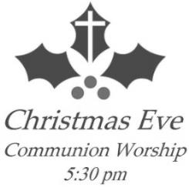

**UPCOMING EVENTS**

**The Christmas Eve Candlelight Service will be held on**

**December 24th at 5:30 pm**

STEP Inc. has once again brought its green recycle bin in the hallway at the church. Please bring in your old broken light sets, cords, even phone cords.

**OTHER EVENTS**

Waverly member, Carl Rabbe will be ordained into the ministry at Waverly Lutheran on Thursday, December 17th at 5:30 pm. A dinner and reception will follow in the fellowship hall. Carl has been called to serve as pastor of United by Faith Lutheran Church in Evergreen park, Illinois.

Renowned organist and pianist Glenn Henriksen will perform a Christmas concert, Sunday, December 20th, 2:00 pm at Immanuel Lutheran Church, Dunnell, MN. Special guests including Millie Kittleson, Swedish folk fiddlers Ivares Pojkarna (Ivares Boys), audience hymn-sing, and a visit from Santa Lucia. A reception in honor of Glenn and guests will follow. Free will offering. Refreshments to follow.

