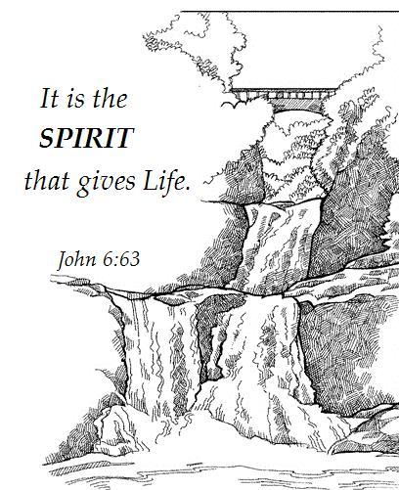

The Spirit gives Life
13th Sunday after Pentecost
August 23rd, 2015

Service of Word and Prayer
With One Voice (WOV), p. 46

Trinity Lutheran Church
Office Phone 776-4781, Fax 776-7888, Summer Office Hours: Mon, Wed & Fri-700-11:00 am
Email: trinitytruman@frontier.com, Website: www.trinity-truman.org
Trinity President: Laurie Wille (507-776-3098) Cell-(507-848-7187)

GATHERING
Congregation reads bold print. *Please stand

PRELUDE
GATHERING REFLECTION
We know that bread is fundamental and foundational to life and living. But in today’s Gospel reading, the Spirit, Jesus says, gives life. It is by the Spirit that the church exists. It is the Spirit that calls, gathers and enlightens the whole church. It is the Spirit of God who enlivens our mission and ministry as Christ’s church, the body of Christ. We come to worship, hear and apply the message of the gospel to our lives and to the life of the church, so it may be a living, breathing entity in our communities. Holy Spirit, enter in, give me life and truth within. Amen.

BELL
WELCOME & ANNOUNCEMENTS
*GATHERING HYMN Be Thou My Vision WOV #776
*GREETING WOV p. 46
*PENTECOST LITANY (Center column)
*PRAYER OF THE DAY: L: The Lord be with you. C: And also with you.
L: Let us pray. Silence Gracious God,
C: you have placed within the hearts of all your children a longing for your word and a hunger for your truth. Grant that we may know your Son to be the true bread of heaven and share this bread with all the world, through Jesus Christ, our Savior and Lord. Amen.
WORD

FIRST READING: Joshua 24:1-2a, 14-18
The Tribes Renew the Covenant
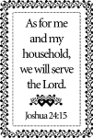
Then Joshua gathered all the tribes of Israel to Shechem, and summoned the elders, the heads, the judges, and the officers of Israel; and they presented themselves before God. ² And Joshua said to all the people, “Thus says the Lord, the God of Israel: Long ago your ancestors—Terah and his sons Abraham and Nahor—lived beyond the Euphrates and served other gods. ¹⁴ “Now therefore revere the Lord, and serve him in sincerity and in faithfulness; put away the gods that your ancestors served beyond the River and in Egypt, and serve the Lord. ¹⁵ Now if you are unwilling to serve the Lord, choose this day whom you will serve, whether the gods your ancestors served in the region beyond the River or the gods of the Amorites in whose land you are living; but as for me and my household, we will serve the Lord.” ¹⁶ Then the people answered, “Far be it from us that we should forsake the Lord to serve other gods; ¹⁷ for it is the Lord our God who brought us and our ancestors up from the land of Egypt, out of the house of slavery, and who did those great signs in our sight. He protected us along all the way that we went, and among all the peoples through whom we passed; ¹⁸ and the Lord drove out before us all the peoples, the Amorites who lived in the land. Therefore we also will serve the Lord, for he is our God.”

The Word of the Lord. C: Thanks be to God.

PSALM 34:15-22 Congregation reads the bold print.
¹⁵ The eyes of the LORD are on the righteous, and his ears are open to their cry.
¹⁶ The face of the LORD is against evildoers, to cut off the remembrance of them
from the earth.

¹⁷ When the righteous cry for help, the LORD hears, and rescues them from all their
troubles.
¹⁸ The LORD is near to the brokenhearted, and saves the crushed in spirit.

¹⁹ Many are the afflictions of the righteous, but the LORD rescues them from them all.
²⁰ He keeps all their bones; not one of them will be broken.

²¹ Evil brings death to the wicked, and those who hate the righteous will be condemned.
²² The LORD redeems the life of his servants; none of those who take refuge in
him will be condemned.

SECOND READING: Ephesians 6:10-20 (NRSV)
Finally, be strong in the Lord and in the strength of his power. ¹¹ Put on the whole armor of God, so that you may be able to stand against the wiles of the devil. ¹² For our struggle is not against enemies of blood and flesh, but against the rulers, against the authorities, against the cosmic powers of this present darkness, against the spiritual forces of evil in the heavenly places. ¹³ Therefore take up the whole armor of God, so that you may be able to withstand on that evil day, and having done everything, to stand firm. ¹⁴ Stand therefore, and fasten the belt of truth around your waist, and put on the breastplate of righteousness. ¹⁵ As shoes for your feet put on whatever will make you ready to proclaim the gospel of peace. ¹⁶ With all of these, take the shield of faith, with which you will be able to quench all the flaming arrows of the evil one. ¹⁷ Take the helmet of salvation, and the sword of the Spirit, which is the word of God. ¹⁸ Pray in the Spirit at all times in every prayer and supplication. To that end keep alert and always persevere in supplication for all the saints. ¹⁹ Pray also for me, so that when I speak, a message may be given to me to make known with boldness the mystery of the gospel, ²⁰ for which I am an ambassador in chains. Pray that I may declare it boldly, as I must speak.

The Word of the Lord. C: Thanks be to God.

* GOSPEL ACCLAMATION Lord, Let My Heart Be Good Soil WOV #713

*GOSPEL: John 6:56-69 C: Glory to you, O Lord.
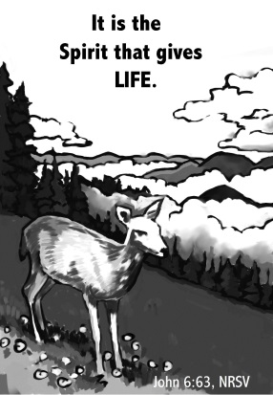
Those who eat my flesh and drink my blood abide in me, and I in them. ⁵⁷ Just as the living Father sent me, and I live because of the Father, so whoever eats me will live because of me. ⁵⁸ This is the bread that came down from heaven, not like that which your ancestors ate, and they died. But the one who eats this bread will live forever.” ⁵⁹ He said these things while he was teaching in the synagogue at Capernaum. ⁶⁰ When many of his disciples heard it, they said, “This teaching is difficult; who can accept it?” ⁶¹ But Jesus, being aware that his disciples were complaining about it, said to them, “Does this offend you? ⁶² Then what if you were to see the Son of Man ascending to where he was before? ⁶³ It is the spirit that gives life; the flesh is useless. The words that I have spoken to you are spirit and life. ⁶⁴ But among you there are some who do not believe.” For Jesus knew from the first who were the ones that did not believe, and who was the one that would betray him. ⁶⁵ And he said, “For this reason I have told you that no one can come to me unless it is granted by the Father.” ⁶⁶ Because of this many of his disciples turned back and no longer went about with him. ⁶⁷ So Jesus asked the twelve, “Do you also wish to go away?” ⁶⁸ Simon Peter answered him, “Lord, to whom can we go? You have the words of eternal life. ⁶⁹ We have come to believe and know that you are the Holy One of God.”

L: The Word of the Lord. C: Praise to you, O Christ.

CHILDREN’S SERMON
SERMON
*HYMN OF THE DAY Let Us Break Bread Together
1 Let us break bread together on our knees.
Let us break bred together on our knees.

Refrain: When I fall on my knees with my face to the rising sun,
O Lord, have mercy on me.

2 Let us drink wine together on our knees.
Let us drink wine together on our knees. [Refrain]
3 Let us praise God together on our knees.
Let us praise God together on our knees. [Refrain]

RESPONSE OT THE WORD WOV p. 49
PEACE p. 50
PRAYER
OFFERING OFFERTORY Create in Me WOV #732
OFFERING PRAYER WOV p. 51
PRAYERS OF INTERCESSION L: God of mercy C: hear our prayer.
THE LORD’S PRAYER WOV p. 52
SENDING

*BLESSING Almighty God, Father, + Son and Holy Spirit, bless you now and forever.
Three-Fold Amen.

*SENDING HYMN Blest Are They WOV #764
*BELL
*SENDING L: Go in peace. Serve the Lord. C: Thanks be to God!
+++++++++++++++++++++++++++++++++++++++++++++++++++++++++++++++++++++++++++++++++++++++++++++++++

Bread for myself is a material question. Bread for my neighbor is a spiritual one. ~ Nikolai Berdyaev

Copyright 2013 Augsburg Fortress. All rights reserved. Reprinted by permission under Augsburg Fortress Liturgies Annual License#15562-ELW

Readings for Next Sunday: Deut 4:1-2, 6-9; Ps 15; James 1:17-27; Mark 7:1-8, 14-15, 21-28

We remember in our prayers…all who face catastrophic illness, surgery, and bindings of all kinds as well as the homebound: Bea Behrens, Agnes Carlson, Lisa Carlson & family, Donna Fisk, Danny Lang, Jim Shoen and Bryce Hansen. Be present with your Spirit, Lord, and lead us to be your presence to all. Amen.

ANNOUNCEMENTS

Please keep up with your pledged giving. We have had a deficit lately.

TODAY: This is a formal notice that we will be having a congregational vote today whether to employ Pastor Krista Strum on a regular part-time basis.
THIS WEEK IN OUR PARISH

TUESDAY, AUGUST 25- Mending at Truman Senior Living Center

TRINITY’S Vacation Bible School
August 26th & 27th
9:00 am—4:00 pm
Please invite your friends and relatives
Kindergarten—7th grade

Also we are looking for help with VBS— ½ or complete days.
We have a list of supplies that will be needed that is posted
on the window in the narthex.

There will be a kick off for Sunday School on Sept. 13th, we will be singing VBS songs in church. It will also be Noisy Sunday.

WEDNESDAY, AUGUST 26-9 am Messenger Assembly
There will be a Parent/Student Confirmation meeting with Pastor Krista Strum at Trinity at 6:30 pm.
SUNDAY, AUGUST 30-Worship at 9 AM
Reader: Marilyn Duncanson
Ushers: *Mark Durkee, Dallas Wegner, Lowell Noorlun and Clayton Duncanson
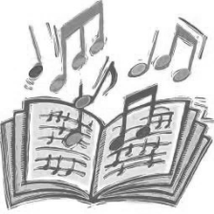
SUNDAY, SEPTEMBER 6TH WILL BE
HYMN SING SUNDAY-9 AM WORSHIP

We sent out a survey last month for you to pick all your favorite hymns you would like to sing. We have compiled them and will sing them during the service on Sunday, September 6th.
Starting September 13th Trinity’s Worship time
will now be 10:30 am.

Sunday School will start at 9:30 am.

PASTOR KRISTA STRUM’S FIRST DAY WILL BE SEPTEMER 13TH.

