14th Sunday after Pentecost
August 21, 2016
Evangelical Lutheran Worship, Setting 10

Trinity Lutheran Church

Office Phone 776-4781, Fax 776-7888, Sumer Office Hours: Mon, Wed & Fri. 7:00-11:00 am
Email: trinitytruman@frontier.com, Website: www.trinity-truman.org
PASTOR KRISTA STRUM
Cell-(507)995-1233, Email: pkstrumom@me.com
Pastor Krista’s Summer Hours: Wed. 8:30-12:00 pm & Thurs. 8:30-12:00 pm

GATHERING

Congregation reads bold print *Please stand

PRELUDE
BELL
ANNOUNCEMENTS
*CONFESSION AND FORGIVENESS—Prayer of Confession
Loving God,
We confess that we have sinned.
Even though we want to do what is right, we did not always succeed this week.
Not only did we fail to do what was right, but at times we consciously chose to think and act in ways we knew were wrong.
We are truly sorry, and we ask for your forgiveness.

WORDS OF ASSURANCE
Friends, hear this:
Through the life, death and resurrection of Jesus Christ, we have been set free from the power of sin! It no longer needs to control us. So be at peace: your sins are forgiven!
Go out, and live in the light of Christ.
Thanks be to God!

*GATHERING SONG My Faith Looks Up to Thee ELW #759

*GREETING
The grace of our Lord Jesus Christ, the love of God, and the communion of the Holy Spirit be with you all. And also with you.

* KYRIE ELW p. 203
* CANTICLE OF PRAISE – (VERSE 3) ELW p. 204
* PRAYER OF THE DAY L: The Lord be with you. C: And also with you.
L: Let us pray,
O God, mighty and immortal, you know that as fragile creatures surrounded by great dangers, we cannot by ourselves stand upright. Give us strength of mind and body, so that even when we suffer because of human sin, we may rise victorious through your Son, Jesus Christ, our Savior and Lord. Amen.

WORD
FIRST READING: Deuteronomy 6:4-9
4Hear, O Israel: The LORD is our God, the LORD alone. 5You shall love the LORD your God with all your heart, and with all your soul, and with all your might. 6Keep these words that I am commanding you today in your heart. 7Recite them to your children and talk about them when you are at home and when you are away, when you lie down and when you rise. 8Bind them as a sign on your hand, fix them as an emblem on your forehead, 9and write them on the doorposts of your house and on your gates.

Word of God, word of life. Thanks be to God.

*GOSPEL ACCLAMATION ELW p. 205
*GOSPEL: John 1:35-51 C: Glory to you, O Lord.
35The next day John again was standing with two of his disciples, 36and as he watched Jesus walk by, he exclaimed, "Look, here is the Lamb of God!" 37The two disciples heard him say this, and they followed Jesus. 38When Jesus turned and saw them following, he said to them, "What are you looking for?" They said to him, "Rabbi" (which translated means Teacher), "where are you staying?" 39He said to them, "Come and see." They came and saw where he was staying, and they remained with him that day. It was about four o'clock in the afternoon. 40One of the two who heard John speak and followed him was Andrew, Simon Peter's brother. 41He first found his brother Simon and said to him, "We have found the Messiah" (which is translated Anointed). 42He brought Simon to Jesus, who looked at him and said, "You are Simon son of John. You are to be called Cephas" (which is translated Peter). 43The next day Jesus decided to go to Galilee. He found Philip and said to him, "Follow me." 44Now Philip was from Bethsaida, the city of Andrew and Peter. 45Philip found Nathanael and said to him, "We have found him about whom Moses in the law and also the prophets wrote, Jesus son of Joseph from Nazareth." 46Nathanael said to him, "Can anything good come out of Nazareth?" Philip said to him, "Come and see." 47When Jesus saw Nathanael coming toward him, he said of him, "Here is truly an Israelite in whom there is no deceit!" 48Nathanael asked him, "Where did you get to know me?" Jesus answered, "I saw you under the fig tree before Philip called you." 49Nathanael replied, "Rabbi, you are the Son of God! You are the King of Israel!" 50Jesus answered, "Do you believe because I told you that I saw you under the fig tree? You will see greater things than these." 51And he said to him, "Very truly, I tell you, you will see heaven opened and the angels of God ascending and descending upon the Son of Man."

The gospel of the Lord. Praise to you, O Christ.

SERMON
*HYMN OF THE DAY What a Friend We Have in Jesus ELW #742

*CREED (SALMON sheet in the back of the red hymnal) or ELW p. 206

*PRAYERS OF THE PEOPLE
L: Lord in your mercy C: Hear our prayer
PEACE The peace of Christ be with you always. And also with you.

MEAL
OFFERING
OFFERING SONG Let the Vineyards be fruitful Lord… ELW #184
OFFERING PRAYER
God of mercy and grace, the eyes of all wait upon you, and you open your hand in blessing.
Fill us with good things at your table, that we may come to the help of all in need,
through Jesus Christ, our redeemer and Lord. Amen.

*Thanksgiving at the table elw p. 108

*LORD’S PRAYER (SUNG) - found on the salmon sheet in the back cover of the red hymnal

INVITATION TO COMMUNION Come to the banquet, for all is now ready.
COMMUNION
COMMUNION SONG Eat This Bread: Jesus Christ, Bread of Life ELW #472
PRAYER AFTER COMMUNION Let us pray.
Gracious God, in this meal you have drawn us to your heart, and nourished us at your table with food and drink, the body and blood of Christ. Now send us forth to be your people in the world, and to proclaim your truth this day and evermore, through Jesus Christ, our Savior and Lord. Amen.

*BLESSING Three fold Amen…
*SENDING SONG Shall We Gather at the River ELW #423
*DISMISSAL Go in peace. Serve the Lord. Thanks be to God.
BELL/POSTLUE
+++++++++++++++++++++++++++++++++++++++++++++++++++++++++++++++++
Copyright © 2016 Augsburg Fortress. All rights reserved. Reprinted by permission under Augsburg Fortress Liturgies Annual License #SAS103469. New Revised Standard Version Bible, copyright © 1989, Division of Christian Education of the National Council of the Churches of Christ in the United States of America. Used by permission. All rights reserved.

Readings for next Sunday: Prov. 25:6-7, Ps. 112, Heb. 13:1-8,. 15-16, Luke 14:1, 7-14
We remember in our prayers…all who face catastrophic illness, surgery, and bindings of all kinds as well as the homebound: Bea Behrens, Lisa Carlson & family, Danny Lang, and Deloris Strehlo.
TODAY: Please join us for coffee hour after worship services.

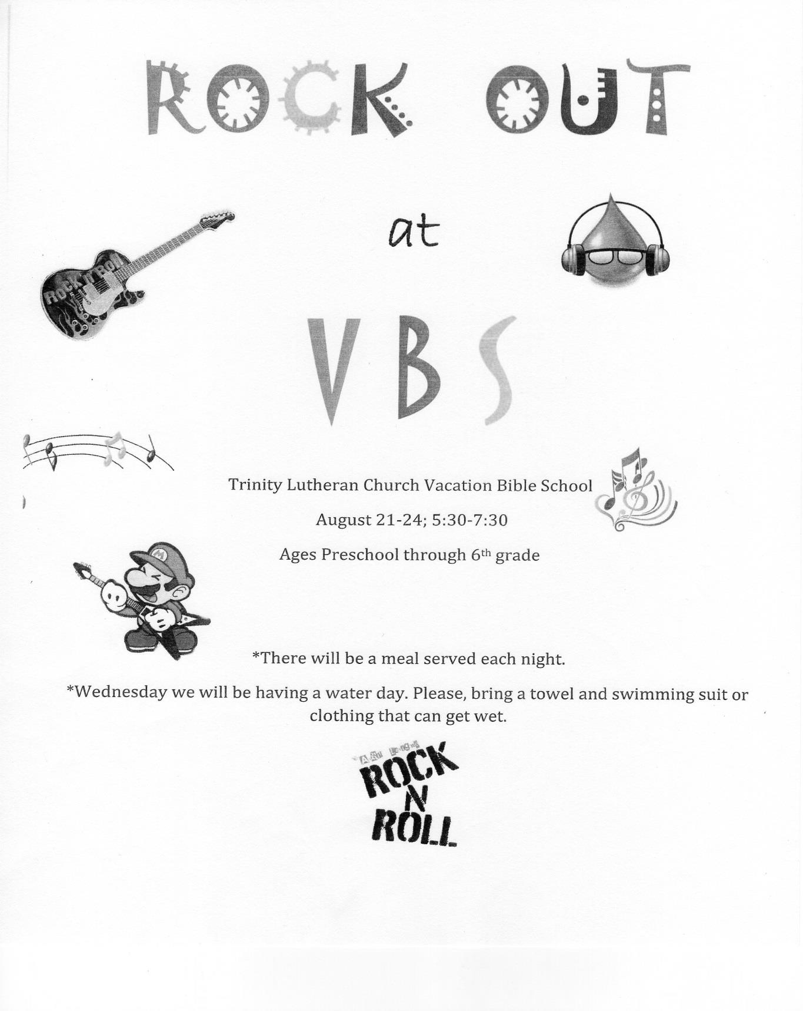
a
TODAY!
THIS WEEK IN OUR PARISH

TODAY: TRINITY’S VBS WILL BE HELD TODAY from 5:30 – 7:30 pm.
The theme is “Rock at VBS” All preschool through 6th grade are invited to attend.

THERE WILL BE NO MENDING ON AUGUST 23rd AT TRUMAN SENIOR LIVING
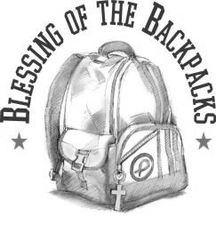
SUNDAY, AUGUST 28—Blessing of the Backpacks
8:45 AM WORSHIP
Coffee Hour will be held after worship
Reader: Ciera Drevlow,
Ushers: *Lowell Noorlun, Dave Sorenson, Dallas Wegner and Mike Taylor

FOR YOUR INFORMATION
The Heat Fund Goal has been met! We reached $46,750.00. Thank you to all who contributed to Trinity’s new furnace expense.

Back to school
Early one morning, a mother woke her son, who whined about having to go to school.
“Give me two reasons why you don’t want to go,” she said.
“Well,” he complained, “the kids don’t like me, and neither do the teachers!”
“Nonsense,” she said. “Come get ready.”
“Give me two reasons why I should go,” the son protested.
“Well, for one, you’re 52,” she said. “For another, you’re the principal!”

