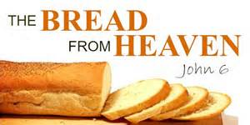

***The Bread from Heaven***

**12th Sunday after Pentecost**

**August 16th, 2015**

**Service of the Word and Prayer**

**Evangelical Lutheran Worship, ELW p. 211**

**Trinity Lutheran Church**

Office Phone 776-4781, Fax 776-7888, Summer Office Hours: Mon, Wed & Fri-7-11 am

 Email: [trinitytruman@frontier.com](mailto:trinitytruman@frontier.com), Website: [www.trinity-truman.org](http://www.trinity-truman.org)

Trinity President: Laurie Wille (507-776-3098) Cell-(507-848-7187)**GATHERING**

*Congregation reads* ***bold print*** *\*Please stand*

**PRELUDE**

**GATHERING REFLECTION**

*Bread is the common staple of pretty much every culture in every time. So, God describes what he is doing to demonstrate his loving care for his people. When the visitors came to Abraham, he offered them bread. Israel received manna (a form of bread) in the wilderness. Bread was a form of hospitality and blessing. The Jewish prayer, called Barakah, says “Blessed are you, Lord our God, king of the universe, who brings forth true bread from heaven. Daily bread is not only Wonder bread, but wondrous bread of life from God himself.* **Blessed are you, Lord my God, for providing what I need in spirit and body. Amen.**

**BELL**

**WELCOME & ANNOUNCEMENTS**

**\*CONFESSION & FORGIVENESS (*right column)* ELW p. 211**

**\*GATHERING HYMN *Borning Cry* ELW #732**

**\* GREETING** L: The grace of our Lord Jesus Christ, the Love of God, and the Community of the Holy Spirit be with you all.

**C: And also with you.**

**\*HYMN OF PRAISE *Have No Fear Little Flock* ELW #764**

**\*PRAYER OF THE DAY** L: The Lord be with you. **C: And also with you.**

L: We pray together *Silence* O God, powerful and compassionate,

**C you shepherd your people, faithfully feeding and protecting us. Heal each of us, and make us a whole people, that we may embody the justice and peace of your Son, Jesus Christ, our Savior and Lord. Amen.**

**WORD**

**FIRST READING Proverbs 9:1-6 (NRSV)**

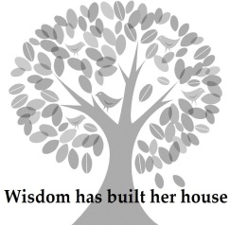**Wisdom’s Feast**

Wisdom has built her house, she has hewn her seven pillars. 2She has slaughtered her animals, she has mixed her wine, she has also set her table. 3She has sent out her servant-girls, she calls from the highest places in the town, 4“You that are simple, turn in here!” To those without sense she says, 5“Come, eat of my bread and drink of the wine I have mixed. 6Lay aside immaturity, and live, and walk in the way of insight.”

Word of God, Word of Life. **C: Thanks be to God.**

**PSALM**  *The psalm readings are in the front part of the hymnal, page 339*

**Psalm 34:9-14**

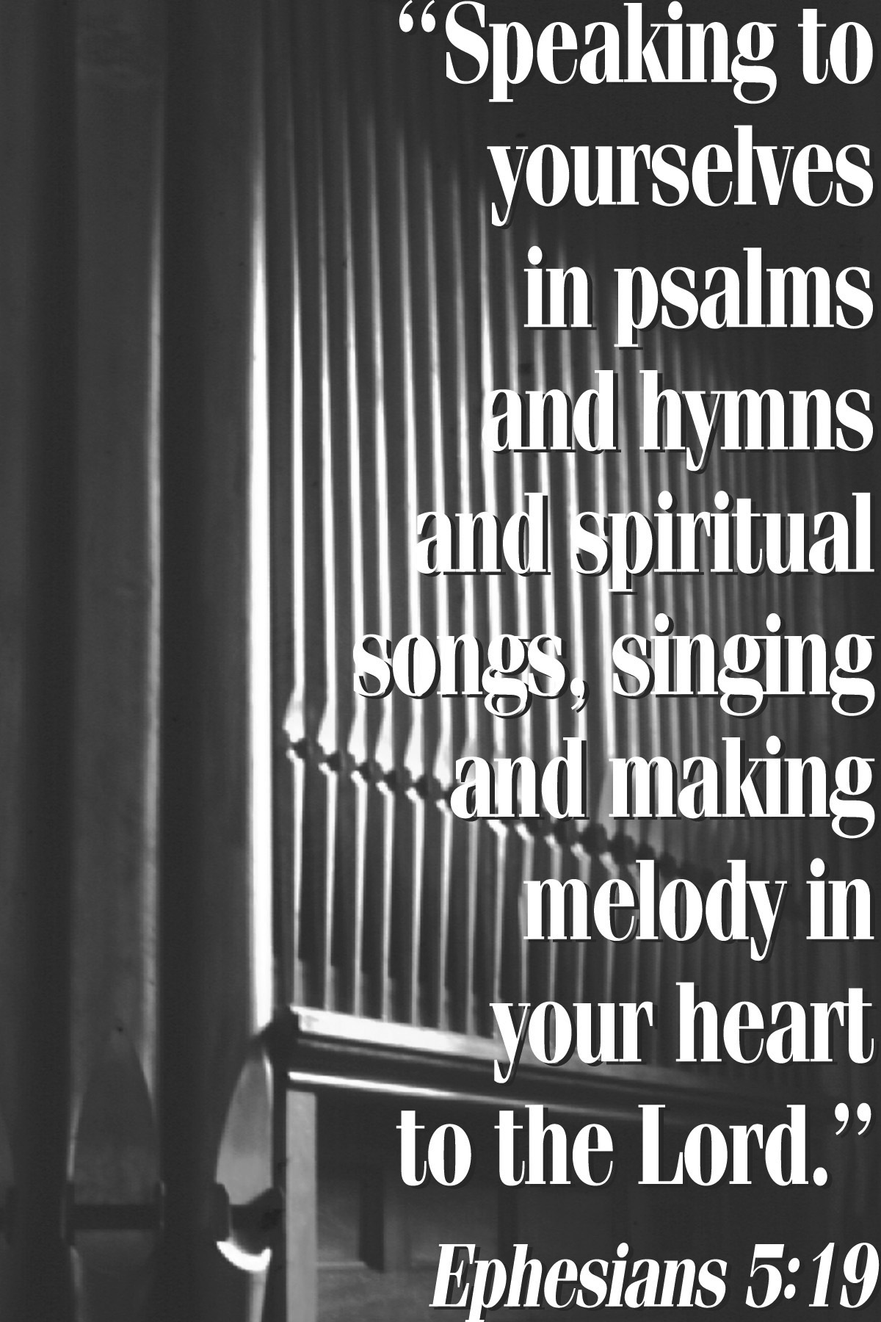

**SECOND READING Ephesians 5:15-20 (NRSV)**

Be careful then how you live, not as unwise people but as wise, 16making the most of the time, because the days are evil. 17So do not be foolish, but understand what the will of the Lord is. 18Do not get drunk with wine, for that is debauchery; but be filled with the Spirit, 19as you sing psalms and hymns and spiritual songs among yourselves, singing and making melody to the Lord in your hearts, 20giving thanks to God the Father at all times and for everything in the name of our Lord Jesus Christ.

Word of God, Word of Life. **C: Thanks be to God.**

**\*GOSPEL ACCLAMATION** *Lord, Let My Heart Be Good Soil* **ELW # 512**

\***GOSPEL: John 6:51-58 C: Glory to you O Lord.**

I am the living bread that came down from heaven. Whoever eats of this bread will live forever; and the bread that I will give for the life of the world is my flesh.”

52The Jews then disputed among themselves, saying, “How can this man give us his flesh to eat?” 53So Jesus said to them, “Very truly, I tell you, unless you eat the flesh of the Son of Man and drink his blood, you have no life in you. 54Those who eat my flesh and drink my blood have eternal life, and I will raise them up on the last day; 55for my flesh is true food and my blood is true drink. 56Those who eat my flesh and drink my blood abide in me, and I in them. 57Just as the living Father sent me, and I live because of the Father, so whoever eats me will live because of me. 58This is the bread that came down from heaven, not like that which your ancestors ate, and they died. But the one who eats this bread will live forever.”

Word of God, Word of Life. **C: Praise to you, O Christ.**

CHILDREN’S SERMON

SERMON

* **HYMN OF THE DAY**  *Children of the Heavenly Father* **ELW #781**

**\*APOSTLES’ CREED** *(salmon sheet on the back cover of the hymnal)*

**OFFERING**

**\*OFFERING HYMN** *Create in Me a Clean Heart***ELW #188**

**\*OFFERING PRAYER**

**\* PRAYERS OF INTERCESSION** L: Lord, in your mercy **C: Hear our prayer.**

**\*THANKSGIVING FOR THE WORD** *gray shaded* **ELW p. 220**

**THE LORD’S PRAYER** *Sung (as found in the back cover of the hymnal, SALMON sheet)*

**SHARING OF THE PEACE** L: The peace of the Lord be with you always.

**C: And also with you.**

**SENDING**

**BLESSING** Almighty God, Father, + Son and Holy Spirit, bless you now and forever.

***Three-Fold Amen.***

**\*SENDING HYMN** *Go My Children With My Blessing* **ELW #543**

**BELL SENDING** L: Go in peace. Serve the Lord. **C: Thanks be to God!**

**POSTLUDE +++++++++++++++++++++++++++++++++++++++++++++++++++++++++++++++++**Reprinted from Evangelical Lutheran Worship, copyright © 2006 Augsburg Fortress. All rights reserved. Used by permission of Augsburg Fortress license #SB107041

**Readings for next Sunday: Josh 24:1-2A, 14-18; Ps 34:15-22; Eph 6:10-20; John 6:56-69**

Prayer requests *We remember in our prayers…all who face catastrophic illness, surgery, and bindings of all kinds as well as the homebound:* ***Bea Behrens, Agnes Carlson, Lisa******Carlson & family, Donna Fisk, Danny Lang, Jim Shoen and Bryce Hansen.*** *Be present with your Spirit, Lord, and lead us to be your presence to all. Amen.*

**ANNOUNCEMENTS**



Please keep up with your pledged giving. We have had a deficit lately.

**TODAY:** Join us after the service for coffee and goodies.

**THIS WEEK IN OUR PARISH**

**MONDAY, AUGUST 17**-Messenger Deadline

**SATURDAY, AUGUST 22**—You are invited to the Service of Installation for Reverend Krista Strum as she is installed as Trinity Lutheran, Madelia’s Pastor. She and her family will be introduced to the community. On Sat. August 22 at 4 pm at the church, 406 W Main Street, Madelia. *A meal in the church basement will follow the service.*

**SUNDAY, AUGUST 23-Worship at 9 AM**

This is a formal notice that we will be having a **congregational vote on August 23rd** to employ Pastor Krista Strum on a regular part-time basis.

*Reader: Please Volunteer*

*Ushers: *Mark Durkee, Dallas Wegner, Lowell Noorlun and Clayton Duncanson*

*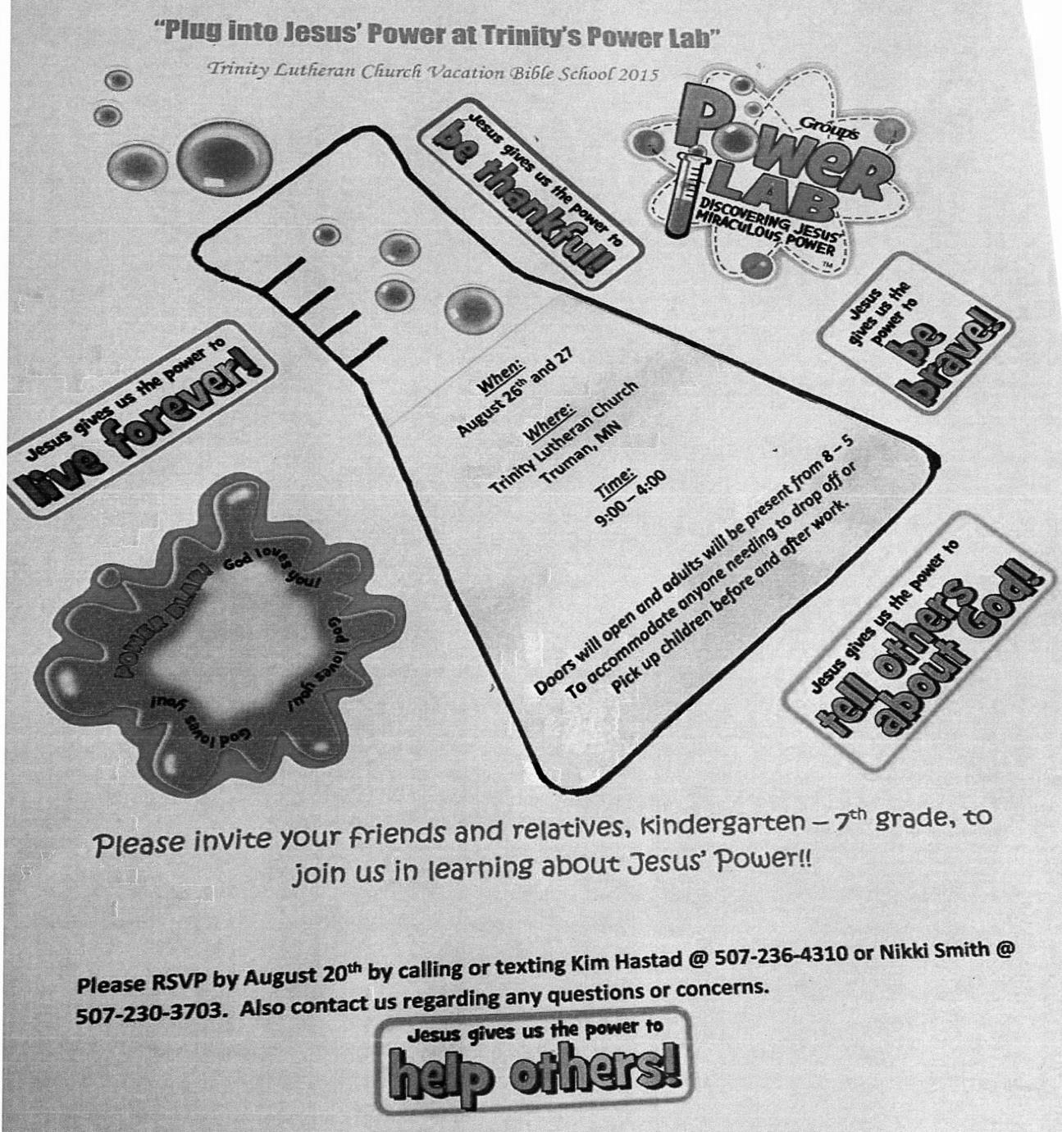***UPCOMING EVENTS**

**ON**

**AUGUST 26 & 27**

**AT TRINITY**

**FROM**

**9:00-4:00 PM**

***There will be a kick off for Sunday School on Sept. 13th, we will be singing VBS songs in church. It will also be Noisy Sunday.***

***Also we are looking for help with VBS— ½ or complete days.***

*We have a list of supplies that will be needed that is posted*

*on the window in the narthex.*

**WEDNESDAY, AUGUST 26**-There will be a Parent/Student Confirmation meeting with Pastor Krista Strum at Trinity at 6:30 pm.

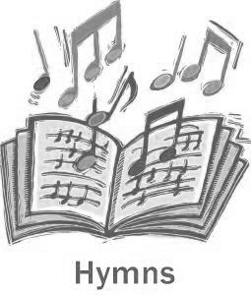

**SUNDAY, SEPTEMBER 6TH WILL BE**

**HYMN SING SUNDAY**

*We sent out a survey last month for you to pick all your favorite hymns you would like to sing. We have compiled them and will sing them during the service on Sunday, September 6th.*



Starting September 13th Trinity’s Worship time will now be **10:30 am.**

Sunday School will start at 9:30 am.

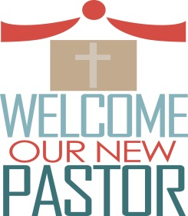

***PASTOR KRISTA STRUM’S FIRST DAY WILL BE SEPTEMER 13TH.***