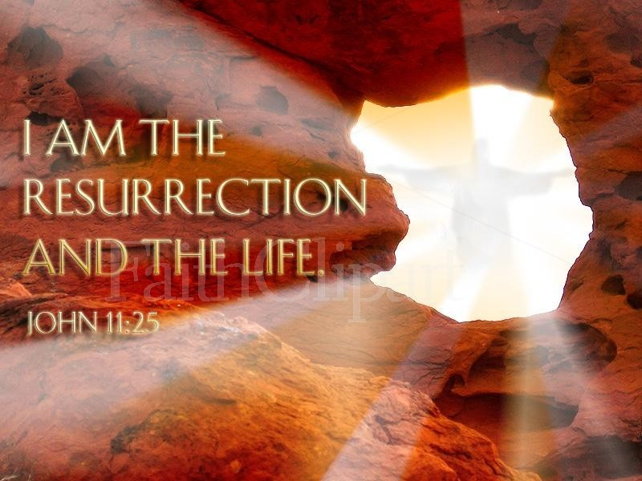

Easter Sunday
The Resurrection of our Lord Jesus Christ
April 5th, 2015

Service of the Word
Evangelical Lutheran Worship, ELW p. 211

Trinity Lutheran Church

Office Phone 776-4781, Fax 776-7888, Office Hours: Mon-8-11, Wed 8-11 & 1-4, F-8-11 am
Email: trinitytruman@frontier.com, Website: www.trinity-truman.org
Interim Kent Krumwiede-Cell #: (507) 848-7192, Email: vicarkent@gmail.com
Office Hours Mon—Thurs 9:00-1:00 pm
GATHERING

Congregation reads bold print *Please stand

PRELUDE
GATHERING REFLECTION
On Easter morning, what reflection could I give but what God has given for us to consider. Christ Jesus, who, though he was in the form of God, did not regard equality with God as something to be exploited, but emptied himself, taking the form of a slave, being born in human likeness. And being found in human form, he humbled himself and became obedient to the point of death -- even death on a cross. Therefore God also highly exalted him and gave him the name that is above every name, so that at the name of Jesus every knee should bend, in heaven and on earth and under the earth, and every tongue should confess that Jesus Christ is Lord, to the glory of God the Father. (Philippians 2:5-11)
Lord, give your people a blessed and safe Easter. Amen.

BELL
EASTER GREETING spoken three times L: He is risen! C: He is risen indeed!

THANKSGIVING FOR BAPTISM ELW p. 97
*GATHERING HYMN Jesus Christ is Risen Today ELW #365
CHILDREN’S SERMON Shir Alleluia Adonai (Sing Alleluia to the Lord)
*KYRIE ELW p. 147
*HYMN OF PRAISE “This is the feast of victory for our God…” ELW p. 149 * PRAYER OF THE DAY L: The Lord be with you. C: And also with you.
L: God of mercy,
C: we no longer look for Jesus among the dead, for he is alive and has become the Lord of life. Increase in our minds and hearts the risen life we share with Christ, and help us to grow as your people toward the fullness of eternal life with you, through Jesus Christ, our Savior and Lord, who lives and reigns with you and the Holy Spirit, one God, now and forever. Amen.
WORD

FIRST READING Isaiah 25:6-9 (NRSV)
⁶ On this mountain the Lord of hosts will make for all peoples a feast of rich food, a feast of well-aged wines, of rich food filled with marrow, of well-aged wines strained clear. ⁷ And he will destroy on this mountain the shroud that is cast over all peoples, the sheet that is spread over all nations; ⁸he will swallow up death forever. Then the Lord God will wipe away the tears from all faces, and the disgrace of his people he will take away from all the earth, for the Lord has spoken. ⁹ It will be said on that day, Lo, this is our God; we have waited for him, so that he might save us. This is the Lord for whom we have waited; let us be glad and rejoice in his salvation.

Word of God, Word of Life. C: Thanks be to God.

PSALM 118:1-2, 14-24 (read responsively bold type)
L: Give thanks to the Lord, for the Lord is good;
C: God’s mercy endures forever.
L: Let Israel now declare,
C: God’s mercy endures forever.
L: The Lord is my strength and my song,
C: and has become my salvation.
L: Shouts of rejoicing and salvation echo in the tents of the righteous;
C: the right hand of the Lord acts valiantly!
L: The right hand of the Lord is exalted!

C: the right hand of the Lord acts valiantly!
L: I shall not die, but live,
C: and declare the works of the Lord.
L: The Lord indeed punished me sorely,
C: but did not hand me over to death.
L: Open for me the gates of righteousness;
C: I will enter them and give thanks to the Lord.
L: This is the gate of the Lord;
C: here the righteous may enter.
L: I give thanks to you for you have answered me
C: and you have become my salvation.
L: The stone that builders rejected;
C: has become the chief cornerstone.
L: By the Lord has this been done.
C: it is marvelous in our eyes.
L: This is the day that the Lord has made;
C: Let us rejoice and be glad in it.

SECOND READING Acts 10:34-43 (NRSV)
³⁴ Then Peter began to speak to them: “I truly understand that God shows no partiality, ³⁵ but in every nation anyone who fears him and does what is right is acceptable to him. ³⁶ You know the message he sent to the people of Israel, preaching peace by Jesus Christ—he is Lord of all. ³⁷ That message spread throughout Judea, beginning in Galilee after the baptism that John announced: ³⁸ how God anointed Jesus of Nazareth with the Holy Spirit and with power; how he went about doing good and healing all who were oppressed by the devil, for God was with him. ³⁹ We are witnesses to all that he did both in Judea and in Jerusalem. They put him to death by hanging him on a tree; ⁴⁰ but God raised him on the third day and allowed him to appear, ⁴¹ not to all the people but to us who were chosen by God as witnesses, and who ate and drank with him after he rose from the dead. ⁴² He commanded us to preach to the people and to testify that he is the one ordained by God as judge of the living and the dead. ⁴³ All the prophets testify about him that everyone who believes in him receives forgiveness of sins through his name.”
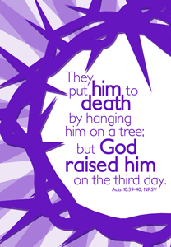
Word of God, Word of Life. C: Thanks be to God.

* GOSPEL ACCLAMATION Alleluia, Lord to whom shall we go… ELW p. 151

*GOSPEL John 20:1-18 C: Glory to you O Lord.
Early on the first day of the week, while it was still dark, Mary Magdalene came to the tomb and saw that the stone had been removed from the tomb. ² So she ran and went to Simon Peter and the other disciple, the one whom Jesus loved, and said to them, “They have taken the Lord out of the tomb, and we do not know where they have laid him.” ³ Then Peter and the other disciple set out and went toward the tomb. ⁴ The two were running together, but the other disciple outran Peter and reached the tomb first. ⁵ He bent down to look in and saw the linen wrappings lying there, but he did not go in. ⁶ Then Simon Peter came, following him, and went into the tomb. He saw the linen wrappings lying there, ⁷ and the cloth that had been on Jesus’ head, not lying with the linen wrappings but rolled up in a place by itself. ⁸ Then the other disciple, who reached the tomb first, also went in, and he saw and believed; ⁹ for as yet they did not understand the scripture, that he must rise from the dead. ¹⁰ Then the disciples returned to their homes.

¹¹ But Mary stood weeping outside the tomb. As she wept, she bent over to look into the tomb; ¹² and she saw two angels in white, sitting where the body of Jesus had been lying, one at the head and the other at the feet. ¹³ They said to her, “Woman, why are you weeping?” She said to them, “They have taken away my Lord, and I do not know where they have laid him.” ¹⁴ When she had said this, she turned around and saw Jesus standing there, but she did not know that it was Jesus. ¹⁵ Jesus said to her, “Woman, why are you weeping? Whom are you looking for?” Supposing him to be the gardener, she said to him, “Sir, if you have carried him away, tell me where you have laid him, and I will take him away.” ¹⁶ Jesus said to her, “Mary!” She turned and said to him in Hebrew, “Rabbouni!” (which means Teacher). ¹⁷ Jesus said to her, “Do not hold on to me, because I have not yet ascended to the Father. But go to my brothers and say to them, ‘I am ascending to my Father and your Father, to my God and your God.’” ¹⁸ Mary Magdalene went and announced to the disciples, “I have seen the Lord”; and she told them that he had said these things to her. Word of God, Word of Life. C: Praise to you, O Christ.

SERMON
*HYMN OF THE DAY Now all the Vaults of Heaven Resounds ELW #367
*THE NICENE CREED (purple sheet inside the back cover of the hymnal or)
*PRAYERS OF INTERCESSION L: Hear us, O God, C: Your mercy is great.
L: The peace of the Lord be with you always. C: And also with you.

MEAL
OFFERING
*OFFERTORY HYMN Create in Me a Clean Heart ELW# 188
OFFERING PRAYER
*THE GREAT THANKSGIVING ELW p. 152
Holy, Holy, Holy p. 153
*WORDS OF INSTITUTION
*THE LORD’S PRAYER ELW p. 154
LAMB OF GOD
THE DISTRIBUTION
All who believe that Jesus Christ is Lord and Savior are welcome to receive Christ’s meal
*POST COMMUION PRAYER C: Amen.

SENDING

*BLESSING Almighty God, Father, + Son and Holy Spirit, bless you with the joy of Easter, both now and forever. Three-Fold Amen.
*SENDING HYMN Thine is the Glory ELW #376
*BELL/SENDING L: Go in peace. Serve the Lord C: Thanks be to God!
POSTLUDE
+++++++++++++++++++++++++++++++++++++++++++++++++++++++++++++++++
Reprinted from Evangelical Lutheran Worship, copyright © 2006 Augsburg Fortress. All rights reserved. Used by permission of Augsburg Fortress license #SB107041

Be thou comforted, little dog, Thou too in Resurrection shall have a little golden tail.
~ Martin Luther

Readings for next Sunday: Acts 4:32-35; Psalm 133; 1 John 1:1-2:2; John 20:19-31
We remember in our prayers…all who face catastrophic illness, surgery, and bindings of all kinds as well as the homebound: Bea Behrens, Vi Benoy, Agnes Carlson, Lisa Carlson & family, Donna Fisk, Danny Lang, and Darrell & Janice Buhmann’s daughter, Roxanne. Be present with your Spirit, Lord, and lead us to be your presence to all. Amen.
A BIG THANK YOU…Hanna Hartman and Zach Hansen for playing their trumpets in the service today!


Thank you for all your prayers and cards during all my surgeries and setbacks. As you can’t get a better church family; I love all of you! May God be with you as he is with me.
Dan & Marianne Lang

THIS WEEK IN OUR PARISH

MONDAY, APRIL 6-Martha Circle meets at Barb Mager’s at 1:30 pm
MONDAY & TUESDAY, APRIL 6 & 7-Vicar Kent will be @ Luther Seminary from Mondays PM until Tuesdays AM.
WEDNESDAY, APRIL 8-BRENDA WILL BE OUT OF THE OFFICE
Choir Practice
7 PM CHURCH COUNCIL MEETING
THURSDAY, APRIL 9- No Circle Bible Study-instead we are taking a tour of MRCI
SATURDAY, APRIL 11-WELCA Spring Gathering in Madelia—registration at 8:30 am
SUNDAY, APRIL 12
9 AM Communion Worship
10 AM Sunday School
Reader: Margaret Durkee, Comm. Server: Mark Durkee, Acolyte: Reese Goeringer
Ushers: *Art Stough, Jeff Maloney, Jackson Maloney and Mason Maloney

Thanks to Those Who Donated Flowers to Trinity For Easter

Howard & LuElla Kautz Jim & Barb Shoen
David & Cathy Sorenson Dorothy Graham
Doyle & Arlene Peterson Connie Selnes
Jan Warrington Lois Lloyd
Jerome & Laurie Wille Dean & Bev Gulbranson
James & Brenda Hansen Tom Dodge
Norman & Marilyn Anderson Lowell & Yvonne Noorlun
JoAnn Knutson

UPCOMING EVENTS

LUTHER MEMORIAL HOME AUXILIARY’S SPRING FESTIVAL
On Tuesday, April 14th at Trinity Lutheran in Madelia. The Salad Luncheon will be held from 11-1 pm. Adults are $6. A Drawing for a variety of prizes to be held at 12:30. Everyone is welcome to attend!

