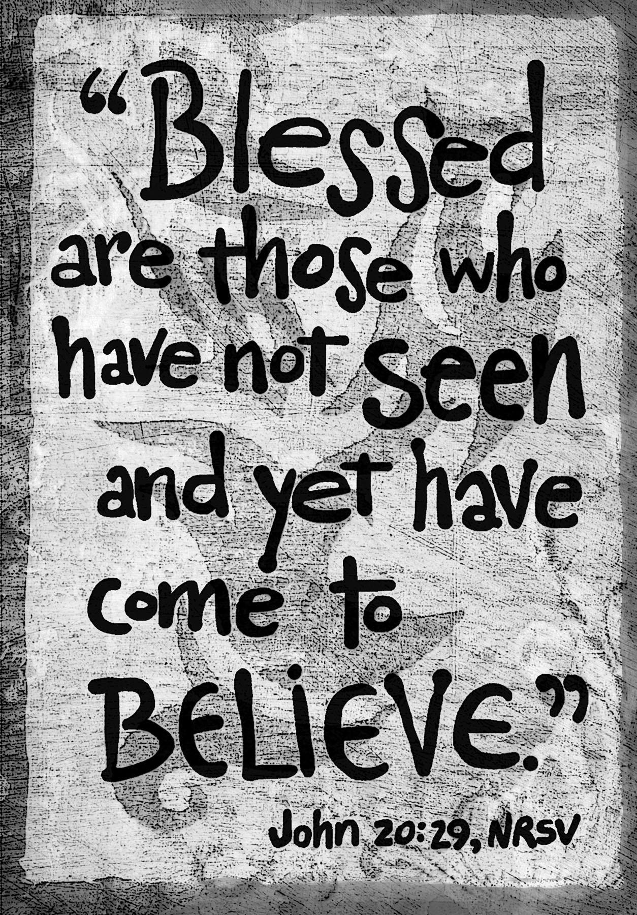

***Second Sunday of Easter***

**April 3, 2016**

**Evangelical Lutheran Worship**

**Trinity Lutheran Church**

Office Phone 776-4781, Fax 776-7888, Office Hours: Mon-8-11, Wed 8-11 & 1-4, F-8-11 am

Email: [trinitytruman@frontier.com](mailto:trinitytruman@frontier.com), Website: [www.trinity-truman.org](http://www.trinity-truman.org)

**Pastor Krista Strum-**Cell-(507)995-1233, Email: pkstrumom@me.com

Pastor Krista’s Hours: Wed. 11-2:30 pm & Thurs. 8:30-2:30 pm

**GATHERING**

*Congregation reads* ***bold print*** *\*Please stand*

**PRELUDE**

**BELL**

**CONFESSION AND FORGIVENESS**

Let us prepare our hearts and minds for worship confessing our sins before God and one another.

Loving God, **we confess that at times we do not share in the joy of the resurrection but are caught up in the worries of the world. We confess that we don’t always live in the spirit of new life but remain discontent, grumbling, and anxious. Forgive us for not sharing in the Good News. Forgive us when we find it more comfortable to worry and complain than to rest in the joy and encouragement of new life in Christ. Call us back to Your ways, O God, to seek hope, reconciliation, restoration and peace. In the name of the Risen Christ, we pray. Amen.**

Christ is risen! The stone is rolled away, the tomb found empty. Mary calls out, “I have seen the Lord!” We have seen Christ too, in every helping hand, in every heartfelt gift, in every choice to restore life in this world. WE are called to this new life, a life of forgiveness and reconciliation. In the name of Jesus Christ our risen Lord you are forgiven! + Accept your forgiveness and know that God loves you and desires great joy for your life. Walk forward on this journey of faith, knowing your brothers and sisters in Christ are with you. **Thanks be to God! Amen.**

**ANNOUNCEMENTS**

**ENTRANCE HYMN** *The Strife Is O'er, the Battle Done*  **ELW #366**

**GREETING**

The grace of our Lord Jesus Christ, the love of God, and the communion of the Holy Spirit be with you all. **And also with you.**

**KYRIE**

L: Kyrie eleison: **C: Lord, have mercy.**

L: Christe eleison: **C: Christ, have mercy.**

L: Kyrie eleison: **C: Lord, have mercy.**

* **PRAYER OF THE DAY** L: The Lord be with you. **C: And also with you.**

L: Let us pray,

**Almighty and eternal God, the strength of those who believe and the hope of those who doubt, may we, who have not seen, have faith in you and receive the fullness of Christ’s blessing, who lives and reigns with you and the Holy Spirit, one God, now and forever.**

**Amen.**

**WORD**

**FIRST READING Revelation 1:4-8**

4John to the seven churches that are in Asia: Grace to you and peace from him who is and who was and who is to come, and from the seven spirits who are before his throne, 5and from Jesus Christ, the faithful witness, the firstborn of the dead, and the ruler of the kings of the earth. To him who loves us and freed us from our sins by his blood, 6and made us to be a kingdom, priests serving his God and Father, to him be glory and dominion forever and ever. Amen. 7Look! He is coming with the clouds; every eye will see him, even those who pierced him; and on his account all the tribes of the earth will wail. So it is to be. Amen.   8“I am the Alpha and the Omega,” says the Lord God, who is and who was and who is to come, the Almighty.

The word of the Lord. **Thanks be to God.**

**PSALM: Psalm 118:14-29** *(please read responsively the* ***bold print****)*

 14The Lord is my strength and my song, and he has become my salvation.

  15**There is a sound of exultation and victory in the tents of the righteous:**

 16“The right hand of the Lord has triumphed! The right hand of the Lord is exalted! The

right hand of the Lord has triumphed!”

 17**I shall not die, but live, and declare the works of the Lord.**

 18The Lord has punished me sorely, but he did not hand me over to death.

 19**Open for me the gates of righteousness; I will enter them; I will offer**

**thanks to the Lord.**

 20“This is the gate of the Lord; he who is righteous may enter.”

 21**I will give thanks to you, for you answered me and have become my**

**salvation.**

 22The same stone which the builders rejected has become the chief cornerstone.

 23**This is the Lord‘s doing, and it is marvelous in our eyes.**

 24On this day the Lord has acted; we will rejoice and be glad in it.

 25**Hosanna, Lord, hosanna! Lord, send us now success.**

 26Blessed is he who comes in the name of the Lord; we bless you from the house of the

Lord.

 27**God is the Lord; he has shined upon us; form a procession with branches up to the horns of the altar.**

 28“You are my God, and I will thank you; you are my God, and I will exalt you.”

 29**Give thanks to the Lord, for he is good; his mercy endures forever.**

**CHILDREN’S TIME**

* **GOSPEL ACCLAMATION** *Halle, Halle, Hallelujah***ELW #172**

\***GOSPEL John 20:19-31 C: Glory to you O Lord.**

19When it was evening on that day, the first day of the week, and the doors of the house where the disciples had met were locked for fear of the Jews, Jesus came and stood among them and said, “Peace be with you.” 20After he said this, he showed them his hands and his side. Then the disciples rejoiced when they saw the Lord. 21Jesus said to them again, “Peace be with you. As the Father has sent me, so I send you.” 22When he had said this, he breathed on them and said to them, “Receive the Holy Spirit. 23If you forgive the sins of any, they are forgiven them; if you retain the sins of any, they are retained.” 24But Thomas (who was called the Twin), one of the twelve, was not with them when Jesus came. 25So the other disciples told him, “We have seen the Lord.” But he said to them, “Unless I see the mark of the nails in his hands, and put my finger in the mark of the nails and my hand in his side, I will not believe.” 26A week later his disciples were again in the house, and Thomas was with them. Although the doors were shut, Jesus came and stood among them and said, “Peace be with you.” 27Then he said to Thomas, “Put your finger here and see my hands. Reach out your hand and put it in my side. Do not doubt but believe.” 28Thomas answered him, “My Lord and my God!” 29Jesus said to him, “Have you believed because you have seen me? Blessed are those who have not seen and yet have come to believe.” 30Now Jesus did many other signs in the presence of his disciples, which are not written in this book. 31But these are written so that you may come to believe that Jesus is the Messiah, the Son of God, and that through believing you may have life in his name.

The gospel of the Lord. **Praise to you, O Christ.**

**SERMON**

**\*HYMN OF THE DAY**  *We Walk by Faith* **ELW #635**

**\*THE CREED** *(SALMON sheet inside the back cover of the red hymnal)*

**\*PRAYERS OF INTERCESSION** *Dona nobis pacem* **ELW #753**

**\*PEACE** L: The peace of Christ be with you always. **C: And also with you.**

**MEAL**

**OFFERING**

**OFFERING PRAYER**

Let us pray. Blessed are you, O God, ruler of heaven and earth. Day by day you shower us with blessings. As you have raised us to new life in Christ, give us glad and generous hearts, ready to praise you and to respond to those in need, through Jesus Christ, our Savior and Lord. **Amen.**

**DIALOGUE**

The Lord be with you. **And also with you.**

Lift up your hearts. **We lift them to the Lord.**

Let us give thanks to the Lord our God. **It is right to give our thanks and praise.**

**SANCTUS**

**Holy, holy, holy Lord, God of power and might,**

**heaven and earth are full of your glory.**

**Hosanna in the highest.**

**Blessed is he who comes in the name of the Lord.**

**Hosanna in the highest. Hosanna in the highest.**

**\*THE GREAT THANKSGIVING**

**\*THE LORD’S PRAYER**  *(SALMON sheet inside the back cover of the red hymnal)*

**COMMUNION** *(All are invited to come to the banquet, for all is ready)*

**COMMUNION HYMN**

**Lamb of God, you take away the sin of the world; have mercy on us.**

**Lamb of God, you take away the sin of the world; have mercy on us.**

**Lamb of God, you take away the sin of the world;**

**grant us peace, grant us peace.**

**\*PRAYER AFTER COMMMUION** L: Let us pray,

**Almighty God, you provide the true bread from heaven, your Son, Jesus Christ our Lord. Grant that we who have received the Sacrament of his body and blood may abide in him and he in us, that we may be filled with the power of his endless life, now and forever. Amen**

**SENDING**

**\*BLESSING** Almighty God, Father, ☩ Son, and Holy Spirit, bless you now and forever.

**Amen.**

***Three-Fold Amen***

**\*SENDING HYMN** *Let All Things Now Living*  **ELW #881**

**\*BELL/SENDING** L: Go in peace. Serve the Lord **C: Thanks be to God!**

**POSTLUDE**

**+++++++++++++++++++++++++++++++++++++++++++++++++++++++++++++++++**

Reprinted from Evangelical Lutheran Worship, copyright © 2006 Augsburg Fortress. All rights reserved. Used by permission of Augsburg Fortress license #SB107041

**Readings for next Sunday: Acts 9:1-6[7-20], Ps. 30, Rev. 5:11-14, John 21:1-19**

Prayer requests

*We remember in our prayers…all who face catastrophic illness, surgery, and bindings of all kinds as well as the homebound:* ***Bea Behrens, Agnes Carlson, Lisa******Carlson & family, Donna Fisk, and Danny Lang.***

**THIS WEEK IN OUR PARISH**

**MONDAY, APRIL 4**-Martha Circle meets at Connie Selnes

**SUNDAY, APRIL 10**

9-10 am Classroom Sunday School, 10-10:30 am Kid friendly snack

10:30 am Communion Worship

*Reader: Brenda Hansen, Comm. Server: Darrel Drevlow, Acolyte: Tallin Cook*

*Ushers: *Art Stough, Jeff Maloney, Jackson and Mason Maloney*

**UPCOMING EVENTS**

**BEGINNING APRIL 4TH**

Fairmont is holding a Greif Support Group on 8 consecutive Mondays, starting April 4th from 6:30-8:30 pm. In “The Sunroom” at Woodland Manor on the campus of Lakeview Health Services, 610 Summit Dr. Fairmont, MN. Held by Trained Greif Facilitators

**APRIL 7, 8 & 9TH**

Martin Luther School’s Rummage & Bake Sale. Thursday & Friday from 4-8 pm, Saturday 8 am – noon. Lots of bargains-clothing, household, toys and books and much misc.

**APRIL 12TH - LUTHER MEMORIAL HOME AUXILIARY’S SPRING FESTIVAL**

On Tuesday, April 12th at Trinity Lutheran in Madelia. The Salad Luncheon will be held from 11-1 pm. Adults are $6. A Drawing for a variety of prizes to be held at 12:30. Everyone is welcome to attend!