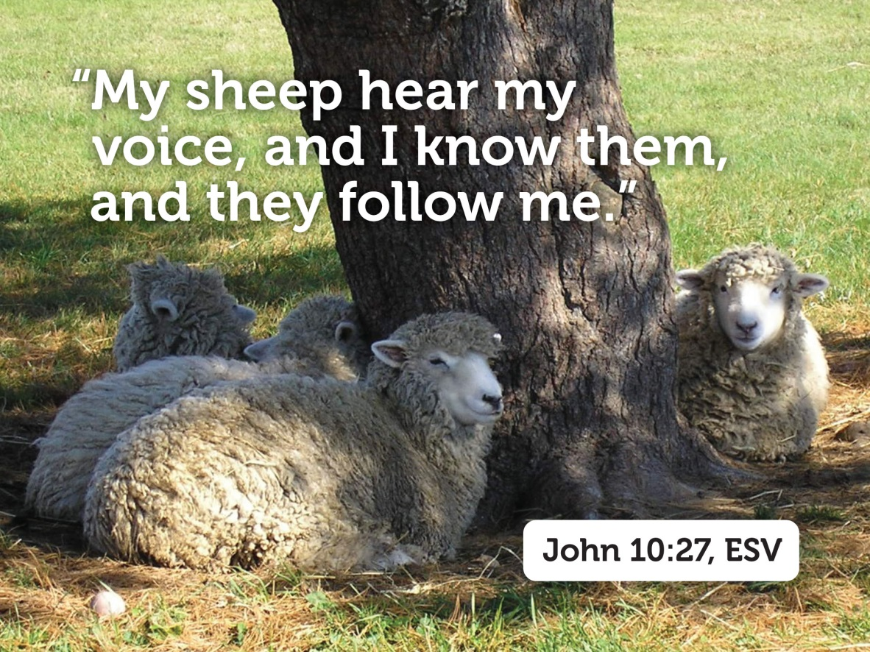

***Fourth Sunday of Easter***

**April 17, 2016**

**Evangelical Lutheran Worship, Setting 4**

**Trinity Lutheran Church**

Office Phone 776-4781, Fax 776-7888, Office Hours: Mon-8-11, Wed 8-11 & 1-4, F-8-11 am

Email: [trinitytruman@frontier.com](mailto:trinitytruman@frontier.com), Website: [www.trinity-truman.org](http://www.trinity-truman.org)

**Pastor Krista Strum-**Cell-(507)995-1233, Email: pkstrumom@me.com

Pastor Krista’s Hours: Wed. 8:30-3:00 pm & Thurs. 10:30-2:00 pm

**GATHERING**

*Congregation reads* ***bold print*** *\*Please stand*

**PRELUDE**

**BELL**

**\*CONFESSION AND FORGIVENESS**

Blessed be the holy Trinity, ☩ one God,

the fountain of living water, the rock who gave us birth, our light and our salvation.

**Amen.**

Let us come into the light, the revealing and healing light of God.

God of grace and glory,

**you have brought us through the night of sin**

**into the light of Jesus’ resurrection.**

**Yet our lives are still shadowed by sin.**

**Make us alive in Christ, O God.**

**Make us new as you make all things new.**

**Rescue us from evil and the gloom of sin, renew us in grace,**

**and restore us to living in your holiness,**

**through Jesus Christ, our risen Lord. Amen.**

Rejoice with all creation around God’s throne!

The light of the risen Christ puts to flight all evil deeds, washes away sin,

restores innocence to the fallen, casts out hate, brings peace, and humbles earthly pride. Jesus Christ loves you and ☩ frees you from your sins by his blood.

To him be glory and dominion forever and ever! **Amen.**

**ANNOUNCEMENTS**

**\*GATHERING SONG***Savior, like a Shepherd Lead Us* **ELW #789**

**GREETING**

The grace of our Lord Jesus Christ, the love of God, and the communion of the Holy Spirit be with you all. **And also with you.**

**\*KYRIE ELW p. 147**

**\*HYMN OF PRAISE ELW p. 148**

* **PRAYER OF THE DAY** L: The Lord be with you. **C: And also with you.**

L: Let us pray,

**O God of peace, you brought again from the dead our Lord Jesus Christ, the great shepherd of the sheep. By the blood of your eternal covenant, make us complete in everything good that we may do your will, and work among us all that is well-pleasing in your sight, through Jesus Christ, our Savior and Lord, who lives and reigns with you and the Holy Spirit, one God, now and forever. Amen.**

**FIRST READING: Acts 9:36-43**

36Now in Joppa there was a disciple whose name was Tabitha, which in Greek is Dorcas. She was devoted to good works and acts of charity. 37At that time she became ill and died. When they had washed her, they laid her in a room upstairs. 38Since Lydda was near Joppa, the disciples, who heard that Peter was there, sent two men to him with the request, “Please come to us without delay.” 39So Peter got up and went with them; and when he arrived, they took him to the room upstairs. All the widows stood beside him, weeping and showing tunics and other clothing that Dorcas had made while she was with them. 40Peter put all of them outside, and then he knelt down and prayed. He turned to the body and said, “Tabitha, get up.” Then she opened her eyes, and seeing Peter, she sat up. 41He gave her his hand and helped her up. Then calling the saints and widows, he showed her to be alive. 42This became known throughout Joppa, and many believed in the Lord. 43Meanwhile he stayed in Joppa for some time with a certain Simon, a tanner.

The word of the Lord. **Thanks be to God.**

**PSALM: Psalm 23** *(please read responsively the* ***bold print****)*

1The Lord is my shepherd; I shall not be in want.

 2**The Lord makes me lie down in green pastures and leads me beside still waters.**

3You restore my soul, O Lord, and guide me along right pathways for your name’s sake.

 4**Though I walk through the valley of the shadow of death, I shall fear no evil;**

**for you are with me; your rod and your staff, they comfort me.**

5You prepare a table before me in the presence of my enemies; you anoint my head with oil, and my cup is running over.

 6**Surely goodness and mercy shall follow me all the days of my life, and I will dwell in the house of the Lord forever.**

**SECOND READING: Revelation 7:9-17**

9After this I looked, and there was a great multitude that no one could count, from every nation, from all tribes and peoples and languages, standing before the throne and before the Lamb, robed in white, with palm branches in their hands. 10They cried out in a loud voice, saying, “Salvation belongs to our God who is seated on the throne, and to the Lamb!” 11And all the angels stood around the throne and around the elders and the four living creatures, and they fell on their faces before the throne and worshiped God, 12singing,  “Amen! Blessing and glory and wisdom and thanksgiving and honor and power and might  be to our God forever and ever! Amen.” 13Then one of the elders addressed me, saying, “Who are these, robed in white, and where have they come from?” 14I said to him, “Sir, you are the one that knows.” Then he said to me, “These are they who have come out of the great ordeal; they have washed their robes and made them white in the blood of the Lamb. 15For this reason they are before the throne of God, and worship him day and night within his temple, and the one who is seated on the throne will shelter them. 16They will hunger no more, and thirst no more; the sun will not strike them, nor any scorching heat; 17for the Lamb at the center of the throne will be their shepherd, and he will guide them to springs of the water of life, and God will wipe away every tear from their eyes.”

The word of the Lord. **Thanks be to God.**

**TRINITY CHOIR** “Old Time Religion Medley” *piano by Ralph Flitter*

**CHILDREN’S TIME-SUNDAY SCHOOL SINGS**

* **GOSPEL ACCLAMATION** *Halle, Halle, Hallelujah***ELW #172**

\***GOSPEL John 10:22-30 C: Glory to you O Lord.**

22At that time the festival of the Dedication took place in Jerusalem. It was winter, 23and Jesus was walking in the temple, in the portico of Solomon. 24So the Jews gathered around him and said to him, “How long will you keep us in suspense? If you are the Messiah, tell us plainly.” 25Jesus answered, “I have told you, and you do not believe. The works that I do in my Father’s name testify to me; 26but you do not believe, because you do not belong to my sheep. 27My sheep hear my voice. I know them, and they follow me. 28I give them eternal life, and they will never perish. No one will snatch them out of my hand. 29What my Father has given me is greater than all else, and no one can snatch it out of the Father’s hand. 30The Father and I are one.”

The gospel of the Lord. **Praise to you, O Christ.**

**SERMON**

**\*HYMN OF THE DAY**  *Have No Fear, Little Flock***ELW #764**

**\*THE CREED** *(SALMON sheet inside the back cover of the red hymnal)*

**\*THE PRAYERS OF INTERCESSION**

**\*PRAYER PETITIONS** *Dona nobis pacem* **ELW #753**

**\*PEACE** L: The peace of Christ be with you always. **C: And also with you.**

**OFFERING**

**OFFERING HYMN**

**OFFERING PRAYER** Let us pray,

Blessed are you, O God, ruler of heaven and earth. Day by day you shower us with blessings. As you have raised us to new life in Christ, give us glad and generous hearts, ready to praise you and to respond to those in need, through Jesus Christ, our Savior and Lord. **Amen.**

**\*THE LORD’S PRAYER**  *(SALMON sheet inside the back cover of the red hymnal)*

**SENDING**

**\*BLESSING**

The blessing of the Lord God Almighty, the blessing of ☩ Christ, the Lamb who was slain,

and the blessing of the Holy Spirit of truth be among you and remain with you always.

***Three fold Amen***

**SENDING SONG***Lead Me, Guide Me***ELW #768**

**\*BELL/SENDING** L: Alleluia. Go in peace. Share the good news.

**C: Thanks be to God! Alleluia.**

**POSTLUDE**

**+++++++++++++++++++++++++++++++++++++++++++++++++++++++++++++++++**

Copyright © 2016 Augsburg Fortress. All rights reserved. Reprinted by permission under Augsburg Fortress Liturgies Annual License #SAS103469. New Revised Standard Version Bible, copyright © 1989, Division of Christian Education of the National Council of the Churches of Christ in the United States of America. Used by permission. All rights reserved.

**Readings for next Sunday:** Acts 11:1-18, Ps. 148, Rev. 21:1-6, John 13:31-35

Prayer requests

*We remember in our prayers…all who face catastrophic illness, surgery, and bindings of all kinds as well as the homebound:* ***Bea Behrens, Agnes Carlson, Lisa******Carlson & family, Donna Fisk, Danny Lang and Kent Hyndman.***

Thank you to Keegan & Carson Hastad for playing the piano and singing for the pre-lude of church today. They are instructed by Miss Kim Breamer.



Thank you to Ralph Flitter for his talent on playing the piano for

the Choir song today. He is from Faith Lutheran in Madelia.

Deepest Sympathy to the family of James Hansen on the death of his mother, Violet Hansen who passed away on Thursday. Her funeral is today at 3 pm at the Truman Church of Christ. Visitation is 1 hour prior to the service.

**THIS WEEK IN OUR PARISH**

A Handbell Festival Concert, “Ringing Our Praise,” will be held at American Lutheran Church in Windom Today at 300 pm. Everyone is invited to enjoy the music of five area Handbelll Choirs and Handbell Ensembles from Gustavus Adolphus College.

**FRI & SAT APRIL 22 &23**-Pat Jones Scrapbooking at the church

**SUNDAY, APRIL 24**

9-10 am Group Sunday School,

10:30 am Worship

*Reader: Barb Shoen, Acolyte: Miah Krebs*

*Ushers: *Art Stough, Jeff Maloney, Jackson and Mason Maloney*

A representative from the Struthers Parkinson’s Center in Minneapolis will be giving a presentation in Fairmont on **Wednesday, April 20th at 1:00pm at the Lakeview Methodist Health Care Center**. This event is being sponsored by CREST and there is no admission charge. It is open to anyone who is taking care of a loved one with Parkinson’s, has questions about the disease, or looking for ways to provide support for the family.

**SATURDAY, APRIL 23-**ANEW FROM THE ASHES…A Hog Roast Benefit for St. James Lutheran Church & School in Northrop. Serving from 4-8 pm. Free will offering. Come & Go Sale 4-8 pm. Event is sponsored by area churches and the community. Will be held at Martin Luther High School, Northrop.

**UPCOMING EVENTS**

**SUNDAY, MAY 1**-Blessing of the Seeds Sunday

**SUNDAY, MAY 8-**Mother’s Day, Last Day of Sunday School and Teacher Recognition

**SUNDAY, MAY 15**-CONFIRMATION two students will affirm their baptism

**SUNDAY, MAY 22**-Graduates Recognition and Reception