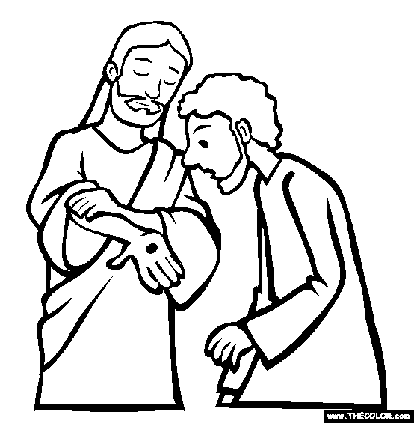

The Marks of the Church
2nd Sunday of Easter
April 12th, 2015

Holy Communion, Setting 4
Evangelical Lutheran Worship (ELW) p. 147

Trinity Lutheran Church
Office Phone 776-4781, Fax 776-7888,
Office Hours: Mon-8-11, Wed 8-11 & 1-4, F-8-11 am
Email: trinitytruman@frontier.com, Website: www.trinity-truman.org
Interim Kent Krumwiede-Cell #: (507) 848-7192,
Email: vicarkent@gmail.com Office Hours Mon—Thurs 9:00-1:00 pm
GATHERING

Congregation reads bold print *Please stand

PRELUDE
GATHERING REFLECTION
Psalm 133 is a short and to the point psalm, It is a psalm of ascent. That is, it is a psalm that was sung by the Jews when they would "ascend" to visit the Holy Temple three times annually for the festivals. This is a celebration of unity of community. Not just unity of the faith community, but of the whole community. This unity is described as the oil of anointing. It is an oil of blessing, and not just a little oil, but an abundance of oil. So much oil that it runs down the head onto the robes. It is used metaphorically for the abundance of God’s blessing of unity God has granted all who share the faith in God’s love and promise. God of blessing, join your people into one body in Christ, in faith, in love and in hope. Amen.

BELL
WELCOME & ANNOUNCEMENTS
*CONFESSION & FORGIVENESS left column ELW p. 94
*GATHERING HYMN I Know that My Redeemer Lives ELW #619
*GREETING
*KYRIE ELW p. 147
*HYMN OF PRAISE “This is the feast of victory for our God…” ELW p. 149 * PRAYER OF THE DAY: L: Almighty God,
C: with joy we celebrate the day of our Lord’s resurrection. By the grace of Christ among us, enable us to show the power of the resurrection in all that we say and do, through Jesus Christ, our Savior and Lord, who lives and reigns with you and the Holy Spirit, one God, now and forever. Amen.
WORD

FIRST READING Acts 4:32-35 (NRSV)
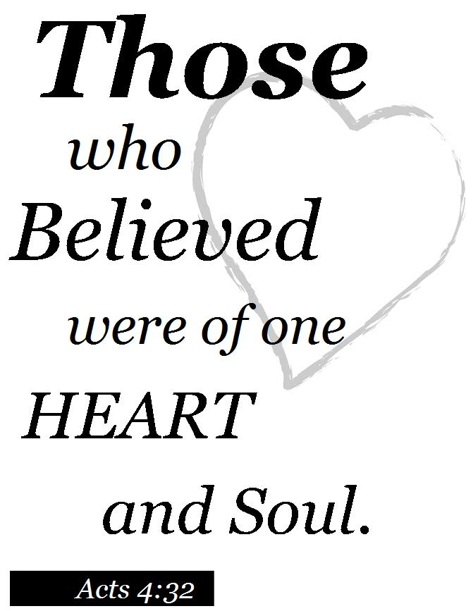
The Believers Share Their Possessions
³² Now the whole group of those who believed were of one heart and soul, and no one claimed private ownership of any possessions, but everything they owned was held in common. ³³ With great power the apostles gave their testimony to the resurrection of the Lord Jesus, and great grace was upon them all. ³⁴ There was not a needy person among them, for as many as owned lands or houses sold them and brought the proceeds of what was sold. ³⁵ They laid it at the apostles’ feet, and it was distributed to each as any had need.

Word of God, Word of Life. C: Thanks be to God.
PSALM 133 (the psalms begin on ELW p. 338, assembly reads the indented lines)

SECOND READING 1 John 1-2:2 (NRSV)
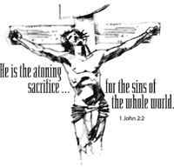
We declare to you what was from the beginning, what we have heard, what we have seen with our eyes, what we have looked at and touched with our hands, concerning the word of life— ² this life was revealed, and we have seen it and testify to it, and declare to you the eternal life that was with the Father and was revealed to us— ³ we declare to you what we have seen and heard so that you also may have fellowship with us; and truly our fellowship is with the Father and with his Son Jesus Christ. ⁴ We are writing these things so that our joy may be complete. ⁵ This is the message we have heard from him and proclaim to you, that God is light and in him there is no darkness at all. ⁶ If we say that we have fellowship with him while we are walking in darkness, we lie and do not do what is true; ⁷ but if we walk in the light as he himself is in the light, we have fellowship with one another, and the blood of Jesus his Son cleanses us from all sin. ⁸ If we say that we have no sin, we deceive ourselves, and the truth is not in us. ⁹ If we confess our sins, he who is faithful and just will forgive us our sins and cleanse us from all unrighteousness. ¹⁰ If we say that we have not sinned, we make him a liar, and his word is not in us. 2 My little children, I am writing these things to you so that you may not sin. But if anyone does sin, we have an advocate with the Father, Jesus Christ the righteous; ² and he is the atoning sacrifice for our sins, and not for ours only but also for the sins of the whole world.

Word of God, Word of Life. C: Thanks be to God.

* GOSPEL ACCLAMATION Lord, Let My Heart Be Good Soil ELW #512

*GOSPEL John 20:19-31 C: Glory to you O Lord.
Jesus Appears to the Disciples
¹⁹ When it was evening on that day, the first day of the week, and the doors of the house where the disciples had met were locked for fear of the Jews, Jesus came and stood among them and said, “Peace be with you.” ²⁰ After he said this, he showed them his hands and his side. Then the disciples rejoiced when they saw the Lord. ²¹ Jesus said to them again, “Peace be with you. As the Father has sent me, so I send you.” ²² When he had said this, he breathed on them and said to them, “Receive the Holy Spirit. ²³ If you forgive the sins of any, they are forgiven them; if you retain the sins of any, they are retained.” Jesus and Thomas—²⁴ But Thomas (who was called the Twin), one of the twelve, was not with them when Jesus came. ²⁵ So the other disciples told him, “We have seen the Lord.” But he said to them, “Unless I see the mark of the nails in his hands, and put my finger in the mark of the nails and my hand in his side, I will not believe.” ²⁶ A week later his disciples were again in the house, and Thomas was with them. Although the doors were shut, Jesus came and stood among them and said, “Peace be with you.” ²⁷ Then he said to Thomas, “Put your finger here and see my hands. Reach out your hand and put it in my side. Do not doubt but believe.” ²⁸ Thomas answered him, “My Lord and my God!” ²⁹ Jesus said to him, “Have you believed because you have seen me? Blessed are those who have not seen and yet have come to believe.”
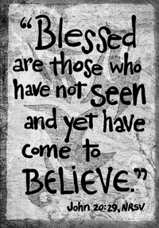
The Purpose of This Book—³⁰ Now Jesus did many other signs in the presence of his disciples, which are not written in this book. ³¹ But these are written so that you may come to believe that Jesus is the Messiah, the Son of God, and that through believing you may have life in his name.

Word of God, Word of Life. C: Praise to you, O Christ.

CHILDREN’S SERMON

SERMON
*HYMN OF THE DAY Christ is Risen! Alleluiah! ELW #382
*APOSTLES’ CREED salmon sheet in back of the red hymnal
*PRAYERS OF INTERCESSION L: Hear us, O God, C: Your mercy is great.
L: The peace of the Lord be with you always. C: And also with you.

THANKSGIVING
OFFERING
*OFFERTORY HYMN Create in Me a Clean Heart ELW# 188
*THE GREAT THANKSGIVING ELW p. 152
Holy, Holy, Holy p. 153
*WORDS OF INSTITUTION
*THE LORD’S PRAYER ELW p. 154
L: Come, receive the mark of the church, the bread and the wine. Amen.
LAMB OF GOD p. 154
THE DISTRIBUTION
All who believe that Jesus Christ is Lord and Savior are welcome to receive Christ’s meal
*POST COMMUION PRAYER C: Amen.

SENDING

*BLESSING Almighty God, Father, + Son and Holy Spirit, bless you now and forever.
Three-Fold Amen.
*SENDING HYMN Lift High the Cross ELW #660
*BELL/SENDING L: Go in peace. Serve the Lord C: Thanks be to God!
POSTLUDE
++++++++++++++++++++++++++++++++++++++++++++++++++++++++++++++++
Reprinted from Evangelical Lutheran Worship, copyright © 2006 Augsburg Fortress. All rights reserved. Used by permission of
Augsburg Fortress license #SB107041

Unity is strength... when there is teamwork and collaboration,
wonderful things can be achieved. ~ Mattie Stepanek

Readings for next Sunday: Acts 3:12-19; Psalm 4; 1 John 3:1-7; Luke 24:36b-48

We remember in our prayers…all who face catastrophic illness, surgery, and bindings of all kinds as well as the homebound: Bea Behrens, Vi Benoy, Agnes Carlson, Lisa Carlson & family, Donna Fisk, Danny Lang, and Darrell & Janice Buhmann’s daughter, Roxanne. Be present with your Spirit, Lord, and lead us to be your presence to all. Amen.


Thank you for all your prayers and cards during all my surgeries and setbacks. As you can’t get a better church family; I love all of you! May God be with you as he is with me.
Dan & Marianne Lang

TODAY: The Truman Fireman’s Fundraising Breakfast is Today from 9-1 pm at the Truman Firehall-free will offering. Serving: pancakes, eggs, bacon, sausage, hashbrowns, coffee, juice and milk. Proceeds will go towards the Truman Fireman Relief Association- for equipment.

THIS WEEK IN OUR PARISH

MONDAY & TUESDAY, APRIL 13 & 14-Vicar Kent will be @ Luther Seminary from Mondays PM until Tuesdays AM.
TUESDAY, APRIL 14- LUTHER MEMORIAL HOME AUXILIARY’S SPRING FESTIVAL-On Tuesday, April 14th at Trinity Lutheran in Madelia. The Salad Luncheon will be held from 11-1 pm. Adults are $6. A Drawing for a variety of prizes to be held at 12:30. Everyone is welcome to attend!
WEDNESDAY, APRIL 15-Choir Practice at 6 pm
THURSDAY, APRIL 16- Preschool Screening at Trinity from 8-3 pm
FRIDAY, APRIL 17-Last day to submit news items to our newsletter “The Messenger”
Announcements (Continued)

FRIDAY & SATURDAY, APRIL 17 & 18-Pat Jones Scrapbooking at the church.
SUNDAY, APRIL 19-Noisy Sunday
9 AM Worship
10 AM Sunday School
Reader: David Sorenson, Acolyte: Kylee Harder
Ushers: *Art Stough, Jeff Maloney, Jackson Maloney and Mason Maloney

UPCOMING EVENTS

KNIGHTS OF COLUMBUS BREAKFAST

The Fairmont Knights of Columbus will be hosting a breakfast fundraiser for CREST on Sunday, April 19th from 9am-Noon at the K-C Hall, located at 920 East 10th Street in Fairmont. The meal will include pancakes, sausages, milk, juice & coffee. Admission to this event will be by free-will offering and members of the CREST staff & board will be on hand to answer any questions you may have about the CREST program. If you can’t stay, takeout meals will be available and all proceeds will benefit the CREST program in Martin County.

Interfaith Caregivers, Faith in Action conducts a variety of support groups for Caregivers in Martin County. [A Caregiver is a family member, close friend or neighbor who takes care of a frail or disabled older person]. Group Services include: caregiver consultation, group education and support, and “Powerful Tools for Caregivers” an educational workshop. Current offerings include:
- Caregiver Connection meets at Fairmont United Methodist Church the 1st Tuesday of each month at 1:30 pm
- Caregiver Connection meets at Grace Lutheran Church-Fairmont on the 2nd Tuesday of each month at 1:30 pm
- Caregiver Connection meets at Trimont Covenant Church on the 3rd Tuesday of each month at 2:30 pm.

To register, call Interfaith Caregivers office at 507-526-4684. There is no cost to enroll.

Coping with the Death of a Loved One? A Grief Support Group Can Help you:
When: 8 Consecutive Tuesdays, April 14, 2015 (Free of charge)
Time: 6:30 pm to 8:30 pm
Where: The Sunroom” at Woodland Manor-Lakeview Health Services, Fairmont Mn
Contact: Naomi Segar at 507-526-7970 in inquire and pre-register

