**

***Third Sunday of Easter***

**April 10, 2016**

**Evangelical Lutheran Worship**

**Trinity Lutheran Church**

Office Phone 776-4781, Fax 776-7888, Office Hours: Mon-8-11, Wed 8-11 & 1-4, F-8-11 am

Email: [trinitytruman@frontier.com](mailto:trinitytruman@frontier.com), Website: [www.trinity-truman.org](http://www.trinity-truman.org)

**Pastor Krista Strum-**Cell-(507)995-1233, Email: pkstrumom@me.com

Pastor Krista’s Hours: Wed. 11-2:30 pm & Thurs. 8:30-2:30 pm

**GATHERING**

*Congregation reads* ***bold print*** *\*Please stand*

**PRELUDE**

**BELL**

**CONFESSION AND FORGIVENESS**

Let us prepare our hearts and minds for worship confessing our sins before God and one another.

Loving God, **we confess that at times we do not share in the joy of the resurrection but are caught up in the worries of the world.  We confess that we don’t always live in the spirit of new life but remain discontent, grumbling, and anxious.  Forgive us for not sharing in the Good News.  Forgive us when we find it more comfortable to worry and complain than to rest in the joy and encouragement of new life in Christ.  Call us back to Your ways, O God, to seek hope, reconciliation, restoration and peace.  In the name of the Risen Christ, we pray. Amen.**

Christ is risen!  The stone is rolled away, the tomb found empty.  Mary calls out, “I have seen the Lord!” We have seen Christ too, in every helping hand, in every heartfelt gift, in every choice to restore life in this world.  We are called to this new life, a life of forgiveness and reconciliation.  In the name of Jesus Christ our risen Lord you are forgiven! +  Accept your forgiveness and know that God loves you and desires great joy for your life.  Walk forward on this journey of faith, knowing your brothers and sisters in Christ are with you.  **Thanks be to God! Amen.**

**ANNOUNCEMENTS**

**\*ENTRANCE HYMN***Now All the Vault of Heaven Resounds*  **ELW #367**

**GREETING**

The grace of our Lord Jesus Christ, the love of God, and the communion of the Holy Spirit be with you all. **And also with you.**

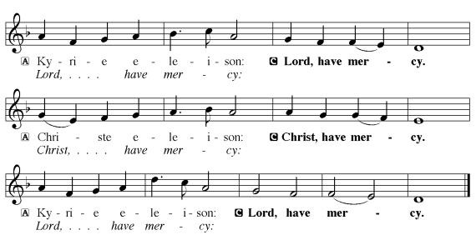**KYRIE**

* **PRAYER OF THE DAY** L: The Lord be with you. **C: And also with you.**

L: Let us pray,

**Eternal and all-merciful God, with all the angels and all the saints we laud your majesty and might. By the resurrection of your Son, show yourself to us and inspire us to follow Jesus Christ, our Savior and Lord, who lives and reigns with you and the Holy Spirit, one God, now and forever. Amen.**

**FIRST READING: Acts 9:1-6 [7-20]**

1Saul, still breathing threats and murder against the disciples of the Lord, went to the high priest 2and asked him for letters to the synagogues at Damascus, so that if he found any who belonged to the Way, men or women, he might bring them bound to Jerusalem. 3Now as he was going along and approaching Damascus, suddenly a light from heaven flashed around him. 4He fell to the ground and heard a voice saying to him, “Saul, Saul, why do you persecute me?” 5He asked, “Who are you, Lord?” The reply came, “I am Jesus, whom you are persecuting. 6But get up and enter the city, and you will be told what you are to do.”

The word of the Lord. **Thanks be to God.**

**PSALM: Psalm 30** *(please read responsively the* ***bold print****)*

1I will exalt you, O Lord, because you have lifted me up and have not let my enemies

triumph over me.

2**O Lord my God, I cried out to you, and you restored me to health.**

3You brought me up, O Lord, from the dead; you restored my life as I was going down to

the grave.

4**Sing to the Lord, you servants of his; give thanks for the remembrance of his**

**holiness.**

5For his wrath endures but the twinkling of an eye, his favor for a lifetime.

6**Weeping may spend the night, but joy comes in the morning.**

7While I felt secure, I said, “I shall never be disturbed. You, Lord, with your favor,

made me as strong as the mountains.”

8**Then you hid your face, and I was filled with fear.**

9I cried to you, O Lord; I pleaded with the Lord, saying,

10**“What profit is there in my blood, if I go down to the pit? Will the dust**

**praise you or declare your faithfulness?**

11Hear, O Lord, and have mercy upon me; O Lord, be my helper.”

12**You have turned my wailing into dancing; you have put off my sackcloth and**

**clothed me with joy.**

13Therefore my heart sings to you without ceasing;

**O Lord my God, I will give you thanks forever.**

**CHILDREN’S TIME**

* **GOSPEL ACCLAMATION** *Halle, Halle, Hallelujah***ELW #172**

\***GOSPEL John 21:1-19 C: Glory to you O Lord.**

1After [he appeared to his followers in Jerusalem,] Jesus showed himself again to the disciples by the Sea of Tiberias; and he showed himself in this way. 2Gathered there together were Simon Peter, Thomas called the Twin, Nathanael of Cana in Galilee, the sons of Zebedee, and two others of his disciples. 3Simon Peter said to them, “I am going fishing.” They said to him, “We will go with you.” They went out and got into the boat, but that night they caught nothing. 4Just after daybreak, Jesus stood on the beach; but the disciples did not know that it was Jesus. 5Jesus said to them, “Children, you have no fish, have you?” They answered him, “No.” 6He said to them, “Cast the net to the right side of the boat, and you will find some.” So they cast it, and now they were not able to haul it in because there were so many fish. 7That disciple whom Jesus loved said to Peter, “It is the Lord!” When Simon Peter heard that it was the Lord, he put on some clothes, for he was naked, and jumped into the sea. 8But the other disciples came in the boat, dragging the net full of fish, for they were not far from the land, only about a hundred yards off. 9When they had gone ashore, they saw a charcoal fire there, with fish on it, and bread. 10Jesus said to them, “Bring some of the fish that you have just caught.” 11So Simon Peter went aboard and hauled the net ashore, full of large fish, a hundred fifty-three of them; and though there were so many, the net was not torn. 12Jesus said to them, “Come and have breakfast.” Now none of the disciples dared to ask him, “Who are you?” because they knew it was the Lord. 13Jesus came and took the bread and gave it to them, and did the same with the fish. 14This was now the third time that Jesus appeared to the disciples after he was raised from the dead.

  15When they had finished breakfast, Jesus said to Simon Peter, “Simon son of John, do you love me more than these?” He said to him, “Yes, Lord; you know that I love you.” Jesus said to him, “Feed my lambs.” 16A second time he said to him, “Simon son of John, do you love me?” He said to him, “Yes, Lord; you know that I love you.” Jesus said to him, “Tend my sheep.” 17He said to him the third time, “Simon son of John, do you love me?” Peter felt hurt because he said to him the third time, “Do you love me?” And he said to him, “Lord, you know everything; you know that I love you.” Jesus said to him, “Feed my sheep. 18Very truly, I tell you, when you were younger, you used to fasten your own belt and to go wherever you wished. But when you grow old, you will stretch out your hands, and someone else will fasten a belt around you and take you where you do not wish to go.” 19(He said this to indicate the kind of death by which he would glorify God.) After this he said to him, “Follow me.”

The gospel of the Lord. **Praise to you, O Christ.**

**SERMON**

**\*HYMN OF THE DAY**  *Love Divine, All Loves Excelling***ELW #631**

**\*THE CREED** *(SALMON sheet inside the back cover of the red hymnal)*

**\*THE PRAYERS**

**\*PRAYER PETITIONS** *Dona nobis pacem* **ELW #753**

**\*PEACE** L: The peace of Christ be with you always. **C: And also with you.**

**MEAL**

**PRESENTATION OF THE GIFTS**

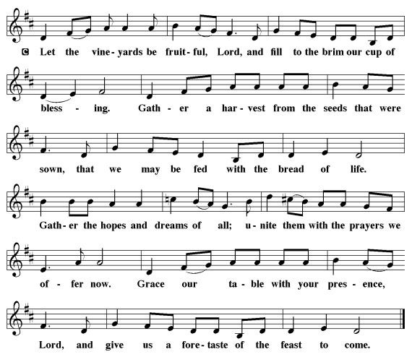

**OFFERING PRAYER** Let us pray,

**Blessed are you,** **O God, ruler of heaven and earth. Day by day you shower us with blessings. As you have raised us to new life in Christ, give us glad and generous hearts, ready to praise you and to respond to those in need, through Jesus Christ, our Savior and Lord. Amen.**

**\* WORDS OF INSTITUTION**

**\*THE LORD’S PRAYER**  *(SALMON sheet inside the back cover of the red hymnal)*

**COMMUNION** *(All are invited to come to the banquet, for all is ready)*

**COMMUNION HYMN**

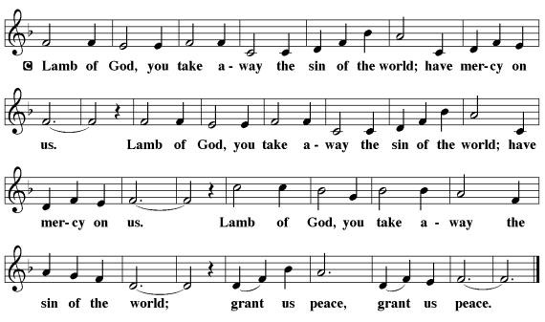

**\*PRAYER AFTER COMMMUION** L: Let us pray,

**Almighty God, you provide the true bread from heaven, your Son, Jesus Christ our Lord. Grant that we who have received the Sacrament of his body and blood may abide in him and he in us, that we may be filled with the power of his endless life, now and forever. Amen**

**SENDING**

**\*BLESSING**

Christ asks if we love him?

If we say yes, he says; “Then care for one another.”

This is our opportunity to make a difference, to live lovingly on the frontiers of his bright new world.

**We cannot promise to do it perfectly, but we can give it a go, relying on his abundant wisdom to take our small love, and fit it into a larger pattern of good for all creation.**

May God bless the world in which you move, and bless your home and bless your friends.

May God bless the eyes with which you see, and bless the ears with which you listen.

May God bless the way you use your hands, bless the way you employ your tongues.

The Almighty God; Father, Son and Holy Spirit grants you - grace, mercy and peace today, tomorrow and always. ***Three fold Amen***

**\*SENDING HYMN** *(VERSES 1-3 &8)  I Know that My Redeemer Lives!***ELW #619**

**\*BELL/SENDING** L: Go in peace. Serve the Lord **C: Thanks be to God!**

**POSTLUDE**

**+++++++++++++++++++++++++++++++++++++++++++++++++++++++++++++++++**

Copyright © 2016 Augsburg Fortress. All rights reserved. Reprinted by permission under Augsburg Fortress Liturgies Annual License #SAS103469. New Revised Standard Version Bible, copyright © 1989, Division of Christian Education of the National Council of the Churches of Christ in the United States of America. Used by permission. All rights reserved.

**Readings for next Sunday:** Acts 9:36-43, Ps. 23, Rev. 7:9-17, John 13:31-35

Prayer requests

*We remember in our prayers…all who face catastrophic illness, surgery, and bindings of all kinds as well as the homebound:* ***Bea Behrens, Agnes Carlson, Lisa******Carlson & family, Donna Fisk, Danny Lang and Kent Hyndman.***

**THIS WEEK IN OUR PARISH**

**TODAY:** The Truman Firemen are hosting a Fundraising Breakfast today from 9:00-1:00 pm at the Firehall. Fee-Will Offering. Serving pancakes, eggs, bacon, sausage, hash-browns, coffee, juice and milk.

**TUESDAY, APRIL 12**- Early Childhood Screening at Trinity from 8-3 pm.

Trinity Lutheran in Madelia is hosting **the Spring Festival in Madelia**. The Salad Luncheon portion of the event will be held from 11-1 pm. Adults are $6. A Drawing for a variety of prizes to be held at 12:30. Everyone is welcome to attend!

**WEDNESDAY, APRIL 13**-Church Council meeting at Trinity

**FRIDAY, APRIL 15**-Last Day to submit news items to the Messenger

**SATURDAY, APRIL 16**-Beauty for Ashes Celebration at the High School in Madelia

**The Lion’s Club is having a Burger Bash on Saturday, April 16 from 5-7 pm at the Community Building. All proceeds will go to the Truman Parade Committee.**

**SUNDAY, APRIL 17**

9-10 am Classroom Sunday School, 10-10:30 am Kid friendly snack

10:30 am Worship **(🎜Sunday School Sings in Church) 🎜**

*Reader: Johnnie Zaharia, Acolyte: Carson Peters*

*Ushers: *Art Stough, Jeff Maloney, Jackson and Mason Maloney*

A Handbell Festival Concert, “Ringing Our Praise,” will be held at American Lutheran Church in Windom on Sunday, April 17 at 300 pm. Everyone is invited to enjoy the music of five area Handbelll Choirs and Handbell Ensembles from Gustavus Adolphus College.